Solving nonlinear PDE for option pricing under illiquidity

Huimin Chung∗ San-Lin Chung
Ming-Chih Lai Chia-Nung Yang

Abstract

This paper considers the pricing model of options under illiquidity. A new numerical procedure for solving the nonlinear parabolic partial differential equation is explored. Furthermore, we demonstrate the pricing error that results from market illiquidity. Empirical tests of the option pricing models for stock options show that the liquidity option pricing model outperform Black-Scholes model.

1. Introduction
Market liquidity is one of the most critical factors in investment decisions and derivative pricing. There is a growing support for the proposition that liquidity affects the asset dynamics and trading strategies. This paper aims to investigate how the price process is affected by dynamic trading strategy and how dynamic trading strategy is influenced by stock price process. Market prices are determined by the supply and demand of traded assets. However, most of financial models assume that the supply and demand are perfect elasticity, which means the orders, including market order and limit order, do not affect the traded asset price. All investors who are considered as small traders have tiny impact in financial market individually. As a manner of fact, the volume of traded assets must influence on the price of traded assets in real market circumstance. The large traders are persons who have a market power and significant part of the shares. Consequently, we argue that their hedging strategy have great impact on stock price and volatility. Hence, the stock price is very likely affected by their hedging strategy and the influence of the large trader hedging strategy becoming a critical issue in financial market.
There are many theoretical studies and empirical studies which support the effect of liquidity of transaction cost on asset dynamics. Furthermore, portfolio choice is also determined by the liquidity assets. Liquidity of assets is one of the factors which play a major role in the formulation of optimal trading policy followed by traders.
This paper provides a comprehensive framework for the pricing of European option pricing and models the dynamic trading strategy in financial market due to illiquidity. According to many pervious research and related articles we know that it will have great influence on pricing and hedging strategy for traded asset such as derivatives when market becomes illiquid or transaction cost becomes higher. Thus, the hedgers can hardly completely replicate their portfolio in illiquidity market and thus result in a lot of hedging error.
In our model analysis, we focus on the circumstance under market illiquidity and perfect liquidity. The classical Black-Scholes (BS) framework is based on many assumptions and the most important Black-Scholes formula assumption relative to this paper is “The stock and option price are not affected by placing orders.” We relax this assumption for the following further analysis and figure out the relationship between the option pricing and the market liquidity.
In market microstructure theory, we say that the feedback effect is based on the violation of this assumption. The large trader might be able to use his market power in order to manipulate market prices in his favor. Sometimes the large trader is called by informed trader who has more information than small trader in market.
We examine how price impact on the underlying asset market that affect the replication of a European contingent claim and find out the best hedging strategy. If the feedback effect exists, we need to develop a new financial model fitting the real market condition and the large trader or investors can use this model for the option pricing and hedging.
The standard market microstructure models of Kyle (1985) and Back (1992, 1993) use an equilibrium approach to investigate how informed traders reveal information and affect the market price through the trading. The equilibrium asset prices are directly influenced by the informed trader’s trades that shown by Kyle (1985) and Back (1992, 1993).
Jarrow (1992) investigates market manipulation trading strategy by large traders in the stock market and the large traders are defined as a person who has influence on prices by generalizing and extending Hart (1977) to a stochastic economy. Furthermore, Jarrow make more generalization in model and distinguishing between the real wealth and the paper wealth while calculate the traders’ position. He argues that asymmetry creates the manipulation opportunity and the large trader can use their market power to manipulate prices and generate profit without any risk.
Jarrow (1994) shows that the introduction of option markets might result market manipulation strategy. Simply speaking, he defines the manipulation strategy as arbitrage opportunity regarding the large trader. He shows that if the stock market and derivative market are perfectly aligned, so-called synchronous market condition, the large trader can hardly manipulate prices. Jarrow (1994) identifies this condition to be equivalent to the no arbitrage condition. But if the small trader or noise traders have only incomplete information about the large traders’ behavior and reaction, the small trader could fail to synthetically replicate the call options.
Esser and Moench (2003) introduce a continuous-time model for an illiquid market and revise the market liquidity parameter from deterministic liquidity model to stochastic liquidity model (henceforth SL) which demonstrates that the market liquidity follows a stochastic process. Furthermore, they analyze positive feedback strategies and contrarian feedback strategies. They find the market volatility generally increasing compared to BS model when positive feedback strategies exist. Moreover, they derive a closed-form expression for the option pricing model and exploit a pragmatic method to calculate the price of liquidity from plain vanilla put options. However, the SL model is very sophisticated than the Frey model in numerical computation and empirical study. Thus, we do not consider the stochastic factor into the liquidity for Occam’s razor purpose.
Cetin, Jarrow, Protter and Warachka (2006) use the stochastic supply curve modeling the liquidity risk and their empirical studies demonstrate that liquidity cost are a significant factor of option price. Furthermore, they find that in-the-money (ITM) options are subject to the lowest percentage impact of illiquidity component, even thought ITM options is expensive. On the contrary, the out-of-the-money (OTM) options are significant affected by the factor of illiquidity despite OTM options are cheaper than ITM options. They define liquidity cost of the discrete trading strategies and estimate the liquidity parameter of the stochastic supply curve. The empirical evidence shows that the liquidity cost increases quadratically with transaction sizes.
Recently research concentrates on the pricing and hedging aspects which are introduced by the market illiquidity and the presence of the price impact effects on stock prices regarding the large traders. Frey (1998, 2000), Schonbucher and Wilmott (2000), Frey and Patie (2001), Bank and Baum (2004), as well as Liu and Yong (2005).are some famous articles and they calibrate the nonlinear pricing PDE in the illiquidity of the option pricing. Cetin, Jarrow, Protter and Warachka (2006) is the latest paper which provide a “reduced form” illiquidity model for constructing a discrete trading strategy within temporary price impacts. They not only utilize a simple framework for estimating the parameter of the stochastic supply curve by regression but also build up an optimal discrete time hedging strategy rather than the nonlinear PDE pricing model.
There would be a tough problem as we introduce the large traders’ trading and hedging actives into European option pricing model. In fact, the asset dynamics depend on many parameters such as the Delta hedging strategy, market liquidity, Gamma and so on. This characteristic renders the pricing problem nonlinear. Thus, we face the problem that the nonlinear PDE is more difficult than BS model for getting the exact solution. In section 3, we show a better way of numerical skill which can avoid solving the nonlinear PDE problem directly.
In practice, the traders often use the Black-Scholes model that the stock price is described by a lognormal random process. Nevertheless in BS model the traders’ trading or hedging their position according to a misspecified model that could generate serious pricing and hedging error especially when liquidity becomes worse. That is the reason why we use the nonlinear PDE model rather than BS-PDE pricing model and the nonlinear PDE model is designated as the Frey model in the following research.
First of all, we provide the nonlinear parabolic partial differential equation (the Frey model) to modify the original Black-Scholes partial differential equation (BS-PDE) for option pricing under market illiquidity framework and the proof of the Frey model will present in Appendix. Secondly, we demonstrate the hedging error formula result from market illiquidity and claim the new volatility term for feedback effect trading strategies.
In general, PDE problem can be solved by certain numerical method including finite difference method (FDM), finite element method (FEM), and finite volume method and so on. In fact, obtaining the analytical solution of PDE is not easily even though there are many well-developed numerical methods. In our methodology, we utilize FDM which is the most fundamental and simplest framework in the computation of PDE.
The rest of this paper is organized as follows. In section 2, we introduce the model that is modification of BS-PDE and derive the Frey model (nonlinear PDE model). In section 3, we provide numerical results of the nonlinear PDE pricing model for European calls. Section 4 provides the empirical study and verifies the estimation loss function. Section 5 contains the concluding remark and further research. Appendix provides the concept of the Thomas algorithm and the comparison of the heat equation and the BS-PDE.

2. The Model
This paper considers the pricing model of options under illiquidity and the following several sections are the core of this paper. In this section, following Frey (2000) and Frey and Patie (2001), we assume that there are two traded assets: bond and stock in the market where bond is a risk-free asset (i.e. cash account) and stock is a risky asset which follows a stochastic process. Simultaneously, we consider the bond as a numeraire (i.e., sometimes called discount factor) and assume that bond market is perfect liquidity that there is no liquidity problem exist. Now we focus on liquidity problem in the stock market.
The BS model assumes that the underlying stock have perfect liquidity, meaning that investors can buy or sell a large amount of stock without affecting the stock price in market so that there is no feedback effect in the market. However, we take the market liquidity variable into account in the model due to the liquidity problem is an existent fact in the stock market. In this study, we do not assume the parameter of liquidity following a certain stochastic process, meaning that the liquidity is deterministic and it is not stochastic.
The following sections will introduce the basic assumptions and asset dynamics firstly. Secondly, the Frey model will be conducted and then we introduce the tracking error of the model. After that we explore the numerical method applications in the model. Finally, we present the smooth version of the model which proposed by Frey and Patie (2001).

2.1 Basic assumptions and asset dynamics
We now introduce the basic model setup proposed by Frey and Patie (2001). The risky asset (i.e. the stock) follows the stochastic process without drift term
, (1)
where is the number of stock shares held by large investor, i.e. the trading strategy of the large trader. The variable denotes the right-continuous process, and is a non-negative constant liquidity parameter. A large value of the parameter means that the market becomes more illiquid. Moreover, we state that the parameter is equal to zero as the market reduces to the BS world with perfect liquid. Recall that the drift term plays a role in stock dynamics in the assumption of the BS model. After the change of measure, however, the drift term is removed from the BS-PDE which is dominated by risk-free rate in risk neutral measure.
Frey (2000) and Frey and Patie (2001) discuss the influence of the trading strategy on the asset process with a smooth stock trading strategyand suppose that the large trader utilize the strategy of the form . Thus, the asset dynamic becomes a new dynamics and then we can obtain the new effective asset dynamics by Ito formula with the following form
, (2)
where
, (3)
, (4)

Derivation of the new asset dynamics
We suppose that the large trader utilize the strategy of the form for a function and it is satisfying a mathematical assumption with two variables which are once continuously differentiable in time and twice continuously differentiable in stock. The trading strategy of large trader expanded by Ito formula and thus we can get the form
. (5)
Firstly, we have already known the stock prices are controlled by the following stochastic process.
.
Secondly, we substitute the Equation (5) into the second term of the RHS of the Equation (1) and thus we obtain the Equation (6).
.
(6)
By rearrangement,
(7)
Therefore, generates the following explicit form for asset dynamics
.
(8)
In this section, we provide a simple proof of the new effective asset dynamics. In next section, we interpret how the Frey model is controlled by the Equation (12) and clarify all of basic assumptions in the model.

2.2 The Frey model (nonlinear parabolic PDE)
The Frey model has two significant characteristics different from Black-Scholes PDE. First, the risk-free rate does not play a role in Frey model. Second, the Frey model argues that the volatility is not a constant volatility. In the Frey model, the volatility term is dominated by three main parameters, and in the Frey model. However, we can utilize the three main parameters to capture the volatility behavior in real markets. The parametercan be utilized to describe the asymmetry of liquidity. Generally, markets tend to be more liquid in the bull market than in the bear market. Thus, Frey and Patie (2001) denote the parameter in the following form
, (9)
where the parameteris usually larger thanin empirical study. The parameter plays an important role in this model. The asymmetry of liquidity can be explained bywith financial sense. The third critical factor is . We are familiar with the Greeks in options pricing and hedging. In the Frey model, the parameter represents the value of gamma and it is also a crucial factor in the model.
First, plays a role in Equation (3) & (4) and thus it would affect the asset dynamic. If we want to simulate the sample path of the stock price afterward, the parameter must be calculated by FDM before the simulation. Second, it goes without saying that has a great influence on the size of hedging error and the large trader’s trading strategy. In section 2.3, we will demonstrate the relationship between the parameter and tracking error with mathematical equation.
There are two major trading strategy which include positive feedback trading and contrarian feedback trading. When the large trader adopting the positive feedback trading strategy. On the other hand, the larger trader employs the contrarian feedback trading strategy as . Moreover, is also vital when we discrete the Frey model in numerical computation and the detail of this part will be presented in section 2.4.

The Frey Model (nonlinear parabolic PDE)
We denote that there is a solution of the Frey nonlinear PDE model. Specifically, the Frey model and terminal condition is given by
, (10)
, (11)
where is the large traders’ strategy and it must satisfies a critical assumption with . Obviously, we observe the Frey model setting risk-free rate equal to zero and illustrate the PDE formula under risk neutral measure without drift term (i.e. risk-free rate equal to zero). However, we can improve the Frey model by taking risk-free rate into account, making the pricing model more general than Frey’s and we present the form of the Frey model with risk-free rate. For tractability, we still assume that the parameter, risk-free rate, equal to zero the same as Frey’s model setting for “parsimonious principle” in numerical analysis.

2.3 Tracking error (hedging error)
Firstly, we realize the large traders following the trading strategy with and the volatility of asset price is. Secondly, we employ the Ito formula to so that we can obtain
, (12)
equivalently,
, (13)
where we denote is the payoff of derivative at maturity day. Hence, and the payoff of derivative at maturity day can be represented in this form
(14)
Assuming we have already known the Frey nonlinear PDE model. If the Frey model holds, we can eliminate the last term in the right hand side (abbreviated RHS) of the Equation (14). Now we denote the tracking error. The tracking error measures the difference between the terminal payoff of the European option (i.e.) and the replication of derivative (i.e.) which duplicated by bond and stocks with the self-financing trading strategy. Using the tracking error can easily track and judge the performance of hedging strategy. In fact, we regard and as the total cost and the total revenue respectively in economic sense.
We conclude that a positive value of displays the large trader who loss the money in the hedging strategy, meaning the payoff of the replication of derivative can not completely cover the payment of European style option at maturity date. Thus, the large traders suffer loss from under-hedging at maturity day.
According to self-financing trading strategy, we can obtain the option payoff at terminal time by the following representation
, (15)
where and . Next we demonstrate that the tracking error under BS world and as self-financing trading strategy holds.
(16)
Frey (2000) demonstrates that the Black-Scholes hedging is costly under imperfectly liquid market and the tracking error is always absolutely positive-value in BS world. We can display the tracking error in the following form
, (17)
If , then . Hence, we conclude and the tracking error is positive. When , we can get the same result in this integral form. In a word, the value of the tracking error is always positive if the large trader uses the Black-Scholes option pricing model in illiquid market.

2.4 Numerical method applications in the Frey model
In this section, we are interested in how to discretize the Frey model which is a complex nonlinear PDE. Obviously, the coefficient of the Frey model is an unknown number which includes the solution that we want to solve it. In Frey and Patie (2001), they use the Newton method to solve the whole nonlinear system. However, using the Newton method might quite sophisticate and spending much more computational time in programming procedure. As a result, we provide an alternative approach that transfers the nonlinear problem into the linear system and this approach can reduce the computational costs. We will demonstrate the detail of methodology in the following.
Firstly, we use the explicit method for the calculation of the coefficient. After we solve the coefficient in the first step, the nonlinear PDE becomes the linear PDE and therefore the coefficient of the model is known at this moment. Secondly, we use the implicit method to solve every linear system at each time step. Recall the Frey model without the risk-free rate (zero drift)
,
However, we impose the risk free rate term in the model which improves the model more general than the Frey model.
, (18)
Using the finite difference methods, the Frey model can be represented in this form
, (19)
where
. (20)
We denote that is the numerical solution and is the exact solution of the Frey model, is the index of the time, is the index of the space. We have already known the value of at timedue to the explicit method as computing the PDE at time . Therefore, all the gird of call option value can be obtained by FDM easily. Figure 1 displays the basic concept of the implicit method.

[Insert Figure 1 here]

2.5 The smooth version of nonlinear PDE
We find a serious problem in this termas we check the numerical data and find that this term violates the basic assumption “” in programming process. If we do not address this numerical problem, the nonlinear PDE will display a non-smooth solution in option intrinsic value and generating bad numerical solution. Therefore, using some skill in nonlinear PDE, we revise the violation of the basic assumption by the following form:
. (21)
In Frey and Patie (2001), they choose =0.02 and =0.85 for the smooth version of nonlinear PDE. Frey and Patie (2001) do not explain how the parameter would be selected and the detail of methodology does not appear in their paper. If we do not impose artificial conditions in the PDE model, the denominator of second coefficient in Equation (21) could be greater than one. Frey and Patie (2001) provide this approach to settle the non-smooth numerical solution problem in option pricing. General speaking, the more smooth PDE we have, the more precise solution we get.
The second coefficient of PDE in Equation (21) is controlled by some of the factors and the numerical boundary value are governed by and . We can treat andas the artificial condition or the barrier. We state that is the maximum value of and use the parameter to control and thus this term will not be negative anymore. Hence, we obtain smooth solution in the Frey model. Secondly, the parameter control the volatility term in nonlinear PDE. The termcan be explained by the minimum value of the volatility under illiquidity market condition. The smooth version of PDE proposed by Frey and Patie (2001) sounds great but this approach might affect the stability of the numerical solution. Since the disadvantage of this revised PDE is too artificial that designedly limit the numerical value in certain boundary to avoid the violation of the basic assumption. We test the call option value, delta (i.e., first derivative) and gamma (i.e., second derivative) and finding the value of gamma will explode as . This phenomenon tells us that the smoothed version of PDE is absolutely not a unique approach as we calculate the second derivative. The second derivative represents the variation of the hedging strategy for large trader. Consequently, we should carefully use the smoothed version of PDE when we need to build up a hedging strategy in the certain period.

3. Numerical Result
Section 3 provides the numerical result of the Frey model. We compare the option pricing under different liquidity circumstances and compute the speed of programming with direct method and iterative method. Finally, we check the condition number of the linear system in each time step from “coarse grid” to “find grid.”

3.1 Option pricing under perfect liquidity market
In section 3.1, we set the parameter, which means that the Frey model is equivalent to the classical BS model. Our benchmark set of underlying parameters is reported in Table 1.

[Insert Table 1 here]

According to Table 1, we obtain that the exact solution of BS call option price is 7.9260. Moreover, we display the profile of the numerical solution in Figure 1 and verify the numerical solution of the Frey model with the BS model in perfect liquidity market. The terminal payoff and intrinsic value of call option are showed in Figure 1.

[Insert Figure 2 here]

3.2 Option pricing under imperfect liquidity market
In section 3.2, we implement the option pricing under illiquid market. The assumption and the parameter setting dose not change except the parameter . We want to realize the call option value with different liquidity. In figure 2, we present the outcomes for a 1-year call option with other parameter setting for different values of the market liquidity ranging from 0 to 0.5. Figure 2 shows that the relationship betweenand call option value. However, we observe that the large trader will spend more money to hedge a call option under worse market liquidity condition. Thus, the hedge cost of the large trader is increasing in the parameter .

[Insert Figure 3 here]

3.3 The computation speed of direct method and iterative method
One of the important issues is to explore the efficient method for solving the tridiagonal system. While there are several methods for solving the linear system, the iterative and direct methods are explored in our study. Jacobi, Gauss-Seidel (GS) and successive over-relaxation (henceforth, SOR) are most prevailing iterative method (indirect method). For direct method, the Gauss-eliminate type is the basic routines for solving linear system and usually based on some forms of Gaussian elimination with pivoting. The LU decomposition and the Thomas algorithm are the most popular approach in direct method for solving the linear system. It notes worthy that the Thomas algorithm is the most efficient way for solving “the tridiagonal linear system.” If the linear system is not tridiagonal, the Thomas algorithm is not suitable and can not be used in non-tridiagonal type system. The setting of parameters is the same as Table 1 and the parameter is assumed to be zero.

Table 2 demonstrates some of results from numerical method and compares the computational speed in three different methods. First, the Thomas algorithm is apparently the fastest way to address the tridiagonal system and it can save a lot of time for our procedure. According to the result of the Table 2 is not significant in the column of “elapsed time” because the mesh grid is “coarse.” If we increase the partition of time and (stock) space, the Thomas algorithm will obviously exhibit its computational power. Second, the disadvantage of GS method is time-consuming and the accuracy of the solution depends on the number of iterations. The detail of the Thomas algorithm will show in Appendix. Hence, we abandon the iterative method because it is time-wasted. In our point of view, the Thomas algorithm is most efficient and fastest method for solving the tridiagonal system but a majority of textbook still uses LU-decomposition to solve the tridiagonal system in each time step. As a result, the Thomas algorithm provides a great improvement in numerical scheme and it decreases the computational costs.

[Insert Table 2 here]

3.4 The condition number of tridiagonal system
The condition number measures the sensitivity of the linear system. As the size of the coefficient matrix increases, the condition number will increase and the solution of the linear system becomes sensitive to the numerical methods. Using a different way to take an inverse in the coefficient matrix will result in a different solution. Table 3 shows that the relationship between the condition number and market liquidity.

[Insert Table 3 here]

Obviously, the condition numberis increasing in the liquidity parameter when holds constant. On the other side, we increase the partition of the space and the parameter holds constant at the same time. In Table 4, the condition number grows about quadruple as decreases a half and thus we claim that the solution is stable. Consequently, we conclude the numerical solution of the Frey model is not sensitive to the size of the coefficient matrix because the relative ratio of condition number is quite stable. The following table displays the relative ratio of condition number.

[Insert Table 4 here]

In this section, we not only check the condition number of the linear system at each time step but also list the maximum value of the condition number in each time step. We consider that the sensitivity of the numerical solution is highly correlated with the condition number. At beginning, we conjecture that the coefficient of matrix could generate a great influence on numerical solution of the option pricing model as the market liquidity becomes worse. However, we demonstrate that the condition number increases quadruply as the partition of the space increases double and thus the sensitivity of the solution is conducted.

4. Empirical Study
We present a test of the performance of the option pricing model under illiquidity for individual stock option prices for the sample period from January 1, 2000 through December 31, 2004. Our empirical study is based on call option contract's close quote price taken to be the bid-ask mid-point price. Moreover, we check the integrity of the quotes and remove unreasonable data in our empirical work. First, we compute the Black-Scholes implied volatility (BS-IV) for each exercise price everyday and then the BS-IV with higher than 100% or lower than 0% are excluded in our dataset. Let denote the daily close price of options at day . In addition, we denote as call option prices from the Frey nonlinear PDE model. The liquidity parameter is estimated numerically with two stages by the following equations.
Stage 1:
, (22)
Stage 2:
, (23)
, (24)
where the variable presents the number of exercise quote price in each day and presents the number of trading day. The above Equation (22) is a nonlinear least square (henceforth, NLS) estimator because the element is the numerical solution from the Frey nonlinear PDE model. On the other hand, we can also claim that the above Equation (22) is a type of estimation loss function and therefore the parameter is a minimum (squared) distance estimator.
The following illustrates the detail procedure regarding the estimation of the liquidity parameter. First, we use the moving window method to do the whole estimation procedure. Second, we utilize the pattern search algorithm into the whole estimation procedure. Here the Pattern search algorithm can be employed for finding the minimum of objective function and obtaining the parameter which correspond to the local minimum objective function. Third, we determine the number of day in the moving window and then calculate BS-IV for each exercise price per day. After that we compute the arithmetic mean of BSIV after excluding the unreasonable value of the BS-IV. We use the data of the firstdays to determine the parameter of the -th day. i.e., if we select =2 for the number of the moving windows which means that we use the first two days’ observations to determine the parameter of the third day. Hence, the third parameter represents the first parameter that we estimated in our empirical study and then we use the same approach for getting the rest of parameters. As a result, we obtain a sequence of the parameter :
, (25)
where is the length of date in the sample. We use the pattern search algorithm to determine the optimal parameter in the minimization of the square of the difference between the theoretical price and the observed price. We propose the pattern search algorithm for estimating liquidity parameter of the Frey model. The pattern search algorithm is a popular approach in optimization especially for solving bound constrained nonlinear programs, linear unconstrained problem and some kind of minimization problem.
However, we should give an initial-guess value, the lower bound and the upper bound of the parameter in this algorithm. Since the pattern search algorithm can not obtain the global minimum of the objective function. Hence, we set a vector of initial-guess which can be applied to find every optimal parameter for every different initial-guess value and then we pick up the most appropriate parameter to be the first estimator. After we get the first estimator, the rest of estimation procedures are the same except we impose the former estimator to be the initial-guess value as we estimate in the rest of estimation procedure.
The empirical study can be divided into three parts. In the first part, we focus on the bear market in short term period and then test the fitting ability of the Frey model. Furthermore, we compare the pricing error with the BS model. In the second part, we select a number of companies to be the objective of our study and choice the period of time from 2000 to 2004 which is lager than the first part. In the last part, we verify the suitability of the estimation loss function.

4.1 Bear market (short term)
We observe the trajectory of the IBM stock price and find the underlying asset having the down trend phenomenon in 2002. According to the market microstructure theory, we argue that the bear market often occur the market illiquidity. Thus, we have more interest in the fitting ability of the Frey model especially when illiquid market happened. We display the trajectory of the underlying stock price of the IBM Company from 2000 to 2004 and only 2002 respectively and the Table reports the descriptive statistics

[Insert Figure 4 here]
[Insert Table 5 here]

Only the at the money (ATM) call option are used in our empirical study because we consider that the OTM and ITM option are not suitable for the analysis of the pricing error. The pricing error will generate more bias result from the volatility smile and skew pattern.

[Insert Table 6 here]

In Table 6, we compute the theoretical price of the BS model and the Frey model. First, we compare the mean of the ATM option pricing error of the IBM Company in 2002 and showing the numerical result with the different and UB and given the fixed LB. According to the numerical result of the Table 6, the pricing of the Frey model is smaller than the BS model significantly and the result of pricing error is nothing to do with the upper bound of the parameter. Moreover, we find the number of the moving window does not have great impact on the pricing. Thus, the second part of the empirical study set =1. If the number of the moving window is given, no matter what the setting of UB, the pricing error of two option pricing model is not change almost surely. In Figure 5, we show that the profile of the liquidity parameter estimated from the Equation (23) & (24) by the pattern search algorithm. Obviously, we observe that the liquidity parameter is quite stable so that we obtain accurate and reliable result from the pricing error of two option pricing model. Figure 6 shows the graph of the stock option price and the pricing error respectively.

[Insert Figure 5 here]
[Insert Figure 6 here]

4.2 Normal market (median term)
We select a number of companies which list on Chicago Board Options Exchange (CBOE). Table 7 reports the symbol and the name of the sample in the second part of empirical study.

[Insert Table 7 here]
[Insert Table 8 here]

The estimation method is the same as the first part of empirical study. However, we select a longer period of time for the analysis of the pricing error. The Frey model displays unexpected fitting ability and tracks the asset dynamics for every stock option. Moreover, all of the stock options have pass through the pair t-test except the AMR stock option. Although the pricing error of the Frey model 0.3494 is smaller than the BS model’s 0.4447, the result of t-test is not significant resulting from the option price of the AMR have two jump phenomena happened on March 2000 and January 2001 respectively.

[Insert Table 9 here]
[Insert Figure 7 here]

If we eliminate jump effect, the pricing error of the Frey model still significantly differs from the BS model in the AMR stock option during the period from February 2001 to December 2004. Hence, we conclude that the Frey model exhibits a gorgeous ability for the stock option and it obtains more precise solution than the BS model especially for illiquid market.

4.3 The loss function
Christoffersen and Jacobs (2004) emphasize the consistency in the choice of the loss function is important. If a theoretical model is implemented using an inappropriate estimation loss function, then the more mean squared error (MSE) we get. In the following analysis, we introduce many loss functions for investigating the accurate estimation of the liquidity parameter when evaluating the Frey model. We compare the value of MSE between the Frey model and the BS model since the loss function can be treated as the criteria of the model selection.
There are many loss functions are employed in literature and practice. First, the traditional loss function is composed of the dollar loss function and the percentage loss function and those can be divided into two categories respectively. Thus, mean squared dollar errors ($MSE), mean absolute dollar errors ($MAE), mean squared percentage errors (%MSE) and mean absolute percentage errors (%MAE) can be defined as
, (26)
, (27)
, (28)
, (29)
where and are the model call option prices and the observations respectively. Secondly, we introduce the implied volatility loss function; that is, the implied volatility MSE and it also can be defined by
, (30)
where the implied volatility are
, (31)
, (32)
and is the inverse of the BS formula, the rest of inputs in the BS model are also given as we calculate the implied volatility MSE.

[Insert Table 10 here]

Table 10 reports the results of the MSE of two models with respect to different sample. The traditional loss functions shows that the Frey model apparently performs better than the BS model and the IVMSE displays that Frey model somewhat better than the BS model. Since jump phenomena are found by the trajectory of the implied volatility in the sample of AMR and WDC, the Frey model reduces the fitting ability per se. However, the rest of sample still exhibit a fabulous performance in the Frey model with smaller MSE and therefore we identify the performance of two theoretical option pricing models. Unquestionably, the Frey model shows that it can capture more the pattern of the market than the BS model. Furthermore, the estimation method of the liquidity is checked. Thus, we not only claim that the choice of the loss function is appropriate but also obtain the reliable results in our empirical work.

5. Conclusion
This paper considers the pricing model of options under illiquidity. According to the model proposed by Frey and Patie (2001), we explore a new approach for solving the nonlinear PDE rather than the Newton method. Furthermore, we employ the Thomas algorithm for solving the tridiagonal system and propose the pattern search algorithm for getting the liquidity parameter respectively and therefore the process is not time-wasting. After a preliminary numerical study of the model, we apply it to stock call option prices for the sample period January 1, 2000 to December 31, 2004. We demonstrate that the pricing error results from market illiquidity in the first part of empirical study. In the second part of empirical study, we enlarge the sample period and check the fitting ability of the Frey model. The Frey model, for the most of part, not only exhibits good outcomes regardless the length of the sample period but also presents excellent performance in illiquid market. The Frey model really represents a vital improvement with respect to the BS model in terms of pricing error and it provides a reasonable option pricing model for the pricing of a block order in terms of price impact. We argue that the serious pricing biases of the BS model can be explained by the nonlinear feedback effect and thus if the large trader uses the Frey model rather than the BS model, they could avoid unnecessary loss from the stock option market.
In further research, the singularity separating method (SSM) can be applied to the option pricing. Since the SSM is adopted, precise numerical solution can be obtained very quickly. The SSM method is proposed by You-Lan Zhu who improves the terminal condition of the option. There is a singularity point in the terminal payoff as the stock price equals to the exercise price and thus numerical solution will have a bad accuracy and reduced convergence rate around the singularity point even though the numerical solution will become smooth finally. However, we do not use the SSM method into our numerical scheme. If we want to get more rigorous solution of the PDE, we should adopt the SSM in our frameworks.
Recently, the field of the computational finance grows up quickly. We believe that the Frey model can be calculated by other numerical schemes but until now we consider that the new approach of mine is the fastest way for solving the Frey model. Accordingly, the large trader who uses the Frey model obtaining the more accurate theoretical price and the fastest way in a short term period so that they make the right strategy immediately and establish the optimal position in the market.

References

Back, K., (1992): Insider trading in continuous time, Review of Financial Studies, 5, 387-409.
Back, K., (1993): Asymmetric information and options, Review of Financial Studies, 6, 435-472.
Bakstein, D., (2001): The pricing of derivatives in illiquid markets, Working paper.
Bange, M. M., (2000): Do the portfolio of small investors reflect positive feedback trading?, Journal of Financial and Quantitative Analysis, 35, 239-255.
Bank, P., and D. Baum, (2004): Hedging and portfolio optimization in financial markets with a large trader, Mathematical Finance, 14, 1-18.
Bollen N. P. B., and Robert E. Whaley, (2004): Does net buying pressure affect the shape of implied volatility functions?, Journal of Finance, 59, 711-753.
Brandimarte, P., (2002): Numerical Methods in Finance: A MATLAB-Based Introduction, Wiley.
Brenner, M., R. Eldor, and S. Hauser, (2001): The price of options illiquidity, Journal of Finance, 56, 789-805.
Cetin, U., R. Jarrow, P. Protter, and M. Warachka, (2006): Pricing options in an extened Black Scholes economy with illiquidity: theory and empirical evidence, Review of Financial Studies, 19, 493-529.
Christoffersen, P., and K. Jacobs, (2004): The importance if the loss function in option valuation, Journal of Financial Economics, 72, 291-318.
Esser, A., and B. Moench, (2003): Modeling feedback effects with stochastic liquidity, Working paper.
Etling, C., and T. W. Miller, Jr., (2000): The relationship between option moneyness and relative liquidity, Journal of Futures Markets, 20, 971-987.
Fausett, L. V., (2002): Numerical Methods: Algorithms and Applications, Prentice Hall.
Frey, R., (1998): Perfect option replication for large traders, Finance and Stochastics, 2, 115-142.
Frey, R., (2000): Market illiquidity as a source of model risk in dynamic hedging, in Model Risk, ed. by R. Gibson, RISK Publications, London.
Frey, R., and A. Stremme, (1997): Market volatility and feedback effects from dynamic hedging, Mathematical Finance, 7, 351-374.
Frey, R., and P. Patie, (2001): Risk management for derivatives in illiquid markets: A simulation study, RiskLab, ETH-Zentrum, Zurich, Switzerland.
Guo, Ming, and Hui Ou-Yang, (2005): A model of asset pricing with market impact costs and transactions costs, Working paper.
Higham, D. J., (2004): An introduction to financial option valuation: Mathematics, Stochastics and Computation, Cambridge.
Jarrow, R., (1992): Market manipulation, bubbles, corners and short squeezes, Journal of Financial and Quantitative Analysis, 27, 311-336.
Jarrow, R., (1994): Derivatives securities markets, market manipulation and option pricing theory, Journal of Financial and Quantitative Analysis, 29, 241-261.
Koren, M., and A. Szeidl, (2002): Portfolio choice with illiquid assets, Working paper.
Kumar, S., (2003): Determinants of liquidity in open electronic limit order book, Working paper.
Kyle, A., (1985): Continuous auctions and insider trading, Econometrica, 53, 1315-1335.
Landsiedl, F., (2005): The market microstructure of illiquid option markets and interrelations with the underlying market, Working paper.
Liu, H., and Jiongmin Yong, (2005), Option pricing with an illiquid underlying asset market, Journal of Economic Dynamics and Control, 29, 2125-2156.
Lo, A. W., H. Mamaysky, and J. Wang, (2001): Asset prices and trading volume under fixed transaction costs, Working paper.
Lyukov, A., (2004): Option pricing with feedback effects, International Journal of Theoretical and Applied Finance, 7, 757-768.
Mancino, M.E., and S. Ogawa, (2003): Nonlinear feedback effects by hedging strategies. Stochastic Processes and Applications to Mathematical Finance, Proceedings of 2003 Symposium at Ritsumeikan University, World Scientific.
Nofsinger, J. R., and R. W. Sias, (1999): Herding and feedback trading by institutional and individual investors, Journal of Finance, 54, 2263-2295.
O’Hara, M., (1995): Market Microstructure Theory, Blackwell Publishers, Oxford.
Pastor, L., and R. F. Stambaugh, (2001): Liquidity risk and expected stock returns, Working paper.
Persuad, A., (2003): Liquidity Black Holes: Understanding, Quantifying and Managing Financial Liquidity Risk, Risk Books.
Platen, E., and M. Schweizer, (1998): On feedback effects from hedging derivatives, Mathematical Finance, 8, 67-84.
Schonbucher, P. J., and P. Wilmott, (2000): The feedback effect of hedging in illiquid markets, SIAM Journal on Applied Mathematics, 61(1), 232-272.
Shleifer, A., (2000): Inefficient Markets: An Introduction to Behavioral Finance, Oxford.
Shreve, S.E., (2004): Stochastic Calculus for Finance II: Continuous-Time Models, Springer.
Trefethen, L. N., and D. Bau, III, (1997): Numerical Linear Algebra, SIAM.
Wilmott, P., (2000): Paul Wilmott on Quantitative Finance, 2 volume set, John Wiley & Sons.
Zhu, You-Lan, Xiaonan Wu, and I-Liang Chern, (2004): Derivatives Securities and Difference Methods, Springer.

Appendix

A.1 The Thomas Algorithm
An efficient algorithm for the solution of tridiagonal system is based on Gaussian elimination with the coefficient of the diagonal elements scaled to one at each stage. The Thomas algorithm takes advantage of the zero elements that already present in the coefficient matrix and avoids unnecessary computational operations. Therefore, we need to store only the non-zero elements and save a lot of memory in programming process.
The Thomas Algorithm is an adaptation of the LU Decomposition (Gaussian elimination) idea to solution of a linear system with tridiagonal or band diagonal coefficient matrix. The fundamental linear system can be written in the form
Wheredenote the unknown vector and denote the right hand side (RHS) vector in this linear system. Here, the coefficient matrix is full of zeros except for the diagonal, the super-diagonal and the sub-diagonal factors, as shown below
The size of the coefficient matrix is. When the matrix is extremely large (e.g., the dimension of is), a considerable obviously reduction in memory requirements and increase in programming speed can be acquired by storing the nonzero elements in three vectors instead of saving the whole matrix. By the way, this algorithm takes only operations and the entire routine can be solved very fast, accurately and concisely. Finally, the Thomas algorithm works well when the coefficient matrix is diagonally dominant. We only introduce the Thomas algorithm for solving the tridiagonal system in this section. However, the detail of the Thomas algorithm or others can refer to the related textbooks or papers.

A.2 The Comparison of the heat equation and the BS-PDE

Scheme | Heat Equation. | Heat Equation  Stability Condition | Local Truncation error | Black-Scholes PDE (BS-PDE) | BS-PDE Stability Condition
FTCS | Explicit |  |  | Implicit | unconditional stable
BTCS | Implicit | unconditional stable |  | Explicit
Note: The implicit method presents an unconditional stable property since we use it for solving the Frey model and obtaining the theoretical option prices.
Tables

Table 1: The basic parameter setting in option pricing
= 50 | = 0 | = 1 | = 0.4
= 50 | = 100 | = 0.5 | = 0.01
= 0 | = 0 | =0.02 | =0.85

Table 2: The comparison of the computational speed with different method
 | Call Option Price | Elapsed Time (sec) | Category
X=inv(A)*b | 7.9136 | 9.172
X=A\b ("backslash operator") | 7.9136 | 7.234
Thomas algorithm | 7.9136 | 6.281 | direct method
LU-decomposition | 7.9136 | 8.125 | direct method
Gauss-Seidel (GS) | 7.9134 | 79.344 | iterative method
The elapsed time is based on the following system requirement. The operation system of the computer is Windows XP SP2, CPU is AMD Athlon 1800+ 1.54 GHz and RAM is 768 MB. The speed of computation might rely on the different operation system, and it could be accelerating the computational speed as we using a better-level computer than our system requirement currently.

Table 3: The condition number of tridiagonal system
 |  | condition number
2 | 50 | 7.70 | 78.82 | 263.98 | 310.61 | 346.66 | 365.08
1 | 100 | 29.66 | 402.90 | 1155.90 | 1449.90 | 1613.50 | 1653.80
0.5 | 200 | 120.50 | 1536.10 | 5331.40 | 6204.70 | 6888.90 | 7543.30
0.25 | 400 | 491.48 | 6755.90 | 22713.00 | 26979.00 | 28570.00 | 30525.00

Table 4: The relative of the condition number
3.8512 | 5.1117 | 4.3787 | 4.6679 | 4.6544 | 4.5300
4.0624 | 3.8126 | 4.6123 | 4.2794 | 4.2695 | 4.5612
4.0787 | 4.3981 | 4.2602 | 4.3482 | 4.1473 | 4.0466

Table 5: The Descriptive Statistics of the IBM
Descriptive Statistics 1: IBM 2002Jan-2002Dec
 | Average call price | Standard error | Number of contracts
ITM | 22.9692 | 0.3637 | 1691
ATM | 2.4345 | 0.071 | 256
OTM | 0.1204 | 0.0057 | 2374
Note: moneyness denotes, ATM denotes, ITM denotes and OTM denotes.

Table 6: The pricing errors of the BS model and the Frey model
Underlying stock: IBM 2002Jan-2002Dec
 | BS | Frey | t-statistic | Std Dev | p-value
Panel A: UB = 0.1
1 | 0.9361 | 0.2339 | 20.6333 | 0.3797 | 9.5122E-69
2 | 0.9379 | 0.2618 | 19.8031 | 0.3802 | 1.1111E-64
3 | 0.9340 | 0.2728 | 19.3945 | 0.3789 | 1.1632E-62
4 | 0.9363 | 0.2807 | 19.1376 | 0.3800 | 2.2449E-61
Panel B: UB = 0.2
1 | 0.9361 | 0.2341 | 20.6183 | 0.3799 | 1.1231E-68
2 | 0.9379 | 0.2618 | 19.8031 | 0.3802 | 1.1110E-64
3 | 0.9340 | 0.2728 | 19.3945 | 0.3789 | 1.1632E-62
4 | 0.9363 | 0.2807 | 19.1376 | 0.3800 | 2.2453E-61
Panel C: UB = 0.3
1 | 0.9361 | 0.2341 | 20.6183 | 0.3799 | 1.1231E-68
2 | 0.9379 | 0.2618 | 19.8031 | 0.3802 | 1.1110E-64
3 | 0.9340 | 0.2728 | 19.3945 | 0.3789 | 1.1632E-62
4 | 0.9363 | 0.2807 | 19.1376 | 0.3800 | 2.2453E-61
Panel D: UB = 0.4
1 | 0.9361 | 0.2341 | 20.6183 | 0.3799 | 1.1231E-68
2 | 0.9379 | 0.2618 | 19.8031 | 0.3802 | 1.1110E-64
3 | 0.9340 | 0.2728 | 19.3945 | 0.3789 | 1.1632E-62
4 | 0.9363 | 0.2807 | 19.1376 | 0.3800 | 2.2448E-61

Table 7: The sample of the second part empirical study
Symbol | Name
AMR | AMR Corporation
BAX | Baxter International, Inc.
BBY | Best Buy Co., Inc.
HDI | Harley-Davidson, Inc.
SNPS | Synopsys, Inc.
WDC | Western Digital Corporation
WFC | Wells Fargo & Company

Table 8: The Descriptive Statistics of the sample in the second part
Descriptive Statistics 2
 | Average call price | Standard error | Number of contracts
Panel A: AMR
ITM | 5.4963 | 0.0650 | 4369
ATM | 1.0598 | 0.0778 | 544
OTM | 0.5762 | 0.0297 | 6527
Panel B: BAX
ITM | 10.1935 | 0.1190 | 4089
ATM | 1.9231 | 0.0376 | 729
OTM | 0.3284 | 0.0082 | 3904
Panel C: BBY
ITM | 15.6534 | 0.1092 | 9161
ATM | 2.1737 | 0.0412 | 945
OTM | 0.2580 | 0.0058 | 7943
Panel D: HDI
ITM | 9.6730 | 0.0833 | 4345
ATM | 1.5253 | 0.0277 | 867
OTM | 0.2310 | 0.0063 | 3110
Panel E: SNPS
ITM | 10.1935 | 0.1190 | 4089
ATM | 1.9231 | 0.0376 | 729
OTM | 0.3284 | 0.0082 | 3904
Panel F: WDC
ITM | 3.1452 | 0.0542 | 1830
ATM | 0.3520 | 0.0136 | 178
OTM | 0.0795 | 0.0012 | 3766
Panel G: WFC
ITM | 9.7272 | 0.0861 | 4916
ATM | 1.1482 | 0.0210 | 793
OTM | 0.1070 | 0.0032 | 3342

Table 9: The pricing errors of the BS model and the Frey model
 | 2000Jan-2004Dec
Symbol | BS | Frey | t-statistic | Std Dev | p-value
AMR | 0.4447 | 0.3494 | 0.9267 | 2.5678 | 0.3542
BAX | 0.5640 | 0.3686 | 10.5374 | 0.4628 | 1.9753E-25
BBY | 0.4812 | 0.2020 | 24.3921 | 0.2857 | 1.1291E-118
HDI | 0.3823 | 0.3518 | 2.4087 | 0.3157 | 0.0161
SNPS | 0.3259 | 0.1577 | 19.6413 | 0.2139 | 5.6992E-80
WDC | 0.1254 | 0.0921 | 6.4311 | 0.1293 | 1.5137E-10
WFC | 0.5254 | 0.1717 | 27.8892 | 0.3166 | 3.4166E-149
Note: the pricing error is calculated by the mean absolute dollar errors ($MAE).

Table 10: The comparison of the loss function
 | 2000Jan-2004Dec
 | $MAE | $MSE | %MAE | %MSE | IV_MSE
Panel A: AMR
BS | 0.4447 | 6.7816 | 0.3720 | 0.3915 | 0.4365
Frey | 0.3494 | 6.7151 | 0.2059 | 0.1227 | 0.4525
Panel B: BAX
BS | 0.5640 | 0.5571 | 0.3877 | 0.3863 | 0.0323
Frey | 0.3686 | 0.3250 | 0.2057 | 0.0918 | 0.0163
Panel C: BBY
BS | 0.4812 | 0.3434 | 0.4342 | 0.9516 | 0.0203
Frey | 0.2020 | 0.0920 | 0.1514 | 0.1522 | 0.0052
Panel D: HDI
BS | 0.3823 | 0.2624 | 0.5024 | 2.0671 | 0.0143
Frey | 0.1495 | 0.0481 | 0.1819 | 0.3581 | 0.0027
Panel E: SNPS
BS | 0.3259 | 0.1636 | 0.3810 | 0.8984 | 0.0167
Frey | 0.1577 | 0.0588 | 0.1518 | 0.1620 | 0.0042
Panel F: WDC
BS | 0.1254 | 0.0382 | 0.6473 | 1.0471 | 0.1025
Frey | 0.0921 | 0.0194 | 0.4417 | 0.3693 | 0.1908
Panel G: WFC
BS | 0.5254 | 0.4340 | 1.4964 | 15.6398 | 0.0247
Frey | 0.1717 | 0.0718 | 0.5514 | 2.7546 | 0.0042

Figures

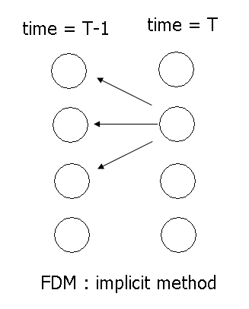
Figure 1: Implicit finite difference method
Figure 2: Option pricing under perfect liquidity market

Figure 3: Option pricing under illiquidity market
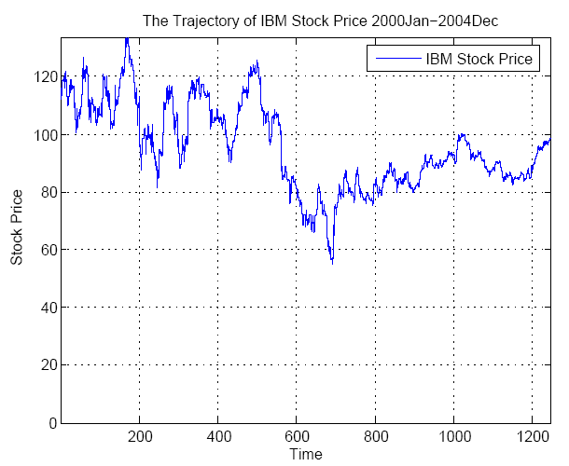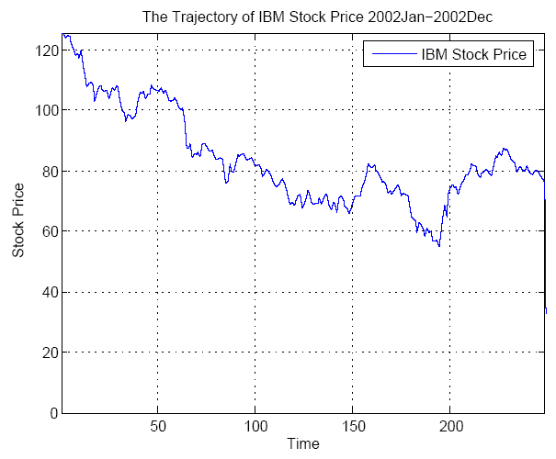
Figure 4: The trajectory of IBM stock price
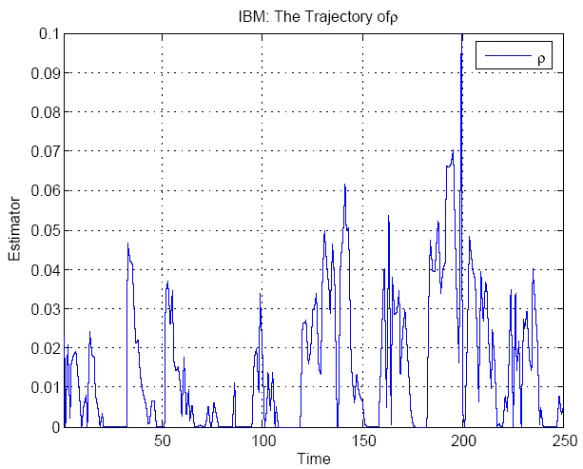
Figure 5: The trajectory of the liquidity parameter
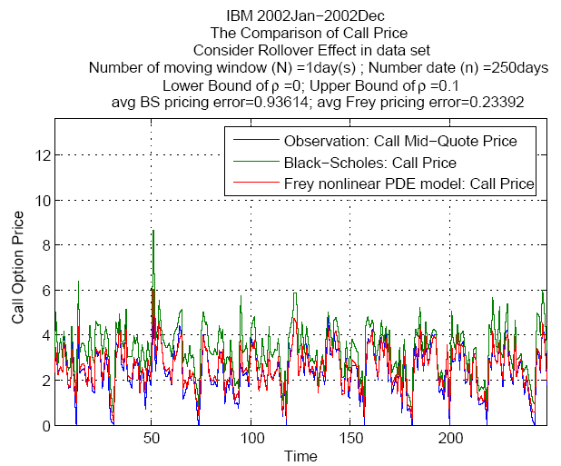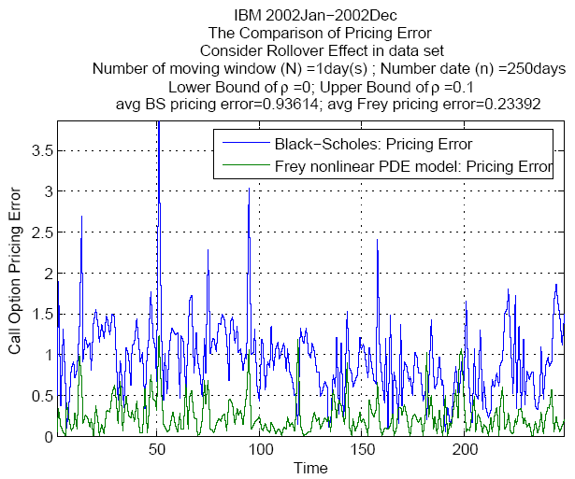
Figure 6: the option price and the pricing error of the IBM
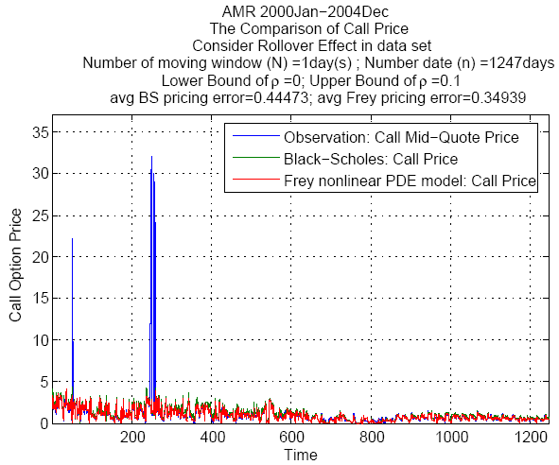
Figure 7: The stock option price of the AMR Company

 Huimin Chung and Chia-Nung Yang are with the Graduate Institute of Finance at National Chiao Tung University. San-Lin Chung is with the Department of Finance at National Taiwan University. Ming-Chih Lai is with the Department of Applied Mathematic at National Chiao Tung University. The authors would like to thank Wei-Peng Chen and Chuan-Hsiang Han for helpful suggestions and valuable comments. All remaining errors are our own. Corresponding author: Huimin Chung, Graduate institute of Finance, National Chiao Tung University, 1001 Ta Hsueh Road, Hsinchu 300, Taiwan. Tel: 886-3-5712121 ext. 57075. E-mail: chunghui@mail.nctu.edu.tw.
See, for example, Pastor and Stambaugh (2001) and Lo, Mamaysky and Wang (2001).
Koren and Szeidl (2002)
In Esser and Moench (2003), the liquidity follows a certain stochastic process. Their framework generalizes the constant liquidity model of Frey (2000) and they impose a stochastic factor into the liquidity. Hence, the stochastic liquidity model of Esser and Moench (2003) is more sophisticated than the Frey model; it’s becoming very complex in the modeling of option pricing and in constructing the hedging strategies when the market liquidity is considered as a random source. In this paper, we do not deal with this kind of complicated circumstance in the parameter of liquidity which follows a certain stochastic process.
The stock is often designated as the space in the FDM application
Kamara and Miller (1995) show that the relationship between moneyness and liquidity is asymmetric. Etling and Miller, Jr. (2000) also state that although the maximum value of liquidity is near the money, liquidity does not decrease symmetrically as strike price move away from at the money (ATM).
Frey (2000) shows the basic concept of tracking error. Theoretically, the tracking error can be treated as a “cumulative dividend stream with instantaneous dividend.” By the way, we should notice that Frey (2000) does not consider the parameterin the model and in the tracking error.
See Appendix, the implicit method is unconditional stable. Thus, we purpose to solve the Frey model is solved by implicit method.
Two artificial conditions are imposed into the PDE model.
The term is .
See Trefethen and Bau (1997).
We should be careful as doing the numerical analysis especially for the application of the option pricing model in finance issue.
The parameter , and should not be estimated simultaneously since it does not easily obtain the accurate value of three parameters at the same time and it is time-consuming for getting three parameters. Therefore, we only focus on the estimation of the liquidity parameter rather than the other two in our empirical study.
If the reader have more interest in the pattern search algorithm, you might search related article or take a look at the MATLAB help file where provide the concise programming code and the condensed introduction.
We denote that the most appropriate parameter corresponds to the smallest objective function.
The more we set, the more computational time we need. However, the length of the moving window impact on the computational cost significantly but it does not affect the result of the pricing error of two option pricing model in our empirical study. As a result, we denote =1 in the following analysis.
The graph of liquidity parameter seems like unsmooth and volatile result from the scale of the vertical axis. In fact, the liquidity estimator is quite smooth as we readjust the range of the vertical axis.
The jump effect is not the consideration of the Frey model since we can not significantly distinguish the Frey from the BS when jump phenomenon happened. Therefore, we get a very reasonable consequent on the underlying asset of the AMR.
Some of article says singularity removing transformation (SRT) method but they offer the same concept regarding the numerical method.
See Fausett (2002)
See Higham (2004), chapter 23
See Wilmott (2000), second volume

