Portfolio Size and Lifecycle Asset Allocation in Pension Funds

Preliminary Draft: Comments welcome

Anup K. Basu Michael E. Drew
Doctoral Candidate Professor of Finance
School of Economics and Finance School of Economics and Finance
Queensland University of Technology Queensland University of Technology
Australia Australia

Abstract

Lifecycle funds offered by retirement plan providers allocate aggressively to risky asset classes when the employee participants are young and gradually switch to more conservative asset classes as they grow older and approach retirement. This approach focuses on maximizing growth of the accumulation fund in the initial years and preserving its value in the later years. This paper simulates terminal wealth outcomes under conventional lifecycle asset allocation rules as well as those given by contrarian strategies that reverse the direction of the switching of assets. Our evidence suggests that the general increase in portfolio size as one approaches retirement is significant from an asset allocation perspective. Due to this portfolio size effect, we find the terminal value of accumulation in retirement account to be critically dependent on the asset allocation strategy adopted by the participant in later years (relative to earlier years). By investing conservatively in such crucial phase, lifecycle strategies recommended by financial advisors sacrifice significant growth opportunity and prove counterproductive to the participant’s wealth accumulation objective. This does not seem to be compensated adequately in terms of reducing the risk of potentially adverse outcomes.

Lifecycle funds have gained great popularity in recent years. Sponsors of defined contribution (DC) plans offer more and more of these funds as investment options to their participants. In many cases, these funds serve as default investment vehicles for plan participants who do not make any choice about investment of their plan contributions. According to Mercer, the total assets under management with the top 5 providers of lifecycle funds at the end of 2005 were nearly $100 billion. The rapid growth in lifecycle invest programs in DC plans is often attributed to the fact that they simplify asset allocation choice for millions of ordinary investors who supposedly lack the knowledge or inclination to adjust their portfolios over time. For them, the lifecycle fund offers an automatic ‘set it and forget it’ solution by modifying the asset allocation of retirement investments periodically in tune with the investors’ changing capacity to bear risk.

So what is the age-based pattern of investing followed by lifecycle funds? The central theme of all lifecycle models of investing is that, all other things remaining equal, the portfolio of an older investor should be different from that of a younger investor. Malkiel [1996] states that the risk capacity of investors depend on their position in the lifecycle irrespective of their individual attitudes towards risk. According to him, as an individual’s risk capacity gets reduced with age, one’s portfolio should also become increasingly conservative.

The above prescription is consistent with the advice given by most financial advisors. They point out that a severe downturn in the stock market at later stages of working life can have dangerous consequences for the financial health of a participant holding a stock-heavy retirement portfolio, not only because it can significantly erode the value of the nest egg but also because it leaves the participant with very little time to recover from the bad investment results. Lifecycle funds, on the other hand, are specifically designed to preserve the nest egg of the greying investor. By gradually switching investments from stocks to less volatile assets over time, they aim to lessen the chance of confronting extremely adverse investment outcomes close to retirement.

Another often cited argument in support of reducing the proportion of risky assets in the portfolio over time is the notion of time diversification according to which the risk or volatility of asset returns are reduced with the length of the holding period. Therefore, investors would be more inclined to hold risky assets with higher expected returns over long horizons than over shorter periods of time. This implies that younger investors, who have long investment horizons, should allocate higher proportions of their portfolios to stocks and reduce these proportions as they age.

The belief that younger individuals can assume greater risk than older individuals and therefore should invest more in risky assets like stocks have been generally well accepted by DC plan providers so much so that it now serves as an important investment principle anchoring most participant education programs in United States (Utkus [2005]). Undoubtedly, this has contributed to the growth in number of ‘age based’ or ‘target retirement’ lifecycle funds offered by various providers in United States. While they differ from one another with respect to how and when the switching from stocks to less volatile assets occurs, there is total unanimity about the overall direction of the switch- higher allocation to stocks during early years of employment and gradual shift to more conservative assets like bonds and cash as the investor approaches retirement. For example, the Vanguard Target Retirement Funds prospectus states that ‘It is also important to realize that the asset allocation strategy you use today may not be appropriate as you move closer to retirement. The Target Retirement Funds are designed to provide you with a single Fund whose asset allocation changes over time as your investment horizon changes. Each Fund’s asset allocation becomes more conservative as you approach retirement.’

The effect of long horizons on the investor’s final wealth outcome has been examined by many researchers. Most of these studies consider the case of a multi-period investor who invests in a portfolio of assets at the beginning of the first period and reinvests the original sum and the accumulated returns over several periods in the investment horizon. The situation of retirement plan participants, however, is more complex because they make fresh additional investments in every period till retirement in the form of plan contributions. Therefore, the retirement plan participant’s terminal wealth is not only determined by the strategic asset allocation governing investment returns but also by the contribution amounts that go into the retirement account every period since these alter the size of the portfolio at different points on the horizon.

A recent observation by Robert Shiller [2005a] harps on this issue and questions the intuitive foundation of conventional lifecycle switching for retirement investors. Shiller argues that “a lifecycle plan that makes the percent allocated to stocks something akin to the privately- offered lifecycle plans may do much worse than a 100% stocks portfolio since young people have relatively little income when compared to older workers…... The lifecycle portfolio would be heavily in the stock market (in the early years) only for a relatively small amount of money, and would pull most of the portfolio out of the stock market in the very years when earnings are highest.” The statement is remarkable in asserting that the portfolio size of plan participants at different points of their working life is significant from an asset allocation perspective.

The size of the participant’s retirement portfolio is likely to grow over time, not only because of possible growth in earnings and size of contributions as Shiller indicates, but also due to regular accumulation of plan contributions and investment returns. In such case, it would make little sense for the investor to follow the prescriptions of conventional lifecycle asset allocation. By moving away from stocks to low return asset classes as the size of their funds grow larger, the investor in effect would be foregoing the opportunity to earn higher returns on a larger sum of money invested.

In this paper, we examine whether by reducing allocation to stocks as the participants approach retirement the lifecycle investment strategy benefits or works against the retirement plan participant’s wealth accumulation goals. We are particularly interested to test whether growing size of the accumulation portfolio in later years indeed demands a higher allocation to stocks to produce better outcomes. However, since an important objective of lifecycle strategy is to avoid the most disastrous outcomes at retirement, we examine various possible scenarios, particularly the most adverse ones, to assess their efficacy as investment vehicle of choice for plan participants.

Data and Methodology
We examine the case of a hypothetical retirement plan participant with starting salary of $ 25,000 and contribution rate of 4%. The growth in salary is taken as 4% per year. The participant’s employment life is assumed to be 41 years during which regular contributions are made into the retirement plan account. For the sake of simplicity, we assume that the contributions are credited annually to the accumulation fund at the end of every year and the portfolios are also rebalanced at the same time to maintain the target asset allocation. Therefore, the first investment is made at the end of first year of employment followed by 39 more annual contributions to the account.

A number of studies in recent years including Booth and Yakoubov [2000] and Shiller [2005] compare terminal wealth outcomes of 100% stocks or other fixed weight portfolios with those of lifecycle portfolios and find little reason for investors to choose lifecycle strategies for investing retirement plan contributions. But these studies are not specifically designed to test whether the allocation towards stocks should be favoured during the later stages of the investment horizon because of the growth in size of one’s portfolio. This is because the competing strategies examined invest in different asset classes for different lengths of time and therefore they are bound to result in different outcomes simply because of the return differentials between the asset classes. For example, one may argue that a 100% stocks portfolio may dominate a lifecycle portfolio purely because the former holds stocks for longer duration. The role played by the growing size of the portfolio over time and its interplay with the asset allocation in influencing the final wealth outcome is not very clear from this result.

To find out whether the growth in size of contributions and overall portfolio with the investor’s age renders the conventional lifecycle asset allocation model counter-productive, as Shiller conjectures, we push the envelope a bit further. We consider hypothetical strategies which invest in less volatile assets like bonds and cash when the participants are younger and switch to stocks as they get older i.e. strategies that reverse the direction of asset switching of conventional lifecycle models. These strategies, which we call contrarian strategies in the remainder of this paper, are well placed to exploit the high returns offered by the stock market as the participants accumulation fund grow larger during the later part of their career. The final wealth outcomes of can then be evaluated to find how these contrarian strategies measure up to comparable lifecycle strategies.

Initially, we construct four lifecycle strategies all of which initially invest in a 100% stocks portfolio but start switching assets from stocks to less volatile assets (bonds and cash) at different points of time - after 20, 25, 30, and 35 years of commencement of investment respectively. We make a simplified assumption that the switching of assets takes place annually in a linear fashion in such a manner that in the final year before retirement all four lifecycle strategies are invested in bonds and cash only. The proportion of assets switched from stocks every year is equally allocated between bonds and cash.

Next we pair each lifecycle strategy with a contrarian strategy that is actually its mirror image in terms of asset allocation. In other words, they replicate the asset allocation of lifecycle portfolios in the reverse order. All the four contrarian strategies invest in a portfolio comprising only bonds and cash in the beginning and then switch to stocks linearly every year in proportions which mirror the asset switching for corresponding lifecycle strategies. The four pairs of lifecycle and contrarian strategies are individually described below.

Pair A. The lifecycle strategy (20, 20) invests only in stocks for the first 20 years and then linearly switches assets towards bonds and cash over the remaining period. At the end of the 40 years, all assets are held in bonds and cash. The corresponding contrarian strategy (20, 20) invests only in bonds and cash in the initial year of investment. It linearly switches assets towards stocks over the first 20 years at the end of which the resultant portfolio comprises only of stocks. This allocation remains unchanged for the next 20 years.

Pair B. The lifecycle strategy (25, 15) invests only in stocks for the first 25 years and then linearly switches assets towards bonds and cash over the remaining period. At the end of the 40 years, all assets are held in bonds and cash. The corresponding contrarian strategy (15, 25) invests only in bonds and cash in the initial year of investment. It then linearly switches assets towards stocks over the first 15 years at the end of which the resultant portfolio comprises only of stocks. This allocation remains unchanged for the remaining 25 years.

Pair C. The lifecycle strategy (30, 10) invests only in stocks for the first 30 years and then linearly switches assets towards bonds and cash over the remaining period. At the end of the 40 years, all assets are held in bonds and cash. The corresponding contrarian strategy (10, 30) invests only in bonds and cash in the initial year of investment. It linearly switches assets towards stocks over the first 10 years at the end of which the resultant portfolio comprises only of stocks. This allocation remains unchanged for the remaining 30 years.

Pair D. The lifecycle strategy (35, 5) invests only in stocks for the first 35 years and then linearly switches assets towards bonds and cash over the remaining period. At the end of the 40 years, all assets are held in bonds and cash. The corresponding contrarian strategy (5, 35) is initially invested 100% in bonds and cash. It linearly switches assets towards stocks over the first 5 years at the end of which the resultant portfolio comprises only of stocks. This allocation remains unchanged for the remaining 35 years.

The above test formulation allows us to directly compare wealth outcomes for a lifecycle strategy to those of a contrarian strategy that invest in stocks (and conservative assets) for the same duration but at different points on the investment horizon. The allocation of any lifecycle strategy is identical to that of the paired contrarian strategy in terms of length of time they invest in stocks (and conservative assets). They only differ in terms of when they invest in stocks (and conservative assets) - early or late in the investment horizon. For example, in case of pair A, both lifecycle (20, 20) strategy and contrarian (20, 20) strategy invests in a 100% stocks portfolio for 20 years and allocate assets between stocks, bonds, and cash for the remaining 20 years in identical proportions. However, the former holds a 100% stocks portfolio during the first 20 years of the horizon in contrast to the latter which holds a 100% stocks portfolio during the last 20 years of the horizon. The same is graphically demonstrated in Exhibit 1.

To generate investment returns under every strategy, we randomly draw with replacement from the empirical distribution of asset class returns. The historical annual return data for the asset classes over several years is randomly resampled with replacement to generate asset class return vectors for each year of the 40 year investment horizon of the DC plan participant. Thus we retain the cross-correlation between the asset class returns as given by the historical data series while assuming that returns for individual asset classes are independently distributed over time. The asset class return vectors are then combined with the weights accorded to the asset classes in the portfolio (which is governed by the asset allocation strategy) to generate portfolio returns for each year in the 40 year horizon. The simulated investment returns are applied to the retirement account balance at the end of every year to arrive at the terminal wealth in the account. For each lifecycle and contrarian strategy the simulation is iterated 10,000 times. Thus, for each of the eight strategies, we have 10,000 investment return paths that result in 10,000 wealth outcomes at the end of the 40-year horizon.

To resample returns, this paper uses an updated version of the dataset of nominal returns for US stocks, bonds, and bills originally compiled by Dimson, Marsh, and Staunton (2002) and commercially available through Ibbotson Associates. This annual return data series covers a period of 105 years between 1900 and 2004. Since the dataset spans over several decades, we are able to capture the wide-ranging effects of favourable and unfavourable events of history on returns of individual asset classes within our test. The returns include reinvested income and capital gains.

Results and Discussion
Comparing various parameters of the terminal wealth distribution for the lifecycle strategies and their contrarian counterparts provide us a fair view of their relative appeal to the retirement investor. In particular, we look at the mean, the median, and the quartiles of terminal wealth distribution under the different asset allocation strategies. These are given in Exhibit 2. As even a cursory glance would reveal, there are significant differences in these numbers.

For each of the four pairs, we observe that the contrarian strategies result in much higher expected value (mean) than the lifecycle strategies. The difference is most striking for pair A as the mean for the contrarian (20, 20) strategy exceeds that for the lifecycle (20, 20) strategy by a staggering 38%, which means a difference of more than $238,000. While the differences between expected values for other lifecycle and contrarian pairs are less eye-popping, they are still very large. This is borne by the results of the contrarian strategies for pair B, C, and D which beat their lifecycle counterparts by 32%, 22.5%, and 10.6% respectively.

However, it is important to note that the mean is not that the most likely outcome or even average likely outcome for any of the strategies. This is apparent from the skewness of the terminal wealth distributions. The means of the distributions are much higher than the medians indicating the probability of achieving the mean outcome is much less than 50%. In other words, the participants should have ‘better than average’ luck to come up with the mean outcome at retirement. The average outcome in this case is, therefore, much more accurately represented by the median of all outcomes.

But even when one looks at the median estimates, the story does not change at all. For all pairs, the contrarian portfolios beat the lifecycle portfolios hands down. For example, the contrarian (20, 20) strategy in pair A results in final wealth of $639,257. The corresponding lifecycle (20, 20) strategy manages only $512,068 thus falling short by a whooping $127,189. The same margins for pair B, C, and D, are $119069, $81564, $50707 respectively.

We also compare the 75th percentile and 25th estimates which represent the mid-point of the above average and the below average outcomes respectively. For the 75th percentile estimates, which are practically the medians of the ‘above average’ outcomes, the differences between the lifecycle and the corresponding contrarian portfolios grow even wider than those for median estimates. For pair A, the 75th percentile outcome for the contrarian portfolio is larger than the lifecycle portfolio by $304,600 i.e. almost 40%. Even for pair D, where the results for the two strategies are the closest, the contrarian portfolio is still better off by $118,819.

For 25th percentile estimates, which represents the medians of the ‘below average’ outcomes, one would normally expect the lifecycle strategies to perform better given they are specifically designed to protect the retirement portfolio against the adverse market movements in the final years. Well, they certainly do better in terms of closing the gap with contrarian strategies but are still not able to outperform them for any of the pairs. For pair C, where the two estimates are the closest, the result for the contrarian strategy is almost 4% higher than that for the corresponding lifecycle strategy.

Although the dominance of contrarian strategies over their lifecycle counterparts is clearly visible for all pairs, the difference between the outcomes of the two strategies gets monotonically smaller as we move from pair A to pair D. This is expected as each subsequent pair of strategies has greater overlap in terms of holding the same asset class at the same point on the horizon (i.e. identical allocation) than the previous pair. For example, at no point of time do the lifecycle (20, 20) strategy and the contrarian (20, 20) strategy in pair A have identical allocation to the asset classes. In stark contrast, the lifecycle (35, 5) and the contrarian (5, 30) strategies in pair D have identical allocation for 30 years (between 6th and 36th Year), during which both are invested in 100% stocks portfolio, thus resulting in final wealth outcomes that are closer to one another than those produced by other pairs where the lifecycle and contrarian strategies have shorter overlapping periods of identical allocation.

The above results indicate that if the plan participant’s objective is to maximise wealth at the end of horizon, lifecycle strategies vastly underperform relative to the contrarian strategies. Shiller’s emphasis on exposing the portfolio in later years to higher returns of stock market seems to be a possible candidate in explaining the superior 40-year performance of the contrarian strategies. But to obtain a more compelling evidence, we plot the simulated portfolios over time for each of the strategies. Exhibit 3 depicts the accumulation paths over 40 years for each pair of lifecycle and contrarian strategies.

For every lifecycle and contrarian strategy, the slopes of the accumulation curves generally steepen as they move along the horizon which seems to indicate that the potential for rapid growth in retirement nest egg comes only in the later years. What is most striking in this respect is that every lifecycle strategy and its paired contrarian strategy display very similar accumulation outcomes in the initial years despite the contrast in their asset allocation structures. For example, the lifecycle (20, 20 strategy) in pair A invests in a 100% stocks portfolio for the first 20 years while the contrarian (20, 20) strategy invests in a portfolio comprising entirely of bonds and bills at the start and gradually switching towards stocks over that period. In fact, till half way through the 40-year horizon, there is very little to choose between the accumulation patterns of the lifecycle strategy and the contrarian strategy. It is only when the accumulation plots move well beyond the half-way mark they start looking markedly different. This seems to suggest that, in the initial years, accumulation in the retirement account may not be very sensitive to the asset allocation strategy chosen by the participant.

The above finding confirms the importance of growing portfolio size along the investment horizon from the perspective of asset allocation. In the initial years the size of the contributions are relatively smaller resulting in a smaller portfolio size. The return differentials between different asset allocation strategies during this period do not create large differences in the accumulated balance. As the participant moves further along the investment horizon and the portfolio size grows larger, asset allocation assumes a more dominant role as small differences in returns can result in large differences in accumulations. The sensitivity of the accumulated wealth to asset allocation becomes more and more pronounced in the final years before retirement when the size of the portfolio is larger than the previous periods.

The slopes of the accumulation curves under lifecycle strategies and those of the corresponding contrarian strategies become conspicuously different during the later years. The lifecycle portfolios generally enjoy a smooth climb as they move along the horizon while the contrarian portfolios have far steeper ascent. This clearly demonstrates the effect of portfolio size on the terminal wealth outcome. By allowing exposure of large portfolios to stock market in later years, the contrarian strategies produce spectacular growth opportunities. A closer examination of the plots would reveal that in many cases the contrarian portfolios leapfrog over the lifecycle portfolios only at very late stages in the investment horizon but still manage to result in huge differences in terminal balance. For example, accumulation balances for the contrarian (20, 20) strategy in pair A lags behind those of the lifecycle (20, 20) strategy for the best part of 40 years. However not only do they manage to catch up the lifecycle portfolios in the final years before retirement but actually leave them way behind by the time the investors reach the finishing line.

Yet one cannot ignore the fact that the accumulation peaks for contrarian strategies are much rougher. This is certainly indicative of higher variability of outcomes. But does this translate into higher risk? Looking at the skewness of the terminal wealth distributions under contrarian strategies which are characterised by longer upper tails, it is clear that the higher variability is mainly the result of some extremely large accumulation outcomes. If the plan participant’s goal is to avoid the possibility of disastrous outcomes, this kind of variability would be of little relevance in gauging risk.

Looking at the lower tail of the distribution which comprises of the adverse wealth outcomes however, would be more sensible to compare the riskiness of the competing strategies. It is quite possible that higher volatility of returns for contrarian strategies in the later years can result in large losses and very poor terminal accumulations at least in some cases. In other words, lifecycle strategies may actually generate better outcomes at the lower tail of the terminal wealth distribution compared to contrarian strategies. From Exhibit 2, we have already observed that the first quartile outcomes of contrarian strategies dominate those for lifecycle strategies in every case. Now we compare various percentiles of distribution within the first quartile range which may be considered as the zone of most adverse outcomes for the plan participant. Exhibit 4 tabulates the estimates for 1st, 5th, 10th, 15th , and 20th percentiles of the terminal wealth distributions under all strategies.

It is evident from the estimates that lifecycle strategies do produce better outcomes than their contrarian counterparts when we consider only the outcomes in the lowest decile (10th percentile or below) of the distribution. However this is not without exception as we observe that the 10th percentile outcome for the lifecycle (35, 5) strategy in pair D is lower than that of the corresponding contrarian strategy. The difference between the outcomes for every pair is highest for the 1st percentile outcomes and reduces gradually as we consider higher percentiles of the distribution. The difference between the outcomes seems to become insignificant around the 15th percentile level with the contrarian strategies resulting in slightly higher estimates for all but one pair. For percentiles above this level, the dominance of the contrarian strategies increases considerably for all pairs.

The above results show that lifecycle strategies do not always fare better than the contrarian strategies even in terms of reducing the risk of adverse outcomes. Only when we compare the 10th percentile (and below) outcomes, a chance of which occurring is 1 in 10, lifecycle strategies fare slightly better. However, it is very unlikely that investors in reality would select lifecycle asset allocation model with the sole objective of minimizing the severity of these extremely adverse outcomes, should they occur, because the cost of such action is substantial in terms of foregone wealth. For example, if the 10th percentile outcome is confronted at retirement, one could be better off only by about 7% (less than $17,000) by following the lifecycle (20, 20) strategy instead of the contrarian (20, 20) strategy. A difference of this order after 40 years is hardly going to make a difference in the retiree’s lifestyle. On the other hand, for the 90th percentile outcome, which is equally likely to happen, one would be 55% (more than $1.4 million!) better off by following the contrarian (20, 20) strategy instead of the lifecycle (20, 20) strategy. Choosing one strategy over the other in this case may decide whether the retirement years are spent in a cramped city-fringe apartment or in a luxurious villa facing the sea.

The opportunity for risk reduction varies considerably between various lifecycle strategies. These are more visible for lifecycle strategies that start changing their asset allocation relatively earlier in the investment horizon than those that do so later. For example, the 5th percentile outcome for lifecycle (20, 20) strategy is almost 19% higher than the contrarian (20, 20) strategy. The same estimate for lifecycle (25, 15), (30, 10), and (35, 5) strategies, which switch to conservative assets relatively later, vis-à-vis corresponding contrarian strategies 10.55%, 8.46%, and 2.17% respectively indicating declining risk reduction advantage for lifecycle strategies that delay switching to conservative assets. Ironically, reducing the risk of extreme outcomes by switching early to conservative assets involves a very heavy penalty in terms of foregone accumulation of wealth. This becomes apparent from the variation in terminal wealth outcomes for the four lifecycle strategies which switch assets at different points on the horizon.

Summary and Conclusion

The apparently naïve contrarian strategies which, defying conventional wisdom, switch to risky stocks from conservative assets produce far superior wealth outcomes relative to conventional lifecycle strategies in all but the most extreme cases. This demonstrates that the size of the portfolio at different stages of the lifecycle exerts substantial influence on the investment outcomes and therefore should be carefully considered while making asset allocation decisions. In most cases, the growth in plan contribution and portfolio size experienced in the later years of employment seems to justify holding a portfolio which is at least as aggressive as that held in the early years. The evidence presented in this paper lends support to Shiller’s view that the growing size of the participants’ contributions in the later years calls for aggressive asset allocation which is quite the opposite of what is currently done by lifecycle asset allocation funds.

By their own admission, financial advisors recommending lifecycle asset allocation strategies focus on two objectives: maximizing growth in the initial years of investing and reducing volatility of returns in the later years. Our findings suggest that the bulk of the growth in value of accumulated wealth actually takes place in the later years. The first objective, therefore, has little relevance to the overarching investment goal of augmenting the terminal value of plan assets. We do find some support for pursuing the second objective of reducing volatility in later years to lessen the impact of severe market downturns but this comes at the high cost of giving up significant upside potential. Therefore, a strategy of switching to less volatile assets a few years ahead of retirement can only be rationalized if the employee participant has already accumulated wealth well in excess of their accumulation target a few years before retirement.

If lifecycle strategies are aimed at preserving accumulated wealth, then one has to first ensure sufficient accumulation in the retirement investor’s account before recommending switch towards conservative investments. Unfortunately, this is not the case with lifecycle portfolios currently used in DC plans, where the asset switching is done following a pre-determined mechanistic allocation rule without giving any cognizance to the actual accumulation in the account. It seems that retirement investors would be better off by refraining from blindly adopting these age-based investment strategies that are keen on preservation even when there is not much to preserve.

References

Bodie, Zvi, Robert C. Merton, and William F. Samuelson. “Labor Supply Flexibility and Portfolio Choice in a Life Cycle Model.” Journal of Economic Dynamics and Control, 16 (1992), pp. 427-449.

Booth, Philip, and Yakoub Yakoubov. “Investment Policy for Defined-contribution Pension Scheme Members Close to Retirement: An Analysis of the “Lifestyle” Concept.” North American Actuarial Journal 4 (2000), pp. 1-19.

Kritzman, Mark and Don Rich. “Beware of Dogma: The Truth about Time Diversification.” Journal of Portfolio Management, 24 (Summer 1998), 66-77.

Malkiel, Burton G. A Random Walk Down Wall Street: The Time Tested Strategy for Successful Investing New York: W.W.Norton & Co., 2003.

Samuelson, Paul A. “Risk and Uncertainty: A Fallacy of Large Numbers.” Scientia, 98 (1963), pp. 108-113.

Samuelson, Paul A. “The Judgment of Economic Science on Rational Portfolio Management: Timing and Long-horizon Effects.” Journal of Portfolio Management, 16 (Fall 1989), pp. 4-12.

Shiller, Robert. “The Lifecycle Personal Accounts Proposal for Social Security: A Review.” National Bureau of Economic Research Working Paper No. 11300, May 2005.

Shiller, Robert. “Lifecycle Portfolios as Government Policy.” The Economists' Voice, 2 (2005a), Article 14.

Thorley, Steven R. “The Time-diversification Controversy.” Financial Analysts Journal, 51 (May/June 1995), pp. 68-76.

Utkus, Stephen P. “Selecting a Default Fund for Defined Contribution Plan.” Vanguard Centre for Retirement Research, July 2004.

EXHIBIT 1

ASSET ALLOCATION AT DIFFERENT POINTS OF INVESTMENT HORIZON

PAIR A
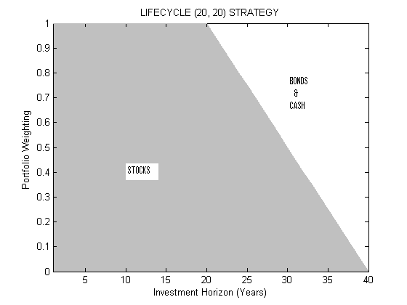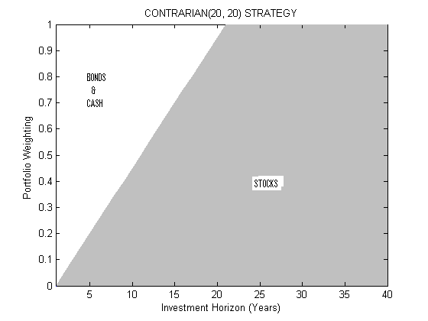

PAIR B
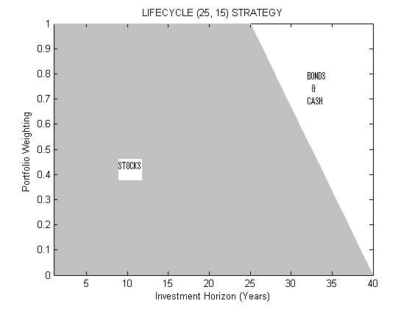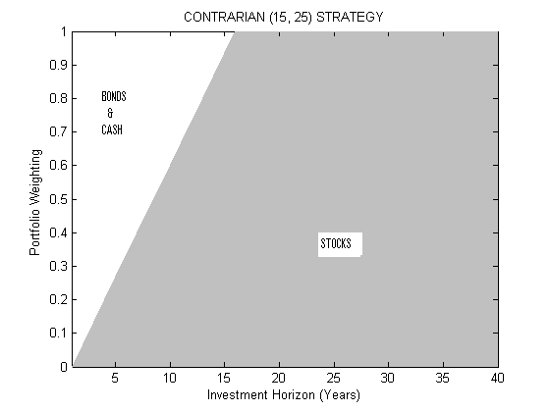

EXHIBIT 1 (CONTINUED)

PAIR C
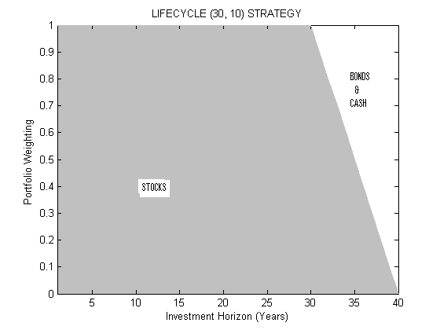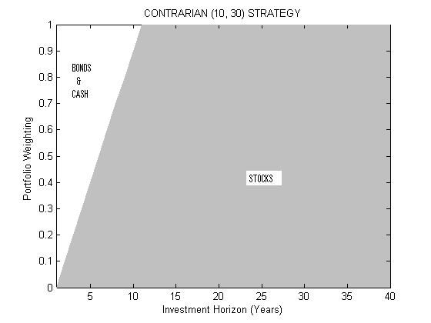

PAIR D
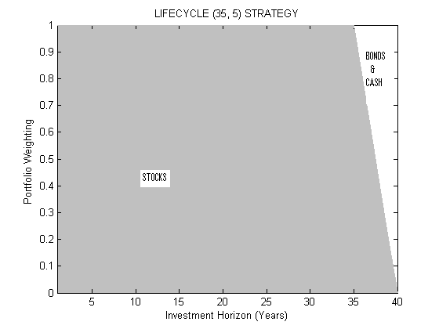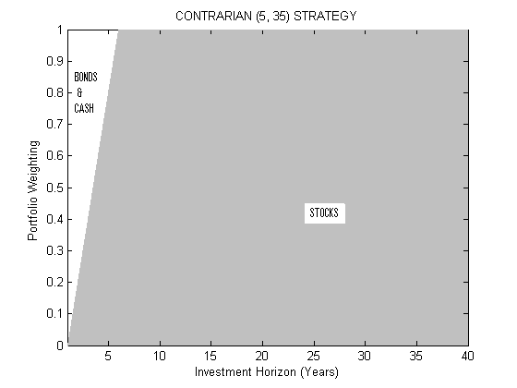

EXHIBIT 2
TERMINAL VALUE OF RETIREMENT PORTFOLIO

Strategy | Mean | Median | 25th Percentile | 75th Percentile
Pair A
Lifecycle (20,20) | 629157 | 512068 | 351805 | 770730
Contrarian (20,20) | 867200 | 639257 | 380563 | 1075330
CONT - LCYL (%) | 37.8 | 24.8 | 8.2 | 39.5
Pair B
Lifecycle (25,15) | 731515 | 567695 | 367438 | 891094
Contrarian (15,25) | 965836 | 686764 | 395331 | 1201615
CONT - LCYL (%) | 32.0 | 21.0 | 7.6 | 34.8
Pair C
Lifecycle (30,10) | 848387 | 626252 | 389072 | 1044717
Contrarian (10, 30) | 1038859 | 707816 | 404085 | 1276483
CONT - LCYL (%) | 22.5 | 13.0 | 3.9 | 22.2
Pair D
Lifecycle (35,5) | 1001055 | 702098 | 408649 | 1228028
Contrarian (5,35) | 1106965 | 752805 | 428332 | 1346847
CONT - LCYL (%) | 10.6 | 7.2 | 4.8 | 9.7
CONT – LYCL = Contrarian Strategy Terminal Value – Lifecycle Strategy Terminal Value
(Expressed as percentage of the lifecycle strategy terminal value)

EXHIBIT 3

SIMULATED ACCUMULATION PATHS OVER INVESTMENT HORIZON

PAIR A

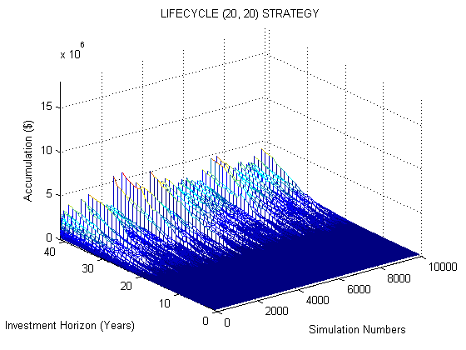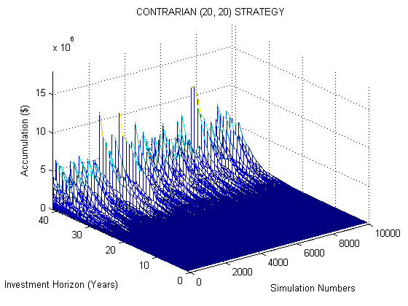

PAIR B

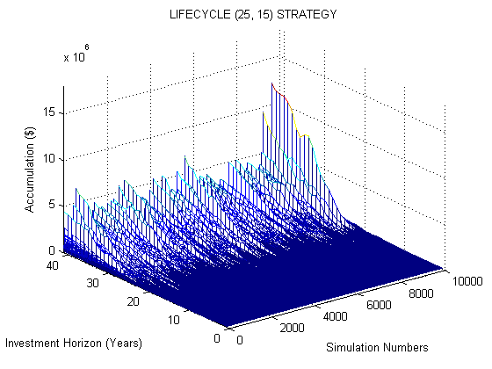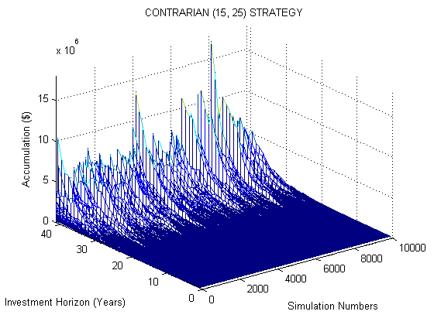

EXHIBIT 3 (CONTINUED)

PAIR C

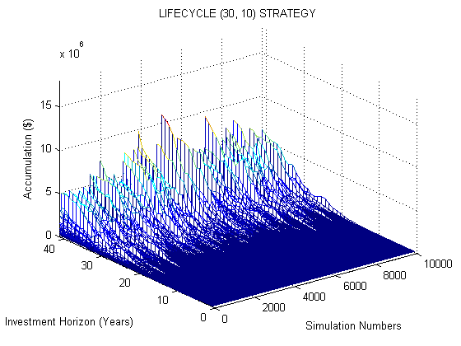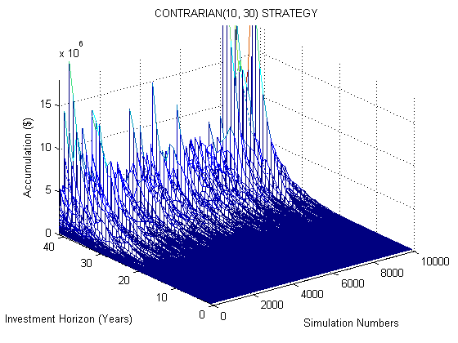

PAIR D

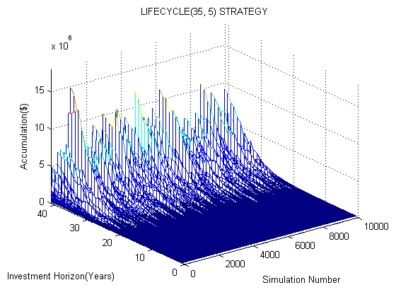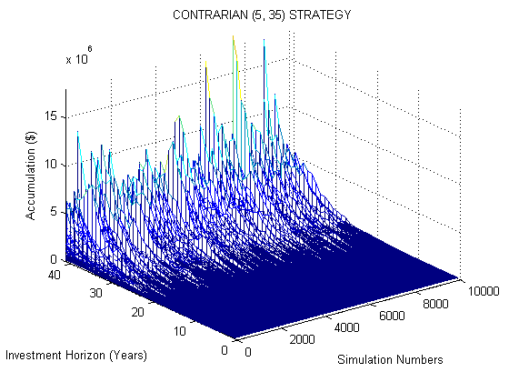

EXHIBIT 4
TERMINAL PORTFOLIO VALUES FOR ADVERSE OUTCOMES

Asset Allocation Strategy | Percentiles of Distribution
 | 1 | 5 | 10 | 15 | 20
Pair A
Lifecycle (20,20) | 162882 | 214530 | 256707 | 290431 | 323247
Contrarian (20,20) | 110126 | 180398 | 239931 | 290574 | 331848
LCYL – CONT (%) | 47.90 | 18.92 | 6.99 | (0.05) | (2.59)
Pair B
Lifecycle (25,15) | 152932 | 208005 | 253943 | 294558 | 331147
Contrarian (15,25) | 115825 | 188154 | 247662 | 299162 | 346463
LCYL – CONT (%) | 32.04 | 10.55 | 2.54 | (1.54) | (4.42)
Pair C
Lifecycle (30,10) | 141669 | 209009 | 259961 | 304379 | 346696
Contrarian (10, 30) | 110883 | 192702 | 252134 | 303390 | 357783
LCYL – CONT (%) | 27.76 | 8.46 | 3.10 | 0.33 | (3.10)
Pair D
Lifecycle (35,5) | 133859 | 202638 | 262596 | 312296 | 363806
Contrarian (5,35) | 117895 | 198339 | 266980 | 319553 | 373990
LCYL – CONT (%) | 13.54 | 2.17 | (1.64) | (2.27) | (2.72)
LYCL - CONT = Lifecycle Strategy Terminal Value - Contrarian Strategy Terminal Value
((Expressed as percentage of the contrarian strategy terminal value)

Not all ‘lifecycle’ funds change their asset allocation over time. Static allocation funds offered by various providers which have same exposure to various asset classes throughout the investment horizon are also sometimes categorised as lifecycle or lifestyle funds. In contrast, the lifecycle funds, we discuss in this paper change their allocation over time and therefore often referred to as age-based or target retirement funds. It is this type of age-based lifecycle funds that have witnessed highest growth in the last few years [Mottola and Utkus, 2005].
The belief that time reduces risk has been forcefully challenged by Samuelson [1963, 1989]. But the debate remains unresolved because the mathematical proof of irrelevance of time in determining investment risk critically rests on assumptions like random distribution of stock returns and constant relative risk aversion, which are themselves open to question. See, for example, Thorley [1995]. Bodie, Merton, and Samuelson [1992] posit a different justification for lifecycle portfolio choice based on human capital considerations.
Information about precise asset allocation of existing lifecycle funds at every point on the horizon is rarely made available in the providers’ prospectus. Our formulation follows the general direction of the switch and does not try to consciously replicate the allocation of any of the existing funds.
The 90th percentile terminal wealth estimates, although not provided with this paper, are available from the author on request.

