Stock Prices and the Location of Trade: Evidence from China-backed ADRs

Xue Wang
College of Business
Loyola University New Orleans
Email: xuewang@loyno.edu
Phone: (504) 864-7925

Lee J. Yao*
College of Business
Loyola University New Orleans
Email: yao@loyno.edu
Phone: (504) 864-7966

*Corresponding author
(Authors are in alpha order)

Stock Prices and the Location of Trade: Evidence from China-backed ADRs

Abstract

This study examines whether the trading location affects equity returns of China-backed American Depository Receipts (ADRs) traded in the US. If international financial markets are integrated, stock prices should be affected only by their fundamentals; otherwise, stock prices may also be affected by their trading locations/investor sentiment. We find that China ADRs’ returns are affected more by the US market fluctuations than by Chinese market returns. We interpret the results as suggesting that country-specific investor sentiment affects stock prices.

Keywords: Location of Trade; Investor Sentiment; Financial Market; China ADRs

JEL classification: F21, F36, and G15

Introduction

Finance theory suggests that trading location should not affect stock returns if international financial markets are integrated (Karolyi and Stulz (2003)). However, if financial markets are not perfectly integrated, stock prices are also affected by trading locations besides their fundamentals . In this study, we examine the relation between stock returns and trading location by studying China-backed American Depository Receipts (ADRs) traded in the US.

Previous studies provide mixed evidence on whether trading location has an impact on stock prices movements. Some recent studies show that stock prices are more affected by the market of their trading locations, which indicates that investor sentiment influences stock prices. For example, Froot and Dabora (1999) examine the effect of trading location on stock returns by studying pairs of large, “Siamese twin” companies and find that the twin stocks are correlated more with the markets they trade on. Chan et al. (2003) investigate the return dynamics of Jardine Group stocks after they were delisted from Hong Kong market. After the delisting, the trading activities moved from Hong Kong to Singapore and the business stays in Hong Kong and mainland China. They find that Jardine stocks are correlated less (more) with the Hong Kong (Singapore) market after the delisting, indicating the importance of trading location to stock prices. They interpret the evidence as suggesting that country-specific investor sentiment affects stock returns. Other studies also show evidence supporting that investor sentiments have an impact on stock returns (for example, Bodurtha et al. (1995), Werner and Keidon (1996), Suh (2003), Grossmann et al (2007), and Cheng et al. (2008)).

In contrast, Phylaktis and Manalis (2005) examine whether trading location affects informationally linked stocks’ prices by studying price dynamics of Greek stocks listed on the Greek and the two German stock exchanges, Frankfut and Berlin. They find that the Greek stocks trading in German markets are priced regarding the Greek market. The authors interpret the evidence as implying that location of trade does not matter to the price dynamics of securities. Some other studies investigate the price discovery for cross-listed stocks suggest that the home market is more important in the price discovery process than the US market (Lieberman et al. (1999), Grammig et al. (2004), and Chen et al. (2010)).

The objective of this study is to extend the literature by examining whether and to what extent, the trading location matters to stock price dynamics for China-backed ADRs trading in the NYSE.

ADRs represent shares of a non-US company that trade in the US financial markets and are issued by a US depository bank. ADRs provide US investors a tool to invest in foreign companies to gain international diversification and potential higher returns without cross-border and cross-currency transaction costs. China-backed ADRs offer us a good experiment to test the impact of trading location on stock prices because the Chinese stock market has a twelve-hour (or thirteen-hour in winter time) gap from the US stock market trading hours. The difference in the trading schedule between the US and China markets provide a unique market setting to identify the source of returns. During trading hours of the Chinese market, public information is cumulated and reflected in the ADRs’ overnight returns. ADRs’ daytime returns incorporate only private information/investor sentiment (i.e., the effect of trading location) and noise. Because Chinese market trading hours have no overlap with the US market trading hours, the impact of US market on China-backed ADRs’ return can be solely due to the trading location/investor sentiments or noise, but not to public information.

This study contributes to the literature by providing a clearer interpretation on the impact of trading location on stock prices. Chan et al (2003) examine the effect of trading location on Jardine Group companies after their trading activities moved from Hong Kong to Singapore. They find that returns of Jardine Group are correlated more with Singapore market relative to Hong Kong market after the delisting. However, being the market of Jardine Group’s trading activities, the Singapore market helps processing information generated in Hong Kong or Mainland China. Their results showing the impact of trading location on returns of Jardine Group could be due to information besides investor sentiments. While our study examines the impact of US market on returns of China-backed ADRs traded in NYSE. Due to the twelve- or thirteen-hour lag between the US market and China market, the impact of US market on China-backed ADR returns is not a result of any value-relevant information generated and processed in the trading hours of the China market. Since the US market is not involved in China ADR firms’ value-relevant information creation or processing during trading hours of the US market, impacts of the US market on China ADR returns can be clearly attributable to country-specific investor sentiments.

Another benefit of examining China-backed ADRs traded in NYSE is to avoid the non-synchronized trading and cross-currency trading problem in many international dual market studies. The China-backed ADRs and the US and China index funds examined in this study are all traded in the US financial markets. Therefore, their returns are measured both in the US dollars and within the same trading and non-trading periods.

Firstly, we use daily data on China-backed ADRs traded in the New York Stock Exchange (NYSE), the Xinhua China 25 Index Fund (FXI) and the S&P 500 Fund (IVV), to examine whether the daily (close-to-close) IVV returns affect daily (close-to-close) China-backed ADR portfolio (EADR) returns and whether the daytime (open-to-close) or overnight (close-to-open) IVV returns affect daytime (open-to-close) and overnight (close-to-open) China-backed ADR portfolio returns. We find that daily and overnight EADR returns are affected by both daily IVV returns and daytime/overnight IVV returns. While daytime EADR returns are only affected by IVV daytime returns but not by IVV overnight returns. At the same time, FXI daily, daytime and overnight returns have impacts on the daily, daytime and overnight EADR returns. In terms of magnitude, the impact of daily IVV returns on daily EADR returns is larger than daily FXI returns on daily EADR returns. Similarly, daytime (overnight) EADR returns is driven more by daytime (overnight) IVV returns than by daytime (overnight) FXI returns. This result indicates that the EADR returns appear to be affected by trading location (the US stock market). The result is consistent with Chan et al. (2003) and Froot and Dabora (1999), suggesting that stock returns are affected by country-specific investor sentiments.

The use of the equally-weighted ADR portfolio returns offers a benefit of eliminating the noise in each ADR’s daytime returns. As we mentioned earlier, the ADRs daytime returns integrate trading location effects and noise. While we are examining the effects of trading location to equity returns in this study, we use the equally-weighted ADR portfolio returns to reduce the noise component in ADR portfolio returns.

We also use intraday data to estimate the Vector Autoregressive (VAR) model and investigate the Granger causality relations between equally weighted ADR portfolios (EADR), IVV and FXI 10-minute returns. Based on the VAR analysis, we test the impulse response of the equally-weighted ADR portfolio, IVV and FXI returns to each other to examine both the magnitude and the duration of return impacts among the three returns time series. The Granger causality results show that both IVV and FXI granger cause EADR portfolio returns. The Impulse Response of EADR returns to IVV and FXI are both significant. Taken together, the results imply that the US market index (trading location) affects the China-backed ADR returns.

Finally, we perform a Variance Decomposition on the VAR analysis and find both S&P 500 and China index fund returns explain a substantial portion of China ADR returns variation while S&P 500 returns provide more explanatory power. The evidence from returns Granger causality, Impulse Response Function, and Variance Decomposition analysis indicates that the US market has significant impacts on China-backed ADR returns and implies that trading locations tend to play a role in asset prices determination. Therefore, the combined results from daily and intraday data analysis infer that country-specific investor sentiments tend to influence stock prices.

A related question that remains unaddressed is whether investor sentiment is a priced factor. If so, how much risk premium is due to country-specific investor sentiment factor? Although this is an interesting issue to explore, it is beyond the scope of this study. We leave it for further research.

The rest of the paper is organized as follows. Section 2 describes the sample of China-backed ADRs traded in the NYSE and explains the methodology used in the study. Section 3 presents the empirical results. We conclude in Section 4.

Data and Methodology

Data

This study examines the effect of trading location on equity returns by investigating the daily, daytime, overnight, and intraday returns of a US index fund, a Chinese index fund and an equally-weighted portfolio of China-backed ADRs traded on NYSE. The ADRs listed on the NYSE are identified from the JP Morgan ADR universe. The data for each security is collected from the TAQ database for the period of January 2005 to November 2009. We use 10-minute trading intervals data in reporting the results.

The Chinese market is represented by the iShares FTSE/Xinhua China 25 Index Fund (ticker symbol: FXI) traded in the US. The index consists 25 of the largest and most liquid Chinese stocks (Red Chips and H shares) listed and traded on the Hong Kong Stock Exchange (SEHK).

The equally weighted China-backed ADR portfolio (denoted by EADR) composes of forty-one Chinese ADRs traded on the NYSE. The forty-one ADRs are listed in Appendix A. The equally weighted portfolio return is thus a simple average of individual ADR returns. The ADRs are actively traded over the sample period, for example, at least traded once per hour.

The US market is characterized by the S&P 500 Index Fund iShare (ticker symbol: IVV). There is another ETF, SPDR, tracking the S&P 500 Index. IVV is chosen because the trading volume of IVV is more comparable to FXI than SPDR. While SPDR is more actively traded than IVV and has 10 times of the FXI volume.

Daily, Daytime and Overnight return regression

To examine the relation between the US market, Chinese market and the ADR portfolio returns, we first run the following Ordinary Least Squares (OLS) regressions:
(1a)
(1b)
(1c)
, (1d)
where, is the equally weighted ADR portfolio daily returns (close to close), is the close to close returns on IVV, is the close to close returns on FXI. Similarly, is the close to open (overnight) returns on the equally weighted ADR portfolio, and are the close to open returns on IVV and FXI, respectively. While , and are the open to close (daytime) returns on the equally weighted ADR portfolio, IVV, and FXI, respectively.

Vector Autoregressive Model

A Vector Autoregressive (VAR) model analysis is performed to test the lead-lag relation between 10-min intraday returns of EADR, IVV, and FXI. We include four lags of each variable. The VAR(4) is as follows:
(2a)
(2b)
(2c)

where, , , and are 10-minute returns of EADR, IVV, and FXI. Dopen and Dclose are dummy variables which equal one for the first 30 minutes (9:30 a.m. -10:00 a.m.) and the last 30 minutes (3:30 p.m. – 4:00 p.m.). They are included to remove the opening and closing trading effects on returns, if any.

The lead-lag relation between returns of EADR, IVV, and FXI can be attributed to shocks to each return series that are experienced within the same period or after several lags. The lagged impact of these shocks induces causal relations between the returns of China-backed ADR portfolio (EADR) and the two market index funds (IVV and FXI), which can be detected using the Granger F-test. From the VAR(4) estimation above, we test the Granger causality relations by using Wald coefficient restrictions on cross-VAR variables.

The VAR forecast error variance of the EADR, IVV, and FXI returns can be decomposed into the component shocks due to the other returns as well as its own return. We perform Variance Decompositions between IVV, FXI, and EADR 10-minute returns to examine the amount of information each variable contributes to the other variables in the above VAR(4) model. In other words, Variance Decompositions explore the explanatory relations between IVV, FXI, and EADR returns. In order to obtain the variance decomposition, the innovations in the VAR system are orthogonalized by Cholesky decomposition according to a causal permutation of the variables. Generalized Impulse Response Functions are also examined between EADR, IVV, and FXI 10-minute returns to trace the effect of a shock to any one of the three returns on the current and future movements in others.

Results

Daily, Daytime and Overnight return regression

Table 1 represents the descriptive statistics of the sample, with close-to-close, close-to-open, and open-to-close returns for equally-weighted China-backed ADR portfolio (EADR), the S&P 500 Index Fund (IVV), and the iShares FTSE/Xinhua China 25 Index Fund (FXI) reported in Panel A, correlations for close-to-close, close-to-open, and open-to-close returns for EADR, IVV, and FXI reported in Panel B.

[Insert Table 1 around here]

The US market’s average close-to-close return is -0.01 percent, and standard deviation is 1.51 percent during the sample period of January 2005 to November 2009. The US market’s average close-to-open return is 0.02 percent, standard deviation is 0.88 percent. While the open-to-close return for the US market on average is -0.03 percent, and 1.29 percent for standard deviation.

For the Chinese market, the average close-to-close, close-to-open, and open-to-close returns are 0.06, 0.17, and -0.08 percent, respectively. The standard deviations of FXI’s close-to-close, close-to-open, and open-to-close returns are 3.64, 4.06, and 2.35 percent, respectively. It seems that Chinese market index is more volatile during our sample period of January 2005 to November 2009 than the US market index on close-to-close, close-to-open and open-to-close returns. The equally-weighted China-backed ADR portfolio’s close-to-close, close-to-open, and open-to-close returns are 0.10, 0.19, and -0.09 percent on average, respectively. The standard deviation of the EADR’s close-to-close, close-to-open, and open-to-close returns are 2.35, 1.44, and 1.67 percent, correspondingly.

Panel B of Table 1 shows that the China-backed ADR (EADR) open-to-close returns tend to be more correlated with S&P 500 Index Fund (IVV; 0.76) than with the China market Index Fund (FXI; 0.66). The close-to-open returns correlation between EADR and IVV is 0.70, which is also higher than the 0.43 correlation between close-to-open returns of EADR and FXI. While the close-to-close correlation between EADR and IVV (0.77) is almost the same as that between EADR and FXI (0.76). The results suggest that the China ADR returns tend to be correlated more with the US market than with China market.

Table 2 reports the regression results of Models (1a) – (1d). Panel A of Table 2 shows the coefficients estimates and Panel B of Table 2 reports the test results on the equality of paired coefficients. For Model (1a) on EADR close-to-close returns, the coefficients on IVV close-to-close and FXI close-to-close are both positive and significant. The test result in Panel B implies that the coefficient on IVV close-to-close is significantly larger than the coefficient on FXI close-to-close, which suggests the EADR close-to-close returns are more sensitive to IVV close-to-close returns than to FXI close-to-close returns.

[Insert Table 2 around here]

In Model (1b), we run ordinary least squares regression on EADR close-to-close returns against both open-to-close and close-to-open returns of IVV and FXI returns. All the coefficients are positive and significant, suggesting that the EADR close-to-close returns are affected by both open-to-close and close-to-open IVV and FXI returns. The test results in Panel B show that the sensitivity of EADR close-to-close returns on IVV open-to-close is statistically identical to that on FXI open-to-close returns. However, the EADR close-to-close returns are more sensitive to IVV close-to-open than to FXI close-to-open returns. In other words, the variations of IVV close-to-open returns tend to explain a larger proportion of the variations in EADR’s close-to-close returns than the variations of FXI close-to-open returns do.

In Models (1c), we estimate EADR close-to-open returns on IVV and FXI close-to-open and open-to-close returns. The coefficients on all independent variables are significant. We also find that EADR close-to-open returns are more sensitive to IVV close-to-open returns than to FXI close-to-open returns as shown in Panel B.

Results on Model (1d) are shown in the last two columns of Table 2. IVV open-to-close, FXI close-to-open and FXI open-to-close returns have positive and significant impact on EADR open-to-close returns, while IVV close-to-open returns do not affect EADR open-to-close returns significantly. The results in Panel B show that EADR open-to-close returns are affected more by IVV open-to-close returns than by FXI open-to-close returns.

Taken together, the evidence in Table 2 implies that EADR returns are driven more by the US market index fund (IVV) than by Chinese market index fund (FXI). In other words, trading location/investor sentiment appears to have a strong impact on China-backed ADR returns.

Granger Causality Relations

Table 3 reports the Granger causality relations between 10-minute interval EADR, IVV, and FXI returns. We test the Granger causality relations based on estimates of the VAR(4) model as shown in Models (2a)-(2c). The results in Table 3 clearly show that both IVV and FXI 10-minute returns significantly Granger-causes future EADR 10-minute returns during US trading hours, suggesting that trading location/investor sentiment is at least one of the driving forces on the EADR intraday returns.

[Insert Table 3 around here]

Generalized Impulse Responses

The Granger causality analysis above only examines the presence or absence of significant predictive relations among the return series. In this sub-section, we examine the Generalized Impulse Response Functions between EADR, IVV, and FXI 10-minute returns based on the estimates of the VAR(4) model as shown in Models (2a)-(2c). The 10-minute impulse responses results are reported in Figure 1. The evidence suggests that the 10-minute EADR returns are responding to shocks on both IVV and FXI. In other words, shocks to US market index tend to affect the equally-weighted China-backed ADR portfolio returns during trading hours of the US market, which suggests that investor sentiment in the US market influence China-backed ADR returns.

Variance Decomposition

Table 4 reports the results for Variance Decomposition analysis based on the VAR(4) model as shown in Models (2a)-(2c). In panel A, we report the Variance Decomposition results based on IVV, FXI, and EADR permutation. We find that 49.9 percent of the forecast error variance on EADR 10-minute returns can be explained by exogenous shocks on IVV 10-minute returns, while only 10.5 percent can be explained by shocks on FXI 10-minute returns. Panel B represents the Variance Decomposition results based on FXI, IVV, and EADR permutation. In this case, 44.3 percent of the variance on EADR 10-minute returns is explained by FXI returns, while 16.0 percent of the variance on EADR returns can be accounted from the impact of IVV returns. Taking together the results from Panels A and B, we find that the variance on EADR returns tend to be affected by shocks on IVV returns. In other words, the US market has an impact on China-backed ADR returns, which implies that trading market/investor sentiments play a role in determining stock prices.

[Insert Table 4 around here]

Conclusions

In this study, we examine the impact of trading location on equity prices by investigating the relation between the price dynamics of China-backed ADRs and the US market index. According to finance theory, trading locations should not matter to equity returns if the international markets are integrated. The existing literature has shown mixed evidence on whether trading location matters.

We examine the relations between daily, daytime, and overnight returns on the equally-weighted China-backed ADR portfolio, US market index fund, and China market index fund. The evidence clearly shows that the US market index fund has a bigger impact on the equally weighted ADR portfolio’s price dynamics than the impact from China market index fund.

We also study the intraday returns (10-minute) relation between the equally-weighted ADR portfolio, US market index fund, and China market index fund during US market trading hours. The results from Granger Causality analysis, Impulse Response Functions, and Volatility Decomposition also suggest that trading location matters to equity returns.

Because trading hours in China and the US do not overlap, one can exclude the effect of value-relevant information released during trading hours in China from the impact of trading location on stock prices. We interpret our results as indicating that country-specific investor sentiment influences stock prices.

References

Belsley, D. A., Kuh, E. & Welsch, R. E. (1980). Regression Diagnostics: Identifying influential
data and sources of collinearity. New York: John Wiley.

Bodurtha, J. N., Kim, D. S., & Lee, C. M. C. (1995). Closed-end country funds and U.S.
market sentiment. Review of Financial Studies, 8, 879–918.

Chan, K, A Hameed and ST Lau (2003). What if trading location is different from
business location? Evidence from the Jardine Group. Journal of Finance, 58(3),
1221–1246.

Chen, K.C., G. Li, and L. Wu (2010) Price Discovery for Segmented US-Listed Chinese
Stocks: Location or Market Quality? Journal of Business Finance and Accounting, 37
(1) & (2), 242-269.

Cheng, L.T.W., H.G. Fung, and Y. Tse (2008). China’s Exchange Traded Fund: Is There
a Trading Place Bias? Review of Pacific Basin Financial Markets and Policies Vol.
11, No. 1, 61-74.

Datar, V., R. So, and Y. Tse (2008). Liquidity commonality and spillover in the US and Japanese
markets: an intraday analysis using exchange-traded funds. Review of Quantitative Finance &
Accounting, Vol. 31 Issue 4, 379-393.

Froot, K.A., and E.M. Dabora, (1999). How are stock prices affected by the location of
trade? Journal of Financial Economics, 53, 189–216.

Grammig, J., M. Melvin, and C. Schlag (2004). Price Discovery in International Equity
Trading. Journal of Empirical Finance, Vol. 12, No. 1, 139–65.

Grossmann, A., T. Ozuna, and M.W. Simpson (2007). ADR mispricing: Do Costly Arbitrage and
Consumer Sentiment Explain the Price Deviation? Journal of International Financial Markets,
Institutions and Money 17, 361-371.

Karolyi, G.A., and R.M. Stulz (1996). Why Do Markets Move Together? An Investigation of U.S.-
Japan Stock Return Comovements. Journal of Finance, Vol. 51, No. 3, 951-986.

Karolyi, G.A., and R.M. Stulz (2003). Are Financial Assets Priced Locally or Globally? Handbook
of the Economics of Finance, Edited by G.M. Constantinides, M. Harris and R. Stulz 2003
Elsevier B.V.

Li, D., and K. Yung (2004). Institutional Herding in the ADR Market. Review of Quantitative
Finance & Accounting, Vol. 23 Issue 1, 5-17

Lieberman, O., U. Ben-Zion and S. Hauser (1999). A Characterization of the Price
Behavior of International Dual Stocks: An Error Correction Approach. Journal of
International Money and Finance, Vol. 18, 289–304.

Melvin, M., and B. Melvin (2003). Global Transmission of Volatility in the Foreign Exchange
Market. Review of Economics and Statistics 85, 670–679.

Phylaktis, K. and G. Manalis (2005). Price transmission dynamics between
informationally linked securities. Applied Financial Economics 15, 187–201.

Puthenpurackal, J. (2006). Explaining Premiums in Restricted DR Markets and Their Implications:
The Case of Infosys. Financial Management, Vol. 35, Issue 2, 93-116.

Suh, J. (2003). ADRs and U.S. market sentiment. The Journal of Investing 12, 87-95.

Werner, I.M. and A.W. Kleidon (1996). UK and US trading of British cross-listed
stocks: An intraday analysis of market integration. Review of Financial Studies,
9(2), 619–664.

Appendix A Sample China-backed ADRs traded on NYSE, from adr.com.

Name | Exchange | Country | Sector
7 DAYS GROUP HOLDINGS LTD | NYSE | China | Lodging-Hotels
ACORN INTERNATIONAL INC | NYSE | China | Broadcasting (TV,Radio,Cable
AGRIA CORP | NYSE | China | Agriculture
ALUMINUM CORP OF CHINA LTD | NYSE | China | Aluminum
CHEMSPEC INTERNATIONAL LTD | NYSE | China | Chemicals
CHINA DIGITAL TV HOLDING CO LTD | NYSE | China | Computer Software
CHINA DISTANCE EDUCATION HOLDINGS LTD | NYSE | China | Services (Commercial Consum)
CHINA EASTERN AIRLINES CORP LTD | NYSE | China | Airlines
CHINA LIFE INSURANCE CO LTD | NYSE | China | Insurance (Life/Health)
CHINA MASS MEDIA INTERNATIONAL ADVERTISING CORP | NYSE | China | Services (Advertising/Mktg)
CHINA MOBILE LTD | NYSE | China | Cellular/Wireless Telecomms
CHINA NEPSTAR CHAIN DRUGSTORE LTD | NYSE | China | Health Care (Drugs/Pharms)
CHINA PETROLEUM & CHEMICAL CORP | NYSE | China | Oil & Gas (Exploration & Produ
CHINA SOUTHERN AIRLINES CO LTD | NYSE | China | Airlines
CHINA TELECOM CORP LTD | NYSE | China | Integrated Telecom
CHINA UNICOM LTD | NYSE | China | Cellular/Wireless Telecomms
DUOYUAN GLOBAL WATER INC | NYSE | China | Waste Management
E-HOUSE CHINA HOLDINGS LTD | NYSE | China | Real Estate
GIANT INTERACTIVE GROUP INC | NYSE | China | Internet
GUANGSHEN RAILWAY CO LTD | NYSE | China | Railroads
GUSHAN ENVIRONMENTAL ENERGY LTD | NYSE | China | Manufacturing (Specialized)
HUANENG POWER INTERNATIONAL INC | NYSE | China | Electric Companies
LDK SOLAR CO LTD | NYSE | China | Computers (Peripherals)
LONGTOP FINANCIAL TECHNOLOGIES LTD | NYSE | China | Computer Software
MINDRAY MEDICAL INTERNATIONAL LTD | NYSE | China | Health Care (Med Prods/Sups
NEW ORIENTAL EDUCATION & TECHNOLOGY GROUP | NYSE | China | Services (Commercial Consum)
NOAH EDUCATION HOLDINGS LTD | NYSE | China | Computer Services
PETROCHINA CO LTD | NYSE | China | Oil & Gas (International Integ
RENESOLA LTD | NYSE | China | Semiconductors
SEMICONDUCTOR MANUFACTURING INTERNATIONAL CORP | NYSE | China | Semiconductors
SIMCERE PHARMACEUTICAL GROUP | NYSE | China | Health Care (Drugs/Pharms)
SINOPEC SHANGHAI PETROCHEMICAL CO LTD | NYSE | China | Chemicals
SUNTECH POWER HOLDINGS CO LTD | NYSE | China | Semiconductors
TONGJITANG CHINESE MEDICINES CO | NYSE | China | Health Care (Drugs/Pharms)
TRINA SOLAR LTD | NYSE | China | Semiconductors
VANCEINFO TECHNOLOGIES INC | NYSE | China | Computer Services
WSP HOLDINGS LTD | NYSE | China | Machinery
WUXI PHARMATECH CAYMAN INC | NYSE | China | Health Care (Drugs/Pharms)
XINYUAN REAL ESTATE CO LTD | NYSE | China | Homebuilding
YANZHOU COAL MINING CO LTD | NYSE | China | Non-Metals Mining
YINGLI GREEN ENERGY HOLDING CO LTD | NYSE | China | Electrical Equipment & Compone

Figure 1

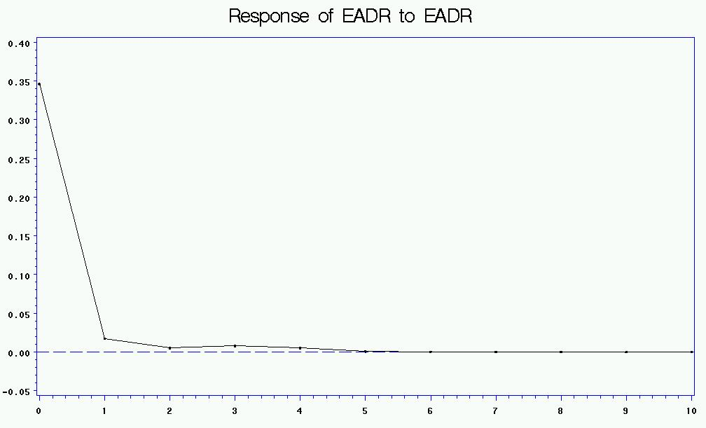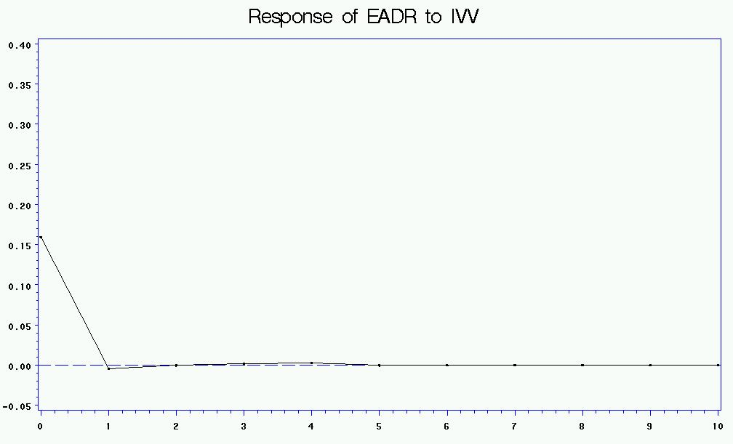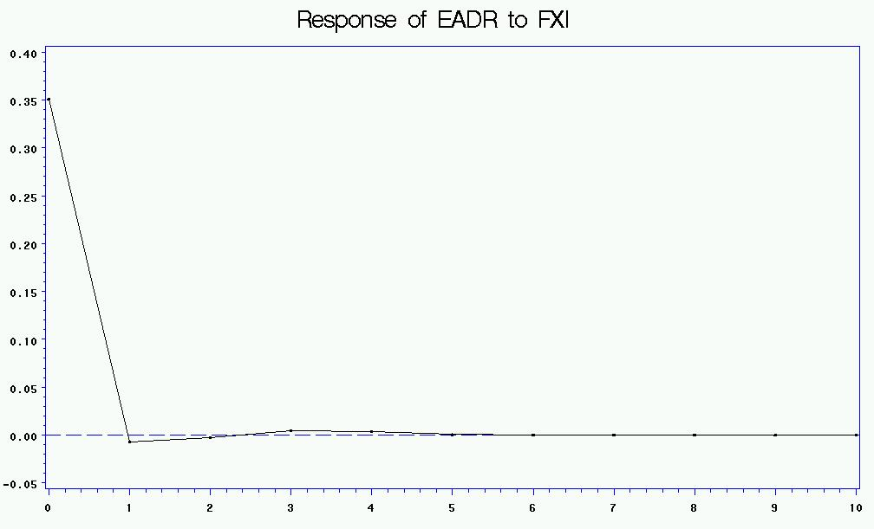
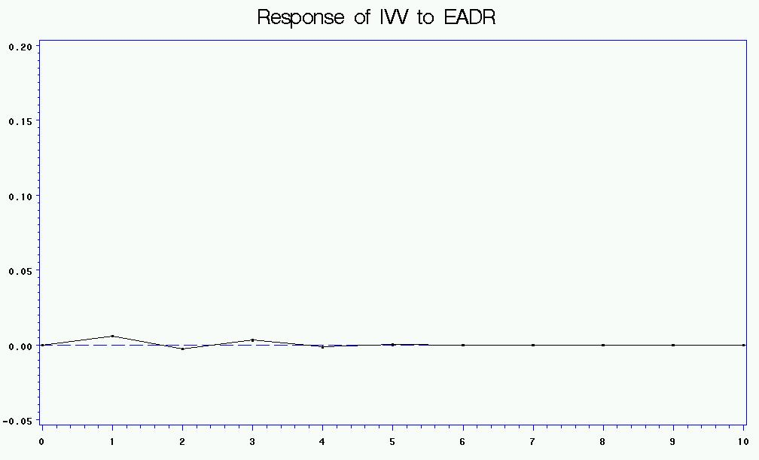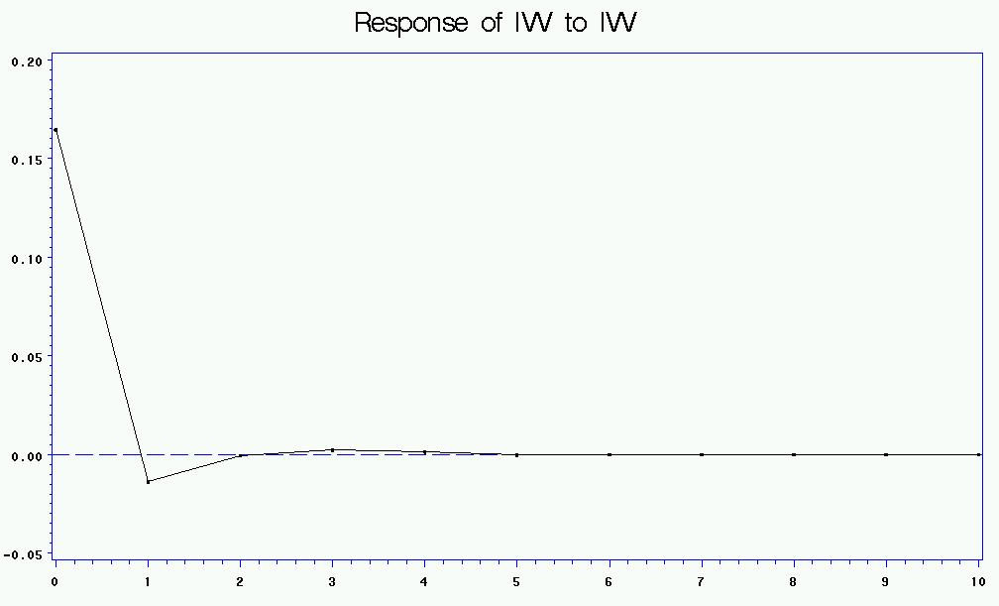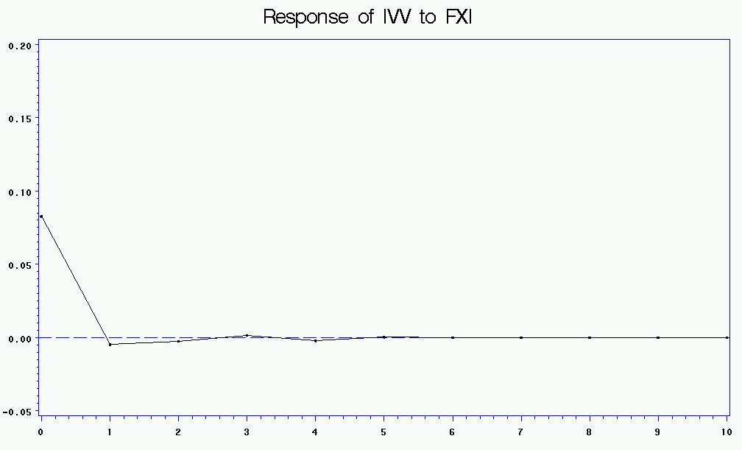
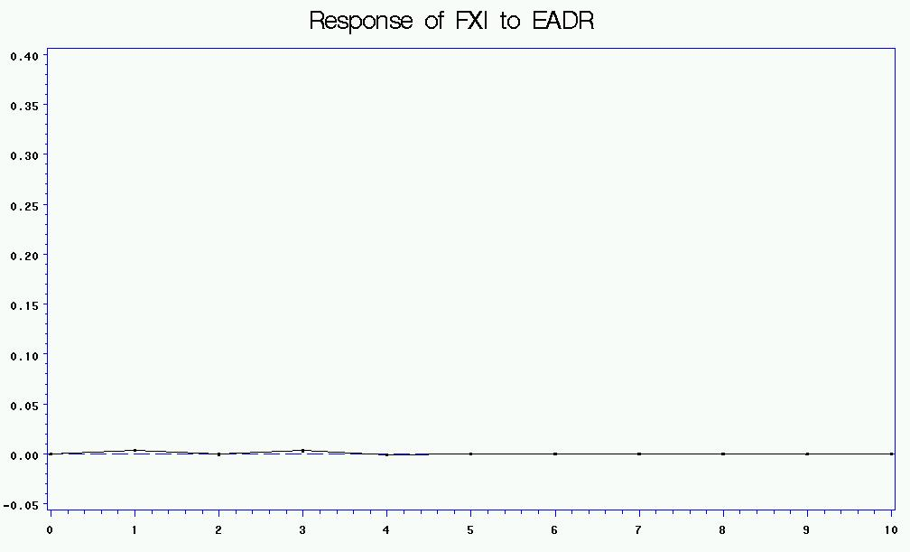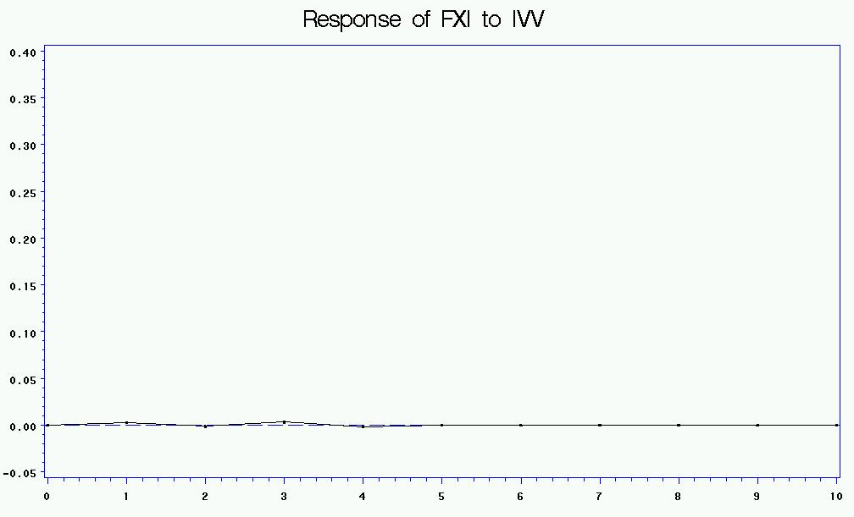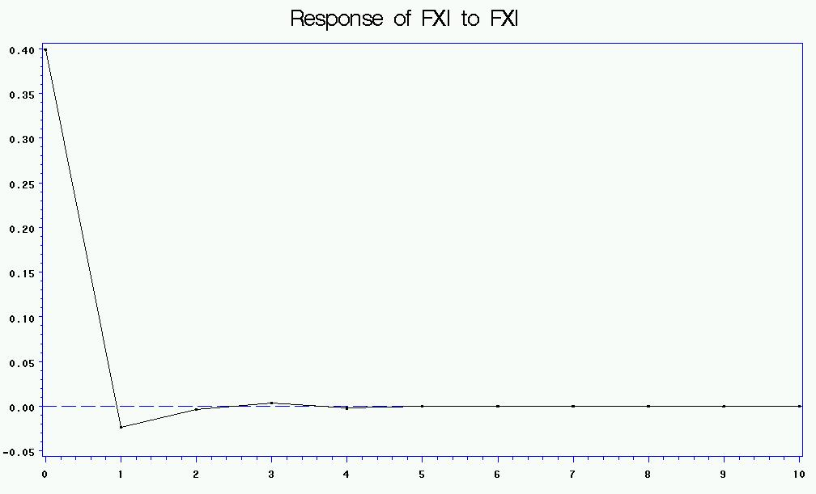

Table 1 Descriptive Statistics

This table describes our sample statistics (Panel A) and correlation coefficients (Panel B) of daily close-to-close, close-to-open and open-to-close returns for the equally-weighted China-backed ADR portfolio (EADR), the iShares FTSE/Xinhua China 25 Index Fund (FXI) and S&P 500 Index Fund iShares (IVV).
Panel A Summary Statistics
Equity returns | Mean | Std Dev | Skewness | Kurtosis
EADR close-to-close | 0.0010 | 0.0235 | -0.1340 | 3.5861
EADR close-to-open | 0.0019 | 0.0144 | -0.1207 | 7.5691
EADR open-to-close | -0.0009 | 0.0167 | -0.4458 | 3.7927
FXI close-to-close | 0.0006 | 0.0364 | -5.3206 | 109.3439
FXI close-to-open | 0.0017 | 0.0406 | 8.5350 | 368.7536
FXI open-to-close | -0.0008 | 0.0235 | -8.1743 | 175.9619
IVV close-to-close | -0.0001 | 0.0151 | 0.0587 | 9.6721
IVV close-to-open | 0.0002 | 0.0088 | 3.0328 | 70.7983
IVV open-to-close | -0.0003 | 0.0129 | -0.3410 | 9.4828
Panel B Correlation coefficients
Close-to-close returns
Correlations | EADR | FXI | IVV
EADR | 1.00 | 0.76 | 0.77
FXI | 0.76 | 1.00 | 0.68
IVV | 0.77 | 0.68 | 1.00
Close-to-open returns
Correlations | EADR | FXI | IVV
EADR | 1.00 | 0.43 | 0.70
FXI | 0.43 | 1.00 | 0.33
IVV | 0.70 | 0.33 | 1.00
Open-to-close returns
Correlations | EADR | FXI | IVV
EADR | 1.00 | 0.66 | 0.76
FXI | 0.66 | 1.00 | 0.68
IVV | 0.76 | 0.68 | 1.00

Table 2 Regression analysis on daily, daytime, and overnight returns

This table reports the regression result on the following models.
,
where, is the equally weighted ADR portfolio daily returns (close to close), is the close to close returns on IVV, is the close to close returns on FXI. Similarly, is the close to open (overnight) returns on the equally weighted ADR portfolio, and are the close to open returns on IVV and FXI, respectively. While , and are the open to close (daytime) returns on the equally weighted ADR portfolio, IVV, and FXI, respectively. In Panel A, t-values are in parenthesis. In Panel B, p-statistics are in parenthesis. *, **, *** denote two-tailed significance at the 10, 5, and 1 percent levels, respectively.

Panel A | Model (1a) |  | Model (1b) |  | Model (1c) |  | Model (1d)
 | EADR close to close |  | EADR close to close |  | EADR close to open |  | EADR open to close
Intercept | 0.0008 | (2.20)** | 0.0009 | (2.35)** | 0.0016 | (5.82)*** | -0.0007 | (-2.43)**
IVV close to close | 0.7539 | (21.74)*** | - |  | - |  | -
IVV open to close | - |  | 0.4011 | (8.64)*** | -0.2087 | (-6.03)*** | 0.6040 | (16.76)***
IVV close to open | - |  | 0.9177 | (18.77)*** | 0.8680 | (23.82)*** | 0.0418 | (1.10)
FXI close to close | 0.2762 | (19.23)*** | - |  | - |  | -
FXI open to close | - |  | 0.5100 | (18.56)*** | 0.2171 | (10.59)*** | 0.2990 | (14.02)***
FXI close to open | - |  | 0.2347 | (19.14)*** | 0.1364 | (14.92)*** | 0.1004 | (10.55)***
Adj. R-square | 0.70 |  | 0.72 |  | 0.58 |  | 0.67
Panel B
Test on IVV_cc=FXI_cc |  | (<.0001)***
Test on IVV_oc=FXI_oc |  |  |  | (0.1208) |  | (<.0001)*** |  | (<.0001)***
Test on IVV_co=FXI_co |  |  |  | (<.0001)*** |  | (<.0001)*** |  | (0.178)

Table 3 Granger causality tests on returns (10-min interval returns)
This table reports Granger causality tests on the following VAR(4) model.
where, , , and are 10-minute returns of EADR, IVV, and FXI. Dopen and Dclose are dummy variables which equal one for the first 30 minutes (9:30 a.m. -10:00 a.m.) and the last 30 minutes (3:30 p.m. – 4:00 p.m.). Chi-squares from the Granger causality tests are reported and p-values are in parenthesis.
 | EADR | IVV | FXI
EADR Granger-causes | - | 50.2 | 30.71
 |  | (<.0001) | (0.0022)
IVV Granger-causes | 177.04 | - | 16.44
 | (<.0001) |  | (0.1719)
FXI Granger-causes | 170.8 | 44.66 | -
 | (<.0001) | (<.0001)

Table 4 Variance Decomposition of returns
This table reports the results of a Variance Decomposition based on the following VAR(4) model.
where, , , and are 10-minute returns of EADR, IVV, and FXI. Dopen and Dclose are dummy variables which equal one for the first 30 minutes (9:30 a.m. -10:00 a.m.) and the last 30 minutes (3:30 p.m. – 4:00 p.m.). Panel A presents the Variance Decomposition results based on IVV, FXI, and EADR permutation. Panel B shows the results of Variance Decomposition based on FXI, IVV, and EADR permutation. The value in cell(i, j) represents the percentage of variation in variable j explained by exogenous shocks on variable i.

Panel A: Permutation used: IVV, FXI, EADR
 | EADR | IVV | FXI
IVV | 49.9 | 99.9 | 32.9
FXI | 10.5 | 00.1 | 67.0
EADR | 39.6 | 00.1 | 00.1

Panel B: Permutation used: FXI, IVV, EADR
 | EADR | IVV | FXI
FXI | 44.3 | 34.4 | 99.9
IVV | 16.0 | 65.5 | 0
EADR | 39.6 | 00.1 | 00.1

Market is considered integrated when asset prices do not depend on where they are traded. While on the other hand, if asset prices are affected by their trading locations, market is said to be segmented (Karolyi and Stulz (2003)).
See Li and Yung (2004) and Puthenpurackal (2006) for detailed descriptions on ADRs.
We examine the relation between daily, day and night returns of the US market and China ADR returns to separate the effects of information and investor sentiments. In intraday returns analysis, we include dummy variables to remove the impact of first 30 minutes and last 30 minutes of the US trading hours, which excludes the impact of information processing for China ADRs.
Following Karolyi and Stulz (1996), we use Chinese ADRs traded in the US in examining the effect of trading location to solve the problem of non-synchronized trading.
www.adr.com, last accessed on December 16, 2009.
Other data intervals have robust results as the 10-minute interval.
http://www.ftse.com/xinhua/english/Indices/International_Investors/Downloads/FXI_China_25_Index_Factsheet.pdf
We use a VAR model instead of a GARCH model to test the lead-lag relation between returns, because the results of VAR model are less model dependent (Melvin and Melvin (2003) and Datar, et al (2008)).
The results are similar if we include six or eight lags of each variable.
Due to high correlations between EADR, IVV, and FXI returns shown in Table 1, multicollinearity is a concern in regression models (1a)-(1d). We use Variance Inflation Factor (VIF) to detect multicollinearity and find that none of the VIF is higher than 10 (Belsley, Kuh, and Welsch, 1980), which suggests that our models (1a)-(1d) do not have multicollinearity problem. VIF results are not reported for brevity, but available upon request.

