Announcement Effects: Taxation of Housing Capital Gains in Seoul
Patric H. Hendershott, Kyung-Hwan Kim, Jin Man Lee and James D. Shilling*
April 17, 2011
Abstract
In early August 2005, a subset of investors in 14 of the 25 districts of Seoul were paying taxes on housing capital gains based on increases in market values since purchase, but in the other 11 districts the gains were based on changes in assessed values. On August 25, the South Korean government announced, as part of an effort to discourage speculation in housing, that as of the start of 2007, investors in the other 11 districts would also be taxed on market value gains. Many investors in the yet-to-be-designated districts had large unrealized capital gains. Because market value gains were roughly a quarter greater than assessed value gains, these investors would be expected to realize their gains prior to 2007.
Because prices were then rising rapidly, these investors had an incentive to postpone their gains until late in 2006. However, the government declared two of the 11 districts speculative watch areas in April 2006. This could be viewed as an additional announcement, in this case that the effective capital gains tax rate could occur at any time, giving investors in the yet-to-be designated districts had an incentive to take their gains immediately.
The question we address is whether these announcements had impacts on house prices. We test for announcement effects using both a spatial equilibrium model and a three-factor Vector Autoregressive model. The results are similar. The August 25 announcement had no impact, while the April 2006 action lowered house prices in the remaining nine yet-to-be-designated districts by roughly ten percent. Moreover, the impact was temporary, being fully eroded in about a year. Thus, if the government can time the announcement of future increases in capital gains tax rates wisely – make it during a house price bubble – the announcement will dampen the bubble and lessen the extent of its ultimate reversal.

* We thank the Korea Institute of Public Finance for financial support.

Patric Hendershott was until recently a part-time Chair in Property Economics and Finance at the University of Aberdeen, Scotland and is Professor Emeritus at the Ohio State University, Kyung-Hwan Kim is Professor, Sogang University, Jin Man Lee is Adjunct Professor, Department of Economics, DePaul University and James D. Shilling is Michael J. Horne Professor of Real Estate Studies at DePaul University.

Announcement Effects: Taxation of Housing Capital Gains in Seoul

The 1986 Tax Act signed by President Reagan on October 22, 1986 was remarkable in many respects. One was the “announcement” of an increase in the maximum tax rate on long-term capital gains and a decrease in the regular income tax rate, both effective months later (on January 1, 1987). This created a huge incentive to take existing long-term gains in 1986 and to delay the receipt of regular income into 1987. Taxpayers responded dramatically. Capital gains realizations doubled from $167 billion in 1985 to $322 billion in 1986, only to fall back to $137 billion in 1987 (Burman, Clausing and O’Hara, 1994). Further, $18.6 billion of 1986 corporate income was deferred to 1987 and what would have been 1987 expenses were pulled into1986 in anticipation of the decline in the corporate income tax rate (Scholes, Wilson and Wolfson, 1992).
On August, 31, 2005, the South Korean government announced a comprehensive package of capital gains tax changes designed to cool housing markets. A subset of investors in 14 of the 25 districts of Seoul were paying taxes on housing capital gains based on increases in market values since purchase, but in the other11 districts were paying taxes on housing gains based on changes in assessed values. Market value gains were roughly a quarter greater than assessed value gains. A key change in the 2005 legislation was that, as of the start of 2007, investors in the other 11 districts would also be taxed on market value gains, creating an incentive to realize existing gains prior to 2007. We document that housing sales increased in these 11 districts relative to the others and provide crude data that suggests prices slipped in these districts relative to the others. Our paper attempts to measure the price impact formally.
The differential geographic impact of the announcement and our access to district level data are the keys to our study. We have monthly data on condominium prices and condominium transactions for each of the 25 Seoul districts over the 1998-2008 period. Condominiums constitute over half of the housing units in Seoul and were the dominant form of housing construction during the previous two decades. The set of physical characteristics for condominiums in the same size classes has varied little over time due to complex building requirements, and greater density under these building requirements allows the developer to make a bigger profit, which has generally limited unit size to between 700 and 1250 square feet. As a result, differences in housing prices across districts in Seoul are associated with either differences in incomes or in amenity levels. Moreover, the price series for each district is effectively a constant quality series.
The paper is organized as follows. In the next section we provide background to the legislated changes in tax rules relating to capital gains, especially the switch from basing the tax on assessed gains to actual gains. In Section 2, we provide data relating to the impact of the August 2005 announcement. Investors in the affected districts increased sales sharply when they foresaw an imminent increase in the effective capital gains tax, and the increased selling appears to have lowered prices in these 11 affected districts relative to the other 14.
We formally test for a house price effect in two ways. In Section 3 we present a model describing the spatial equilibrium of house prices and imbed it in a time series context. Estimation of this model is reported in Section 4. Results of a standard announcement event study following the methodology pioneered by Fama, Fisher, Jensen and Roll (1969) are contained in Section 5. We find that tax selling significantly lowered house prices in all affected districts relative to the unaffected districts (where taxable gains were already equal to actual gains). Moreover, the impact seems to have been reversed after the tax selling stopped.
As a check on the model estimation, we estimate a simple (third-order) Vector Autoregression (VAR) in Section 6. The results from this atheoretic estimation are broadly similar to those from the announcement event estimation. That is, real house prices appear to have been lowered, temporarily, by the announcement of a future increase in the capital gains tax rate. We conclude with a summary of our findings.

- Background
Real house prices rebounded strongly in Seoul after the 1998 Asian Crisis, marking the start of a prolonged period of rising prices. Between late 1998 and the end of 2002, real condominium prices rose by 80 percent in Seoul and 120 percent in a prime residential area in southeast Seoul (KN3). Figure 1 plots these price series for the full 1999-2009 period. Real prices rose another 50 percent in 2005-06, giving increases of 120 and 200 percent respectively. In contrast, the real condo price for the other large cities in Korea rose by less than 50 percent. During the 2007-09 period real prices were roughly flat in both Seoul and the other large cities, but fell by nearly 20 percent in the KN3.
Figure 1 about here
About half of Seoul households were owner-occupiers at that time. Non-owners (and all parents of offspring that were potential independent households) were concerned that high real prices would prevent them (or their offspring) from forming households and becoming owners. The sharp rise in real prices raised the house price/income ratio in Seoul to 7.7 in 2002 was 7.7, far higher than the 4.4 in the nation overall (Korea Housing Finance Corporation). Moreover, speculators were believed to have contributed to the price rise. This created political pressure to rein in price increases, and the government changed the taxation of housing capital gains with a series of actions during 2003-07 in hopes of restraining speculation (see Table 1).
One action was to periodically designate districts as “speculative-watch” areas in which effective capital gains tax rates were increased. Designation and removal of a speculation watch area were determined by the Minister of Finance and Economy (now the Ministry of Finance and Strategy) upon recommendation by the Committee of Ten on real estate price stability. The Committee consisted of the Vice Ministers of Finance and Strategy, of Land, Transport and Maritime Affairs, and of Public Administration and Safety, as well as the Deputy Head of the National Tax Service, the President of the Korea Institute of Public Finance, the President of Korea Appraisal Board plus a scholar expert in real estate, a legal expert in real estate, a representative of consumer protection advocacy, and a representative of the construction industry.
In practice, the Committee was dominated by the first two Vice Ministers. A city or a district could be designated if the rate of housing price appreciation during the previous two months exceeded the national average rate by 30 percent or if the rate of housing price appreciation during the previous year exceeded the national average rate over the previous three years. The committee reviewed each case that met the eligibility criteria and decided whether the district should be designated.
Taxation of capital gains has varied across three different classes of investors: owner-occupiers (with no other residential properties), those holding just one or two properties, and “investors” with three or more properties. Table 1 summarizes capital gains tax rate changes during 2003-07 as they apply to these three groups. We concentrate on the shift from the taxation of capital gains based on “assessed” values to gains based on actual values.
Table 1 about here
The shift to taxing actual gains based on market values occurred differentially both for classes of property holders and for some of those residing in the different districts at different times. The first shift was for owners of three of more properties at the start of 2003. Shortly thereafter, holders of one or two properties whose gain was not tax-exempt (occupiers who owned only a single property were exempt) were affected when their districts were designated as speculative watch areas. Gangnam in May 2003 was the first district to become so designated and by November 2006 all 25 districts were. Table 2 lists the dates on which the different districts were designated (and undesignated).
Table 2 about here
- Responses to the August 2005 Announcement
On August 31, 2005 the government announced its plan to amend the income tax law so that as of January 1, 2007 all districts would effectively be speculative watch districts in that capital gains would be based on increases in actual, not assessed, prices. Thus we would have expected an increase in the taking of gains by investors outside the existing speculative watch areas between the announcement date and the end of 2006 (and the taking of gains would be relatively less in immediately subsequent years). Owing to transactions costs and the expectation of rising prices, one might expect investors to delay the taking of gains until near the end of 2006. However, if any of these districts were designated a watch area prior to the end of 2006, the taking of gains in the other districts would occur virtually immediately in the fear that their district would soon be designated.
From Table 2, we see that 11 of the 25 districts were not speculative-watch areas in late 2005 (just after the announcement date), but all of them became watch areas before the end of 2006. For each of these districts we have computed their average seasonally adjusted monthly transaction volume for the 20 months prior to the announcement (January 2004-August 2005) and the eight months from September 2005 through April 2006 when the first of these districts (Jung and Gangseo) were designated watch areas. We also list the average volumes for May and June 2006, the two months immediately following the surprise designation of these two districts.
Table 3 lists the volumes for these periods and reports the percentage changes between them. In the eight months following the announcement, two districts experienced a fifth and third increases in trading volume while two others had declines of a quarter and a third. The average was roughly no change, i.e., investors were generally delaying the taking of gains. However, following the designation of Jung and Gangseo as watch areas in late April 2006, which indicated that investors could not safely wait until late 2006 to take their gains, volume surged throughout. The increases ranged from 34 to 75 percent and averaged 52 percent. Overall, trading volume responded to the announcement and implementation of the tax changes just as theory would suggest.
Table 3 about here
Whether and by how much these accelerated sales would decrease prices depends on two factors. First, unless sellers were reducing their real estate holdings rather than just traded properties prices would not be affected at all. We do not know sellers motives, but we can estimate what share of the stock the relevant investors held. In 2005, 1.7 million households held the nearly two million houses in Seoul (data in this paragraph are from the Korean Ministry of Finance and Strategy). With half of households being owner-occupiers and 1.54 million households owning only one house, roughly 0.7 million units (1.54 million minus 0.85 million owner-occupiers) or 35 percent were owned by households affected by the speculative watch rules.
We have computed the annual rate of real house price increase in each of the 11 districts during the eight months between the announcement and when Jung and Gangseo were designated as watch areas (April 2006), during the next two months (May and June), during the two to seven months until the districts were designated as speculative watch areas, and during the following 12 months. We then subtract the average annual rate of increase over the same months in the 14 districts that had been designated earlier and report the results in Table 4.
Table 4 about here
Real prices rose virtually continuously in all districts during this period. The relevant issue here is how real prices in the yet-to-be designated districts rose relative to those in the already designated districts. Between the August announcement and the following April, prices rose 9 percent less rapidly in the yet-to-be designated districts (four percent) than in the already designated (13 percent), suggesting some selling pressure. However, in May and June of 2006, the selling pressure seemed to have accelerated as the difference in appreciation nearly doubled to 16 percent. Appreciation accelerated in the yet-to-be designated districts to 14 percent, but far less than in the already designated districts (30 percent on average). During the next two to seven months appreciation was strong in the yet to be designated districts, but very similar to that in the other districts (averages of 27 and 30 percent). However, in the year following designation of the last district, prices rose more rapidly in the later designated districts than in the earlier designated ones, suggesting a reversal of the earlier selling pressure.
While all of this is “suggestive”, it is important to implement econometric testing to be confident about this finding. Moreover, we should note that while 14 percent seems like a large number is was only for a two month period. That is, the impact on the house price level was only about three percent.
- A Model for District Relative House Prices
We begin by specifying a spatial equilibrium model and then imbed it in a time series framework. The utility maximization model follows closely that utilized by Glaeser and Gyourko (2007) to examine arbitrage in housing markets. Households receive utility from two goods: location-specific amenities and goods consumed with income left over after the expenditure on housing. As households move to more desirable locations, they spend more for housing services but consume less non-housing goods and services. With equal to household real income, equal to the real housing outlays, equal to location-specific amenities that households desire and consume (e.g., views, proximity to open spaces, recreational facilities, high-quality schools, etc.), and the subscript referring to the th location, then the homeowner’s utility function at location can be written as .
In equilibrium homeowners must be indifferent between different locations, which implies that 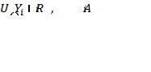 is constant across space. We approximate using a first-order Taylor series approximation expanded around the mean (the “Seoul” average)
(1)
where 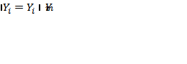, 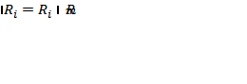, and 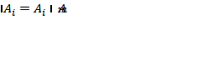 are differences between income, rents, and amenities in location i and in the overall Seoul housing market m, respectively, and 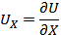 for and . Assuming households are indifferent across locations, 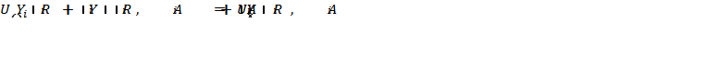 and, solving for 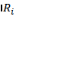, yields
(2)
Real housing outlays at location equal the product of real price (), the real user cost of housing services (), and the size of the housing unit (N), which we assume to be constant across locations:
(3)
where 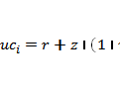, with r being the interest rate, z the depreciation rate, the expected rate of appreciation of real house prices, and the capital gains tax rate. The latter is the only one of these variables that varies across space.
Total differentiation of with respect to location (and approximating the spatial derivatives by their finite differences , 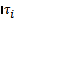, and 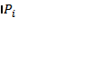) gives
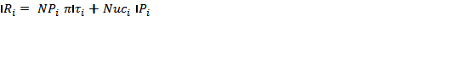 (4)
where 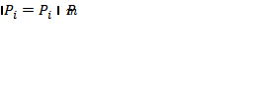, and 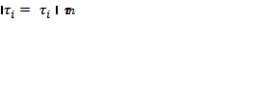. Equating equations (2) and (4) and solving for 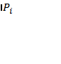,
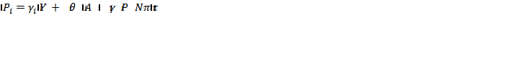 (5)
where 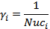, .
We estimate the relationship on data prior to the capital gains rates varying by location in which case the last term in equation (5) is zero, leaving
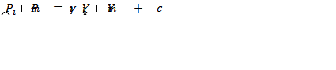 (6)

where the finite differences are expressed directly and 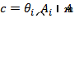 is a location-specific constant representing the advantage location has relative to the overall market (which is assumed to be constant over the time period during which the model is fit to the available data).
We do not have data on household real income and thus on 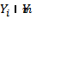. We assume that households spend constant fractions of income on housing services () and nonhousing consumption (1 - ). With , we replace in equation (6) with (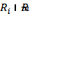)/ .
Both 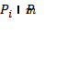 and vary with time. Allowing this variation and introducing an error term,
 (7)
where and is an error term associated with the variation in 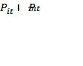. Because 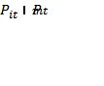 varies with the level of market prices in our data and is measured with error, least squares estimates of (7) would be highly inefficient owing to heteroscedasticity. We correct for heteroscedasticity by dividing both sides of the equation by , which leads to the following equation:
(8)

where .
- Explaining Relative House Price Inflation
We have monthly house price data for the period January 2000 through August 2009 for the districts in Seoul and for the Seoul average. The differences between prices in each of the eleven districts affected by the August 25, 2005 speculative watch announcement and the Seoul average as a percentage of the Seoul average – the dependent variable in equation (8) -- are shown in Figure 2 (these data are from Neonet available at www.neonet.co.kr). At the beginning of the decade prices in Jung and Gwangjin were close to the Seoul average, but those in the nine other districts were 15 to 35 percent lower. Relative prices in these nine drifted downward throughout 2001-03, widening the gap to 30 to 45 percent. During 2004 relative prices rebounded a bit, but then declined again during 2005 and 2006 to 30 to 50 percent below Seoul. Between then and the end of the decade, the percentage gap closed to 20 to 35 percent.
Figure 2 about here
Landlords in Korea do not charge monthly rents as is done in the US. Rather, in lieu of rent tenants are required to put up a large Chonsei deposit on which landlords earn income throughout the lease term at which point the deposit is returned. The annual rent on a house is then the product of the Chonsei deposit ratio (the required deposit paid to the landlord divided by the price of the house), the (before-tax) rate of return that landlords can be assumed to earn on the deposit, and the price of the house.
The deposit ratio has typically been between 0.4 and 0.7 (data on this ratio are also from Neonet). For example, in southern Seoul, the Chonsei deposit ratio was 0.6 to 0.7 during 2000-02, fell to 0.5 to 0.6 during 2004-06, and to around 0.4 in 2008 (see Cho, 2005). In northern Seoul, the Chonsei ratio has typically been about 0.1 lower. In our calculations, the nominal interest rate earned on Chonsei deposits is taken to be the 3-year corporate bond rate (reported by the Bank of Korea).
Figure 3 shows the difference between district and Seoul rent deflated by the Seoul house price -- the primary regressor in equation (8) -- for the eleven districts over the period January 2000 to August 2009. At the beginning of the decade rents in Jung, Gwangjin and Seodaemoon were close to or above the Seoul average, but those in the other eight districts were three to 13 percent lower. Relative rents in these eight were basically flat throughout the decade. Rent in Seodaemoon dipped relative to Seoul for a number of years and then rose above Seoul for the rest of the decade.
Figure 3 about here
Equation (8) is estimated for each district for the January 2000-May 2005 period. We stop the estimation three months before the speculative watch announcement date because the announcement may have been anticipated before the public announcement. Starting three months sooner or later yields similar results. The post-speculative watch period is defined as the twelve months immediately after the speculative watch area designation date.
The estimates for each district are shown in the left panel of Table 5. The equations have s between 0.88 and 0.99 (highly statistically significant F-values) with the exception of Gwangjin district, which has an of only 0.13. The coefficients on the rental variable (the ) are positive, with the exception of Dongdaemun. Moreover, in eight of the 11 districts the t-ratio on this variable is over nine. This strong positive relationship between rent deviations and price deviations is in broad agreement with the findings of Hwang, Quigley and Son (2006).
Table 5 about here
To test for lagged price responses, we added lagged percentage rental gaps to equation (8). The right panel in Table 5 shows that in some districts the lagged value is more important and in others the current value is. However, the sum of the current and lagged coefficients in this equation never differs by more than 0.15 from the current coefficient when lags were not included. That is, adding lagged values in no way alters the qualitative results.
- Testing for Announcement Effects Using the Spatial Equilibrium Model
We use the event study methodology pioneered by Fama et al. (1969) to measure the effects of accelerated tax selling on house prices in Seoul. They measured the effect of stock splits on shareholder wealth by estimating a simple time-series market model using monthly data for the 60 months prior to the split date for 940 splits between January 1937 and December 1959. The model is used to forecast stock prices after the split, and cumulative average residuals are calculated. Similarly, we estimate our spatial equilibrium model of Seoul district house prices on data prior to the August 2005 announcement for the eleven districts, forecast prices after the announcement, and then calculate average residuals.
To estimate what the behavior of house prices would have been in the absence of the announcement, we use the estimates of and obtained from estimation of equation (8) with and without lags to predict future values of the percentage deviation. These forecasted price deviations are compared with actual house price deviations to determine the impact of accelerated selling following the speculative watch area announcement. For each month the residuals are averaged across all districts that had not yet been designated and we perform two tests with them. The first is whether the prices of houses that sold in the 11 as-yet-to-be-designated speculative watch areas declined relative to those in the 14 already designated districts during the period between the speculative watch area announcement and when the district was designated. The second is whether these prices then returned back toward normal in the post-announcement period.
The t-values for these average residuals were calculated by dividing by a weighted average of the percentage house price deviations in the eleven designated speculative watch areas. The standard deviations were obtained by taking the square root of MSEs obtained in the estimation of equation (8). The relative weights were obtained by dividing the average trading volume in each district by the total average trading volume in the eleven designated areas. Here time is kept relative to August 2005 when the speculative watch area designation was announced. Because the announcement date is the same calendar month, the residuals in equation (8) cannot be assumed to be independent. We use Zellner's (1962) seemingly unrelated regression (SUR) estimation to correct for this problem. The procedure involves estimating a set of first pass regressions in which a variance-covariance structure is estimated across and between the system of equations. The variance-covariance matrix is then used to derive estimates of the MSEs of equation (8).
The computed house price announcement effects and associated t-values are reported in Table 6 for the equations estimated with and without lags. The residuals are also calculated using the equations without lags, but excluding the Gwangjin district from the calculation. As can be readily seen, the residuals and t-values are very similar for the two equations and also for estimates excluding Gwangjin. Thus the following discussion holds for all three residual calculations.
Table 6 about here
House price announcement effects in the preannouncement months , , and are negative and insignificant. This is consistent with little or no pre-announcement leakage of capital gains tax change information. The house price effects continue to be negative and insignificant during the speculative watch area announcement month and the six following months (through March 2006). However, the negative residual then increases sharply in April and May, indicating a 10 percent lower price. This lower price continues through (September). The delayed fall in price is consistent with strong selling occurring only when it became clear that the district could be declared a speculative watch area at any time, rather than just at the beginning of 2007.
The house price effects over the period , , are plotted in Figure 4 along with upper and lower bounds of the effects at the 95% confidence level (this is based on estimates from the no-lags-with-Gwangjin calculations). The figure indicates a significant relative house price decline over the interval April 2006 through November 2006.

Figure 4 about here
But what happens to price after the district is designated a watch area? Here we compute for each district the residuals for the first month after their designation, the second month after, and so on and then we average across all districts. Like for Table 6, three calculations are made and reported in Table 7. And like Table 6, the three calculations are very similar. Prices begin ten percent below equilibrium, owing to the announcement effect, and hold their until the 15th month, when they decline almost to zero.
Table 7 about here
The house price post-announcement period effects are plotted in Figure 5, again along with the upper and lower confidence bounds. The residuals in months , , of the post-announcement period are roughly -0.10 and significant. The residuals then decline, becoming insignificant and approaching zero in months and suggesting erosion of the tax selling pressure.
Figure 5 about here

- Testing for Announcement Effects Using a VAR Model
We can also examine the responses to the August 2005 speculative watch area announcement by using a simple (third-order) Vector Autoregression (VAR). Specifically, a VAR model is fitted to the available data described above. The model includes three state variables: the (real) house price in location , , the (real) house price in the overall Seoul housing market, , and the (real) rent at location i, . We can write the model in matrix notation as
(9)

where is a 3-by-1 state vector, and are 3-by-1 vector and 3-by-3 matrix of constant parameters, and an i.i.d. 3-by-1 error term. We estimate the model separately for each speculative watch area. There are thirty parameters to estimate for each district. The model is estimated for the time period January 2000 through May 2005. Forecasts of  are built by plugging the OLS estimates of and in (9) and computing expected values of and for given values of . These values are equivalent to the forecasts we get from equation (8).
We then use these forecasts to estimate residuals – the difference between the actual and predicted percentage house price spread in location – over a fourteen-month interval following the August 2005 speculative watch area announcement. These residuals are then averaged across the ten designated watch areas for each month (Gwangjin is included and then excluded to make the results comparable to the event study results). If there are no abnormal changes in house prices associated with the accelerated gain taking, we should observe no pattern in the residuals. Instead, the residuals should fluctuate around zero and, on average, should equal zero.
We use computed values of 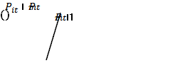 over the estimation period January 2000 through May 2005 to calculate a standard deviation for each designated watch areas. These numbers are then value-weighted to estimate a standard deviation for all 11 designated watch areas. This value is used to assess the significance of the event-window house price declines.
Table 8 provides the results of estimating equation (9) for all 11 designated watch areas. Because we have a sample comprised of 11 districts and three equations for each district, we present the data as follows. The coefficients are the averages of the coefficient estimates over the 11 districts. For each coefficient, we report, in parentheses, the number of estimates that are positive and the number that are negative. Further, we show for each coefficient, in brackets, the numbers of coefficients that are significantly positive and negative (at the 10% level).
Table 8 about here
The average R2 for the district price and rent equations and for the Seoul equations all exceed 0.99. We consider a variable to be significant if at least ten districts have coefficients of the same sign and five of them are significant. Only six variables meet this criterion. For all districts, the lagged value of each of our dependent variables has a positive and significant coefficient (a highly positive AR1 term). The real district house price is also significantly, positively related to the Seoul real price. Lastly, the district rent is related to lagged two (negative) and three (positive) values.
The computed house price announcement effects and associated t-values are reported in Table 9 for the equations estimated with and without using the Gwangjin district in the calculation. As can be readily seen, the residuals and t-values are very similar for the two equations. House price announcement effects in the preannouncement months , , and are effectively zero, indicating no pre-announcement leakage of capital gains tax change information, and they continue near zero for the next four months (through February 2006). However, the residual then becomes significantly negative increases sharply during the spring of 2006, becoming -0.13 in June, indicating a 13 percent lower price. This lower price continues through (September). The delayed fall in price is consistent with strong selling occurring only when it became clear that the district could be declared a speculative watch area at any time, rather than at the beginning of 2007.
Table 9 about here
Figure 6 plots the house price announcement effects (based on the VAR model) and the 95% confidence levels over the period . The residuals are near zero and insignificant pre-announcement and for the first five months following the announcement. The residuals then fall sharply to about -0.125 and become significant in months .
Figure 6 about here
To estimate what happens to price after the district is designated a watch area, we again compute for each district the residuals for the first month after their designation, the second month after, and so on and then we average across all districts. Like for Table 9, two calculations are made and reported in Table 10. And like Table 9, the calculations are very similar. Prices begin 12 percent below equilibrium, owing to the announcement effect, and hold there until the 14th and 15th months, when they decline almost to zero.
Table 10 about here
Figure 7 plots the house price response and confidence levels after districts have been declared speculative watch areas. For the first year, the residual is about -0.13 and statistically significant. It declines slowly throughout the year and then erodes sharply in months t+13 and t+14 to about -0.01. Overall, the VAR-based results suggest about a 12 percentage point price decline when investors are reaping their gains in anticipation of the gains tax rate increase and a reversal about a year after the gains rate actually increases. These price movements have the same timing as those revealed by the spatial-equilibrium-based study, but are slightly larger.
7. Conclusion
On August 31, 2005 it was announced that as of January 1, 2007 the capital gain on small investor owned residential properties in 11 districts in Seoul would be calculated as the change in price since purchase rather than as the change in assessed price. Because actual prices were roughly a fifth greater than assessed prices, the proposed measure of capital gains would increase the tax for those investors by a quarter. This change affected only investors holding one or two non-exempt properties in the 11 districts in Seoul that had not yet been designated “speculative watch” areas. Because the other 14 districts had already been so designated, investors there were already paying taxes on realized actual gains. The beauty of this tax law change is that it created a controlled experiment with two separate groups. Thus even if other general factors affecting the demand for housing units were changing, they would not be expected to affect the two groups of districts differentially.
We have monthly data on condominium prices, condominium transactions and the Chonsei deposit ratios (the product of them and an interest rate being a measure of the rental rate). Looking at direct responses to the announcement, we find that increased trading occurred in the 11 districts relative to the 14 during the period. Some investors in the former districts had an incentive to take residential capital gains while none in the latter did. Moreover, the raw data suggest that house prices declined in the 11 districts relative to the other 14 districts.
We then carried out an event study, comparing performance differences between the two district groups. Many investors in the yet-to-be-designated districts had large unrealized capital gains and thus would be expected to realize their gains prior to 2007. But because prices were rising rapidly in late 2005, these investors had an incentive to postpone their gains until late in 2006. However, the government began declaring additional districts speculative watch areas in April 2006, at which point investors in the yet-to-be designated districts had an incentive to take their gains immediately. Whether this would affect house prices depended on the extent to which current investors wished to move funds out of housing versus just trading properties.
We estimate a strong relationship between prices and rents. If the capital gains taxation announcement affected prices, we would see a shift in the price-rent relationship following the announcement. The results are consistent with investors shifting out of housing and doing so as hypothesized. In particular, house prices did not seem to be affected immediately following the announcement of the early 2007 taxation change, but were affected after the additional watch designations in April 2006. In particular, relative prices fell by seven percent in the spring of 2006. Moreover, this decline was reversed about a year after districts were declared speculative watch areas.
In addition to the event study, we estimated an atheoretical three-factor Vector Autoregressive model. The three factors are district house prices, Chonsei deposit ratios and the overall Seoul house prices. Here we obtained an estimate of 12 percent lower prices, again with a reversal a year later.
Both sets of estimates suggest that announced future increases in capital gains tax rates can have a temporary effect on house prices. Thus, if the government can time the announcement wisely – announce higher future tax rates during a house price bubble – the announcement will dampen the bubble and lessen the extent of its ultimate reversal.
References

Alm, J. Uncertain Tax Policies, Individual Behavior and Welfare, American Economic Review, 1988, v. 76, 237-245.
Ambrose, B.W. and Kim, S. Modeling the Korean Chonsei Lease Contract, Real Estate Economics, 2003, v. 31, 53-74.
Burman, Leonard, Clausing, Kim, and O’Hare, John. Tax Reform and Realizations of Capital Gains in 1986, National Tax Journal, 1994, v. 47, 1-18.
Cho, Dongchul. Interest Rate, Inflation, and Housing Price: With an Emphasis on Chonsei Price in Korea, NBER Working Paper No. 11054, 2005.
Hwang, Min, Quigley, John M., and Son, Jae Young. The Dividend Pricing Model: New Evidence from the Korean Housing Market, Journal of Real Estate Finance and Economics, 2006, v.32, 205-228.
Kopczuk, Wojciech and Slemrod, Joel. Dying to Save Taxes: Evidence from Estate Tax Returns on the Death Elasticity, Review of Economics and Statistics, 2003, v. 85, 256-265.
Scholes, Myron, Wilson, Peter, and Wolfson, Mark. Firms’ Responses to Anticipated Reductions in Tax Rates: The Tax Reform Act of 1986, Journal of Accounting Research, 1992, v.30, 161-185.
Slemrod, Joel. The Economic Impact of the Tax Reform Act of 1986 in J. Slemrod, ed., Do Taxes Matter? Cambridge MA, The MIT Press, 1990, 1-12.

Table 1: Categorization and Summary of Capital Gains Tax Changes, 2003-06

Classes of holders of condominiums that capital gains tax law treats differently:
- Owner occupiers who own and occupy a single unit.
- Investors defined as those that own three or more units.
- Others who own one unit that they don’t occupy or two units, one of which they may occupy.
Types of changes in capital gains tax law provisions affecting each of the three classes:
- To be exempt from taxation on a gain sale, owner-occupiers had to own the property for three years, and, beginning on 1/1/03, had to occupy the unit for at least a year. The occupation period was increased to two years on 1/1/04.
- Others were taxed on the actual capital gain, rather than on an “assessed” gain, starting on 1/1/03. The tax rate on this gain if taken within two years was raised on 1/1/04 and the rate on gains with any holding period was raised on 1/1/05.
- The tax rate on short term gains was raised on 1/1/04. Investors became taxed on the actual, rather than assessed, gain starting when their district was declared a “speculative watch” area. These start times ranged from May 2003 to November 2006.

Table 2: Dates That Districts Were Designated as Speculative Watch Areas
2003
4/30: Gangnam
5/28: Gangdong, Songpa, and Mapo
6/14: Seocho, Yeungdungpo, Gwangjin, Yongsan
7/19: Eunpyeong, Geumcheon, Yangcheon, Jungrang and Dongjak
2004
12/19: Jungrang undesignated
2005
1/25: Gwangjin undesignated
6/30: Seongdong
8/16: Guro
9/15: Jongro
2006
4/25: Jung and Gangseo
6/23: Gwangjin
10/27: Gangbuk, Seongbuk, Gwanak
11/24: Nowon, Dobong, Dongdaemunn, Seodaemun, Jungrang
2008
All districts except Gangnam, Seocho and Songpa were undesignated on 11/3.

Table 3: Trading Volume in Speculative Watch Areas, 2004-2007
 | Average Monthly Trading Volume |  |  |  | % Change in Trading Volume
 | (1) | (2) | (3) |  | (4) | (5)
District Name | 1/04-8/05 | 9/05-4/06 | 5/06-6/06 |  | (1) to (2) | (2) to (3)
Jung | 153 | 205 |  |  | 34%
Gangseo | 979 | 977 |  |  | 0%
Gwangjin | 386 | 458 | 635 |  | 19% | 39%
Kangbuk | 675 | 469 | 778 |  | -31% | 66%
Seongbook | 1087 | 982 | 1311 |  | -10% | 34%
Gwanak | 895 | 771 | 1115 |  | -14% | 45%
Nowon | 1181 | 1185 | 2147 |  | 0% | 81%
Dobong | 931 | 691 | 1187 |  | -26% | 72%
Dongdaemoon | 564 | 592 | 831 |  | 5% | 40%
Seodaemoon | 691 | 669 | 925 |  | -3% | 38%
Jungrang | 555 | 500 | 784 |  | -10% | 57%
Average | 736 | 682 | 1079 |  | -3% | 52%

Table 4: Annualized House Price Changes in Districts Designated on 8/31/2005 to 1/1/2007 Relative to Previously Designated Districts
 | 11 Designated Districts |  |  |  | Previously Designated Districts |  |  |  |  | Difference
 | (1) | (2) | (3) | (4) |  | (5) | (6) | (7) | (8) |  | (9) | (10) | (11) | (12)
 | 9/05-4/06 | 5/06-6/06 | 7/06-Spec Watch | Spec Watch-Spec Watch+12 months |  | 9/05-4/06 | 5/06-6/06 | 7/06-Spec Watch | Spec Watch-Spec Watch+12 months |  | =(1)-(5) | =(2)-(6) | =(3)-(7) | =(4)-(8)
Jung | 0.08 |  |  | 0.16 |  | 0.13 |  |  | 0.16 |  | -0.05 |  |  | 0
Gangseo | 0.1 |  |  | 0.26 |  | 0.13 |  |  | 0.16 |  | -0.03 |  |  | 0.10
Gwangjin | 0.05 | 0.38 |  | 0.27 |  | 0.13 | 0.30 |  | 0.16 |  | -0.08 | 0.09 |  | 0.11
Gangbuk | -0.01 | 0.21 | 0.32 | 0.23 |  | 0.13 | 0.30 | 0.22 | 0.13 |  | -0.14 | -0.09 | 0.10 | 0.10
Seongbuk | 0.05 | 0.09 | 0.1 | 0.22 |  | 0.13 | 0.30 | 0.22 | 0.13 |  | -0.08 | -0.21 | -0.12 | 0.09
Gwanak | 0.05 | 0.21 | 0.32 | 0.2 |  | 0.13 | 0.30 | 0.22 | 0.13 |  | -0.08 | -0.09 | 0.10 | 0.07
Nowon | 0.01 | 0.06 | 0.44 | 0.26 |  | 0.13 | 0.30 | 0.34 | 0.07 |  | -0.12 | -0.24 | 0.10 | 0.19
Dobong | 0.02 | 0.06 | 0.26 | 0.26 |  | 0.13 | 0.30 | 0.34 | 0.07 |  | -0.11 | -0.24 | -0.08 | 0.19
Dongdaemunn | 0.02 | 0.07 | 0.21 | 0.16 |  | 0.13 | 0.30 | 0.34 | 0.07 |  | -0.11 | -0.23 | -0.13 | 0.09
Seodaemun | 0.05 | 0.10 | 0.14 | 0.16 |  | 0.13 | 0.30 | 0.34 | 0.07 |  | -0.08 | -0.20 | -0.20 | 0.09
Jungrang | 0 | 0.08 | 0.34 | 0.15 |  | 0.13 | 0.30 | 0.34 | 0.07 |  | -0.13 | -0.22 | 0 | 0.08
Average | 0.04 | 0.14 | 0.27 | 0.21 |  | 0.13 | 0.30 | 0.30 | 0.11 |  | -0.09 | -0.16 | -0.03 | 0.10

Table 5: Estimation Results of Spatial Equilibrium Market over Pre-Announcement Period
 | Spatial Equilibrium Market Model |  |  |  |  | Spatial Equilibrium Market Model with Lag
 | c | β₁ | R² | RMSE |  | c | β₁ | β₂ | R² | RMSE
Jung | -55.34 | 2.02 | 0.88 | 0.03 |  | -56.34 | 1.68 | 0.36 | 0.88 | 0.03
 | (-7.11) | (15.39) |  |  |  | (-7.27) | (6.47) | (1.49)
Gangseo | -27.37 | 3.45 | 0.97 | 0.04 |  | -26.71 | 2.39 | 1.09 | 0.97 | 0.04
 | (-2.41) | (16.09) |  |  |  | (-2.34) | (1.75) | (0.79)
Gwangjin | -16.51 | 0.36 | 0.13 | 0.02 |  | -16.53 | 0.33 | 0.03 | 0.13 | 0.02
 | (-2.88) | (3.07) |  |  |  | (-2.85) | (0.46) | (0.04)
Gangbuk | 150.97 | 4.41 | 0.98 | 0.05 |  | 148.49 | 3.55 | 0.84 | 0.98 | 0.05
 | (5.50) | (16.82) |  |  |  | (5.28) | (1.87) | (0.46)
Seongbuk | 75.23 | 6.63 | 0.94 | 0.07 |  | 68.60 | 1.55 | 4.99 | 0.95 | 0.07
 | (3.50) | (13.78) |  |  |  | (3.25) | (0.65) | (2.17)
Gwangak | -117.24 | 1.88 | 0.82 | 0.10 |  | -115.06 | 1.59 | 0.35 | 0.82 | 0.10
 | (-1.87) | (1.02) |  |  |  | (-1.70) | (0.44) | (0.09)
Nowon | 312.41 | 8.48 | 0.99 | 0.03 |  | 323.99 | 4.16 | 4.47 | 0.99 | 0.03
 | (14.95) | (29.71) |  |  |  | (16.24) | (2.97) | (3.14)
Dobong | 179.23 | 5.46 | 0.99 | 0.04 |  | 176.67 | 4.38 | 1.06 | 0.99 | 0.04
 | (10.80) | (31.10) |  |  |  | (10.31) | (2.62) | (0.65)
Dongdaemun | -257.32 | -0.80 | 0.89 | 0.09 |  | -249.46 | -4.24 | 3.55 | 0.90 | 0.09
 | (-4.51) | (-0.83) |  |  |  | (-4.38) | (-1.63) | (1.42)
Seodaemun | -17.15 | 7.42 | 0.88 | 0.08 |  | -20.24 | 2.90 | 4.49 | 0.89 | 0.08
 | (-0.90) | (9.29) |  |  |  | (-1.08) | (1.09) | (1.78)
Jungrang | 310.74 | 7.12 | 0.95 | 0.08 |  | 308.79 | 6.76 | 0.34 | 0.95 | 0.08
 | (5.44) | (10.50) |  |  |  | (5.06) | (1.80) | (0.10)
Note: t-statistics are reported in parentheses.
Table 6: Spatial Equilibrium Market Estimates of House Price Effects during Speculative Watch Area Announcement Period
Period | Month/Year | Average | Average  Predicted with Lagged  Values | Average  wo Gwangjin
t-3 | 6/05 | -0.06 | -0.06 | -0.07
 |  | (-1.16) | (-1.03) | (-1.27)
t-2 | 7/05 | -0.07 | -0.07 | -0.08
 |  | (-1.34) | (-1.19) | (-1.44)
t-1 | 8/05 | -0.06 | -0.06 | -0.06
 |  | (-1.13) | (-0.96) | (-1.22)
t | 9/05 | -0.05 | -0.04 | -0.05
 |  | (-0.87) | (-0.74) | (-0.95)
t+1 | 10/05 | -0.03 | -0.03 | -0.04
 |  | (-0.80) | (-0.64) | (-0.88)
t+2 | 11/05 | -0.03 | -0.03 | -0.04
 |  | (-0.83) | (-0.67) | (-0.90)
t+3 | 12/05 | -0.03 | -0.03 | -0.03
 |  | (-0.81) | (-0.65) | (-0.87)
t+4 | 1/06 | -0.03 | -0.03 | -0.03
 |  | (-0.78) | (-0.62) | (-0.82)
t+5 | 2/06 | -0.03 | -0.03 | -0.03
 |  | (-0.75) | (-0.6) | (-0.79)
t+6 | 3/06 | -0.05 | -0.04 | -0.05
 |  | (-1.14) | (-0.93) | (-1.16)
t+7 | 4/06 | -0.07 | -0.07 | -0.07
 |  | (-1.84) | (-1.54) | (-1.87)
t+8 | 5/06 | -0.10 | -0.10 | -0.1
 |  | (-2.50) | (-2.09) | (-2.59)
t+9 | 6/06 | -0.11 | -0.11 | -0.11
 |  | (-2.76) | (-2.30) | (-2.76)
t+10 | 7/06 | -0.11 | -0.10 | -0.11
 |  | (-2.67) | (-2.22) | (-2.67)
t+11 | 8/06 | -0.11 | -0.10 | -0.11
 |  | (-2.65) | (-2.20) | (-2.65)
t+12 | 9/06 | -0.11 | -0.10 | -0.11
 |  | (-2.70) | (-2.25) | (-2.70)
Note: t-statistics are reported in parentheses.

Table 7: Spatial Equilibrium Market Estimates of House Price Effects during Post-Speculative Watch Area Announcement Period
Period | Average | Average  Predicted with Lagged  Values | Average  wo Gwangjin
t+1 | -0.11 | -0.10 | -0.11
 | (-2.65) | (-2.23) | (-2.77)
t+2 | -0.10 | -0.10 | -0.11
 | (-2.56) | (-2.15) | (-2.71)
t+3 | -0.10 | -0.10 | -0.11
 | (-2.49) | (-2.09) | (-2.67)
t+4 | -0.10 | -0.09 | -0.10
 | (-2.40) | (-2.01) | (-2.59)
t+5 | -0.09 | -0.09 | -0.10
 | (-2.33) | (-1.95) | (-2.54)
t+6 | -0.09 | -0.08 | -0.10
 | (-2.17) | (-1.82) | (-2.45)
t+7 | -0.09 | -0.09 | -0.10
 | (-2.21) | (-1.85) | (-2.54)
t+8 | -0.09 | -0.09 | -0.11
 | (-2.34) | (-1.97) | (-2.70)
t+9 | -0.09 | -0.09 | -0.11
 | (-2.36) | (-1.98) | (-2.73)
t+10 | -0.10 | -0.10 | -0.11
 | (-2.45) | (-2.06) | (-2.84)
t+11 | -0.10 | -0.10 | -0.12
 | (-2.50) | (-2.11) | (-2.89)
t+12 | -0.10 | -0.10 | -0.12
 | (-2.51) | (-2.12) | (-2.91)
t+13 | -0.10 | -0.10 | -0.12
 | (-2.59) | (-2.19) | (-2.97)
t+14 | -0.09 | -0.09 | -0.06
 | (-2.35) | (-2.02) | (-1.51)
t+15 | -0.03 | -0.03 | -0.01
 | (-0.74) | (-0.67) | (-0.32)
t+16 | -0.03 | -0.03 | -0.01
 | (-0.76) | (-0.68) | (-0.32)
Note: t-statistics are reported in parentheses.
Table 8: Estimation Results of VAR Model over Pre-Announcement Period
 | P_{it} |  | P_{mt} |  | B_{it}
Intercept | 11.15 |  | -57.48 |  | 20.34
 | (7,4) |  | (0,11) |  | (9,2)
 | [1,1] |  | [0,4] |  | [4,0]
P_{it-1} | 1.03 |  | -0.22 |  | -0.07
 | (11,0) |  | (6,5) |  | (2,9)
 | [11,0] |  | [1,2] |  | [1,0]
P_{mt-1} | 0.16 |  | 1.40 |  | 0.05
 | (10,1) |  | (11,0) |  | (8,3)
 | [7,0] |  | [11,0] |  | [1,1]
B_{it-1} | 0.12 |  | 0.26 |  | 1.52
 | (8,3) |  | (8,3) |  | (11,0)
 | [1,0] |  | [0,0] |  | [11,0]
P_{it-2} | -0.39 |  | -0.20 |  | -0.08
 | (0,11) |  | (4,7) |  | (4,7)
 | [0,2] |  | [1,1] |  | [0,1]
P_{mt-2} | -0.02 |  | -0.38 |  | 0.02
 | (5,6) |  | (1,10) |  | (6,5)
 | [1,1] |  | [0,3] |  | [1,0]
B_{it-2} | -0.23 |  | -0.34 |  | -0.81
 | (0,11) |  | (3,8) |  | (1,10)
 | [0,0] |  | [0,0] |  | [0,9]
P_{it-3} | 0.21 |  | 0.57 |  | 0.10
 | (9,2) |  | (9,2) |  | (6,5)
 | [3,0] |  | [4,1] |  | [3,0]
P_{mt-3} | -0.07 |  | -0.14 |  | -0.04
 | (1,10) |  | (3,8) |  | (2,9)
 | [1,2] |  | [0,1] |  | [0,1]
B_{it-3} | 0.21 |  | 0.27 |  | 0.28
 | (10,1) |  | (8,3) |  | (10,1)
 | [2,0] |  | [0,0] |  | [5,0]
RMSE | 46.34 |  | 155.14 |  | 24.44
R² | 0.998 |  | 0.997 |  | 0.992
Note: Average of estimated coefficients during the pre-announcement period, January 2000-August 2005. The first number in parentheses is the number of coefficients that are positive and the second those that are negative. The first number in brackets is the number of positive coefficients that are statistically significant (at 10% level) and the second those that are negative and statistically significant. RMSE and R² are the averages across all districts.

Table 9: VAR Estimates of House Price Effects during Speculative Watch Area Announcement Period
Period | Month/Year | Average | Average  wo Gwangjin
t-3  t-3 | 6/05 | -0.03 | -0.03
 |  | (-2.20) | (-2.24)
t-2 | 7/05 | -0.01 | -0.01
 |  | (-0.69) | (-0.62)
t-1 | 8/05 | 0.01 | 0.01
 |  | (0.43) | (0.47)
t | 9/05 | 0.01 | 0.01
 |  | (0.66) | (0.74)
t+1 | 10/05 | 0.01 | 0.01
 |  | (0.84) | (0.97)
t+2 | 11/05 | 0.00 | 0.00
 |  | (0.16) | (0.01)
t+3 | 12/05 | -0.01 | -0.01
 |  | (-1.05) | (-0.93)
t+4 | 1/06 | -0.02 | -0.02
 |  | (-1.83) | (-1.67)
t+5 | 2/06 | -0.03 | -0.03
 |  | (-2.50) | (-2.41)
t+6 | 3/06 | -0.06 | -0.06
 |  | (4.69) | (-4.62)
t+7 | 4/06 | -0.08 | -0.08
 |  | (-6.76) | (6.74)
t+8 | 5/06 | -0.11 | -0.12
 |  | (9.48) | (9.74)
t+9 | 6/06 | -0.13 | -0.13
 |  | (-10.53) | (-10.53)
t+10 | 7/06 | -0.13 | -0.13
 |  | (-10.54) | (-10.54)
t+11 | 8/06 | -0.13 | -0.13
 |  | (-10.79) | (-10.79)
t+12 | 9/06 | -0.13 | -0.13
 |  | (-11.10) | (-11.10)

Note: t-statistics are reported in parentheses.

Table 10: VAR Estimates of House Price Effects during Post-Speculative Watch Area Announcement Period
Period | Average | Average  wo Gwangjin
t+1 | -0.13 | -0.11
 | -(11.26) | -(2.77)
t+2 | -0.13 | -0.11
 | -(10.73) | -(2.71)
t+3 | -0.12 | -0.11
 | -(10.36) | -(2.67)
t+4 | -0.12 | -0.10
 | -(10.18) | -(2.59)
t+5 | -0.12 | -0.10
 | -(9.87) | -(2.54)
t+6 | -0.11 | -0.10
 | -(9.56) | -(2.45)
t+7 | -0.12 | -0.10
 | -(9.66) | -(2.54)
t+8 | -0.12 | -0.11
 | -(9.88) | -(2.70)
t+9 | -0.12 | -0.11
 | -(9.63) | -(2.73)
t+10 | -0.11 | -0.11
 | -(9.59) | -(2.84)
t+11 | -0.11 | -0.12
 | -(9.52) | -(2.89)
t+12 | -0.11 | -0.12
 | -(9.25) | -(2.91)
t+13 | -0.11 | -0.12
 | -(9.01) | -(2.97)
t+14 | -0.07 | -0.06
 | -(6.25) | -(1.51)
t+15 | -0.03 | -0.01
 | -(2.48) | -(0.32)
t+16 | -0.03 | -0.01
 | -(2.64) | -(0.32)
Note: t-statistics are reported in parentheses.

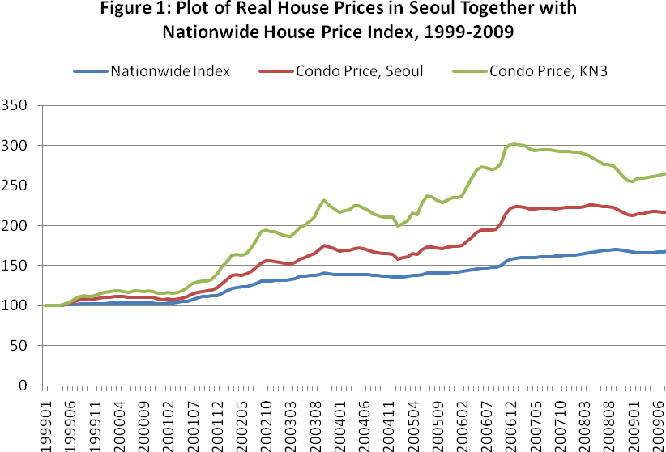

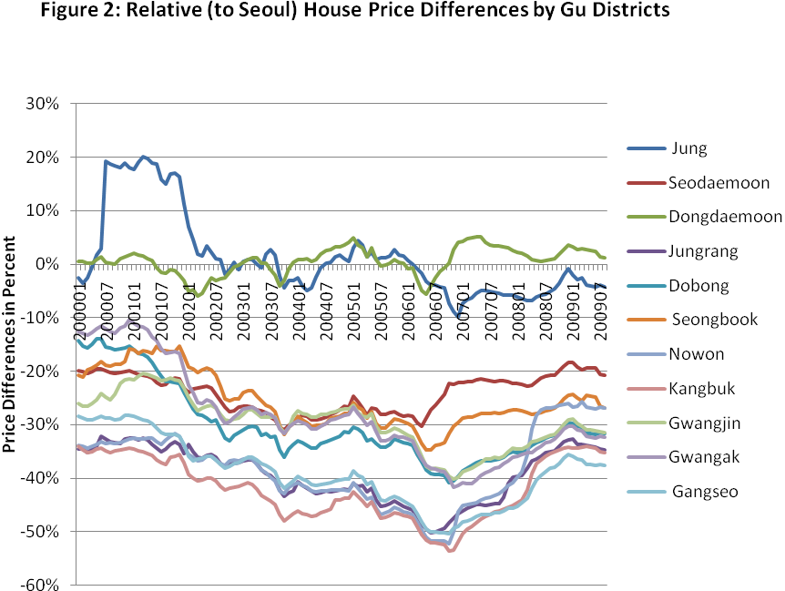

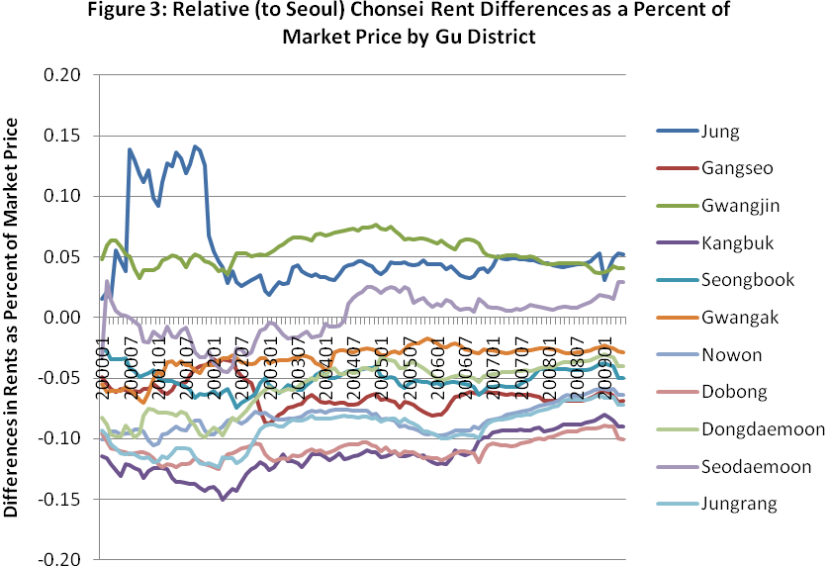

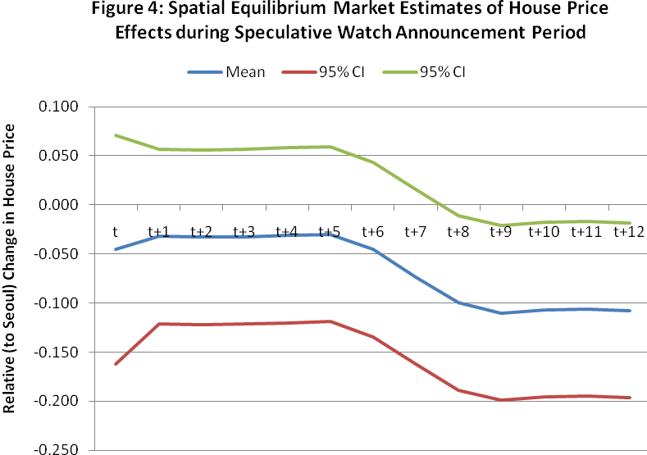

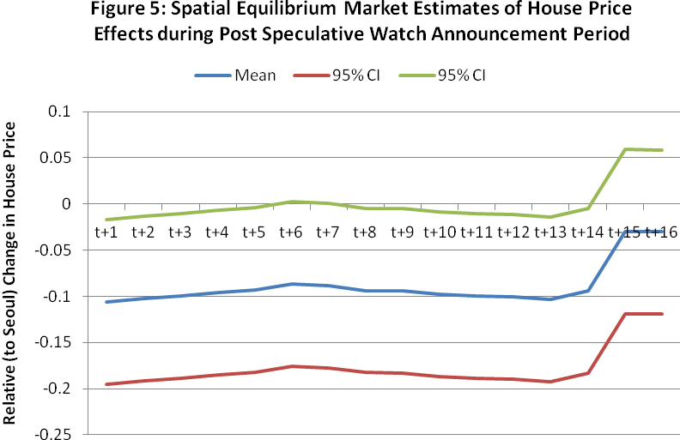
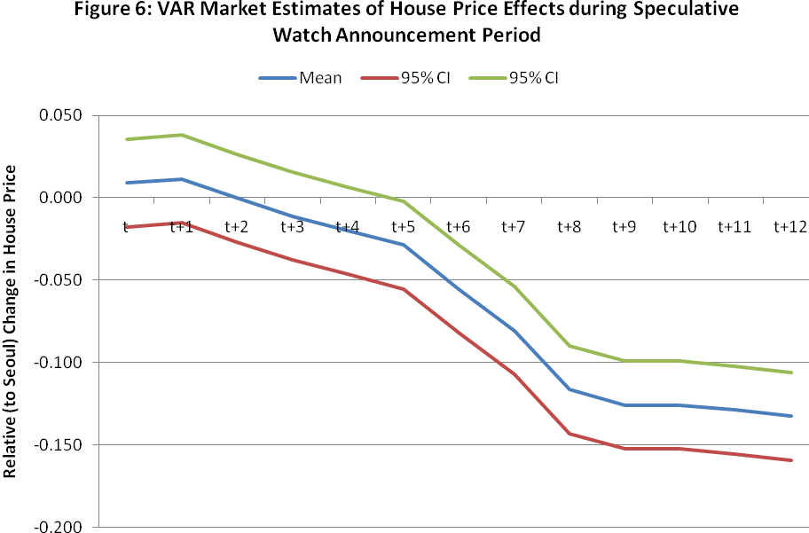

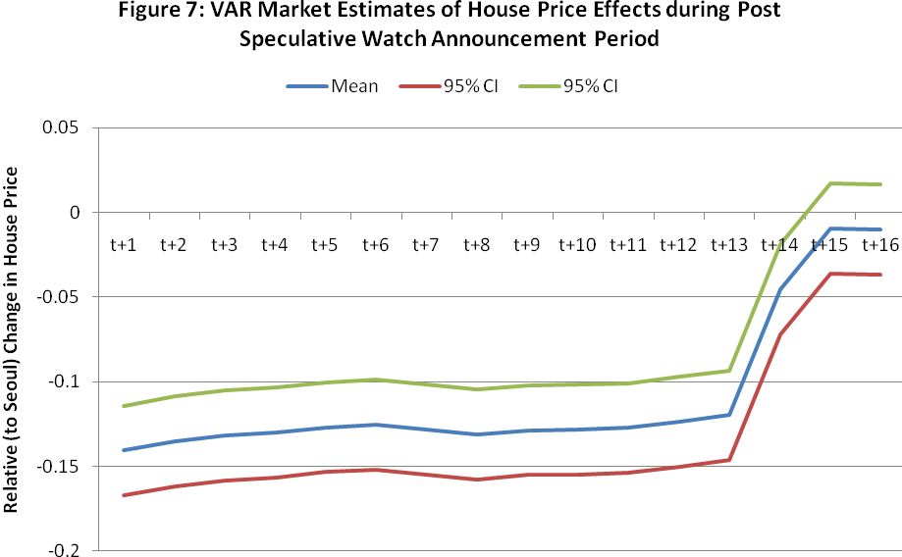

Enactment was assured much earlier. The House-Senate conference committee passed the bill on August 16, and the full Senate approved a similar bill by a 97-3 vote on June 24.
Slemrod (1990) describes the timing of transactions with respect to anticipated changes in the tax structure as the most sensitive behavioral response. Kopczuk and Slemrod (2003) give many examples of timing responses.
While long-term capital-gains realizations of corporate stock in the fourth quarter of 1986 were up 373 percent relative to 1985, realizations of depreciable property were up only 27 percent, possibly owing to larger transactions costs (Burman, Clausing and O’Hara, Tables 4 and 6).
See Hwan, Quigley, and Son (2006, pp 207-09) for detailed discussion of the condominium market.
The ferocity of changes violates one tenet of a good tax system; the uncertainty for investors caused by the changes is utility decreasing (Alm, 1988).
Given the movements in prices shown in Figure 1, it is only longer term (over three years) holders of properties that would have had significant gains to reap. Because large investors were already being taxed on actual gains, only those holding a couple properties, the third class in Table 1, were affected.
Gwangjin is an outlier here with appreciation of 38 percent, far higher than the other districts and even greater than the previously designated districts (see Table 5 below for further evidence on the unusual behavior of prices in Gwanglin). Excluding Gwangjin, the difference in appreciation was nearly 20 percent.
The interest rate is after tax. For simplicity, we assume no location variation in income tax rates.
See Ambrose and Kim (2003) for a detailed discussion and analysis of the Korean rental contract.
If the speculative watch area announcements are partially or completely anticipated, the new information will be acted upon before the announcement date and one should observe price declines prior to the announcements.
In the formal testing for capital gains tax effects, we have estimated with and without the Gwangjin data because the prediction value of this equation is so poor.
The methodology assumes that there is no opportunity immediately prior to the tax selling to improve utility or to make economic profits by buying (selling) houses whose prices are too low (high). Fama et al. (1969) stipulate this by assuming security prices reflect all available information.
In most event studies the event does not occur simultaneously (see Fama et. al. above).
The eleven Seoul equations differ in that the district price and rent variables are from different districts.

