A Theory of Stock Bubble Formation and Market Crash: New Perspective from Hydrodynamics Using Econophysics Approach

Chun-Chun Lin, Kehluh Wang, Joung-Yol Lin³

Abstract

In this paper we analyze the characteristics of extreme behavior in stock prices. First, we discuss the stock market dynamics using hydrodynamics model. By deriving the nonlinear Burgers equation with diffusion terms, we investigate the market bubbles as well as the crash events through abstract physics concept. To solve the uncertainty problem in the market crashes, we utilize the similarity in the stretched group and the traveling wave. In this way we find the solution of Burgers equation which is different from other studies using the time series analysis. The results show that log-periodic power law, self similarity, criticality of phase transition, interacting agent model, aftershock market model, and rational expectation bubbling can all be described through parameters in the Burger equation. Empirical evidence shows that the complexity between viscous oscillation and burst convection is more significant in the long run than in the short run.

Keywords：Econophysics；Stock bubbles；Market crashes；Burgers equation
1. Introduction
Extreme behaviors in stock market dynamics have spurred many studies on financial bubbling and crash events. These behaviors include dramatic changes in prices, returns, and trading volumes due to various endogenous and exogenous factors (Dider, 2003). A market crash can be considered as a radical price drawdown. The mean reversion process makes the real price decline toward the baseline of the previous cycle (Anders, 2003).
Using system dynamics approach, Johansen and Sornette (1996; 1997) showed that US market crashes in 1929 and 1987 can be modeled as an energy release in earthquake. Plerou, Gopinikrishnan and Rosennow (2000) applied statistical physics to demonstrate the similarities between extreme market behaviors and magnetization effect or melting point during the phase transformation. From the evidences in 1929 and 1987, herding behavior as well as the hedging allocation caused the sustainable crashes (Kaizoji, 2000). Watanabe, Takayasu and Takayasu (2007) used fluid dynamics for the modeling of stock market crash. Banerjee (1992), Nofsing and Sia (1999) utilized herding behavior in the stock market to inspect short-run and long-run evolution processes, linear equilibrium and nonlinear behaviors in the market. Elyas, Priyal & Tribhuvan (1998) and Chung & Kim (2005) explained the local bubbling formation and crash event with various time-spatial distribution of trading patterns. Hwang & Salmon (2004), Chiang & Li (2010), and Chiang & Dazhi (2010) further exploited herding analysis to understand the occurrence of abnormal jumps in stock prices and trading volumes.
In this study, we focus on the interactions between convection and diffusion effects in Burgers equation (Jordan, 2008) to probe the nonlinear and crash behaviors in the stock market. Various physical characteristics of turbulent flow through its convection and kinematical viscosity coefficient (Enflo and Rudenko, 2002) are analyzed to establish a novel model. Using the interdisciplinary econophysics approach (Xavier, Parameswaran, Vasiliki and Eugene, 2007), we can explore more details, with empirical supports, about the stock market bubbling and crashes.
The remaining Sections are organized as follows: Section 2 explains the hydrodynamics model and Burgers equation for the stock market dynamics. Some propositions and hypotheses, together with the empirical evidence, are discussed in Section 3. Section 4 concludes.
2. Hydrodynamics model and Burgers Equation for stock market dynamics
2.1 Hydrodynamics model
Moffat (1999) found that influences from long-term investors to short-run investors can be characterized with the laminar and turbulence similarity in hydrodynamics. This perspective allows the utilization of a critical parameter M to determine the turbulence behaviors in market fluctuation.
Imagine that a stock stays at a “position” $x$ with time $t=t_{0}$. The stock price is denoted as $u={\text{dx}}/{\text{dt}}$ and the pathway of its price behavior is determined by $\text{dx}=\text{udt}$. Hence, the market momentum of this stock can be expressed as $K=ρu$, where ρ is the trading volume.
Define the following total differential operator: ${\text{Du}}/{\text{Dt}}=∂u/∂t+u∂u/∂x$.
The last term represents for price change by convection contribution. The continuity equation of stock market dynamics can be expressed as $∂ρ/∂t+ρ∂u/∂x=0$.
To characterize the equilibrium of stock market dynamics, we can assume the inertial force $ρ{\text{Du}}/{\text{Dt}}$ be balanced by external force f and normal force in x direction, depicted as $ρ{\text{Du}}/{\text{Dt}}=ρf−∂p/∂x$, (1)
where p is defined as the influence of local economic entity.
The parameter μ used to scribe the fluid behavior is adopted to demonstrate the characteristics of stock market viscosity. Substitute parameter μ in eq.(1), and we have $ρ(∂u/∂t+u∂u/∂x)=ρf−∂p/∂x+μ∂^{2}u/∂x^{2}$ .
Assuming negligible external force f, it becomes $ρ(∂u/∂t+u∂u/∂x)=−∂p/∂x+μ∂^{2}u/∂x^{2}$. (2)
Constant ν=μ/ρis defined as diffusion contribution.
Set$x=Lx^{'}$,$u=Uu^{'}$ and $t=t^{'}L/U$ and substitute into Eq.(2), we obtain $∂{u^{'}}/∂t^{'}+u^{'}∂{u^{'}}/∂x^{'}=−∂{P^{'}}/∂x^{'}+M^{−1}∂^{2}{u^{'}}/∂x^{}$,
where $M={\text{UL}}/ν$ in this dimensionless equation can be comprehended as the control parameter that is analogous to Reynolds number for describing the fluid characteristics in hydrodynamics theory. If M is large, the stock behavior is governed by nonlinear convection in the sense of fluid motion. On the contrary, the small M implies that stock is affected by the diffusion term with dissipative effect, in which the disturbances in stock price evolution will become dispersed under the damping effect. Hence, the instantaneous information in any moment can be denoted as $I=μ(\frac{∂u}{∂x})^{2}$. And its dimensionless form is defined as $I^{'}=μ(U/L)^{2}(∂{u^{'}}/∂x^{'})^{2}$ .
In the sense of fluid dynamics, Burgers equation with convection and diffusion terms makes it feasible to analyze the system dynamics in terms of the interaction between long-term and short-term forces in the stock market. Under the viscosity-free circumstances, nonlinear convection effects dominate with a time-variant jumping process. However, this abrupt transition process drives the jump behavior to become dissipative, while staying in an environment with viscosity effect. Thus, it is understandable that the transaction cost and information diffusion often affect an investor’s herding behaviors. In a macro point of view, system dynamics with viscosity effect can be sustained to form a series of bubbles during the market recession. Ultimately, this structure will make the system unstable and become crashed by herding effect.
2.2 Nonlinear Burgers equation with convection and diffusion terms
The convection and diffusion effects can be described in nonlinear Burgers equation:
$(∂u/∂t)+αu(∂u/∂x)=ν(∂^{2}u/∂t^{2})$ (3)
$I\text{.}C\text{.} u(x,0)=u_{0}(x)$  (4)
where $α≥0$ is convective coefficient, ν is kinetic viscosity coefficient.
With the same initial condition as eq.(4), Burgers equation can be split into two parts:
1. Linear diffusion equation (α=0): $(∂u/∂t)=ν(∂^{2}u/∂t^{2})$
2. Nonlinear convection equation (ν=0, α=1): $(∂u/∂t)+u(∂u/∂x)=0$
Burgers equation consists of convection and diffusion effects which interact with each other to determine the characteristics of the fluid motion. The nonlinear effects become dissipative and delayed once the diffusion term dominates in the motion of the fluid and convection effect makes diffusion behavior to become abrupt. The viscosity coefficient ν characterizes the behavior, like Reynolds number (M) in fluid dynamics, which is the key to exhibit the extreme behavior of stock market. With increasing price and trading volume in the bull market, the dynamics of higher M or smallerνimplies that stock market acts like the fluid motion in higher flow through nonlinear convection effect. On the contrary, the dynamics with smaller M or higherνimplies that stock market acts like the fluid motion in smaller flow, where the market system can be constructed with dissipative diffusion term by damping effects. In general, volatility observed in the stock market is often depicted as extremely chaotic and results from external impacts which may determine trader’s investing attitude.
2.3 Similarity solution of the stretched group
To solve Burgers equation in eq. (3), we can set the similarity transformation (Bluman and Cole, 1974) of the stretched group as
$u(x,t)=t^{m}f(η)\text{ ; }$$η(x,t)=x/{t^{n}}$ (5)
where m and n are the power indexes to be determined,ηis the similarity variable to build up f(η).
Substitute eq.(5) into eq.(3) to give $t^{m−1}(\text{mf}−nηf^{'})+{αt}^{2m−n}ff^{'}={νt}^{m−2n}f^{''}$(6)
Hence, it splits into the following problems：
(1). Linear diffusion equation (α=0):
We can set m-1=m-2n, n=1/2 in eq. (5) and acquire the similarity transformation as $u(x,t)=t^{m}f(η)$;$η=x/{\sqrt{t}}$
where m is an arbitrary constant determined by initial or boundary conditions and f(η) satisfies $νf^{''}+(1/2)ηf^{'}−\text{mf}(η)=0$
For linear diffusion equation ($m={−1}/2$), set $m={−1}/2$ to have the corresponding fundamental solution:
$u(x,t)=f(η)/{\sqrt{t}}=(1/2\sqrt{\text{πν}t})e^{{−η^{2}}/4ν}$, -∞ < η < ∞ (7)
Therein the particular solution in eq. (7) for t=0 is a Dirac delta function depicted in Fig.1.
$u(x,0)=\underset{t→0^{+}}{\text{lim}}(1/2\sqrt{\text{πν}t})e^{{−x^{2}}/4νt}=δ(x)$,$\int_{−∞}^{∞}{δ(x)\text{dx}}=1$
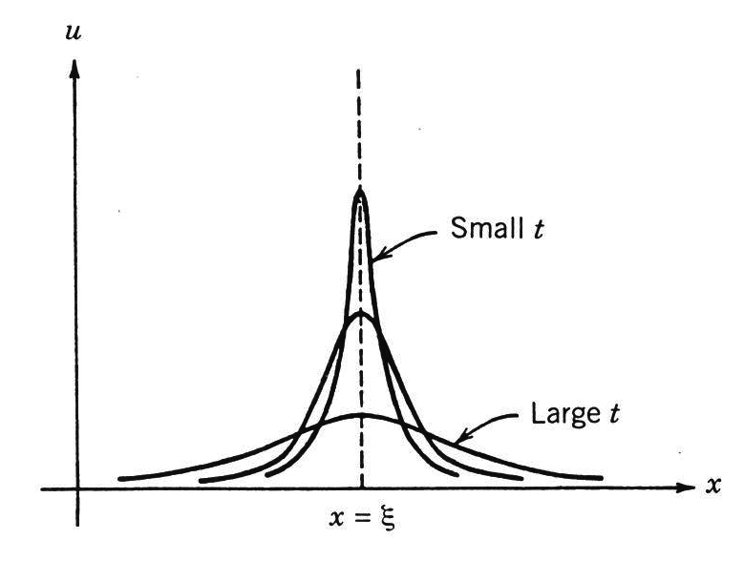
Fig. 1. Fundamental solution of diffusion equation

With insignificant herding behavior, the stock market dynamics is governed by the diffusion effect in Burger equation where the similarity solution is a Dirac delta function which implies the short-term equilibrium.
In essence, the fundamental solution of diffusion equation in Burgers model corresponds to the diffusion behavior in BS model (Ingber, et al, 2000). The characteristics of this PDE solution are determined by its linear diffusion solution with a boundary condition. In the short run, stock market often evolves under the influence of noisy volatility but will come back to the equilibrium status.
From the point of view in information dynamics, Zeira (1999) agreed that the super-cool or super-hot stock market caused by information efficiency can illustrate stock market recession around the bull or the bear market. The capital market would experience expansion or compression process under the short-run market triggered by information burst. Therefore, the imitation of the interacting investors will make stock market instable. When the stock market situated in a stable flow motion under proper viscosity effect, the capital flow in the market will behave in an ordered way with information propagation. Though price behavior experiences log-periodic oscillation in the short run, the oversupply can dissipate and stock market can maintain the supply-demand recession (Moffat, 1999).
In summary, fluid motion with the finite viscosity effect is similar to the stock market behavior where no significant herding effect from interacting agent exists permanently. Therefore, the price jump process by external shock in the short-run will be dissipated and delayed, which implies an inconsistent investing attitude and decision action. The re-balanced structure for supply-demand chain can sustain for stock market momentum in certain stability, which makes log-periodic oscillation rational in forming the market bubbles under equilibrium.
Next, consider the condition of nonlinear convection equation (α=1,ν=0) and set m-1=2m-n or n=1+m in eq.(6) to acquire similarity transformation as
$u(x,t)=t^{m}f(η) ; η=x/{t^{1+m}}$
where m is a constant to be determined and f(η) satisfies $ff^{'}−(m+1)ηf^{'}+\text{mf}(η)=0$
Besides, there exists expanded wave and compressed wave from nonlinear wave motions in high speed fluid dynamics. The compressive wave is also called the impacted wave or shock wave. The similarity in the stock market is that stock price or trading volume may not catch the information propagation or locate in the lagged phase of the information frontier. In terms of the expanded wave, the similarity is that the stock price or trading volume may behave in leading phase of the information propagation or locate in the leading edge of the information frontier. We will illustrate the stock bubbling mode with fluid motion corresponding of the expanded-wave properties.
(1) Expanded-wave solution (m=0)
Set m=0 and consider the initial condition is an expanded wave form:
$u(x,0)=u_{1}$ ， x＞0
$u(x,0)=u_{2}$＜$u_{1}$， x＜0
We can obtain the corresponding solution, as depicted in Fig. 2. (a) & (b).
$u(x,t)=\left\{\begin{matrix}u_{2}, η≤u_{2} \\ η, u_{2}<η<u_{1} \\ u_{1}, η≥u_{1}\end{matrix}\right.$
u
x
Fig.2. (a) Expanded wave solution in a phase portrait
To form a market bubble during the bull market, the average stock price $u_{1}$ is higher than the average stock price $u_{2}$ in previous period and stay in that state under dynamical equilibrium.
η=x / t
x
t
Fig.2. (b) Expanded wave solution in dynamical equilibrium
The stock price becomes bubble with oscillatory process.

During the bubbling formation, the stock price moves toward the verge of crash due to endogenous factors. The empirical analysis from speculative bubbling model proposed by Johansen and Sornette (1996) provides evidences that price drawdown behavior matches the pattern of log-periodic-power laws. Furthermore, Johansen and Sornette (2004) suggested the following generalized nonlinear model:
$μ(B)B=(m/2B){\left[Bσ(B)\right]}^{2}+μ_{0}{\left[B(t)/{B_{0}}\right]}^{m}$
$σ(B)B=σ_{0}{\left[B(t)/{B_{0}}\right]}^{m}$
$B_{0}$,$μ_{0}$, m＞0 and $σ_{0}$ are key parameters which are related to the scaling property, effective drift effect, nonlinear extent and stochastic measurement for volatility, respectively. According to the cooperatively collective behavior from the interacting-agent model, the herding behavior of investors in stock market can be depicted as the positive feedback mechanism of $μ(B(t))$ and $σ(B(t))$ with respect to the price changes (Sornette and Malevergne, 2002). The rationality results from the fact that the significant volatility process may attract further trading actions from more buyers and sellers.
In summary, the price behavior in the bull market can be depicted as an expansion process of rational bubbling in the short run, which promotes various log-periodic oscillation patterns, and the stock price can reach new high once again until the timing of criticality. Hence, the pattern is consistent with the expanded wave properties in our Burgers equation model. With an increasing convection coefficient α in the sense of fluid motion, new industrial capacities and new investors join the market with the inflation of information efficiency. This makes trading capacity of stock market go climbing. Simultaneously, the stock price increases and deviates from its fundamental value. This process results in the stock price and trading volume rising toward the top, and thus the speculative bubbles are formed similar to our expanded wave pattern.
(2) Fundamental solution for nonlinear convection equation ($m={−1}/2$).
Set $m={−1}/2$ to get the corresponding solution as $u(x,t)=f(η)/{\sqrt{t}}=η/{\sqrt{t}}=x/t$
Nonlinear convection effect may affect the fundamental solution of linear diffusion equation to become an abrupt jump. As explained by the information dynamics (Zeira, 1999),the overestimated or underestimated value from investor’s mental process can be used to depict the stock market recession for both the bull and the bear stage. In the long run, the stock market is apt to be triggered by the burst of industrial information which promotes a series of capital expansion and compression processes. Simultaneously, herding investors in interacting-imitation process may reach extremely high consistency in their intentions, which results in stock market to become instable and deviate from the equilibrium. Under the long-run pattern of log-periodic oscillations, it accumulates more bubbling sequences. With increasingly violent oscillations, the capital flow in the stock market will no longer return to the stable equilibrium once the critical point is reached. From fluid dynamics point of view, the capital flow with viscous-free effect will behave as a turbulence under the information propagation (Moffat, 1999), which ruin the stock market equilibrium and enter the crash stage.

3. Propositions and hypotheses
From Burgers equation model, we can understand that the convection and diffusion effects (Sionoid and Cates, 1994) can be used to illustrate the stock price behavior in bull and bear markets. As the stock market is promoted by the expansion process from the industry or by the delegation activities from monetary politics, waves of investors will participate. In the short term the stock price behaves like a drawdown process due to market oversupply, but in the long run, the transition of the states never destroys the structure of the market equilibrium under successive log-periodic oscillations. Therefore, the stock market is still sustained in the bull market.
In terms of the relationship between information propagation and herding behavior, the same group of investors in random diffusion process will make the consistent decision to gradually form the herding behavior. Therefore, Eguiluz and Zimmermann (2000) claims that the statistical distribution of stock returns behaves in a pattern of power law as velocity information diffuses slower than that of trade actions. As a result, the price behavior forms the market bubbles. When the velocity information diffuses faster than that of trade actions, the distribution of extreme high return rises. Hence, the stock market enters into the crash stage.
Proposition 1：In the pricing process of log-periodic oscillation, the more significant the interactive investor behaves in imitation, the more the convection effect dominates the market.
Proposition 2：In the log-periodic oscillation of the price pattern, the less significant the herding effect in stock market, the more the diffusion effect in the stock price.
Proposition 3：In the long run, the stock market will be bubbling along log-periodic oscillation with the rising stock price process until reaching the critical top point. This can be denoted by expanded wave properties in the fluid motion.
Proposition 4：In the long run, the stock price will be bubbling with the market toward the critical top point of phase transition during the bull stage, where the log-periodic oscillation behavior becomes more frequent when reaching the critical point.
Proposition 5：In the short run, the stock price will bring about the phase transition from critical top to the market crash with successive price drawdown under the external shock.
Proposition 6：As the stock market stays in the crash stage and is affected by external intervention with viscous effect, the impacts of the crash will be dissipated or buffered by diffusion effect, which will promote the elongation of aftershock duration.
According to the model deduced from the nonlinear Burgers equation as described above, we conclude that the stock market with finite viscosity effect implies little herding effect from investors. Hence, the price bubble behavior without external shock can be modeled using fluid motion and Burgers equation. We thus have the following testable hypotheses:
Hypothesis 1：The less the viscous effect in the bull stage of the stock market, the shorter the duration for bubbling formation.
Hypothesis 2：The bubbling of the stock has relatively higher viscosity effect during the bull market than during the bear market.
Hypothesis 3：In the long run, the bubbling duration is longer in the bull market than in the bear market.
Hypothesis 4：In the long run, the bubbling of the stock has relatively more complicated oscillation in the bull market than in the bear market.
Hypothesis 5：With relatively higher viscosity effect where the stock market starts in bull stage, the sustainable inflation of stock price and trading volume will promote the market to reach the ending state with relatively lower viscosity effect.
Hypothesis 6：With relatively lower viscosity effect where the stock market starts in bull stage, the sustainable inflation of stock price and trading volume will promote the market to reach the ending state with relatively higher viscosity effect.
Hypothesis 7：With relatively higher viscosity effect where the stock market starts in bear stage, the sustainable deflation of stock price and trading volume will promote the market to reach the ending state with relatively lower viscosity effect.
Hypothesis 8：With relatively lower viscosity effect where the stock market starts in bear stage, the sustainable deflation of stock price and trading volume will promote the market to reach the ending state with relatively higher viscosity effect.
Using the monthly data of The Taiwan Stock Exchange Capitalization Weighted Index for the sample period from January 1983 to December 2010, we observe that there exists a violent fluctuation around the 3-year moving average (blue line) once passing the critical tip close to 10000 points. There are three regimes to consider the significant herding behavior. Firstly, herding behavior mainly happened during the 2003, 2004, and 2005, when the economic situations for these years were better. Secondly, the longest lasting period of herding was from March 2005 to January 2006, totally 11 months. Thirdly, herding happens mostly in January, November and December during the sample period.
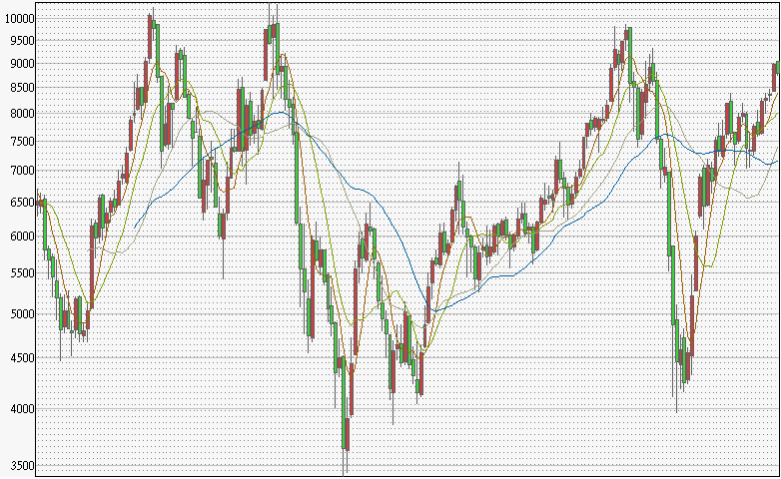
(a)
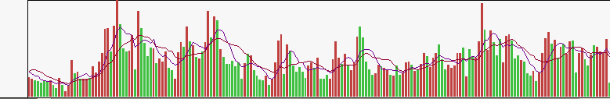
(b)
Fig. 3. Monthly data of (a) The Taiwan Stock Exchange Capitalization Weighted Index and (b) the trading volume from July 1983 to December 2010. The moving average curves of different duration represent the optimal log-periodic representations appropriate to different time scale in characterizing the long-term viscous effect.

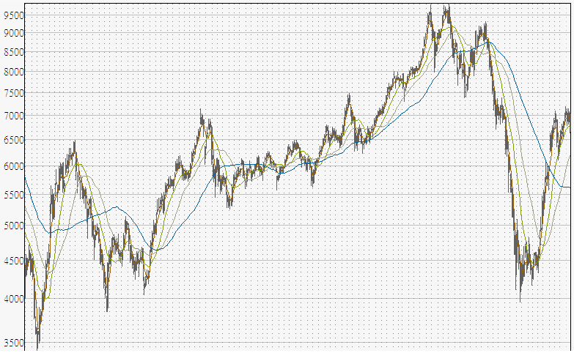
(a)
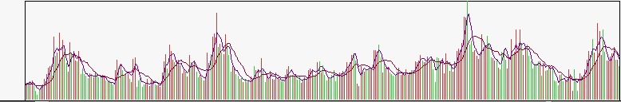
(b)
Fig. 4. Weekly data of (a) The Taiwan Stock Exchange Capitalization Weighted Index and (b) the trading volume from September 2001 to December 2010. The moving average curves of different duration represent the optimal log-periodic representations appropriate to different time scale in characterizing the middle-term viscous effect.

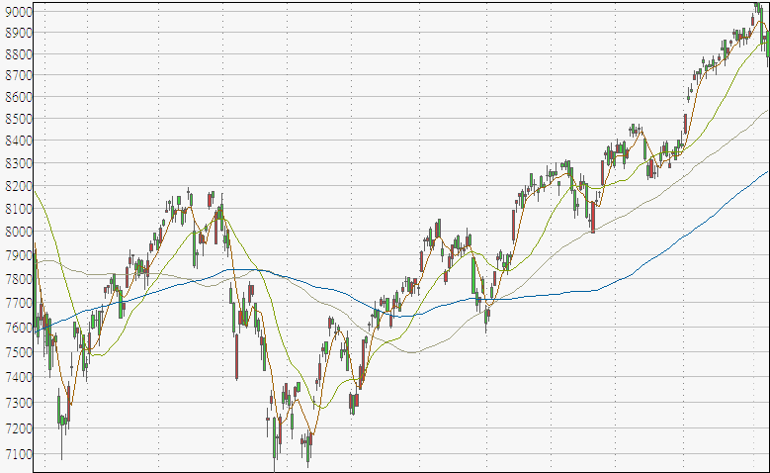
(a)
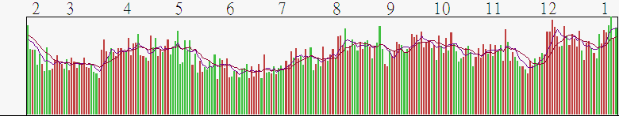
(b)
Fig. 58. Daily data of (a) The Taiwan Stock Exchange Capitalization Weighted Index and (b) the trading volume from January 2010 to December 2010. The moving average curves of different duration represent the optimal log-periodic representations appropriate to different time scale in characterizing the short-term viscous effect.

The daily K-bar chart of The Taiwan Stock Exchange Capitalization Weighted Indexes provides the evidences that the oscillatory frequency in the bull market is higher than that in the bear market, which illustrates that the convention effect overwhelms the diffusion effect in the sense of fluid dynamics. The viscosity alternation of different fluctuation regimes in the stock market looks insignificant along the bull and the bear periods. The weekly and the monthly K-bar charts of The Taiwan Stock Exchange Capitalization Weighted Indexes give evidences that the oscillatory duration in the bull market is longer than that in the bear market. In the long run, the oscillatory pattern in bull regime becomes more complicated than that in the bear regime. It brings about the viscosity alternation of different fluctuation regimes in the stock price dynamics, which implies that the market bubble formation is resulted from the interaction between the convection and the diffusion effects in the sense of hydrodynamics.

4. Conclusion
The objective of this paper is to develop a theory on stock market bubbling and crash phenomenon using the hydrodynamics model. In the sense of fluid dynamics, the stock market behaves like a ship moving forward by balancing the diffusion effect and convection effect to successively attain a new equilibrium, in which the herding behavior of interacting imitation among investors, as a viscous effect, plays a crucial role. According to the rational bubble model, the essence of the stock bubble formation can be derived from the prospect that the price deviates from the fundamental value. Along the successive oscillation in the bubbling process, more and more investments will aggregate toward a price approaching the critical peak until it brings about a phase transition and causes the stock market crash. Hence, we obtain the insight that viscous effect significantly influences the sequential characteristics of the beginning and the ending point along the bull and the bear market.
For further studies, there remain some quantitative tasks to be verified:
(1) To derive a dynamic market process, using fluid dynamics, to describe the extreme behaviors in the stock market.
(2) To develop and validate a multidimensional construct relevant to the viscous effect as a key to scribe the stock market equilibrium, guided by the crucial diffusion and convection terms in Burgers equation.
(3) To examine the bubbling formation and the crash mechanism in the stock market and provide a better understanding on the investment environments and how traders should search for optimal entry condition using the theory of market bubbling and crash.

References
Anders J., “Characterization of Large Price Variations in Financial Markets”. Physica A, 324 (2003), pp.157-166.
Banerjee, A., “A simple model of herd behavior”. Quarterly Journal of Economics, 107 (1992), pp.797-818
Bluman, G. W. and J. D. Cole, “Similarity methods for differential equations”, In Appl. Math. Sci., Springer-Verlag, New York, (1974) No. 13,.
Chiang,T. C. and Dazhi Zheng, “An empirical analysis of herding behavior in global stock markets”, Journal of Banking & Finance, 34 (2010), pp.1911-1921
Chiang, T. C.. Jiandong Li and Lin Tan, “Empirical investigation of herding behavior in Chinese stock market: Evidence from quantile regression analysis”, Global Finance Journal, 21 (2010), pp.111-124
Chung, Kee H. and Youngsoo Kim, the dynamics of dealer markets and trading costs, Journal of Banking & Finance, 29 (2005), pp.3041-3059.
Dider S., “Critical Market Crashes,” Physica A, 378 (2003), 1-98.
Eguiluz,V.M. and M.G. Zimmermann, Phys. Rev. Lett. 85 (2000), pp.56-59
Elyas Elyasiani, Priyal Perera, Tribhuvan N. Puri, “Independence and dynamic linkages between stock markets of Sri Lanka and its trading partners”. Journal of Multinational Financial Management, 8 (1998), pp.89-101
Enflo, B.O, Rudenko, O.V. “To the theory of generalized Burgers’ equation”. Acta Acust United Acust, 88 (2002), pp.1-8.
Ingber, L. and J.K. Wilson, “Statistical Mechanics of Financial Markets: Exponential Modifications to Black-Scholes”, Mathematical and Computer Modeling, 31 (2000), pp.167-192
Jordan, P. M., “A Note on Burgers’ Equation with Time Delay: Instability via Finite-time Blow-up,” Physics Letters A, 372 (2008), pp.6363-6367.
Kaizoji ,T., “Speculative Bubbles and Crashes in Stock Markets: An Interacting-agent Model of Speculative Activity, Physica A ,287 (2000), pp.493-506.
Moffat, J. W., “A dynamical model of the capital markets”, Physica A, 264 (1999), pp.532-542
Nofsinger, J., Sias, R., “Herding and feedback trading by institutional and individual investors”, Journal of Finance, 54 (1999), pp.2263-2295
Plerou, V., Gopinikrishnan, P., and B. Rosennow, “Econophysics: Financial Time Series from a Statistical Physics Point of View,” Physica A, 279 (2000), pp.443-456.
Sionoid, P.N, Cates AT. “The generalized Burgers and Zabolotskaya-Khokhlov equations: transformations, exact solutions and qualitative properties”. Proc R Soc lond A; 447 (1994), pp.253-70.
Hwang, S.and Mark Salmon, “Market stress and herding”. Journal of Empirical Finance, 11 (2004), pp.585-616.
Sornette, D. and Y. Malevergne, “From Rational Bubbles to Crashes,” Physica A, 299 (2002), pp.40-59
Watanabe, K., Takayasu, H. and M. Takayasu, “A Mathematical Definition of the Financial Bubbles and Crashes, Physica A, 383 (2007), pp.120-124.
Xavier, G., Parameswaran, G., Vasiliki, P. and S. Eugene, “A Unified Econophysics Explanation for the Power-law Exponents of Stock Market Activity,” Physica A, 382 (2007), pp.81-88
Zeira, J., “Informational Overshooting, Booms, and Crashes,” Journal of Monetary Economics, 43 (1999), pp.237-257.

PhD. Candidate, Department of Business Administration, National Chen Chi University, Taipei, Taiwan. E-mail: d92355512@yahoo.com.tw, TEL: 886-2-22340618, FAX: 886-2-2234-0618.
Professor and Director, Institute of Finance, National Chiao Tung University, Hsinchu, Taiwan. E-mail: lkwang@mail.nctu.edu.tw, TEL:886-3-5731760. ³ Professor and Dean, College of Management, Asia University, Taichung, Taiwan. E-mail: jylin@asia.edu.tw, TEL:866-4-2332-3456 ext.1936.

