Activism and the Move Away From Staggered Boards

Re-Jin Guo, University of Illinois – Chicago

Timothy A. Kruse, Xavier University

**Tom Nohel, Loyola University – Chicago

March 28, 2011

Abstract

In this paper we compile a comprehensive sample of firms that decide to dismantle their staggered board in favor of annual director elections. We focus on the period following the passage of the Sarbanes-Oxley act of lat 2002. We find 368 instances between 2003 and 2008, continuing the recent trend identified in Guo, Kruse, and Nohel (2008). Investor reaction to these decisions is muted but nonetheless significantly positive a the 1% level. As in our earlier paper we find that shareholder activism is instrumental in pushing this self-imposed governance reform, but we find that the form of activism is of considerable importance: when the change is pushed by aggressive hedge fund activists the board is likely to embrace annual elections immediately and the markets react very favorably to the change, while if the change is pushed by non-binding shareholder proposals, the response is to drag out the change as much as possible and the markets are commensurately unimpressed.

** Corresponding author. Please address comments and suggestions to Prof. Tom Nohel, Department of Finance, Loyola University, 820 North Michigan Avenue, Chicago, IL 60611, (312) 915-7065, tnohel@luc.edu.

- Introduction
The staggered board, a structure whereby directors typically have non-synchronous terms of three years rather than having to face annual elections, is arguably the most consequential takeover defense. As such, staggered boards have drawn the ire of activist shareholders and governance experts alike. The result is a significant reduction in the incidence of staggered boards: in 2001 roughly 60% of publicly-traded companies had staggered boards, while that proportion has fallen to under half today. In an earlier study, we found that non-binding shareholder proposals (what Ferri (2010) calls “low cost” activism) were an important catalyst in the move away from staggered boards. More recently, activist hedge funds have emerged as an alternative and better-financed vehicle to channel shareholder angst, and to benefit financially from improvements in the governance environment. In this paper, we document the extent to which activism of any type continues to push this change in governance practice. Moreover, we distinguish between different forms of activism for this purpose and examine and compare the wealth effects and other aspects of each.
Staggered boards, and their anti-takeover amendment cousins, poison pills, continue to figure prominently in the battle for shareholder democracy. The use of these defenses in tandem creates a veritable fortress against would-be suitors. For all intents and purposes, no poison pill meant to deter a hostile takeover has ever been triggered. Moreover, since it is the board of directors rather than the shareholders that control the fate of most poison pills, the ability to influence the board is paramount. But gaining control of a staggered board requires winning elections at two separate annual shareholders’ meetings, making this prohibitively expensive. In fact, no prospective suitor has ever gained control of a staggered board by voting out incumbent directors. The difficulty of fighting through a staggered board was recently brought to the fore in the much-watched battle between rivals Air Products and Airgas.
Several recent papers in the academic literature support the notion that staggered boards destroy shareholder value. These include Bebchuk et al. (2002), Bebchuk and Cohen (2005), Daines (2001), Faleye (2007), Guo et al. (2008), and Bebchuk et al. (2011). Yet, of these, only Guo et al. (2008) considers the role of shareholder activists in advancing this cause. Moreover, the sample period in Guo et al. (2008) runs only through 2004 and therefore pre-dates most hedge fund activism. And while the Bebchuk et al. (2011) paper focuses on a clever natural experiment based on a very recent event, it does not consider a role for shareholder activists.
The move away from staggered boards in favor of unitary boards (i.e., boards whose directors face annual elections) is but one of many contemporaneous attempts to empower shareholders. Other examples include the battle over proxy access, the battle over the new rules requiring shareholders to have a ”say on pay”, a push to de-emphasize the influence of broker non-votes, and the push for majority voting in director elections. This push accelerated following the fallout from the bursting of the internet and telecom bubbles and the ensuing revelations of corporate fraud that led to the passage of the Sarbanes-Oxley Act in late 2002. In fact, Guo et al. (2008) document that of the 188 incidents of firms moving from staggered to unitary boards from 1988 through 2004, approximately 2/3 of them occurred in 2003 or 2004.
In terms of shareholder proposals, it wasn’t that proposals to de-stagger the board only began in earnest in 2003, since there were significant numbers of such proposals already in the mid 1990s, and they even received considerable support (See Georgeson, 1996, 2000, and 2004). Instead, it appears that finally, beginning in 2003 and continuing thereafter, management started to listen to shareholders and seek changes to mollify them.
In this paper, we build on our earlier paper, Guo et al. (2008), and put together a sample of instances of firms whose management has stated an intention to put a resolution to de-stagger the board to a shareholder vote or simply de-staggered by board vote. We focus on the post-Sarbanes-Oxley period (i.e., 2003-2008) and find 359 separate events. We find that the overall reaction to the decision to de-stagger shows a small increase in shareholder wealth of 0.5% (significant at the 1% level) over the 3-day announcement period centered on the event date. This seems to be driven primarily by the instances where an activist hedge fund has taken an active role in trying to reform the target firms’ governance.
A comprehensive analysis of the role that external pressure plays in driving this change in governance reveals that a majority of firms that eventually decide to move to annual director elections face some form of shareholder pressure. But the nature of the pressure has considerable impact on the response of the targeted firm and the response in the markets to the announced change. Specifically, there is considerable variation in the pace of the change in board structure: firms that face pressure in the form of shareholder proposals tend to phase in the move to annual director elections over several years, while firms that have been targeted by activist hedge funds tend to de-stagger their boards by the next shareholders meeting if not immediately (that is, all of the directors agree to resign and face reelection that very year if the shareholders approve the proposal to de-stagger). Moreover the markets respond in kind, bidding up the shares of firms targeted by activist hedge funds, perhaps in anticipation of an eventual takeover, while being unresponsive to a de-staggering prompted by shareholder proposals.
Following this introduction, we review the literature on staggered boards, governance, and firm value in Section 2. Section 3 describes our sample, data sources, and circumstances surrounding the original adoption of the staggered board. Section 4 analyzes the implementation decision, Section 5 presents and analyzes the wealth effects, and Section 6 concludes.

2. Staggered Boards, Corporate Governance, and Firm Value
Researchers have been examining the use of anti-takeover protections for nearly 30 years. The earlier literature is rather inconclusive in many respects with few papers showing significant wealth effects on the adoption of takeover defenses. Moreover, those that do find significant effects are unable to reach a consensus on the question of whether defenses are good or bad for shareholders.
Underlying this lack of consistency is a theoretical debate over whether takeover defenses help or hurt shareholders. On the one hand, the defenses are clearly a way for poorly performing managers to entrench themselves. But, on the other hand, some claim that defenses enhance the bargaining position of the incumbent board, leading ultimately to a higher premium on deals that eventually go through.
Recent work shows that staggered board are the most important defense. It is not a staggered board in isolation but rather the combination of a staggered board and a poison pill that creates a near impenetrable defense. But since a board can install a pill at any time without shareholder approval, the staggered board becomes the key element of this defense. If you control the board, the fate of the poison pill is in your hands. The poison pill is so effective that no pill has ever been triggered. Bebchuk and Cohen (2005) argue that since the staggered board/poison pill combination is so effective other ATAs like fair price provisions are largely irrelevant in modern takeover contests. Daines (2005) makes a similar argument.
Governance experts and shareholder activists have been fighting against staggered boards for some time. As a result, the number of firms attempting to get shareholder approval to stagger their boards has declined precipitously since 1990. One exception to this trend is that firms going public often adopt a staggered board prior to their IPO. In fact from 1988 to 1999, the proportion of firms going public with staggered boards has increased from 36.2% to 82.0% (Field and Karpoff, 2002, Daines and Klausner, 2001, Coates, 2001). Another exception is that some states have adopted laws meant to shield local firms from potential hostile offers.
Several recent papers have paid considerable attention to staggered boards (i.e., Bebchuk et al, 2002a, b; Bechuk and Cohen, 2005; Bebchuk, Cohen, and Ferrell, 2006; Daines, 2005; and Faleye, 2007; John and Kadyrzhanova, 2009). For example, Faleye (2007) showcases specific ways in which staggered boards help to entrench management. He shows that firms with classified boards are less likely to fire the CEO when warranted, reduce the effectiveness of independent directors, are more likely to have officers whose pay is unresponsive to performance, and are less likely to implement (non-binding) shareholder proposals when passed. Fortunately, our results indicate that shareholders are getting the impression that staggered boards are not value-maximizing and management is starting to listen (see also Murti, 2005; and Ganor, 2007).
John and Kadyrzhanova (2009) explores the idea that would be acquirers look for the easy targets – that is, firms with the fewer defenses relative to their industry peers. Using the complete IRRC panel data set, they find that among industries characterized by a higher incidence of classified boards (the dictator firms), the relation between a specific firm having a classified board and the probability of (1) a bid and (2) conditional on a bid, successful acquisition is negatively related to whether it has a classified board (in other words, if everybody else has a classified board, you had better as well – cause you have a big target on your forehead if you don’t). However, the relation does not hold among firms in the democracy portfolio (i.e., industries characterized by the lowest incidence of classified boards). Moreover, announcements of takeovers of firms with classified boards lead to higher abnormal returns for industry firms, but only in industries with low incidence of classified boards among other industry firms In other words, firms in industries with lots of defenses are unlikely to become targets – so they don’t get a positive wealth effect.
Bebchuk, Cohen, and Wang (2011) take advantage of two recent decisions in Delaware regarding director elections to perform a natural experiment examining the value destroying impact of staggered boards. Over the past year, Air Products & Chemicals, Inc has been pursuing a hostile takeover offer for Airgas, Inc. The battle has been made more difficult by the Airgas’ staggered board structure. As a result, Air Products hit upon the idea to make a shareholder proposal calling for Airgas to move its annual meeting forward from its typical August date to January, reducing the time it would take Air Products to wage and (perhaps) win two proxy fights, gaining control of the board. Of course, it went to the courts. The first decision, by the Chancery Court, was in favor of Air Products. However, the Supreme Court then overturned the decision in favor of Airgas. Bebchuk, Cohen, and Wang perform an event study of over 3,000 firms on the two decision dates. Overall, the announcement effect of the Chancery Court decision was significantly positive and then the effect was reversed on the Supreme Court decision. The effect was strongest for smaller, more undervalued firms, e.g., those most likely to be a takeover target. The authors argue their results help resolve an endogeneity issue surrounding takeover defenses. Specifically, it is more likely that takeover defenses reduce firm value.
Overall, the recent research makes it much harder to make the case that staggered boards are good for shareholders. Voting and proposal patterns over the last 15 years indicate shareholders increasingly recognize the detrimental effect of a staggered board. Moreover, institutions such as activist hedge funds and pension funds and proxy advisory services such as Institutional Shareholder Services (ISS) and Glass-Lewis generally act against staggered boards.
Shareholder activists have long made the removal of takeover defenses a primary goal. However, the effectiveness of the activism, frequently pursued via shareholder proposals, has been mixed (see Gillan and Starks, 2000 for a survey). More recently hedge funds have become common and occasionally vocal shareholder activists. The activists have many goals, particularly getting their targets acquired. However, removing takeover defenses such as staggered boards and poison pills are seen as an important step increasing shareholder value regardless of the ultimate target independence (see Brav, Jiang, Thomas, and Partnoy, 2008; Greenwood and Schor, 2009). Greenwood and Schor partition their sample by whether the activist target is ultimately acquired. They report both the short- and long-term abnormal returns are significantly positive only for the firms that are acquired within 18 months of the initial 13D filing. A firms’ decision to de-stagger its board can be viewed as an important step towards that eventual acquisition.
3. Sample Selection and Data Sources
Our primary sample consists of firms that choose to de-stagger their boards between 2003 and 2008. We collect data on the incidence of staggered boards from the governance database available from the Investor Responsibility Research Center (IRRC) and from Riskmetrics. The sample firms are first identified from firms that change their staggered board status in the IRRC data and/or a change is reported in a Riskmetrics report. We supplement the sample by searching the Dow Jones Newswire (Factiva) and Lexis-Nexis with the key words "declassification," "de-staggering," "declassify," "de-stagger," and "annual election of directors." Our final sample consists of 368 firms and is relatively evenly distributed over the sample period. We combine our sample with that of an earlier paper covering 1987 to 2004 (Guo, Kruse, and Nohel, 2008) and present this longer time series in Figure 1. As can be seen in Figure 1, 430 companies have announced an intention to de-stagger their boards over 1987 to 2008, the vast majority having done so since 2003. The remarkable increase in the number of firms de-staggering their boards is part of general trend towards improved governance in the wake of scandals such as Enron and Worldcom. In this paper, we focus our attention on these later de-staggering events (i.e., subsequent to the Sarbanes-Oxley legislation).
We collect information regarding the de-staggering proposals from proxy statements filed with the Securities and Exchange Commission (SEC) in the year of the decision to de-stagger and from press reports for each sample firm. An important consideration is the speed that the firms de-stagger their board (i.e., what is the first year that shareholders will have the opportunity to elect the entire board for the first time). We can find this information for 362 of our sample firms. The fastest outcome has all directors resigning immediately and allowing shareholders the opportunity to elect the entire board in the proposal year (year 0). Other firms drag out the process as long as possible. In this case, all directors serve out their terms and the current slate of directors is still elected to a three year term. Then beginning with the next year, directors are elected to a new one year term. As a result, shareholders do not vote for the entire board until three years after the de-staggering event. Of course, intermediate cases are also possible. We provide information regarding the relative frequency of each type of implementation in the first section of Table 1. We also provide information on the relative frequency of each type over the sample period. There is an increasing trend towards dragging out the process as much as possible. A typical management reason for the phased-in approach is to smooth the transition to the new method of electing directors, however, there are few if any logistical issues involved in transitioning to annual director elections. We therefore conclude that these instances likely represent foot-dragging on the part of directors.
We also collect information on concurrent management and shareholder proposals regarding other takeover defenses and information concerning share ownership and the board of directors from the proxy statements. We provide summary statistics in the next two sections of Table 1. Typical management proposals include eliminating supermajority voting provisions (44 cases), allowing shareholders the right to call a special meeting (10 cases), and instituting majority voting for directors (9 cases). In five cases, management called for the elimination of cumulative voting for directors. This latter proposal can be seen as an attempt to minimize the impact of the de-staggering decision. The most common shareholder proposals usually call for majority voting in director elections (20 cases), elimination of supermajority voting provisions (9 cases), and the elimination of poison pills (8 cases).
In terms of other board characteristics, the typical board consists of ten members of which just over three quarters are independent. On average, officers and directors hold 10% of their firm’s shares.
We collect data on the degree of entrenchment of the sample firms and industry firms. We use the E-index of Bebchuk, Cohen, and Ferrell (2009) as our entrenchment index. These data are available for all firms covered by IRRC on Bebchuk’s website. The E-Index is the sum of six dummy variables indicating the presence of a staggered board, poison pill, whether there exists limits to shareholder bylaw amendments, whether there is a supermajority requirement for mergers, whether there exists limits to shareholder charter amendments, and whether there is a golden parachute. Our sample firms typically are well protected with about three of the defenses, which is slightly greater than their industry peers.
We collect information on the incidence of shareholder activism at the de-staggering firms. We use Riskmetrics and proxy statements to examine the incidence of shareholder proposals calling for annual elections in the three years up to the announcement. We also examine Schedule 13Ds and news articles for evidence of shareholder activism targeted at the sample firms. The Securities and Excahnge Commission requires investors acquiring a stake of 5% or greater with an intent to influence management to file a Schedule 13D within 10 days of crossing the 5% threshold. We focus our attention on Item 4 of the 13D statements which details the plans of the investor. In many cases, the language is simply boilerplate language to the effect the investor bought the shares because they view them as undervalued and that the shareholder might informally contact the target management. In other cases, the shareholders take a much more active role including writing letters, attending board meetings, making shareholder proposals, and even running proxy fights for board seats. A frequent outcome of this activism is that the board eventually decides to de-stagger. As can be seen in the fifth part of Table 1, over half of the sample firms are subject to at least one of these forms of activism.
We collect a wide array of accounting data for our sample firms. We industry-adjust the figures by deducting the median figure based on three digit SIC code. We report these industry-adjusted figures in the bottom portion of Table 1. Overall, our sample firms tend to out-perform their industry peers while maintaining more leverage.
4. The implementation decision
We examine the relation between the speed at which the firms implement their decision to de-stagger and the type of activism in two ways. First, Figure 3 shows the proportion of firms choosing to first allow shareholders the opportunity to elect the entire board by year contingent on the type of activism. In Table 2, we use a coarser division in which the firms allow the election of the entire board either in the year of implementation or by the next year (immediate) or whether they drag out the process through three or four annual meetings (phased). As reported in Figure 3 and in Table2, shareholder proposals have a perverse impact on the managements’ decision. This is consistent with the idea that management still feels it is necessary to listen to shareholder proposals more than they might have in the past. Even so, they still feel comfortable enough to drag out the process as long as possible. In contrast, firms subjected to more active investors tend to accelerate the de-staggering process.
Next, we examine whether the presence of other takeover defenses plays a role in the speed at which the de-staggering decision is implemented. Table 3 reports the relation between the sample firms’ E-index, the average industry protection, and the relative degree of protection the sample firm has to its industry peers. The first portion of Table 3 divides the sample into the four years in which shareholders can first elect all directors and the second portion uses the simpler immediate v phased distinction. Either way, it is clear that firms with a high degree of takeover protection and firms coming from industries with higher protection want to drag out the process as long as possible.
Finally, we perform a regression of the implementation decision and report the results in Table 4. Consistent with the results of Table 3, companies tend to drag out the process as long as possible in response to shareholder proposals. As with Table 4, firms coming from industries with a high degree of takeover protection want to maintain their staggered board as long as they can. Overall, these results coupled with those of John and Kadyrzhanova (2009) suggest that firms feel more vulnerable to takeover when their industry peers are well protected. The results also suggest that firms with poorer governance tend to drag out the process. That is, lower CEO ownership, CEO/CB duality, and larger boards are also positively related to the time to complete the de-staggering process.

5. Wealth Effects
We perform a standard event study of the announcement effects of the decision to de-stagger the board. We calculate 3-day CARs using the earliest of three possible dates: (1) the date the intention to put the staggered board to a shareholder vote was announced or simply the date the board announced its decision to de-stagger (if no shareholder vote is necessary) some time before the actual vote, (2) the date the firm released its preliminary proxy statement including the de-stagger vote with the SEC, or (3) the filing date of the definitive proxy statement with the de-stagger vote. Note not all firms have press announcements or preliminary proxy statements. We report the CAR’s in Table 5. For the entire sample, the CARs are small but significant with the mean and median announcement effects of 0.5% and 0.2%, respectively.
We also examine the announcement effects for a variety of sub-samples. Perhaps the most interesting is when we divide the sample by whether shareholder activists, typically hedge funds, targeted the firms prior to their decision to de-stagger. In this case, the CAR’s are approximately 1.5%. This finding is consistent with Greenwood and Schor (2009) who provide evidence that hedge fund shareholder activism creates the most shareholder value when the target firms are eventually acquired. They also report that activism sometimes has unintended consequences. Namely the target firm is ultimately acquired in 15.7% of the incidences in which the initial goal of the activism was governance improvements.
6. Conclusion
In this paper, we study firms decisions to eliminate a staggered board in favor of annual director election, with an emphasis on the period following the passage of Sarbanes-Oxley, namely from 2003-2008. Our focus is on the role that shareholder activism plays in the decision to de-stagger the board, the speed of implementation of the switch to annual director elections, and the response of the market to this decision. A fairly comprehensive study of earlier such events was already published as Guo et al. (2008), but the sample period in that study (1988-2004) predated the vast majority of hedge fund activism. In the Guo et al. (2008) paper, we found that shareholder proposals were an important catalyst in prompting firms to switch to annual election of directors.
We find this trend continuing since we find that approximately a third of all decisions to de-stagger are preceded by shareholder pressure in the form of non-binding proposals. However, when we consider the speed of eventually moving to annual director elections, it is clear that shareholder interests are not of paramount importance since the tendency in these instances is to drag out the conversion to annual director elections for as long as possible. In contrast, events preceded by interest/prodding from activist hedge funds leads to an immediate switch to annual elections.
In terms of wealth effects, overall we see that the market responds favorably to a switch to annual director elections (significant at the 1% level). But this overall average masks a more striking result: the response to a de-stagger announcement that was preceded by an aggressive 13-d filing from an activist hedge fund prompts a jump in share prices of around 1.5%, while a de-stagger announcement prodded by a shareholder proposal shows little is any reaction. It is likely, that the de-staggering prompted by the activist hedge fund is thought to pre-sage an eventual takeover.
References

Agrawal, A., Mandelker, G., 1990. Large Shareholders and the Monitoring of Managers: The Case of Antitakeover Charter Amendments. Journal of Financial and Quantitative Analysis 25, 143-161.

Bates, T., Becher, D., Lemmon, M., 2007. Board Classification and Managerial Entrenchment: Evidence from the Market for Corporate Control. Journal of Financial Economics, forthcoming.

Bebchuk, L., Coates IV, J., Subramanian, G., 2002a. The Powerful Antitakeover Force of Staggered Boards: Theory, Evidence, and Policy. Stanford Law Review 54, 887-951.

Bebchuk, L., Coates IV, J., Subramanian, G., 2002b. The Powerful Antitakeover Force of Staggered Boards: A Reply to Symposium Participants and Further Evidence. Stanford Law Review 55, 885-918.

Bebchuk, L., Cohen, A., 2005. The Costs of Entrenched Boards. Journal of Financial Economics 78, 409-433.

Bebchuk, L., Cohen, A., Ferrell, A., 2009. What Matters in Corporate Governance? Review of Financial Studies.

Bebchuk, L., Cohen, A., Wang, C., 2011, Staggered boards and the wealth of shareholders: Evidence from a natural experiment. Harvard University working paper.

Bhagat, S., Jefferis, R., 1991. Voting Power in the Proxy Process: The Case of Antitakeover Charter Amendments. Journal of Financial Economics 30, 193-225.

Bizjak, J. Marquette, C., 1998. Shareholder proposals to rescind poison pills: all bark and no bite. Journal of Financial and Quantitative Analysis 53, 499-521.

Brav, A., W. Jiang, R. Thomas, and F. Partnoy, 2008. Hedge fund activism, corporate governance, and firm performance, Journal of Finance 63, 1729-1775.

Coates IV, J., 2001. Explaining Variation in Takeover Defenses: Blame the Lawyers. California Law Review 89, 1301-1421.

Comment, R. Schwert, W., 1995. Poison or Placebo? Evidence on the Deterrence and Wealth Effects of Modern Antitakeover Measures. Journal of Financial Economics 39, 3-43.

Core, J., Guay, W., Rusticus, T., 2006. Does Weak Governance Cause Weak Stock Returns? An Examination of Firm Operating Performance and investor Expectations. Journal of Finance 61, 655-687.

Cremers, K.Nair, V., 2005. Governance Mechanisms and Equity Prices. Journal of Finance 60, 2859-2894.

Daines, R., 2005, Do Classified Boards Affect Firm Value? Takeover Defenses After the Poison Pill. working paper.

Daines, R. Klausner, M., 2001. Do IPO Charters Maximize Firm Value? Antitakeover Protection in IPOs. Journal of Law, Economics and Organization 17, 83-120.

Davis, G. Kim, H., 2007. Business Ties and Proxy Voting By Mutual Funds. Journal of Financial Economics 85, 552-570.

DeAngelo, H Rice, E., 1983. Antitakeover Charter Amendments and Stockholder Wealth. Journal of Financial Economics 11, 329-59.

Del Guercio, D., Hawkins, J., 1999. The motivation and impact of pension fund activism. Journal of Financial Economics 52, 293-340.

Del Guercio, D., Wallis, L., Woidtke, T., 2006. Do Boards Pay Attention When Institutional Investors “Just Vote No”?: CEO and Director Turnover Associated With Shareholder Activism. working paper.

Dittmar, A., Mahrt-Smith, J., 2007. Corporate Governance and the Value of Cash Holdings. Journal of Financial Economics 83, 599-634.

Eckbo, E., Maksimovic, V., Williams, J., 1990. Consistent Estimation of Cross-Sectional Models in Event Studies. Review of Financial Studies 3, 343-65.

Faleye, O. 2007. Classified Boards and Long-Term Value Creation. Journal of Financial Economics 83, 501-529.

Field, L. Karpoff, J., 2002. Takeover defenses at IPO firms. Journal of Finance 57, 1857-1889.

Ganor, M., 2007. Why do managers dismantle staggered boards? American Law and Economics Association Annual Meetings, Paper 5, Berkeley Electronic Press.

Georgeson Shareholder Services, 2001, Annual Report on Shareholder Proposals.

Georgeson Shareholder Services, 2004, Annual Report on Shareholder Proposals.

Georgeson Shareholder Services, 2005, Annual Report on Shareholder Proposals.

Gillan, S., Starks, L., 2000. Corporate governance proposals and shareholder activism: the role of institutional investors. Journal of Financial Economics 57, 157-305.

Gompers P., Ishii, J., Metrick, A., 2003. Corporate Governance and Equity Prices. Quarterly Journal of Economics 118, 107-155.

Greenwood, R. and M. Schor, 2009. Hedge fund investor activism and takeovers, Journal of Financial Economics 92, 362-375.

Institutional Shareholder Services, 2004. Post Season Report, A New Corporate Governance World: From Confrontation to Constructive Dialogue.

Jarrell, G., Poulsen, A., 1987. Shark Repellents and Stock Prices: The Effects of Antitakeover Amendments Since 1980. Journal of Financial Economics 19, 127-168.

Jensen, M., 1986. Agency Costs of Free Cash Flow, Corporate Finance and Takeovers. American Economic Review 76, 323-329.

John and Kadryzhanova, 2009. Does board classification matter for industry rivals? Evidence of spillover effects in the market for corporate control. Working Paper.

John, K., Kedia, S., 2003. Design of Corporate Governance: Role of Ownership Structure, Takeovers, Bank Debt, and Large Shareholder Monitoring. New York University Working Paper.

Karpoff, J. Malatesta, P., 1989. The Wealth Effects of Second-Generation State Takeover Legislation. Journal of Financial Economics 25, 291-322.

Klausner, M., 2002. Institutional shareholders’ split personality on corporate governance: active in proxies, passive in IPOs. Directorship 28, 7-13.

Lehn, K., Patro, S., Zhao, M., 2007. Governance Indices and Valuation Multiples: Which Causes Which? Journal of Corporate Finance, forthcoming.

Linn, S., McConnell, J., 1983. An Empirical Investigation of Anti-Takeover Amendments on Common Stock Prices. Journal of Financial Economics 11, 361-399.

Lipton, M., 1979, Takeover Bids in the Target’s Boardroom, The Business Lawyer 35, 101-134.

Mahoney, J., Sundaramurthy, C., Mahoney, J., 1996. The Differential Impact on Shareholder Wealth of Various Anti-Takeover Provisions. Managerial and Decision Economics 17, 531-549.

McWilliams, V., 1990. Managerial Share Ownership and the Stock Price Effects of Antitakeover Amendment Proposals. Journal of Finance 45, 1627-1640.

McWilliams, V., Sen, N., 1997. Board Monitoring and Antitakeover Amendments. Journal of Financial and Quantitative Analysis 32, 491-505.

Morck, R., Shleifer, A., Vishny, R., 1988. Management Ownership and Market Valuation. Journal of Financial Economics 20, 293-316.

Murti, B., June 8, 2005, More Boards May End Staggered Terms, Wall Street Journal.

Schlingemann, F., Stulz, R., Walkling, R., 2002. Divestitures and the Liquidity of the Market for Corporate Assets. Journal of Financial Economics 64, 117-144.

Svaldi, A., February 4, 2004. Xcel backs cutting board terms to a year, Proposal touted to boost accountability, but shareholder activist criticizes grandfather clause. Denver Post C1.

Taub, S., 2004. Few Refills on Poison-Pill Prescriptions. CFO.com.

Thomas, R. Cotter, J., 2007. Shareholder Proposals in the new millennium: Shareholder support, board response, and market reaction. Journal of Corporate Finance 13, 368-391.

Wilcox, J., 2002. Two Cheers for Staggered Boards. Corporate Governance Advisor 10, 1–5.

Yermack, D., 1996. Higher Market Valuation for Firms with a Small Board of Directors. Journal of Financial Economics 40, 185-211.
Figure 1
Distribution of Sample Firms by Year of the Decision to De-stagger

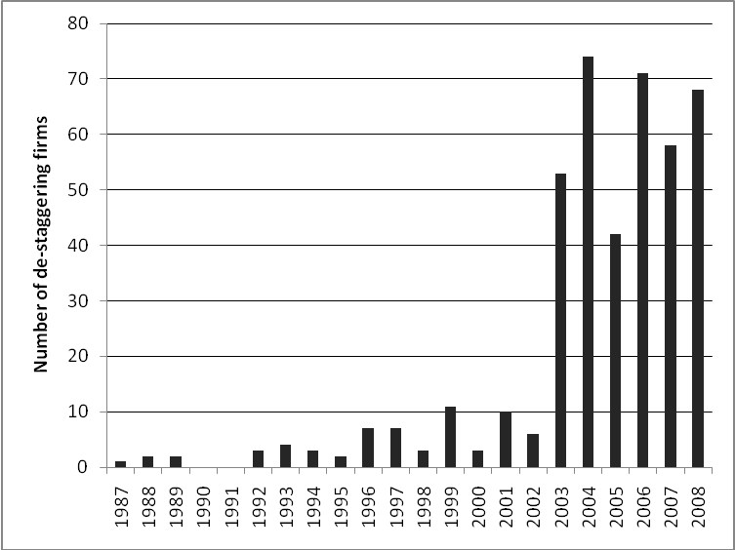

Figure 2
Time series breakdown showing the first year (relative to announcement year) that the shareholders will be able to vote for entire board at same time
i.e., Year 0 = totally immediate, year + 3 = delayed phased

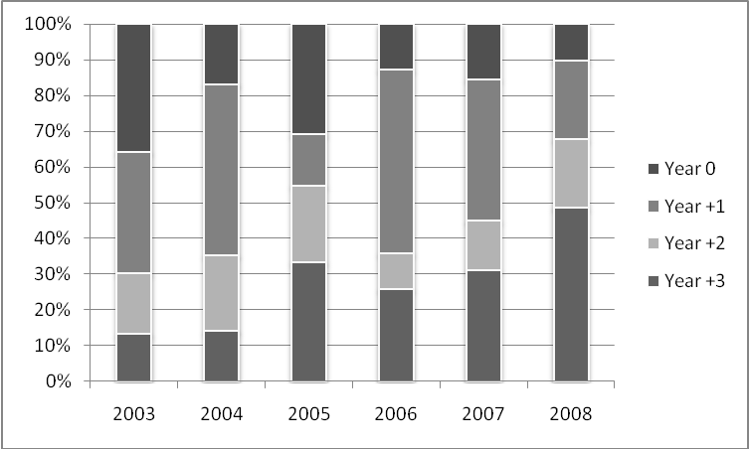

Figure 3a
Impact of activism on board decision regarding speed of de-staggering
The figure shows the percentage of sample firms choosing to allow shareholders the right to elect all directors in a given year depending on the type of activism event.

However, only shareholder proposals and any event have significant chi-squared statistics.

Because of missing info, the n are slightly lower than reported above
Shareholder proposal n = 136
Active event n = 66
Investment only boilerplate n = 36
Any of above n = 207

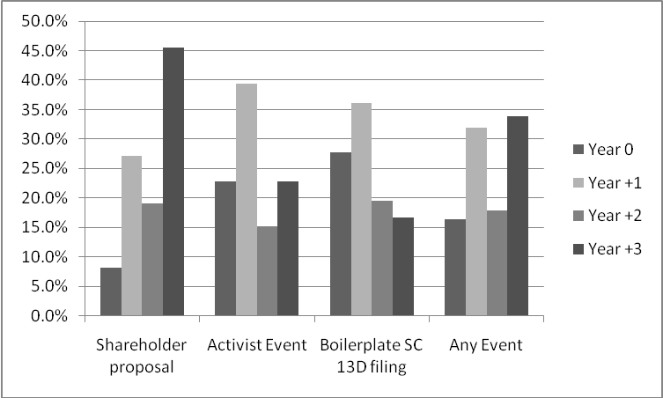

3b This figure is similar except it is for firms that experience only one of the three activism types. In this case, all the chi-squares are significant.

Shareholder proposal n = 105
Active event n = 42
Investment only boilerplate n = 27

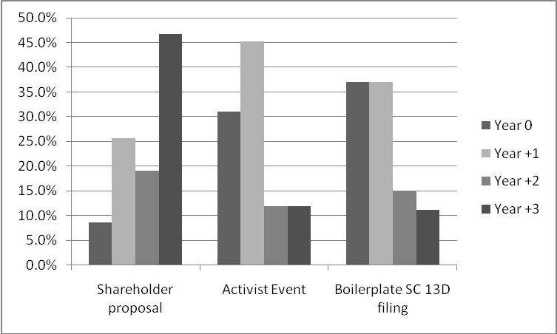
Table 1
Summary Statistics

Variable Mean Median

First year that shareholders can vote for the entire board at once
Year 0 0.191
Year 1 0.365
Year 2 0.169
Year 3 0.276

Board Characteristics:
Board size 10.08
CEO and Chair same person 0.62
Proportion Independent directors 0.77
CEO share ownership 0.03
Officer & Director share ownership 0.10

Other proxy proposals during de-stagger year
Management proposals 0.213
Shareholder proposals 0.118

Anti-takeover devices:
E-index 3.48 3.00
Adjusted E-index (using industry mean) 0.56*** 0.56***
Adjusted E-index (using industry median) 0.48*** 0.25***

Monitoring:
Shareholder proposal 0.381
Activist target 0.183
Investment based 13d filing 0.101
Any of above 0.575

Industry adjusted financial measures
EBITDA/Assets 0.028*** 0.016***
Net Income/Assets -0.003 0.004***
Asset turnover 0.193*** 0.062***
Profit margin -0.281 0.009*
Gross margin -0.304 0.012**
Long-term debt ratio 0.072*** 0.035***
Total debt ratio 0.039*** 0.009**
Market to book 0.106* -0.086
Current ratio 0.316** -0.069
Quick ratio 0.337** -0.107
Cash ratio 0.008 -0.007

Table 2
Activism and immediate v phased

This is another way of looking at the data from figure 3. However, I just lump the two immediate and the two phased events together given the propensity towards either regular immediate and delayed phased.

Activism Immediate Phased chi-square (p value)

Shareholder proposal (n = 136) 48 (35.3%) 88 (64.7%) 36.6 (<0.0001)
Activist event (n = 66) 41 (62.1%) 25 (37.9%) 1.5 (0.223)
Boilerplate 13D (n = 36) 23 (63.9%) 13 (36.1%) 1.1 (0.279)
Either activist or boilerplate 13D 64 (62.8%) 38 (37.2%) 3.1 (0.077)
Any of above (n = 207) 100 (48.3%) 107 (51.7%) 9.7 (0.002)

Table 3
Entrenchment against the implementation decision

The bottom portion is mean figure above median.

Year of first opportunity to elect entire board
Year 0 Year +1 Year +2 Year +3
Firm E-index 2.93 3.30 3.53 3.88
Average industry E-index 2.71 2.85 2.88 3.10
Adjusted E-index 0.25 0.48 0.64 0.75

Immediate Phased Test-statistic
Firm E-index 3.20 3.76 3.22***
3.00 4.00 3.09***

Average industry E-index 2.80 3.02 2.96***
2.68 2.98 2.88***

Adjusted E-index 0.43 0.70 1.90*
0.36 0.73 2.06**

Table 4
Cross-sectional Regression of implementation – higher dependent value means longer time until all directors elected at once for the first time.
(1) (2) (3) (4)
Intercept 0.958** 0.600
(2.31) (1.48)

Active investor -0.156 -
(1.07)

Investment only 13D -0.154 -
(0.82)

Shareholder proposal 0.707***
(6.06) -

Any shareholder pressure - 0.352***
(3.10)

CEO shares -0.613 -1.119*
(0.97) (1.76)

Independent outsiders 0.168 0.469
(0.36) (1.03)

CEO/CB same person 0.177 0.263**
(1.53) (2.26)

Board size 0.044** 0.063***
(2.03) (3.05)

Average industry E-index 0.243*** 0.209
(3.05) (2.56)

R² 0.20 0.13
Adj-R² 0.18 0.11
F-statistic 10.39 8.42

Table 5
CARs

n Mean Median
Entire sample 336 0.0048** 0.0019**

Prior shareholder proposal 132 0.0065 0.0030
No prior shareholder proposal 200 0.0029 0.0009

Prior activist event 59 0.0164***, ## 0.0134***, ###
No prior activist event 277 0.0023 0.0003

Prior boilerplate 13D filing 32 0.0023 0.0050
No prior boilerplate 13D filing 304 0.0051** 0.0016**

Any form of shareholder pressure 192 0.0063* 0.0041**
No form of shareholder pressure 144 0.0028 -0.0005

Year of first opportunity to elect entire board
Announcement year 56 0.0079 0.0017
Year +1 122 0.0049 0.0065**
Year +2 57 -0.0032 -0.0033
Year +3 97 0.0073** -0.0008

Announcement year
2003 47 0.0006 -0.0029
2004 70 -0.0006 0.0025
2005 41 0.0025 -0.0008
2006 69 0.0091** 0.0008
2007 47 0.0155*** 0.0116***
2008 62 0.0026 -0.0017

*, **, *** indicates statistic is significantly different from zero at the 0.10, 0.05, 0.01 levels, respectively.
#, ##, ### indicates the statistics are significantly different from each other at the 0.10, 0.05, 0.01 levels, respectively.

See Guo, Kruse, and Nohel (2008).
According to Georgeson (2010), shareholder proposals to repeal staggered terms for directors, as well as proposals to redeem poison pills are among the most common and are the most popular with shareholders, each garnering close to 70% shareholder support over the period 2006-2010.
The lone exception is the case of Versata v. Selectica, in which Versata intentionally triggered the activation of Selectica’s pill and then challenged its validity in court. However, Selectica’s pill was an NOL pill with a 4.99% trigger, meant to deter transactions that would result in the limiting of Selectica’s ability to make use of their sizeable amount of NOL carry-forwards. These NOL-based pills are not particularly meant to deter possible suitors interested in acquiring the adoptees of the pills.
Air Products had been in negotiations with Airgas since late 2009, and finally went public with a hostile offer at $60 per share in February of 2010. Airgas held firm, rejecting this and all subsequent offers, protected by its staggered board and poison pill. Air Products even managed to place three rogue directors on Airgas’ board at the September 2010 annual meeting, and even argued to move Airgas’ 2011 annual meeting from September to January. This motion was eventually defeated, as was a challenge to Airgas’ pill itself. Finally, Air Products abandoned their bid for Airgas in February of 2011, seemingly not having the patience and/or resources to see their bid through to the next annual meeting in September of 2011. Interestingly, the full board, including the rogue directors nominated by Air Products, unanimously voted down Air Products final bid of $70 per share as inadequate.
A particularly egregious example is the case of Bristol-Myers Squibb. After installing a classified board in 1987, they fielded shareholder proposals to repeal the classified board each year from 1988-2003, the last several years proposals each garnered majority support. Finally, in 2003, they announced that it was important to adhere to shareholder preferences and de-stagger the board.
See, for instance, DeAngelo and Rice (1983), Linn and McConnell (1983), Jarrell and Poulsen (1987), Karpoff and Malatesta (1989), Agrawal and Mandelker (1990), McWilliams (1990), Bhagat and Jeffries (1991), Comment and Schwert (1995), Mahoney, Sundaramurthy, and Mahoney (1996), and McWilliams and Sen (1997) who all look at the wealth effects stemming from the adoption of ATAs by firms. Note that none of these studies has significant coverage of the 1990s in their dataset.
Though limited in scope, the recent work of Bebchuk et al. (2002a,b) raises serious questions about the ability of staggered boards to increase premia in either negotiated or hostile transactions. See also Bates et al. (2007).
According to Klausner (2002), of the 10 proposals to introduce staggered boards made in 2000, 6 were made by firms where insider holdings exceeded 35% of outstanding shares. Of the remaining 4 only 1 passed.

