Financial Crisis of 2007–2010
Winston W. Chang

Department of Economics
SUNY at Buffalo
Buffalo, NY 14260

September 24, 2010
Revised: February 28, 2011

Abstract
This paper provides a systematic review and analysis of the financial crisis of 2007-2010. It first examines the various causes of the crisis, including growth of the housing bubble, easy credit conditions, subprime lending, predatory lending, deregulation and lax regulation, incorrect risk pricing, collapse of the shadow banking system, the commodity bubble, and systemic risk. The paper then discusses the impacts of the crisis on the major financial institutions, the financial wealth in the U.S., the real side of the U.S. economy, and the global economy—including Iceland, Hungary, Latvia, Russia, Spain, Ukraine, Dubai, and Greece. The emergency and short-term policy responses are then discussed. The paper then covers a number of principles of financial reforms and regulatory proposals, and examines a few latest U.S. reform proposals. It concludes with a discussion of the Dodd-Frank Wall Street Reform and Consumer Protection Act of 2010, and the reform of global capital rules—the Basel III accord—which was finally agreed by the Basel Committee on September 12, 2010.

JEL Classification: G00, G01, G18, G20, K20, N20
Keywords: Financial crisis, housing and commodity bubbles, shadow banking system, systemic risk, principles of financial reform, Dodd-Frank Reform Act, Basel III accord.

1. A Brief Introduction to the Financial Crisis
According to leading economic figures, the financial crisis of 2007–2010 has been the most severe financial downturn since the Great Depression of the 1930s. Economist Peter Morici coined the term the “The Great Recession” to describe the period. While the causes are still being debated, many ramifications are clear and include the failure of major corporations, large declines in asset values (some estimates put the drop in the trillions of dollars range), substantial government intervention across the globe, and a significant decline in economic activity. Both regulatory and market based solutions have been proposed or executed to attempt to combat the causes and effects of the crisis. At the time of this writing, significant risks remain for the world economy over the coming years.
After peaking in the United States in 2006, the global housing bubble collapsed. On the national level, home prices in the United States have dropped by almost 40% according to the Case-Schiller Home Price Index from 2006 peak to mid 2009. Securities with risk exposure to housing market plummeted, causing great damage to financial institutions across the globe. Stock markets all over the world suffered large drops in 2008 and early 2009 as questions arose regarding the solvency of major financial institutions and liquidity in the credit markets dried up. Worldwide growth slowed with the tightened credit markets and declines in international trade. Governments, central banks, and international organizations implemented various plans including fiscal expansion, monetary expansion and institutional bailouts at a scale never before seen to attempt to combat the crisis. Many analysts have allocated blame to inaccurate credit ratings for mortgage-backed securities (MBS) and antiquated financial regulatory practices.
While a cover story in BusinessWeek Magazine claims that economists mostly failed to predict the worst international economic crisis since the Great Depression of 1930s, not everyone was caught off guard. Dirk Bezemer in his research credits 12 economists with predicting (with supporting argument and estimates of timing) the crisis: Dean Baker (US), Wynne Godley (US), Fred Harrison (UK), Michael Hudson (US), Eric Janszen (US), Stephen Keen (Australia), Nouriel Roubini (US/Turkey), Jakob Brøchner Madsen & Jens Kjaer Sørensen (Denmark), Kurt Richebächer (US), Peter Schiff (US), and Robert Shiller (US).

2. The Causes
The U.S. financial sector has experienced a phenomenal growth since 1940. As Figure 1 shows, its share in GDP has been on a rapid rise until the recent financial crisis.
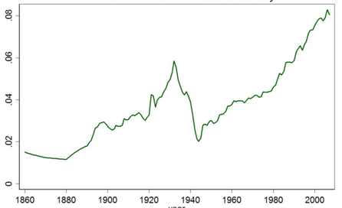
Figure 1. Share of the U.S. financial sector in GDP since 1860.
The event that precipitated the crisis was the overvaluation of the United States housing market in 2006 and the subsequent crash. Housing prices were driven upwards by easy credit and over speculation on the belief in the false truism that housing prices always go up. Low initial rates on adjustable rate mortgages (ARM) and low down payment requirements encouraged short-term speculation with the hopes of selling or refinancing at more favorable terms. After a prolonged period of rising home prices, 2006 saw home prices start to decline as interest rates rose creating a poor refinancing environment. A rapid increase in default activity followed as home prices failed to rise as expected and mortgagors were unable to refinance upon the expiration of the initial ‘teaser’ rates and their ARM reset to higher rates.
Easy credit was available in the United States in the years leading up to the crisis because significant inflows of foreign money allowed the Federal Reserve to keep rates low. Much of the influx of foreign money came from the booming Asian economies and oil producing nations. The low rates were exacerbated by modern financial instruments such as MBS and collateralized debt obligations (CDOs) that gave lenders extra incentive to make various types of loans available to consumers. As the risks associated with loan repayment (mortgages, credit cards, auto loans) were passed through to the investors in these instruments, it became easier for consumers to get loans and debt grew to unprecedented levels. The growth in the markets for these instruments also made it possible for investors all over the world to invest in, and therefore gain exposure to, the U.S. housing market.
Major financial institutions around the world suffered major losses when home prices dropped due to their investments in the subprime MBS market. The vicious cycle of foreclosure and falling house prices started when home values dropped below the value of the outstanding mortgage. The crisis spread to other parts of the economy as asset values and consumer and institutional wealth decreased causing defaults to mount on other types of loans. Global losses across all loan types have been estimated to be in the trillions of U.S. dollars.
At the same time that the housing bubble grew, the shadow banking system started to play a greater part in facilitating credit market liquidity within the U.S. economy. The shadow banking system consists of institutions like investment banks and hedge funds, which are not subject to the same regulations as depository institutions like commercial banks. Many of these institutions had high exposures to the MBS market and suffered large losses leading to unprecedented write downs. These losses were unable to be absorbed because of already high debt burdens. As losses mounted, the credit providing facilities of these institutions dried up inhibiting economic activity across the world. Governments stepped in with bailout funds directed at key financial institutions with hopes of restoring confidence and restarting the flow of credit.

2.1. Growth of the Housing Bubble
Home prices were pushed up by increased demand for housing. During the housing bubble, the growth of home prices outpaced income growth. Over the decade ending in 2006, the price of the typical American house increased 124%. At the peak of the bubble in 2006, the national median home price was 4.6 times the median household income. In 2004 it was 4.0 and over the entire twenty-year period prior to 2001 the ratio ranged from 2.9 to 3.1. This implies that new homebuyers increasingly took on larger loans relative to their incomes. Additionally, existing homeowners leveraged their increased paper wealth by taking out second mortgages or home equity loans (HEL) to finance home improvements and consumer spending.
From the other side, home prices were pulled upwards by a strong appetite from investors for exposure to the high yielding U.S. MBS and CDO markets over the low yielding U.S. treasuries. The flow of foreign money pouring into the U.S. increased from 2000 to 2007, outpacing the growth in supply of relatively safe assets to invest it in. Investment banks used AAA and other highly rated MBS and CDO securities to meet the demand. By 2003, the supply of securities backed by mortgages originated in the traditional way began to run out. Faced with high demand from investment banks and no intention of retaining the resulting loan on their own books, mortgage originators lent with increasingly less stringent standards as long as they could still be sold in the primary market.
The ultimate investors tended to overlook the drop in lending standards because of complexity of the origination, aggregation, and securitization process. CDOs and collateralized mortgage obligations (CMOs) act as conduits through which thousands of underlying mortgage loan payments are aggregated together into a pool and then paid out to a series of tranches by a well defined sequence of priority called a cash flow waterfall. The highest priority tranches garnered AAA or other investment grade ratings, while the lower priority tranches received lower ratings. Due to the sheer magnitude of the pools and the complexity of the waterfall pay down structures, investors relied heavily on the rating agencies’ assessments.
After the peak in 2006, housing prices in the U.S. declined over 20% by the end of 2008, as shown in Figure 2. With decreased asset values, homeowners with ARM were unable to refinance before their interest rates were due to step up. Foreclosures in 2007 increased 79% with approximately 1.3 million properties in some stage of the foreclosure process. This number rose to 2.3 million in 2008 with 9.2% of all mortgages in the U.S. in either delinquency or foreclosure. By the third quarter of 2009 this number rose to 14.4%.
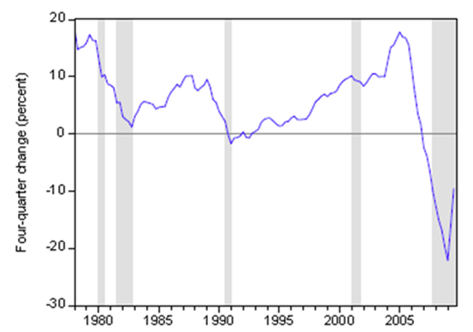
Figure 2. Percentage rate of change in house price, 1978Q1-2009Q3. Shaded areas refer to recession. Source: Bernanke (2010)

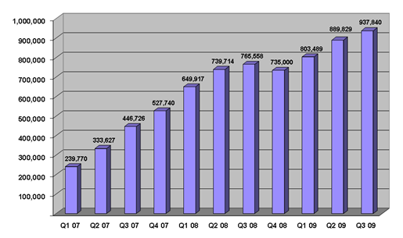
Figure 3. U.S. properties under foreclosure activity

2.2. Easy Credit Conditions
Low interest rates made credit more accessible, enabling American consumers to increase their borrowing. In 2000, the fed funds target rate was 6.5%. Coupled with the perceived risk of deflation, the dot-com bubble and the September 11th terrorist attacks drove the Fed to lower the fed funds rate to 1% by 2003. Ben Bernanke argued that further downward pressure on rates came with the large U.S. current account deficit. The trade deficit’s implicit strong international demand for U.S. financial assets drove up bond prices and therefore drove down yields.
Bernanke’s argument is based on the balance of payments relationship between the current account and the capital account. In order to finance the growing U.S. current account deficit, which increased by $650 billion from 1996 to 2004 or from 1.5% to 5.8% of GDP, the U.S. needed to borrow large amounts of money from abroad. Therefore large amounts of foreign money flowed into the U.S. to finance its imports. The two primary reasons why foreign countries were able to lend to the U.S. were high personal savings rates or high oil prices. American consumers used these borrowed funds to finance current consumption including housing. This inflow of capital increased demand for U.S. financial assets. Foreign government institutions tended to invest in U.S. Treasuries while financial institutions invested in the mortgage market. For these reasons Bernanke suggested that one driver of the crisis was a foreign “savings glut.”
Between mid-2004 and mid-2006, the fed funds target rate increased significantly causing ARM to have a higher interest rate reset and thereby increasing their monthly payments. These less manageable loans coupled with the inverse relationship between interest rates and asset prices made speculation in the housing market riskier.

2.3. Subprime Lending
Subprime loans are those deemed to have a greater risk of default than conventional loans. This can be due to a poorer credit rating of the borrower and different terms of the loan such as lower down payments. In March 2007, 7.5 million first-lien subprime mortgage loans were outstanding totaling $1.3 trillion. High risk subprime lending increased due to government policies and competition among financial institutions like investment banks and the Government Sponsored Enterprises (GSE) Fannie Mae and Freddie Mac.
In 2004, the subprime market grew to 20% of the overall U.S. housing market. At that time the Securities and Exchange Commission (SEC) relaxed its net capital rules thereby making it more attractive for investment banks to increase leverage and expand their MBS issuance. This thirst for MBS spurred more lending to riskier borrowers and spurred the GSEs to follow suit under competitive pressures. The evidence of the poorer loan screening is shown in the rise in subprime defaults, which rose to 25% in 2008 after remaining between 10-15% in the eight years prior to 2006.
Peter Wallison of the American Enterprise Institute has the crisis rooted directly in sub-prime lending by the GSEs. On 30 September 1999, The New York Times reported that the Clinton Administration pushed for sub-prime lending: “Fannie Mae, the nation's biggest underwriter of home mortgages, has been under increasing pressure from the Clinton Administration to expand mortgage loans among low and moderate income people. In moving, even tentatively, into this new area of lending, Fannie Mae is taking on significantly more risk, which may not pose any difficulties during flush economic times. But the government-subsidized corporation may run into trouble in an economic downturn, prompting a government rescue similar to that of the savings and loan industry in the 1980s.” Furthermore, the anti-redlining components of the 1977 Community Reinvestment act (CRA) were regulated and strengthened in 1995. A 2000 study by the U.S. Department of the Treasury found that $467 billion of mortgage credit went to low and middle-income neighborhoods from CRA-covered lenders between 1993 and 1998. This was still only a small portion of the increase in subprime lending as only 25% occurred at CRA-covered institutions.
Even the increase in subprime lending was unable to satisfy investor appetite. The shadow banking system was driven to replicate exposure to the MBS market using financial derivatives one hundred times over! The losses far exceeded the loans.

2.4. Predatory Lending
Predatory lending refers to the practice of unscrupulous lenders, to enter into “unsafe” or “unsound” secured loans for inappropriate purposes. One example is a bait-and-switch technique whereby low advertised interest rates were swapped for higher or adjustable interest terms. In some instances, negative amortization (Neg-Am) was created which acted to conceal the true terms from the borrower until a much later date.
Countrywide, a mortgage lender was charged in California with “Unfair Business Practices” and “False Advertising” by originating “to homeowners with weak credit, ARMs that allowed homeowners to make interest-only payments.”
Speculative mortgagees forego the equity building benefits of home ownership and rely solely on the home price appreciation component of their investment. When home prices decreased, there was little incentive not to default. With rising homeowner defaults, Countrywide ended up being acquired by Bank of America in early 2008.
Employees at mortgage lenders frequently describe an atmosphere whereby they were pushed to originate loans and sell them through to investors with commission incentives. With no intention of keeping loans on their own books, false documentation and fraud became more prevalent.

2.5. Insufficient Regulation and Deregulation
Many argue that regulation lagged behind changes in modern finance. Some areas where change outpaced regulation include the increased relevance of the shadow banking system, the standardization and regulation of new derivative contracts and creative accounting techniques, which took advantage of off-balance sheet financing. To compound matters, financial deregulation was commonplace.

2.5.1 The Gramm-Leach-Bliley Act
In November 1999, President Bill Clinton signed into Law the Gramm-Leach-Bliley Act, which repealed part of the Glass-Steagall Act of 1933. Some point to the Gramm-Leach-Bliley Act as an impetus for reduced separation between traditionally conservative commercial banks and the more risky investment banks.

2.5.2 The Garn-St. Germain Depository Institutions Act
In October 1982, President Ronald Reagan signed into Law the Garn-St. Germain Depository Institutions Act, which began the process of banking deregulation that helped contribute to the savings and loan crises of the late 80's/early 90's, and the subsequent financial crises of 2007-2010. President Reagan stated at the signing, “all in all, I think we hit the jackpot”.

2.5.3 The Net Capital Rule
In 2004, the Securities and Exchange Commission relaxed the net capital rule, which enabled investment banks to substantially increase the level of debt they were taking on, fueling the growth in mortgage-backed securities supporting subprime mortgages. The SEC has conceded that self-regulation of investment banks contributed to the crisis.

2.5.4 Growth of Structured Investment Vehicles (SIV)
The structured investment vehicle (SIV) was invented by Citigroup in the 1980s as a way of moving liabilities off the balance sheet thereby allowing for increased leverage. Confidence remained weak as it was reported that between $500 billion and $1 trillion of liabilities would have to be returned to the balance sheets of the four largest U.S. banks in 2009. Similar balance sheet manipulation techniques were used by Enron, precipitating its downfall in 2001.

2.5.5 The Commodity Futures Modernization Act of 2000
Passed in 2000, this act allowed markets for over-the-counter (OTC) derivatives to be self-regulating. Originally, derivatives were meant as tool to hedge out certain risks associated with investments. However they quickly grew to be speculative tools. Credit Default Swaps (CDS) allowed investors to gain exposure to a certain corporation without investing directly in its debt or equity. Volume in the CDS market grew 100-fold between 1998 and 2008. By late 2008 the total outstanding debt linked to CDS was around $40 trillion and the total outstanding value of the OTC derivative market hit $683 trillion in June 2008. Derivatives used in this manner allowed firms to take on excessive amounts of risk through high leverage ratios. Warren Buffet coined the term “financial weapons of mass destruction” in 2003 when referring to derivatives used as speculative tools.

2.5.6 Consumer and Institutional Over-leveraging
U.S. households and financial institutions became increasingly indebted or overleveraged during the years preceding the crisis. This increased their vulnerability to the collapse of the housing bubble and worsened the ensuing economic downturn. Key statistics include:
- Consumers taking advantage of rising home prices by tapping their growing equity in the form of home equity loans (HELs) that doubled from $627 billion in 2001 to $1,428 billion in 2005, a total of nearly $5 trillion dollars over the period. U.S. home mortgage debt relative to GDP increased from an average of 46% during the 1990s to 73% during 2008, reaching $10.5 trillion.
- U.S. household debt as a percentage of annual disposable personal income was 127% at the end of 2007, versus 77% in 1990.
- In 1981, U.S. private debt was 123% of GDP; by the third quarter of 2008, it increased to 290%.
- From 2003-07, the top five U.S. investment banks each significantly increased their financial leverage. These five institutions reported over $4.1 trillion in debt for fiscal year 2007, about 30% of U.S. nominal GDP for 2007. Lehman Brothers was liquidated, Bear Stearns and Merrill Lynch were sold with the help of Fed intervention, and Goldman Sachs and Morgan Stanley became commercial banks, thereby becoming subject to more regulations. All except Lehman were beneficiaries of government bailout programs. Figure 4 shows the leverage ratios of major investment banks. The leverage ratio, which is total debt divided by stockholders equity, is a measure of the risk taken by a firm. A higher ratio indicates more risk. 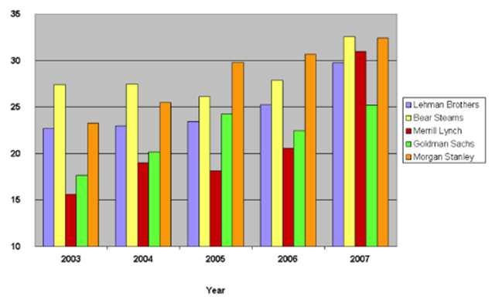 Figure 4. Leverage ratios of major U.S. investment banks
- GSEs owned or guaranteed nearly $5 trillion in mortgage obligations at the time they were placed into conservatorship by the U.S. government in September 2008.
These seven entities, the five investment banks and the two GSEs, were highly leveraged and had $9 trillion in debt or guarantee obligations--an enormous concentration of risk; yet they were not subject to the same regulations as depository banks.

2.5.7 Financial Innovation
Financial innovation, or financial engineering, describes the creation of more and more specialized investment instruments designed to meet specified risk exposure profiles or diverse funding instruments, which can aid in credit flow. Examples pertaining to the financial crisis are ARM (adjustable-rate mortgage), CDO (collateralized debt obligation), CDS (credit default swap), CMO (collateralized mortgage obligation) and MBS (mortgage-backed security). All of these instruments gained in popularity prior to the crisis and some can be very difficult to value when the market for trading them becomes illiquid. An even more extreme example is the “CDO-square” instrument. This is a CDO whose underlying reference entities are themselves other CDOs. Such complex instruments became commonplace leading up to the crisis.
Besides making credit more accessible and allowing for more specialized risk distribution, some financial innovation was designed strictly as a way to bypass regulations. An SIV is one such instrument, which allowed using accounting techniques to mask liabilities. Martin Wolf wrote in June 2009: “...an enormous part of what banks did in the early part of this decade – the off-balance-sheet vehicles, the derivatives and the 'shadow banking system' itself – was to find a way around regulation.”
New trading strategies developed to take advantage of these new instruments. CDOs are often divided into tranches of decreasing priority in the waterfall including senior, mezzanine and equity classes. Before the crisis, hedge funds began to set up correlation trading desks operating on the concept that if defaults across firms or industries were highly correlated then it didn’t matter which class of CDO you invested in, they would all suffer significant losses. One way of being “long correlation” involved buying the equity classes (lower rated and thus cheaper) and selling the mezzanine class (higher rated and thus more expensive).

2.6 Incorrect Risk Pricing
Pricing risk involves adding fees or higher interest rates to compensate an investor for taking on higher risk. There are several reasons why market participants failed to accurately price the risks embedded in their investments. One example is the structural risk that CDO investment introduced into the financial system. The average loss for senior CDO tranches was 68% while mezzanine tranches lost 95% on average. These massive losses left banks crippled with massive write-downs.
Another instance of incorrect risk pricing relates to CDS. A CDS contract has one party paying a periodic premium and a counterparty that pays a lump sum in the case of a credit event, such as the default of a pre-specified company. Bondholders used CDS as way of credit insurance. AIG was a major player in the CDS market. When defaults mounted, it was unable to meet its obligations as a default insurer and was taken over in 2008 by the U.S. government. $180 billion in government funds were needed to fulfill its obligations to its CDS counterparties, including many large financial institutions. The bailout of AIG was argued to have prevented many more failures through the fulfillment of its CDS obligations.
As financial assets became more and more complex, and harder and harder to value, investors were reassured by the fact that both the rating agencies and bank regulators, who came to rely on agencies, accepted as valid some complex mathematical models which theoretically showed the risks were much smaller than they actually proved to be in practice. George Soros commented, “The super-boom got out of hand when the new products became so complicated that the authorities could no longer calculate the risks and started relying on the risk management methods of the banks themselves. Similarly, the rating agencies relied on the information provided by the originators of synthetic products. It was a shocking abdication of responsibility.”

2.7 Collapse of the Shadow Banking System and the Trouble in the Credit Markets
In a June 2008 speech, President and CEO of the NY Federal Reserve Bank Timothy Geithner, who in 2009 became Secretary of the United States Treasury, placed significant blame for the freezing of credit markets on a “run” on the entities in the “parallel” banking system, also called the shadow banking system. These entities, investment banks and hedges funds in particular, became increasingly important as a source of credit in the economy, but were not subject to the same regulatory controls that applied to depository banks. Further, these entities were vulnerable because they borrowed short-term in liquid markets in order to fund purchases of long-term, illiquid and risky assets. This meant that disruptions in credit markets would make them subject to rapid deleveraging, selling their long-term assets at depressed prices. Geithner described that, “in early 2007, asset-backed commercial paper conduits, in structured investment vehicles, in auction-rate preferred securities, tender option bonds and variable rate demand notes, had a combined asset size of roughly $2.2 trillion. Assets financed overnight in triparty repo grew to $2.5 trillion. Assets held in hedge funds grew to roughly $1.8 trillion. The combined balance sheets of the then five major investment banks totaled $4 trillion. In comparison, the total assets of the top five bank holding companies in the United States at that point were just over $6 trillion, and total assets of the entire banking system were about $10 trillion.” He continued by saying that the “combined effect of these factors was a financial system vulnerable to self-reinforcing asset price and credit cycles.”
Paul Krugman put the collapse of the shadow banking system at the center of the crisis. “As the shadow banking system expanded to rival or even surpass conventional banking in importance, politicians and government officials should have realized that they were re-creating the kind of financial vulnerability that made the Great Depression possible—and they should have responded by extending regulations and the financial safety net to cover these new institutions. Influential figures should have proclaimed a simple rule: anything that does what a bank does, anything that has to be rescued in crises the way banks are, should be regulated like a bank.” This lack of regulation was deemed by Krugman to be “malign neglect.”
In September of 2008 there was a run on money market mutual funds. These funds typically invest in short term commercial paper, which is often used as a way for corporations to obtain working capital. Weekly withdrawals from these funds hit $144.5 billion, up from $7.1 billion the week before. Investors’ own fears for the safety of their money lead to corporations being unable to rollover their shot term debt.
The U.S. government responded by extending insurance for money market accounts analogous to bank deposit insurance via a temporary guarantee and with Federal Reserve programs to purchase commercial paper. The TED spread, an indicator of perceived credit risk in the general economy, spiked up in July 2007, remained volatile for a year, then spiked even higher in September 2008, reaching a record 4.65% on October 10, 2008, as shown in Figure 5.
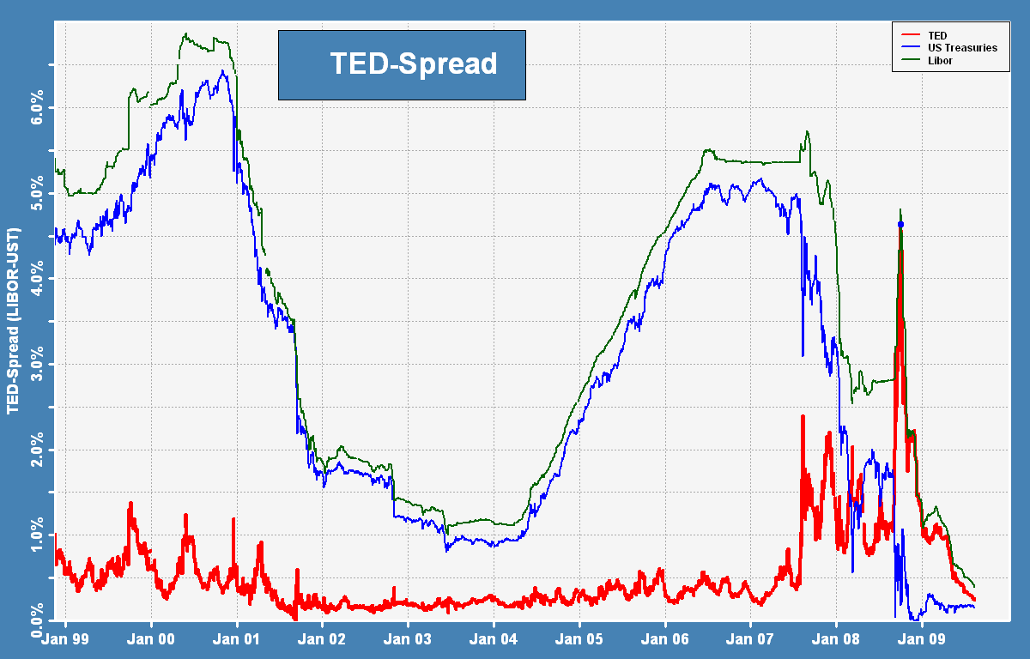
Figure 5. Long-term history of the TED spread
In a dramatic meeting on Thursday, September 18, 2008 then Treasury Secretary Henry Paulson and Fed Chairman Ben Bernanke proposed a $700 billion emergency bailout to key members of congress. Bernanke reportedly tells them: “If we don't do this, we may not have an economy on Monday.” The Emergency Economic Stabilization Act also called the Troubled Asset Relief Program (TARP) was signed into law on October 3, 2008.
Economist Paul Krugman and current U.S. Treasury Secretary Timothy Geithner explain the credit crisis in light of the implosion of the shadow banking system. Investment banks and other entities in the shadow banking system could not provide funds to mortgage firms and other corporations when their access to investor funds dried up.
This meant that nearly one-third of the U.S. lending mechanism was frozen or locked-up and continued to be into June 2009. According to the Brookings Institution, the traditional banking system does not have the capital to close this gap as of June 2009: “It would take a number of years of strong profits to generate sufficient capital to support that additional lending volume.” The authors also indicate that some forms of securitization are “likely to vanish forever, having been an artifact of excessively loose credit conditions.” While traditional banks have raised their lending standards, it was the collapse of the shadow banking system that is the primary cause of the reduction in funds available for borrowing.

2.8 The Commodity Bubble
Following the collapse of the housing bubble the global commodity market entered its own bubble. From early 2007 to mid-2008 oil prices skyrocketed from $50 to $140 a barrel then plunged to $30 by the end of 2008. The bubble has been attributed to the flight of capital from the housing market, pure speculation, increasing concern over the limited supply of natural resources and increased demand from growing, resource-hungry economies in Asia. With more money flowing to oil producing nations, economic growth in the rest of the world suffered under the increased cost burden.
Oil wasn’t the only commodity to undergo a boom followed by a bust. Other commodities also had very wide swings in prices, as shown in Table 1.
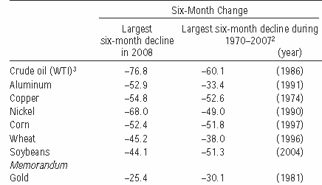
Table 1. The commodity bubble, Source: World Economic Outlook Crisis and Recovery
2.9 Capital Surplus and Manager’s Capitalism
Samir Amin, an Egyptian economist, gives an alternative view on the crisis that is rooted in a fundamental problem with western capitalism itself. Amin’s explanation centers on a growing capital surplus, which started in the 1970s as GDP growth rates in western economies, started to decrease. With fewer profitable outlets in the real economy, investors would place this surplus into the financial markets resulting in periodic booms and busts according to Amin. John Bellamy Foster of the Monthly Review attributes the slowing GDP growth since the 1970s to an increase in market saturation.
Another alternative view looks directly at the business culture that developed in American corporations. John C. Bogle looked in 2005 at the corporate managerial structure for answers: “Corporate America went astray largely because the power of managers went virtually unchecked by our gatekeepers for far too long. They failed to 'keep an eye on these geniuses' to whom they had entrusted the responsibility of the management of America's great corporations.” Some specific changes to corporate culture that he cited as fundamental to allowing the crisis to develop include:
- “Manager's capitalism” which he argues has replaced “owner's capitalism,” meaning management runs the firm for its benefit rather than for the shareholders, a variation on the principal-agent problem
- Escalation in executive compensation packages
- Increased importance placed on share price as a measure of good business
- The failure of gatekeepers, including auditors, boards of directors, Wall Street analysts, and career politicians.

2.9 Systemic Risk
Systemic risk covers the risk of an entire financial system or economy as opposed to the risk associated with a specific entity or sector of the economy. The systemic risk relevant to the crisis is overall financial system instability which is measured by the reliance of the system on specific key entities and can be compounded when certain key events occur. The idea of a firm being “too big to fail” refers specifically to the systemic risk posed by the exposure of the overall welfare of the economy to the success or failure of a specific firm. AIG’s large presence in the CDS bond insurance market exposed the entire system to the potential for massive failure as defaults mounted in the wake of the real estate bubble.

3. Impact on Major Financial Institutions
The International Monetary Fund (IMF) estimated that large U.S. and European banks lost more than $1 trillion from investments in toxic assets backed by bad loans between January 2007 and September 2009. These losses are expected to top $2.8 trillion from 2007-2010. U.S. banks’ losses were forecast to hit $1 trillion and European bank losses will reach $1.6 trillion. The IMF estimated that U.S. banks were about 60 percent through their losses, but British and Eurozone banks only 40 percent. A recession that is caused by the asset price bubble leaving many private-sector balance sheets with more liabilities than assets has been called the “balance sheet recession.”
One of the first victims was Northern Rock, a medium-sized British bank. It requested a bailout from the Bank of England. This in turn led to investor panic and runs on bank in mid-September 2007. Initially, calls for nationalization were ignored. In February 2008, however, the British government took the bank into public hands when no private buyer surfaced. Northern Rock's problems proved to be an early indication of the troubles that would soon befall other banks and financial institutions.
The first companies to be hit were those directly involved in the housing market like home construction firms and mortgage lenders who could no longer obtain financing through the frozen credit markets. Over 100 mortgage lenders went bankrupt during 2007 and 2008. The crisis peaked in September and October 2008. A number of major institutions failed, were acquired under duress, or were subject to government takeover. We discuss a few below.

3.1 Countrywide Financial
Countrywide issued about 17% of all mortgages in the United States in 2007. The California based company was founded in 1969 and its IPO was less than successful, trading over the counter at less than $1 per share. Between 1982 and 2003, Countrywide delivered investors a 23,000% return. Since its business was rooted in subprime mortgages, it faced collapse as a result of the financial crises, and was purchased by Bank of America in July 2008, and is now named Bank of America Home Loans.

3.2 Investment Banks: Bear Stearns, Lehman Brothers and Merrill Lynch
Three of the largest U.S. investment banks, Bear Stearns, Lehman Brothers and Merrill Lynch, were hit hard by the crisis and were either sold in emergency government backed acquisitions, or entered bankruptcy. Bear Stearns was on the brink of collapse in March 2008, when it was sold to JP Morgan Chase, with Federal government’s help. Lehman Brothers’ bankruptcy on September 15, 2008 marked one of the largest bankruptcies in U.S. history. It folded with record $613 billion debt. Barclays and Nomura Holdings bought up different parts of Lehman Brothers along regional lines. The world’s largest brokerage firm, Merrill Lynch, was acquired by Bank of America in 2008 under distressed circumstances.

3.3 Bank Holding Companies: Washington Mutual and Wachovia
The largest bank failure in U.S. history is the collapse of Washington Mutual on September 25, 2008. It was placed into the receivership of the Federal Deposit Insurance Corporation (FDIC). Subsequently, the FDIC sold the banking subsidiaries (minus unsecured debt or equity claims) to JPMorgan Chase for $1.9 billion, and the remaining part of Washington Mutual filed for bankruptcy
The fourth largest bank holding company in the U.S. based on total assets, Wachovia, was arranged by the government to have it sold to Wells Fargo to avoid its imminent failure on December 31, 2008.

3.4 The GSEs: Fannie and Freddie
The Federal National Mortgage Association (FNMA) and The Federal Home Loan Mortgage Corporation (FHLMC), commonly known as Fannie Mae, and Freddie Mac respectively underwent massive changes as a result of the crisis. They are stockholder-owned corporations chartered by Congress during the 60s and 70s. The corporations’ purposes are to purchase and securitize mortgages in order to ensure that funds are consistently available to the institutions that lend money to home buyers, to buy mortgages on the secondary market, pool them, and sell them as MBS on the open market to help facilitate American homeownership through accessible financing. The secondary mortgage market increases the supply of money available for mortgage lending and increases the money available for new home purchases. As of 2008, Fannie and Freddie owned or guaranteed about half of the U.S.'s $12 trillion mortgage market.
On September 7, 2008, the Federal Housing Finance Agency (FHFA) announced that Fannie Mae and Freddie Mac were placed into its conservatorship. The action is one of the most sweeping government interventions in private financial markets in decades. By reassuring the soundness of the GSEs, the conservatorship resulted in MBS values receiving upward support, lowering borrowing costs for banks and owners of Fannie and Freddie debt and the Asian central banks specifically were protected. The common share stock prices of Fannie Mae and Freddie Mac plummeted however, wiping out a great deal of financial wealth, as shown in Figure 6.
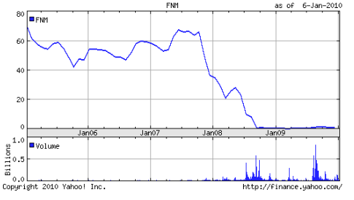
Figure 6. Fannie Mae's stock price

3.5 AIG
Once the 18th largest publicly traded company worldwide and part of the Dow Jones Industrial Average, AIG suffered from the credit crisis and ultimately required over $180 billion in government aid to avoid bankruptcy and its stock price dropped precipitously, as shown in Figure 7. In September 2008 AIG received their first credit line from the Fed in the amount $85 billion in an effort to help the corporation meet its increasing liabilities in the wake of its credit rating being downgraded to AA. In exchange, the Fed received a 79.9% equity stake in the firm.
In addition to direct assistance from the Fed and Treasury, the U.S. government also stepped in to purchase distressed assets owned or guaranteed by AIG. Even while selling off assets and subsidiaries, AIG managed to pay retention bonuses totaling over $160 million, drawing the ire of American public and Congress. Many employees even received hate mail and death threats.
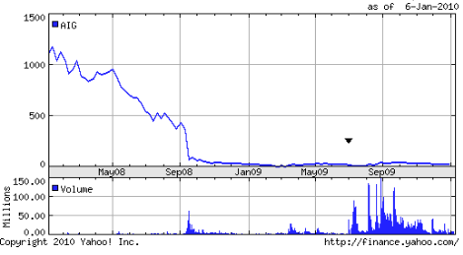
Figure 7. AIG's Stock Price

4. Impact on Financial Wealth in the U.S.
Some statistics regarding the decline in wealth during the crisis:
- From June 2007 to November 2008, the average American lost approximately 25% of their collective net worth.
- The S&P 500 index had lost 45% from the prior year’s highs.
- In November, home prices had fallen 20% from the high in late 2006 with a further 30% drop signaled in the futures market. See Figure 7.
- Total home equity was at $8.8 trillion in the middle of 2008. In 2006 it was at $13 trillion.
- Retirement assets declined 22% while pensions and other savings and investments declined by $1.3 and $1.2 trillion, respectively.
- U.S. home mortgage debt relative to GDP increased from an average of 46% during the 1990s to 73% during 2008, at $10.5 trillion.
All together, losses total a staggering $8.3 trillion. Since peaking in the second quarter of 2007, household wealth is down $14 trillion.
Further, consumption during the boom was fueled when homeowners tapped the increased equity in their homes. Cash used by consumers from home equity extraction doubled from $627 billion in 2001 to $1,428 billion in 2005, totaling nearly $5 trillion over the period. To counter this drop in spending, the U.S. government authorized $13.9 trillion to boost demand. The Fed has transitioned from being the “lender of last resort” to the “lender of only resort” to the “buyer of last resort” as economic activity stalled.

5. Impact on the Real Side of the U.S. Economy
Real gross domestic product decreased at an annual rate of approximately 6 percent in the fourth quarter of 2008 and first quarter of 2009 year-over-year (see Figure 8).
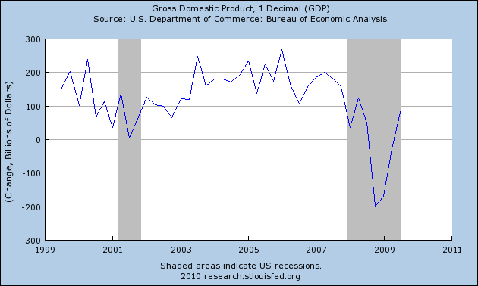
Figure 8. The U.S. GDP, Source: Federal Reserve Bank of St. Louis
The total U.S. civilian employment drastically reduced (see Figure 9) and the U.S. unemployment rate increased to 10.1% by October 2009 and has stayed at 10% for the duration of 2009 (see Figure 10). Additionally, those still employed have suffered decreased workloads as furloughs become more common, especially for state government employees. The average hours per workweek declined to 33, the lowest level since the government began collecting the data in 1964. 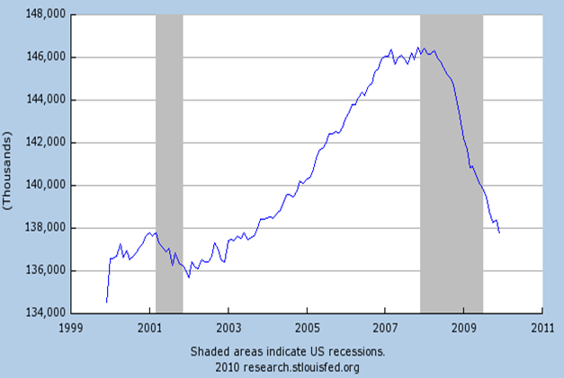
Figure 9. U.S. civilian employment. Source: Federal Reserve Bank of St. Louis
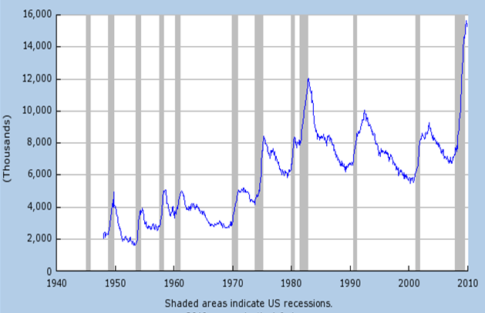
Figure 10. The U.S. unemployed number. Source: Federal Reserve Bank of St. Louis
The U.S. Federal Reserve Open Market Committee release in June 2009 stated: “...the pace of economic contraction is slowing. Conditions in financial markets have generally improved in recent months. Household spending has shown further signs of stabilizing but remains constrained by ongoing job losses, lower housing wealth, and tight credit. Businesses are cutting back on fixed investment and staffing but appear to be making progress in bringing inventory stocks into better alignment with sales. Although economic activity is likely to remain weak for a time, the Committee continues to anticipate that policy actions to stabilize financial markets and institutions, fiscal and monetary stimulus, and market forces will contribute to a gradual resumption of sustainable economic growth in a context of price stability.” Economic projections from the Federal Reserve and Reserve Bank Presidents include typical growth levels (GDP) and inflation of 2-3% and 1-2% respectively in 2010 and for unemployment to level off in 2009 and 2010 around 10% with moderation in 2011.

6. Impact on the Global Economy
On November 3, 2008, the EU-commission forecast a 2009 GDP growth rate of 0.1%, for the countries of the Euro zone (countries that have adopted the Euro) and even contraction for the UK, Ireland and Spain. On November 6, the IMF predicted a worldwide economic contraction of -0.3% for 2009, averaged over the developed economies. On the same day, the Bank of England (BOE) and the Central Bank for the Euro zone (ECB), reduced interest rates from 4.5% to 3% and from 3.75% to 3.25% respectively.
The crisis rapidly developed and spread into a global economic shock, resulting in a number of European bank failures, declines in various stock indexes, and large reductions in the market value of equities and commodities.
Both MBS and CDO were purchased by corporate and institutional investors globally. Derivatives, CDS for example, also increased the interdependence of large financial institutions through counterparty credit risk. Moreover, financial institutions were de-leveraged debt could not be rolled over in the illiquid credit markets and assets had to be sold. The liquidity crisis accelerated and caused a decrease in international trade.
Despite coordinated efforts to quell the crisis, by the end of October 2008 a currency crisis developed. As global capital fled to the safety of stronger currencies such as the yen, the dollar and the Swiss franc, many emerging market countries sought aid from the IMF.
The Brookings Institution reported in June 2009 that U.S. consumption accounted for more than a third of the growth in global consumption between 2000 and 2007. “The US economy has been spending too much and borrowing too much for years and the rest of the world depended on the U.S. consumer as a source of global demand.” With a recession in the U.S. and the increased savings rate of U.S. consumers, declines in growth elsewhere have been dramatic. Looking at some of the largest trading partners of the U.S., the first quarter of 2009 annualized rate of decline in GDP was 14.4% in Germany, 15.2% in Japan, 7.4% in the UK, 9.8% in the Euro area and 21.5% for Mexico.
The Arab world had lost $3 trillion by early 2009 due to the crisis and unemployment in this area is said to be a 'time bomb.' Much of the loss occurred in oil producing Middle-Eastern states and in May 2009, the United Nations reported a drop in foreign investment in Middle-Eastern economies due to a slower rise in demand for oil. In September 2009, Arab banks reported losses of nearly $4 billion since the crisis began.

6.1 Iceland
Iceland's 2007 gross domestic product was 1.293 trillion krónur (€8.5 billion). In 2008, all three of the country's major banks collapsed following their difficulties in refinancing their short-term debt and a run on deposits in the United Kingdom. At over 75% of its GDP, Iceland’s banking collapse is the largest suffered by any country in economic history relative to the size of its economy.
In late September 2008, it was announced that the Glitnir bank would be nationalized. Shortly thereafter, Landsbanki and Glitnir were handed over to receivers appointed by the Icelandic Financial Supervisory Authority (FME) followed immediately by Iceland's largest bank, Kaupthing. On October 6, Prime Minister Geir Haarde said, “There [was] a very real danger ... that the Icelandic economy, in the worst case, could be sucked with the banks into the whirlpool and the result could have been national bankruptcy.” Iceland's external debt was 9.553 trillion Icelandic krónur (€50 billion) in mid 2008, more than 80% of which was held by the banking sector. The assets of the three banks taken under the control of the FME totaled 14.437 trillion krónur at the end of the second quarter 2008, almost 10 times the GDP of the country.
The Icelandic financial crisis has been acute:
- The national currency has depreciated by a factor of two against the U.S. dollar and the Euro, with foreign currency transactions virtually suspended for weeks.
- The Icelandic stock exchange has dropped by more than 90%.
- GDP decreased by 5.5% in real terms in the first six months of 2009.
Outside Iceland, more than half a million depositors (far more than the entire population of Iceland) found their bank accounts frozen amid a diplomatic argument over deposit insurance. German bank BayernLB faces losses of up to €1.5 billion, and has had to seek help from the German federal government. The government of the Isle of Man will pay out half of its reserves, equivalent to 7.5% of the island's GDP, in deposit insurance.
On January 5, 2010, prompted by a petition from 60,000 Icelanders, President Olafur Grimsson rejected a bill that would guarantee for €3.9 billion ($5.5 billion) owed to the British and Dutch governments. In response, Britain’s City minister, Lord Myners, said that Iceland would face exclusion from the global financial system if it failed to meet its obligations. Finnish officials said a related $2.6 billion loan from Nordic countries might be delayed; the IMF said Iceland’s $10 billion loan program would be unaffected, so long as other lenders continued to finance it.

6.2 Ireland
The Irish economy was championed around the world in the years leading up to the crisis as the “Celtic Tiger,” a reference to the Asian Tigers of the Far East. Friendly corporate tax laws and the low interest rates, which came with being part of the euro zone, contributed to expanded credit availability and contributed to Ireland’s own property bubble. In September 2008, with the banks already over extended, the global crisis pushed Ireland into its first recession since the 1980s and the first among euro zone members in the financial crisis. In February 2009, amid a series of banking scandals and the civil unrest, Dublin’s ISEQ index dropped to a 14-year low and the director of the Anglo Irish bank resigned unexpectedly.
Unemployment claims in January 2009 hit 326,000, the highest in a single month on record.

6.3 Hungary
The financial crisis in Hungary was rooted in a large dependence on foreign capital coupled with a large public deficit, one of the biggest in the EU. In order to take advantage of lower interest rates, many Hungarians took out loans in Swiss Francs or Euros to finance home purchases or consumption. Amid the high debt burden, the forint underwent its own currency crisis and dropped 10% on October 10, 2008. The IMF and ECB stepped in with $20 billion in bailout funds later that month. The natural gas pipeline dispute between Ukraine and Russia during the winter of 2008 and high unemployment yielded civil unrest culminating with the resignation of Prime Minister Ferenc Gyurcsány in March 2009.
Hungary currently has implemented high interest rates and has cut many public programs in an effort to meet the standards required for Euro adoption and to avoid such a currency crisis in the future.

6.4 Latvia
After 2000, Latvia had one of the highest GDP growth rates in Europe with significant growth coming from the financial services sector. However, after years of robust economic growth, the Latvian economy dropped 10.5% year-over-year in the last quarter of 2008 and 18% during the first quarter of 2009. Amid the worst riots since the end of Soviet occupation, the Latvian government asked for IMF and ECB bailout funds totaling 7.5 billion Euros. Parex Bank, the country's second largest bank was nationalized, the country was downgraded to non-investment grade BB+, or “junk”, and on February 20, 2009, the Latvian coalition government headed by Prime Minister Ivars Godmanis collapsed.

6.5 Russia
The crisis in Russia was mainly related to the Russian financial markets, the extreme volatility of the price of oil and the political uncertainty caused by the war with the former Soviet republic of Georgia. A World Bank study concluded that despite strong macroeconomic fundamentals, the large role of oil in the economy and 70% drop in the price of oil made the crisis more acute than it otherwise would have been.
The Russian markets lost more than $1 trillion in market value in 2008, but the Micex index gained back more than 50% of its losses in 2009.
From July 2008-January 2009, Russia's foreign exchange reserves fell 35% as the central bank adopted a policy of gradual devaluation to slow down the sharp decline of the ruble. The ruble stabilized in early 2009 and reserves grew 17% to $452 billion by the end of 2009.
Russia emerged from recession in the third quarter of 2009 after two quarters of record negative growth. The Economic Ministry of Russia expects the economy to contract by 8.5% for 2009, and experts expect Russia's economy to grow modestly in 2010. The growth rate in 2010 was estimated to be 1.1% by the Russian Economic Ministry and 4.9% by the OECD.

6.6 Spain
The crisis in Spain was generated by long-term loans (commonly issued for 40 years), the building market crash and the worst unemployment in the Euro zone, which rose to 19.3% in December 2009.
Spain had a large trade deficit, which reached 10% of the Spanish GDP during the summer of 2008. Home price increased by 150% from 1998 to October 2007 then dropped 13.4% by November 2009.
During the third quarter of 2008, GDP contracted for the first time in 15 years.

6.7 Ukraine
The crisis in Ukraine was related to the drop in steel prices and problems with local financial institutions and was exacerbated by the gas dispute with Russia in January 2009. The World Bank predicted Ukraine's economy to shrink 15% in 2009 with inflation at 16.4%. The Ukrainian government however predicted GDP growth of 0.4% and a slowdown in inflation to 9.5% in 2009. The State Statistics Committee reports that actual year-on-year wages in Ukraine fell in October 2009 by 10.9% compared with a 4.8% increase in 2008. In November 2008 the IMF extended a $16.5 billion emergency loan to the Ukraine.

6.8 Dubai
Dubai, one of seven states that make up the United Arab Emirates (UAE), recently experienced a severe financial crisis in which a six-year construction boom has stalled. More than half of all the UAE's construction projects, totaling $582bn (£400bn), have either been put on hold or cancelled, including a $100bn tower project headed by Donald Trump. The root of Dubai’s trouble is its over-ambitious development plan that has included world famous infrastructures and tallest building on earth.
Dubai announced in November 2009 that it would ask creditors of Dubai World, the conglomerate behind its rapid expansion that built the world's tallest building, and Nakheel, the builder of its palm-shaped islands, to agree to freeze debt repayments for six months. Dubai World had a debt of $59 billion debt, and Dubai's total debt stood at $80 billion.
If creditors were to reject proposals to postpone debt repayments, the Dubai government could be forced to hold a fire sale of its real estate assets. In December 2009, Abu Dhabi, the wealthiest of the Emirates, extended Dubai $10 billion in funds to cover a portion debt to be restructured and helped Dubai avert further problems.

6.9 Greece
Greece has also experienced a severe financial crisis. In 2009, its Government’s deficit rose to 12.7 percent of GDP. As a member of the Eurozone, Greece must bring its public deficit to below three percent of GDP, the limit imposed by the Maastricht Treaty, by 2012.
The problems are twofold: First, a fiscal crisis with deficit and debt ratio reaching the unsustainable levels; and, second, the serious lack of competitiveness, with its much too high real exchange rate. Portugal, Spain and Italy are also in a similar situation. These countries’ membership of the Eurozone is a constraint to the solution to this common problem.
It has been argued that neither Greece nor any other country in a similar position could sensibly leave the Eurozone as this would immediately cause a banking crisis. Withdrawal from the Eurozone, apart from the immediate effects on wages, prices and interest rates, would place an unbearable burden on debtors whose debts are denominated in the Euro. This could set off seizure of Greek assets abroad and a cessation of European Union transfer payments to Greece. Moreover, potential defaults on public sector debt would hamper the ability to borrow from abroad. This would force cutting spending to match receipts. Default would also precipitate a banking crisis in Germany whose banks are loaded with these assets.
Many Greeks are hoping for a bailout by richer Eurozone members, as a default by Greece would have a severe contagion effect elsewhere. But this would nurture moral hazard.
Goodhart and Tsomocos (2010) suggested a dual currency approach for the current crisis in Greece. Any of Greece’s external transactions and domestic tax payments will be in Euros, but all domestic transactions will be in a new currency, say drachma. The drachma would be inconvertible into Euro or foreign currencies, and non-residents would not be allowed to borrow and use it. It is anticipated that the general level of wages and prices in terms of Euro will decline, allowing Greece to deflate its economy so that its competitiveness can be restored. The new currency must have a short stipulated life, say only a few years. This measure would impose a severe economic burden on its residents.

7. Emergency and Short-term Responses
The U.S. Federal Reserve and central banks around the world have taken steps to expand money supplies to avoid the risk of a deflationary spiral, in which lower wages and higher unemployment lead to a self-reinforcing decline in global consumption. In addition, governments have enacted large fiscal stimulus packages, by borrowing and spending to offset the reduction in private sector demand caused by the crisis. The U.S. executed two stimulus packages, totaling nearly $1 trillion during 2008 and 2009.
The credit freeze brought the global financial system to the brink of collapse. The response of the Fed, the ECB, and other central banks was immediate and dramatic. During the last quarter of 2008, central banks purchased US$2.5 trillion of government debt and troubled private assets from banks. This was the largest liquidity injection into the credit market, and the largest monetary policy action, in world history. The governments of European nations and the USA purchased $1.5 trillion in newly issued preferred stock from their major banks. Many key non-financial institutions have also been recipients of bail-out funds, incurring large financial obligations. To date, various U.S. government agencies have committed or spent trillions of dollars in loans, asset purchases, guarantees, and direct spending. For a summary of U.S. government financial commitments and investments related to the crisis, see CNN--Bailout Scorecard.
The Fed has used a very aggressive policy to expand credit, buying mortgage securities from the financial institutions in order to stimulate the economy. The short-term rate has hit the zero nominal lower bound, as Figure 12 shows. Having reached the limits of conventional monetary policy, the economy is in a liquidity trap.
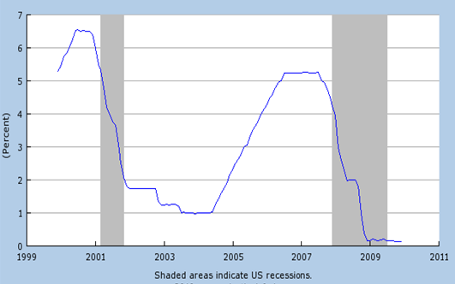
Figure 12. Federal funds rate. Source: Federal Reserve Bank of St. Louis
The yield on the 10-year 2% Treasury inflation-indexed note, due January 15, 2014, also shows a dramatic movement, as Figure 13 shows. It is a useful gauge on market expectations of the future inflation and economic activity.
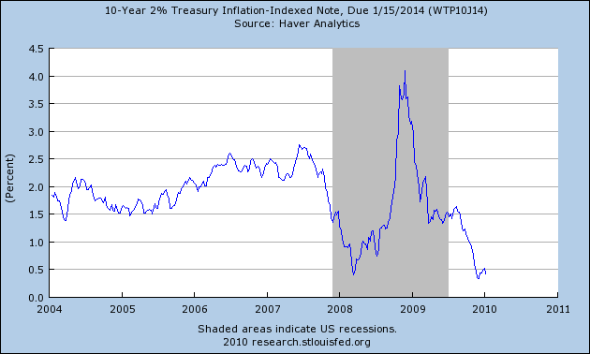
Figure 13. Yield on 10-year 2% Treasury inflation-indexed note, due 1/15/2014. Source: Federal Reserve Bank of St. Louis

8. Principles of Financial Reform and Regulatory Proposals
The recent financial crisis has brought some consensus on the changes that are needed in the global financial sector. As Lipsky (2010) pointed out, some of the needed reforms include:
- Strengthen risk management at many financial firms.
- Re-evaluation of compensation schemes.
- Bolster capital standards.
- Reform regulation and improve supervision.
- Remove impaired assets from financial institutions’ balance sheets.
The reform will have to be weighed against both preserving efficiency and restoring growth, both of which call for renewed credit flows. It is expected that reform of this nature will be politically difficult, as various interest groups will try to influence the direction and the outcome of the reform. There are, however, some key principles that must serve as guidelines for the reform. Specifically, Lipsky (2010) pointed out the following principles:
- The scope of regulation needs to be widened to cover all systemically important institutions.
- Macro-prudential elements need to be added to existing regulation that focuses almost exclusively on individual instruments and institutions.
- Regulatory standards on capital and liquidity must be strengthened to better reflect firm risk exposures and risk profiles. This will necessitate increased capital buffers and new limits on risk-taking.
- A robust resolution regime is required for large, complex financial institutions that operate in multiple jurisdictions.
The Financial Stability Board (FSB), established in 1999 by the Finance Ministers and Central Bank Governors of the Group of Seven (G-7), will take the leading role in coordinating the development of new global standards for regulation and supervision. These standards will then be adopted and implemented at the national level. The IMF will assume the role of monitoring the implementation of the agreed standards.
The G-20 leaders, in their September 2009 Pittsburgh Summit, asked the IMF to investigate how the financial sector could make a fair and substantial contribution to paying for the reform and implementation costs. Issue of cost sharing can be contentious and complex; for example, using a Tobin tax on financial transactions and directly taxing the financial institutions have been suggested.

Separately, Baily, et al. (2009) proposed a detailed set of bipartisan policy statement on the principles and recommendations of financial reform for the U.S. Their principles and recommendations are reproduced below:

8.1 Systemic Risk and Macro-Prudential Regulation
- A new Financial Services Oversight Council (FSOC) should oversee policy on systemic stability.
- That policy should be developed in consultation with the Fed.
- If signs of stress emerge, the FSOC should initiate action, based on consideration of specific responses recommended by the Fed.
- Once approved by the FSOC, interventions should be implemented by the relevant federal financial regulatory agencies.
- The Fed should retain observer status on specific examinations, and have the authority to collect any information directly from financial institutions and markets relevant to monitoring systemic risk that was not available from their primary supervisors.

8.2 Large Complex Financial Institutions
- The larger and more complex an institution, the higher the standards for capital, liquidity and leverage to which it should be held.
- Large institutions should maintain regulator-approved wind-up plans and, if they cannot, they should shrink.
- No institutions, however large or complex, should be “too big to fail.”
- Depository institution failures should continue to be handled by the FDIC.
- A hybrid solution should be adopted for non-depository financial institutions comprising a strengthened bankruptcy process as the default approach and a backstop administrative resolution process, available in exceptional circumstances after strong safeguards have been met.
- In all circumstances, shareholders in a failing institution should lose their investment, senior management responsible for the institutional failure should lose their jobs, and creditors should face a haircut.

8.3 Micro-prudential Regulation and Consolidation
- A new National Financial Regulator (NFR) for safety and soundness regulation should be created by combining the Office of the Comptroller of the Currency (OCC), the Office of Thrift Supervision (OTS) and the Federal Deposit Insurance Corporation (FDIC).
- It should take on all of the micro-prudential responsibilities of the Fed, the Securities and Exchange Commission (SEC), the Commodity Futures Trading Commission (CFTC) and the Federal Housing Finance Agency (FHFA).
- Within the NFR, the FDIC should retain distinct roles for resolution and the deposit insurance fund.
- Capital standards should be significantly increased.
- Banks should issue debt that converts to equity in times of stress.
- Strong liquidity standards should be introduced.
- Regulation should focus on risk governance and management as much as measurement.
- Examinations should be strengthened.

8.4 Strengthening Markets and Market Discipline
- OTC derivative transactions should be recorded with trade registries.
- Collateral in OTC transactions should be managed by third parties.
- The migration of OTC transactions onto clearing houses and exchanges should be encouraged through capital requirements assessed on OTC instruments that are not centrally cleared.
- A private Securitization Board should be created to establish best practices at every stage of securitization including credit ratings.
- Risks that arise from using inaccurate credit ratings in regulation should be addressed.
- Executive compensation should be aligned with risk in financial institutions.
- Banks should issue subordinated debt.
- Excessive subsidization of household mortgage risk should be addressed.
- The FHA and the GSEs should be reformed.

8.5 Consumer Protection
- A new federal Consumer Financial Protection Agency (CFPA) should be created with the sole mandate of protecting consumers of financial products and services.
- The CFPA should have powers of rulemaking, enforcement and preemption of state rules.
- All the powers for consumer protection for financial products and services currently assigned to federal financial regulatory agencies should transfer to the CFPA.
- The other federal financial regulatory agencies should be represented on the CFPA Board to ensure balanced deliberation and coordination of policy.
There are many other specific recommendations. In June 2009, the Obama administration introduced a series of regulatory proposals. These proposals address consumer protection, executive compensation, bank capital requirements, regulation of the shadow banking system and derivatives, and enhanced authority for the Federal Reserve, among others.
Economists, politicians, journalists, and business leaders have proposed various solutions to minimize the impact of the current crisis and prevent recurrence. For example, some drastic ones include Joseph Stiglitz’s proposal to re-instate the separation of commercial and investment banking established by the Glass-Steagall Act, and Simon Johnson’s proposal to break-up institutions that are “too big to fail” to limit systemic risk.

9. Latest Reform Proposals
In January, 2010, President Obama proposed Financial Crisis Responsibility Fee that would only apply to firms that received subsidies from the U.S. with $50 billion or more in consolidated assets. The tax would be calculated by taking the total assets and subtracting it from Tier 1 capital and insured deposits. The remaining amount would be subject to a 0.15% tax. It would raise an estimated $117 billion over 10 years or longer—the amount of TARP funds that likely won’t be repaid by some TARP recipients. TARP funds primarily were given to banks, but most of the program’s losses are expected to come from investments in insurance/financial products giant AIG, and automakers General Motors and Chrysler. Most banks that received TARP money have repaid it, with interest, to the government. Over sixty percent of revenues will most likely be paid by the 10 largest financial institutions. The reason that those banks that have repaid TARP funds would still be subject to the tax is based on the grounds that they had benefited from TARP funds, which were taxpayers’ money.
Two Chicago economists, Diamond and Kashyap, proposed to tax banks based on the difference between their assets at the end of August 2008 and their current level of capital. They argued that the support that these firms received was based on the size of assets before the crisis began, not the size of those assets today.
President Obama on January 21, 2010 proposed new rules designed to restrict the size and activities of the U.S.'s biggest banks. The proposal consists of two rules: the first, dubbed by Obama as the Volcker rule, would bar a bank or a financial institution that contains a bank from owning, investing in, or sponsoring a hedge fund or a private equity fund, or conducting proprietary trading operations unrelated to serving customers for its own profit, though they could continue to offer investment banking services to clients, such as underwriting securities, making markets and advising on mergers. This is at least a return to Glass-Steagall in spirit. Bank regulators would not be simply given the discretion to enforce such a rule. Rather, they would be required to do so. The second rule would limit the size of the bank. Since 1994, no bank can have more than 10% of the nation's insured deposits. The proposed rule would also include non-insured deposits and other assets.
The new proposed rules would reduce the role of banks to their more traditional intermediary functions and would help prevent the “too big to fail” problem. But critics argue that this will reduce the competitiveness of U.S. banks in the world markets.

10. Dodd–Frank Wall Street Reform and Consumer Protection Act
On July 21, 2010, President Barack Obama singed the Dodd–Frank Wall Street Reform and Consumer Protection Act, originally proposed on December 2, 2009, by the Chairman of the House Financial Services Committee Barney Frank and the Chairman of Senate Banking Committee Chris Dodd. This act is the upshot of financial reform called for in response to the financial crises of 2007-2010.
The Act changes the existing regulatory structure by creating a host of new agencies while merging and removing others to streamline the regulatory process, increasing oversight of specific institutions prone to systemic risk, amending the Federal Reserve Act, and promoting transparency, etc. It establishes rigorous standards and supervision to protect the consumers, investors and businesses, ends taxpayer funded bailouts of financial institutions, provides for an advanced warning system on the economic crisis, and sets rules on executive compensation and corporate governance.
Important new agencies created include Financial Stability Oversight Council, the Office of Financial Research, and the Bureau of Consumer Financial Protection. Of the existing agencies, changes are made that affects most of the regulatory agencies currently involved in monitoring the financial system (FDIC, SEC, Comptroller, the Fed, and the Securities Investor Protection Corporation (SIPC). The Act is a monumental document containing over two thousand pages of text. Here we summarize only some major reforms.

10.1 Financial Stability Oversight Council
The Financial Stability Oversight Council is charged to identify and address systemic risks posed by large, complex companies, products, and activities before they threaten the stability of the economy. It will make recommendations to regulators for increasingly stringent rules on firms that grow large and complex enough to pose a systemic risk to the U.S. economy. It is empowered to require nonbank financial companies that would pose a risk to the financial stability to be regulated by the Federal Reserve. Under this provision the next AIG would be regulated by the Federal Reserve. The Council will have the power to approve a Federal Reserve decision to require a large, complex company to divest some of its holdings if it poses a grave threat to the financial stability of the United States. The Council will create an Office of Financial Research within the Treasury with a staff of economists, accountants, lawyers, former supervisors, and other specialists to support the council's mission.

10.2 Improving Bank Supervision and Regulation
The Act will implement the Volcker Rule on banks, their affiliates and holding companies that prohibits proprietary trading, investment in and sponsorship of hedge funds and private equity funds, and to limit relationships with hedge funds and private equity funds. Nonbank financial institutions supervised by the Fed will also face restrictions on their proprietary trading and hedge fund and private equity investments.
The Act will also require large, complex companies to periodically submit plans for their rapid and orderly shutdown should they face the outcome. If they fail to submit acceptable plans, they will be hit with higher capital requirements and restrictions on growth and activity, as well as divestment. The Act authorizes the FDIC to create an orderly liquidation mechanism to unwind failing financial companies by removing their management teams and having their shareholders and unsecured creditors to bear the losses. The Act will charge the largest financial firms $50 billion for an upfront fund, built up over time, to be used if needed for any liquidation. Industry, not the taxpayers, will take a hit for such liquidation. The Act thus ends taxpayer funded bailouts of financial institutions.
The Act will streamline bank supervision with clear lines of responsibility:
1. The Fed will regulate bank and thrift holding companies with assets of over $50 billion.
2. The Office of the Comptroller of the Currency (OCC) will regulate national banks and federal thrifts of all sizes and their holding companies with assets below $50 billion. The Office of Thrift Savings is eliminated.
3. The dual banking system will be preserved, leaving in place the state banking system that governs most of community banks. The FDIC will regulate state banks and thrifts of all sizes and bank holding companies of state banks with assets below $50 billion.

10.3 Transparency and Accountability for Exotic Instruments
The Act will eliminate loopholes that allow risky and abusive practices to go on unnoticed and unregulated. Over-the-counter derivatives will be regulated by the SEC and the CFTC (Commodity Futures Trading Commission), traded on exchanges, and cleared through centralized clearing houses. Uncleared swaps will be subject to margin requirements, and swap dealers and major swap participants will be subject to capital requirements. All trades will be reported so as to enhance regulator's ability to monitor risks.

10.4 New Regulation on Hedge Funds
Hedge funds that manage over $100 million will have to register with the SEC as investment advisers and disclose information about their trades and portfolios. The data will be shared with the systemic risk regulator. The SEC will provide annual report to Congress on how it uses the data to protect investors and market integrity. Those not covered by the SEC will be regulated by individual states.

10.5 Office of National Insurance
The Act creates the Office of National Insurance housed in the Treasury Department to monitor the insurance industry and coordinate international insurance issues. It is charged to study ways to modernize insurance regulation and to provide Congress with reform recommendations.

10.6 Bureau of Consumer Financial Protection
The new independent Bureau of Consumer Financial Protection will protect American consumers from unfair, deceptive and abusive financial products and practices and will ensure people get the clear information they need on loans and other financial products from credit card companies, mortgage brokers, banks and others.
The Bureau will be headed by an independent director appointed by the President and confirmed by the Senate. It will have an independent budget paid by the Fed. The Bureau will have the power to write rules on consumer protection and have the authority to examine and enforce regulations for banks and credit unions with assets of over $10 billion and all mortgage-related businesses (lenders, servicers, and mortgage brokers) as well as large non-bank financial companies, such as large payday lenders, debt collectors, and consumer reporting agencies. Banks with assets of $10 billion or less will be examined by the appropriate bank regulator. The Act will create a new Office of Financial Literacy to educate consumers and a national consumer complaint hotline.
The Dodd-Frank Act is the most sweeping overhaul to financial regulation in the U.S. since the Great Depression. It represents a major shift in the American financial regulatory environment impacting all Federal financial regulatory agencies and affecting almost every aspect of the nation's financial services industry. Still some experts argued that the Act isn’t strong enough, and it does not limit the size of banks.

11. Reform of Global Capital Rules
Since 1988, global capital rules have been set by the Basel Committee on Banking Supervision, a club of regulators relying on national authorities to implement its standards. The 2004 Basel II Accord, an enhanced version of the original rules set in Basel I in 1988, has been adopted by most European banks. Basel II involves the valuation of risk-adjusted assets in order to arrive at the calculation of risk-adjusted capital, which is the difference between the risk-adjusted assets and liabilities. The rules say that Core Tier 1 capital—which consists of common stock and disclosed reserves (or retained earnings) must be at least 2% of a bank’s risk-adjusted assets. Tier 1 capital, which is core tier 1 plus non-redeemable non-cumulative preferred stocks, must be at least 4% of a bank’s risk-adjusted assets. Generally speaking, the rules ensure that the greater the risk to which a bank is exposed, the greater the amount of capital is needed to safeguard its solvency.
But the valuation of assets is difficult because there are so many categories of assets, and in times of emergency, the market prices for some categories may not even exist. Basel II did not prevent the recent financial meltdown. To prevent the recurrence of the recent financial crisis, the Basel Committee on September 12, 2010 reached a new agreement, dubbed Basel III, with the following new rules:
1. Core tier 1 capital to rise from a current 2%, to 3.5% in 2013, to a final minimum of 4.5% in 2015.
2. Tier 1 capital to rise from 4 to 6%.
3. Additional conservation buffer of 2.5%, on top of the 6% tier 1. If capital ratio falls below the buffer line, banks will face supervisory restrictions, for example, on dividends payout. The buffer should consist of common equity, to be phased in from 2016 to 2019.
4. A countercyclical capital buffer will consist of 0-2.5% of loss-absorbing capital. Negotiators left to the discretion of national regulators on how and whether to implement the countercyclical capital buffer that seeks to impose extra requirements on banks during boom times so as to accumulate plenty of reserves if the economy falters.
5. A leverage ratio is introduced that binds the total size of a balance sheet not exceeding 33 times tier 1 assets.
Some have criticized that the timescale for introduction is relatively long, and this could undermine the whole exercise. Some have expressed concern about whether the rules will stick, since some good aspects of Basel II were not implemented under an excess of discretion. Some have argued that banks will in the future provide less credit than they did in the past under the high effective capital ratio of near 10% (Tier one of 6%, conservation buffer of 2.5% plus countercyclical buffer of up to 2.5%). The stricter the rule, the lower will be the bank’s profits, and the consequent reduced growth and investment in the economy.
The Basel III accord was officially approved by the Group of 20 in its November 2010 meeting in South Korea.

E-mail: ecowwc@buffalo.edu; Tel: 1-716-645-8671; Fax: 1-716-645-2127. Web Link: http://www.economics.buffalo.edu/people/faculty/chang/. I am grateful to Patrick Baude for his assistance in the preparation of this paper and to James O’Day for his helpful comments.
For an extensive discussion of the current financial crisis, see Wikipedia’s Financial Crisis of 2007–2010.
Baily, Martin and Douglas Elliott (2009), “The US Financial and Economic Crisis: Where Does It Stand and Where Do We Go From Here?” Brookings Institution.
Roubini, Nouriel (2009), “Ten Risks To Global Growth,” Forbes.com
IMF (2009), World Economic Outlook.
“Why Economists Failed to Predict the Financial Crisis,” Knowledge@Wharton.
Krugman, Paul (2009), “Revenge of the Glut,” The New York Times, March 1.
CDOs Explained, Fortune Magazine.
Bernanke, Ben S. (2010), “Monetary Policy and the Housing Bubble”, paper presented at the Annual Meeting of the American Economic Association, Atlanta, Georgia, January 3.
Bernanke, Ben S. (2005), “The Global Saving Glut and U.S. Current Account Deficit,” Federalreserve.gov.
Altman, Roger C. “Altman-Foreign Affairs-The Great Crash of 2008,” Foreignaffairs.org.
The Community Reinvestment Act after Financial Modernization, April 2000.
CDS was invented in 1997 by Blythe Masters, Cambridge University mathematics graduate, during her mid-twenties when her employer JP Morgan was looking for a way to loan five billion dollars in oil-spill damage money to Exxon without tying up cash that could be chasing new loans. She came up with the idea of selling off all the risk of the loan to the European Bank of Reconstruction and Development. CDS is a primary cause that brought down Bear Stearns, AIG, WaMu and other mammoth corporations such as Enron.
Wolf, Martin (2009), “Reform of Regulation Has to Start by Altering Incentives,” June 23.
Soros, George (2008), “The Worst Market Crisis in 60 Years.” Financial Times (London, UK), March 8.
The TED spread is now calculated as the difference between the three-month London Interbank Offered Rate (LIBOR) and the three-month U.S. T-bill interest rate. TED is an acronym formed from T-Bill and ED, the ticker symbol for the Eurodollar futures contract.
More on systemic risk see http://en.wikipedia.org/wiki/Systemic risk.
See Koo, Richard, C. (2009), “The Age of Balance Sheet Recessions: What Post-2008 U.S., Europe and China Can Learn from Japan 1990-2005,” Nomura Research Institute, Tokyo, March.
Altman, Roger (2009), “The Great Crash, 2008,”, Foreign Affairs
See http://www.marketwatch.com/story/lehman-folds-with-record-613-billion-debt?siteid=rss.
See http://en.wikipedia.org/wiki/Lehman_Brothers.
For more detail about the AIG rescue, see http://en.wikipedia.org/wiki/AIG.
Fackler, Martin (2008), “Financial Crisis Spreads to Emerging Nations,” The New York Times.
“Icelandic Finance: Is It a Blizzard?” The Economist, Jan. 7, 2010.
See Shostak, Frank (2009), What's Behind the Dubai's Financial Crisis? November 30.
Goodhart, Charles and Dimitrios Tsomocos (2010), “The Californian solution for the Club Med,” Financial Times, January 24.
Lipsky, John (2010), “Don’t Forget Financial Sector Reform,” IMFdirect, January 7.
Baily, Martin, et al. (2009), “Principles on Financial Reform: A Bipartisan Policy Statement,” a Task Force Report, the Pew Charitable Trusts, December.
For further information, see Regulatory responses to the subprime crisis and Subprime mortgage crisis solutions debate.
Stiglitz, Joseph (2009), “Capitalist Fools,” Vanity Fair.
Johnson, Simon (2009), “Too Big to Fail or Too Big to Save? Examining the Systemic Threats of Large Financial Institutions,” Testimony submitted to the Joint Economic Committee, U.S. Congress, April 21.
The White House Press Release, January 14, 2010.
Diamond, Douglas D. and Anil K. Kashyap (2010), “Return Our Investment,” New York Time Op-Ed, January 19.
Weisman, Jonathan and Henry J. Pulizzi (2010), “Obama Moves to Restrict Big Banks,” The Wall Street Journal, January 21.
Paul Volcker was the Chairman of the Federal Reserve under Presidents Carter and Reagan (from August 1979 to August 1987). He is currently chairman of the newly formed Economic Recovery Advisory Board under President Obama.
The White House Press Release, January 21, 2010.
For details, see http://docs.house.gov/rules/finserv/111_hr4173_finsrvcr.pdf.
The Basel Committee is named after the city of Basel, Switzerland. Its British spelling “Basle” is less frequently used. Its members come from Argentina, Australia, Belgium, Brazil, Canada, China, France, Germany, Hong Kong SAR, India, Indonesia, Italy, Japan, Korea, Luxembourg, Mexico, the Netherlands, Russia, Saudi Arabia, Singapore, South Africa, Spain, Sweden, Switzerland, Turkey, the United Kingdom and the United States.
See BIS’s press release (2010), Group of Governors and Heads of Supervision Announces Higher Global Minimum Capital Standards, September 12.
For a detailed analysis of Basel’s rules and critiques, see Blundell-Wignall, Adrian and Paul Atkinson (2010), “Thinking beyond Basel III: Necessary Solutions for Capital and Liquidity,” OECD Journal: Financial Market Trends, Issue 1, 1-23.

