Stock Market Reaction to Good and Bad Political News
Muhammad Tahir Suleman
Department of Finance and Statistics
Hanken - Swedish School of Economics and Business Administration
PB. 287(Handelsesplanaden 2),Vaasa, Finland
Email:tahir_suleman@hotmail.com, Tel: +358-46-5964-698

Abstract
Research on political risk tends to elucidate that political news affects ﬁnancial markets. Especially stock markets respond to new information regarding political decisions that may affect domestic and foreign policy. In this study, we examined the effect of good and bad political news on returns and volatility for the KSE100 index and eight sector indexes. We employ the EGARCH model proposed by Engle and Victor (1991) as it allows good and bad news to have a different impact on volatility. Our results show that good news has positive impact on the returns of the KSE100 index and also decreased the volatility. On the other hand, bad political news has negative influence on the returns (decrease the returns) and increase the volatility (positive effect), which is in the line of Engle and Victor (1991) results specifying that bad and good news have different impacts on volatility. Furthermore our results also confirm that bad news has stronger effect (almost double) on the volatility than good news. Such results are consistent with Laakkonen and Lanne (2008). Most of the sectors are also affected by the good and bad news in the same way as KSE100 index. We also find that the results of a few sectors (oil and gas, financial, health care) are not statistically significantly in respond to good and bad political news, indicating that this type of news does not affect the returns or volatility. Our results show that the sectors which respond more towards good news (volatility decreases more than that of other sectors such as basic material and industries) has lower beta, suggesting variance moves quickly through the time.
Keywords: Political risk, Bad and good news, EGARCH, Asymmetry, Karachi Stock Exchange.

Introduction

Over the past decades, researchers have identified numerous factors that can affect stock exchange returns such as economic and political factors. Political risk is the most important especially in developing countries and emerging markets. Political stability system defines political risk as a probability of political events occurring that will change the prospects for profitability of a given investment. Brews (1981) explain political risk as an assortment of risks associated from doing business abroad. Clark (1997) refers it as stochastic element as well as the timing of the political events that cause losses. Clark and Tunaru (2003) explain political risk as the expected arrival rate of political events. Clark and Tunaru (2005) defines political events with significant negative economic and financial consequences that are felt everywhere as beside to political events whose economic and financial outcomes are limited to specific country or region. This means that political risk can arise from a large number of sources, which are often mutually dependent. Authors like Root (1973) and Simon (1982) consider political risk as an event that causes loss.
Research on political risk focus that political news affect ﬁnancial markets. Especially stock markets respond more to new information regarding political decisions that may affect domestic and foreign policy Large amount of literature has linked political uncertainty with excess volatility in stock markets. In the literature we have different point of views regarding the definition of political events. Researchers such as Robock (1971) and Kobrin (1979) or freshly Feils and Sabac (2000), concentrated on political risk as it changes the investment’s overall profitability in both ways. Cutler et al. (1989) and Bittlingmayer (1988) Chan and Wei (1996), Kim and Mei (2001), consider political risk with respect to stock market volatility. Other papers, such as Erb et al. (1995 and 1996), Cosset and Suret (1995), Bekaert (1995), and Bekaert and Harvey (1997) focus on losses and test political risk with respect to stock market performance. Niederhoffer (1971) studies the reaction of the stock market to world events. In his study, Niederhoffer relates world events to subsequent movements in the S&P 500. World events are chosen from the New York Times based on the magnitude of their headlines. Niederhoffer finds that world events exert a discernible influence on the movement of the S&P 500. More specifically, returns following world events tend to be larger in absolute value than returns on other days.
The purpose of this paper is to examine the impact of political uncertainty on stock exchange. This paper analysis the consequences of political news on the stock market returns and volatility. For this purpose we split the political news into two categories (good and bad news). We use the daily data from Karachi Stock Exchange to observe the affect of political news on the stock market. Furthermore, we examine the returns of different sectors to examine either they are also affected by the political news or not. Additionally this also helps us to identify which sector responds more to the political news. We used univariate asymmetric GARCH model, to gauge the impact of political news on the returns and volatility. We specifically used EGARCH as it allows good news and bad news to have different impact on volatility while standard GARCH model does not (Engle and Victor 1991).
Our results shows, that the good news has positive impact on the returns of the KSE100 index and good news also decreased the volatility. On the other hand, bad political news has negative impact on the returns (decrease the returns) and increase the volatility (positive effect). Furthermore our results also confirm that bad news has more affect (almost double) on the volatility than the good news, such results are consistent with Laakkonen and Lanne (2008). Most of the sectors are also affected by the good and bad news in the same way as KSE100 index. We also found that a few sectors (oil and gas, financial, health care) are not statistical significant for good and bad political news, means these type of news do not affect the returns or volatility. We also reported the volatility asymmetry, which is negative in most of the sectors including the KSE 100 which is due to the leverage effect. However the asymmetry for Auto and Parts is positive showing that there is no leverage effect in this. Furthermore, persistence parameter beta is also reported, which is very large in most of the selected sectors including KSE 100 which indicate that variance move slowly through time. Our results divulged that the sectors which response more towards good news (volatility decrease more than other such as basic material and industries) has lower beta, means variance move quickly through the time.
The organization of this study is as follows. Section 2 summarises the literature on event study and the effect of political news on the stock exchange. In Section 3 we discuss the political situation in Pakistan and the history and performance of the Karachi Stock Exchange. Section 4 presents the formulation of hypotheses and EGARCH modelling of ﬁnancial returns and volatility. Section 5 describes the data. Empirical findings are discussed in Section 6. Section 7 discusses empirical results. Further research areas and the conclusion are presented in Section 8.

Methodology

In the empirical framework, we first analyze the series to check whether the series are stationary or non-stationary (random walk) with unit root. The behavior of a time series naturally revolve around the assumption of stationarity, that is, I(0) and the degree of integration I(d). In econometric literature, volatility clustering is modelled as an ARCH process. Robert Engle (1982) in his seminal work on inflation in the UK first introduced the idea of ARCH effect. Later on, Bollerslev (1986) generalized this type of model and introduced the GARCH model. However in this study our main focus is on exponential GARCH model. As the EGARCH is a model allows good news and bad news to have a different impact on volatility (Engle and Victor 1993). Before we discuss about ARCH, GARCH and EGARCH models we need to form a mean equation and variance equations for the models need to be estimated. Then the equation for the political risk is modelled in the EGARCH model. However, first of all we have to determine the characteristics of the series (stationary or non-stationary). The most commonly test used to determine the I (1) against I (0) is the Augmented Dickey- Fuller (ADF) test.

Augmented Dickey- Fuller (ADF) Test

The Augmented Dickey-Fuller (ADF) test is most common test for the order of integration. This test assumes that, the null that the data series is a random walk or an integrated AR model. We assume that is a random walk process,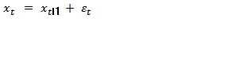. The regression model develop as , where We subtract from both side of the equation to obtain a testable form of dickey and fuller test, which is given below
(1)
where (includes constant and a trend) and are the parameters which are estimated through ordinary least square (OLS) and is assumed as innovation. The null hypothesis is and therefore,, of unit root which is tested against alternative of and , that is is a level or trend stationary series. The expansion of the equation (1) to ADF- test is written as, assuming that is a AR (p) process, then subtracting from both sides and adding lagged differences terms of on right side of equation (1),
, (2)
where, null and alternative hypothesis described the same nature of series as under equation (1) the hypotheses are shown as follow, and for the alternative is.

Phillips-Perron (PP) Test

Phillips and Perron (1988), (PP) incorporates an alternative nonparametric method of controlling for serial correlation when testing for a unit root by estimating the non-augmented Dickey-Fuller test equation and modifying the test statistic so that its asymptotic distribution is unaffected by serial correlation. The PP regression is same as non-augmented DF test equation.
, (3)

where, . The null and alternative hypothesis is the same as in DF and ADF tests so, as the acceptance criteria for test statistics against critical region at some appropriate level of significance. The test statistics is however modified as under,

, (4)

where is an estimate, and the test statistics of, is coefficient standard error, and s is the standard error of the test regression. In addition, is a consistent estimate of the error variance in equation (4). The remaining term,, is an estimator of the residual spectrum at frequency zero, which under stationarity must have met the property of .

The Mean Equation

In order to model a variance equation, specifications for the mean equation need to be made. By estimating a mean equation, residuals needed to model the variance equation are retrieved. In this study returns are described by the following process:

, (5)
where is a constant, and are the parameters, is the return at time t and is the error term at time t. Equation (5) is an ARMA (p,q) model which explains returns as being dependent on previous values of returns and shocks. In order to select the order of an ARMA model for each index and determine which values of p and q describe the time series the best, different combinations of ARMA (p,q) models is being estimated. Estimation is done by using OLS regression (Ordinary Least Squares). The estimated variations of ARMA models are then compared to each other by observing values of some chosen information criterion. Since the Schwarz information criterion seemed to give consistent results, model selection was done by minimizing this information criterion.

The GARCH Model

The GARCH model was developed by Bollerslev (1986). The model is a generalized form of ARCH (developed by Engle in 1982). An ARCH model explains variance as being dependent on previous values of squared shocks. The ARCH model can break its non-negative constraints and requires a large number of lags to be included in order to catch most of the variations in the variance. The GARCH was discovered to be a better fit as it dealt well with non-negativity constraints and needed less number of lags to be included in the model. Furthermore, GARCH models differ from ARCH as it allows the conditional variance to be modelled by past values of itself in addition to the past shock. The GARCH model includes an ARCH component and also an element where the variance today can be explained by previous variances. The general GARCH (q, p) model is defined as:

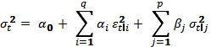, (6)

where p is the order of the GARCH terms and q is the order of the ARCH term. is the conditional variance at time t,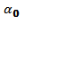 is the constant, and are the parameters, is previous squared shocks and is previous variances. In most of the studies GARCH (1, 1) is being employed. Brooks (2008) states that a GARCH (1, 1) in most cases sufficient to capture the volatility clustering and that higher order is seldom applied in finance. The possibility of negative variances is very rare; restrictions have to be specified for the parameters. The GARCH models effectively capture a number of characteristics of financial time series, such as volatility clustering and thick tailed returns. The model is stationary when the sum of alpha and beta are less than one (). If then process is still stationary since the variance is infinite. The GARCH models are in this study estimated according to maximum likelihood. The error term is assumed to be approximately normally distributed with an average mean of zero and time-varying variance (ε_{t} ~ N (o,)).

Asymmetric GARCH Models

Even though GARCH performs well at describing volatility, its underlying assumption about the behavior of the squared residuals is problematic. The model expects that the same magnitude of positive and negative shocks have the same effects on variance. This is seen in the model by squaring the previous values of shocks. By doing this the sign of the shocks is lost. To solve this problem, asymmetric, non-linear models were introduced. In this study our focus lies only on EGARCH model.

The EGARCH Model

Nelson (1991) introduce the Exponential GARCH which is more useful as compared to GARCH because it allows good news and bad news to have a different impact on volatility and it also allows big news to have greater impact on volatility. This model work in two steps, firstly it considers the means and secondly the variance. One way to define the EGARCH (p, q) model is:

 , (7)

where are parameters for conditional variance estimation. indicate the impact of the last period measures on the conditional variance. If the is positive that means a positive change in stock prices is associated with further positive change and vise versa. is a coefficient which measure the effect of previous period in the information set and explain the past standardized residuals influence on the current volatility. Furthermore, signify the asymmetry effect the in the variance, a negative means that bad news has higher impact on volatility than the good one with the same magnitude. Since EGARCH models the logarithmic time-varying conditional variance, the parameters are allowed to be negative. This means that the model does not require any non-negativity constraints in the parameters. The lack of non-negative restrictions makes the model more attractive than a GARCH and GJR. There is however a necessary constraint regarding the stationarity of the model that needs to be specified. The stationary restriction for an EGARCH (1, 1) model is that the beta is less than one (β < 1). In the case of symmetry, where the magnitudes of positive and negative shocks have equal impact on the variance, γ will be equal to zero. If γ < 0 the magnitude of a negative (positive) shock will cause the variance to rise (fall). If, on the other hand, γ > 0 positive (negative) shocks will cause the variance to rise (fall).

Political Risk and Security Returns with EGARCH

After having measured the univariate return and volatility linkages, we further our analysis by measuring the effect of good news and bad news announcement for the KSE 100 index and other selected sector indexes. We measure the return and volatility response to good and bad political news by adding a dummy variable in our univariate EGARCH model that take the value 1 on news days, else zero. It is important to note that we measure separately the response of each news category, i.e., our model is estimated independently for each news category. More specifically, the univariate EGARCH model with a dummy variable for stock market indexes is defined as follows:
(8)
 (9)
Where

And, 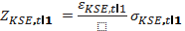
Equation (13) is the return equation and (14) represent the volatility equation.

Data and Descriptive Statistics

The data used in this study was collected from the Karachi stock exchange and Thomson DataStream. It consists of the KSE-100 index and the eight sector indexes those are, oil and gas, financial, basic material, Utilities, food and beverages, Industry, health care and Auto and parts. The data consists of daily closing prices, stated in local currency (rupee). For KSE-100 index data ranges from January 2, 1992 to March 30, 2010 consists of 4686 observations. While, for all the sectors the data range is from July 17, 1992 to March 19, 2010 consist of 4162 observations. The software used in the study is E-views. The daily return series was generated as follow,
 , (10)
where R_{KSE,t} is the return on KSE and KSE_{t} represents the closing value of KSE indexes on the day t. It is important to mention here that the series is adjusted neither for dividends nor for risk free rate. We can ignore the dividends and interest rates as it does not create any significant error when we forecast stock market volatility (Nelson 1991). Descriptive statistics and the interpretation of it is an important part to understand the variance, standard deviation, skewness and kurtosis are all measures of the dispersion. The variance is a measure of how much the variable deviates from its mean value. Skewness is a measure of the symmetry of the probability distribution curve. Zero skewness means a curve is symmetrical around its mean. The kurtosis describes the peak of the distribution curve. The normal distribution has a zero skewness and kurtosis equal to three. (Watsham and Parramore, 1997: 49-63) Summary statistics for our returns series of KSE-100 index, and other sectors are as given in equation (15) are shown on the next page in table 2.
Table 2 shows that the mean value of the KSE100’s return is 0.000384 and the median 0.00000. The standard deviation is about 1.62%. This is a quite high value, with respect to the mean return, indicating that the returns often deviate from the mean. The skewness in this case is nearly -0.32 which indicates a negative skewness indicating that the curve is more concentrated on the left hand side. Indices usually have a weak negative skewness since the stock prices in the long range tend to increase with time. The kurtosis is around 8.62, which is way too high means the curve has a high peak. There is, thus, excess kurtosis in the index meaning that the distributions are leptokurtic. As said earlier, a standard normal distribution should have a skewness of zero and a kurtosis of three. Based on these values we conclude that the data does not follow a normal distribution.
One way to confirm whether the data follows a normal distribution is to look at the Jarque-Bera. In this case, with respect to table 2, the JB is 6243.621 with a p-value of 0, and hence the H₀- hypothesis is rejected which means that the data is not normally distributed. According to the central limit theorem the lack of the normal distribution should not cause any problems here since the theorem states that the OLS regression is approximately normally distributed for large samples. (Luetkepohl, Kraetzig and Phillips, 2004: 45-46). Table 2 shows details of the descriptive statistics of the selected sectors such as financials, industry, utilities etc . All mean returns are positive except of the industries.The skewness of the series indicate that more than half of the series has a negative skewness. Moreover, we also reported the Autocorrelation coefficients for simple and squared returns at first lag in table 2.
Table 2
Descriptive Statistics
 | KSE100 | Oil & Gas | Financial |  | Basic Material | Utilities | Food & Beverage | Industries | Health Care | Auto & Parts
Mean | 0.000384 | 0.000710 | 0.000537 |  | 0.000543 | 0.000125 | 0.000249 | - 8.21E-05 | 0.00037 | 0.000430
Maximum | 0.127622 | 0.079968 |  | 0.599690 | 0.466649 | 0.100000 | 0.141894 | 1.661880 | 0.080424 | 0.188249
Minimum | - 0.132143 | - 0.079968 |  | -0.665583 | - 0.492025 | - 0.100000 | - 0.146459 | - 1.623960 | - 0.080424 | - 0.175946
Std. Dev. | 0.016168 | 0.018789 |  | 0.024635 | 0.020326 | 0.023376 | 0.018209 | 0.041694 | 0.017612 | 0.027705
Skewness | - 0.317182 | - 0.044625 |  | -1.012388 | -0.415931 | - 0.037384 | 0.049201 | 0.587517 | - 0.345953 | 0.320886
Kurtosis | 8.620392 | 6.195686 |  | 198.0464 | 139.5674 | 6.859844 | 11.38876 | 1060.970 | 6.765288 | 8.018726
Jarque-Bera | 6243.621 | 1963.589 |  | 7309815 | 3583390 | 2863.428 | 13521.95 | 2.15E+08 | 2815.809 | 4918.301
Probability | 0.000000 | 0.000000 |  | 0.000000 | 0.000000 | 0.000000 | 0.000000 | 0.000000 | 0.000000 | 0.000000
AC return | 0.022 | 0.018 |  | 0.001 | 0.001 | 0.011 | 0.008 | - 0.013 | - 0.000 | 0.000
AC Sq. return | 0.198 | 0.293 |  | 0.239 | 0.488 | 0.268 | 0.234 | 0.281 | 0.301 | 0.153
Observation | 4686 | 4162 |  | 4162 | 4162 | 4162 | 4162 | 4162 | 4162 | 4162
Note. The Jarque-Bera statistics is computed from the following equation;

Where n is the number of observations, S the skewness and K the kurtosis.
The hypotheses for the JB-test are:
H₀ = normal distribution
H₁ = no normal distribution
The first order return autocorrelation coefficient displays a significantly positive serial correlation for most of the return series. In addition, coefficients measuring the serial correlation in squared returns indicate a presence of volatility clustering effects for all sectors including the KSE 100 index. Thus, we can use GARCH models to capture these characteristics of asset returns. Furthere more all the series reject the H₀- hypothesis for JB- test confirming that these are not normal distributed. Appendix II shows the return series of the data for KSE 100 and other sectors for all the periods since January 1992 to March 2010. From the figure it appears that there are stretches of time where the volatility is high and at some time volatility is low.

News Data

Political news has great impact on the Pakistani stock market as it is clear when the Parliament passes the 18th amendment in the evening and the next day the KSE100 roses by 300 points. In this paper we use political news to test the impact of political risk on stock market volatility. We collected 186 news items in total after careful reading of more than 4000 news. We gathered all the news which are related to politics and include i) agreements between political parties, ii) Conflicts between politicians and army iii) talks and statements given by the leaders of political parties about future policies, iv) Dismissal of governments before time, v) Intervention of army.
After collecting the political news, we sort these news into “good” and “bad” news. We classify them according to their nature and ultimate affect on the economy and response of general public. For instance, in our sample period we have two main parties which are always against each other. So any talk or an agreement between these two parties is considered as good news. However, when these parties try to make fake cases against each other then the news considered as bad one. The interference of army or take over on the democratic government always considered as bad news. We also included the news related to MQM (Muttahida Qaumi Movement) as they are the key role player in the Karachi city the biggest city of the Pakistan.

Empirical Results

The following chapter demonstrate the empirical results of stationarity test, and also from the impact of good news and bad political news on returns and volatility.

Results from Unit Root Test

The first check for return series is to see if it is random walk. One of the implication of being random is that the series never returns to it mean value. We run the unit root test to analyse the distribution properties of the return series. Table 3 illustrates the testing results of the Augmented Dickey-Fuller (ADF) and Phillips and Perron (PP) test. The result of KSE100 and sector for ADF test rejects the unit root at 1% significant level. To further assure the stationarity of the series PP-test regression given in equation (3) was run. The KSE100 return series are stationary under the PP-test and the lag difference is 2, and is based on the minimum values of AIC and SBC. We also reported the test statistics of Sectors returns in the table 3, which are also significant at 1% level and reject the unit root. This means that all the series are stationary by using the first order difference and we can implement models on the available series.
Table 3
Unit Root Test
 | ADF Test | PP-Test
KSE 100 | - 35.56436*** | - 61.85387***
Oil & Gas | - 26.98984*** | - 62.27633***
Financial | - 36.10611*** | - 59.85471***
Basic Material | - 38.24372*** | - 71.77878***
Utilities | - 38.32787*** | - 65.15949***
Food & Beverage | - 37.06774*** | - 63.61407***
Industry | - 40.43444*** | - 71.25901***
Health Care | - 37.21083*** | - 58.32966***
Auto & Parts | - 38.73109*** | - 65.35458***
Note. The critical values MacKinnon critical values, *** means significance at 1% level and ** means significance at 5% level of significance. The ADF and PP statistics in which lag intervals are determined on the criterions of minimization of AIC and SBC value.

Results from EGARCH

We justify the selection of EGARCH models by utilizing the linear models on KSE 100 and other selected sectors with different lags and investigate the best fit model for the data according to Akaike information criterion (AIC) and Schwarz information criterion (SIC). We find ARMA (1, 1) model is the best fit model in most of the series in order to capture the first movement.

Impact of Good Political News

First we test the impact of good political news on the stock returns, means how returns responds to the good news. In general, we know that good news increase the returns. The empirical results from Univariate EGARCH model (13) & (14) are reported in Table 4. As it clear the table that good political news dummy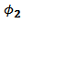 is positive (0.007288***) and is significantly and statistically significant at 1 % for KSE 100 index. Moreover the results of dummy variable for sector indexes is also positive and statistically significant showing that good political news have positive effect on returns. Financial, Auto and Parts sector show more positive returns (0.010607*** and 0.009291** respectively) as compared with other sectors make, which make clear that they react more to positive news with respect to others. This is a good sign because whenever political parties sit together to solve the matters for public interest and it influence the market in a positive way. Now, turning our concern to the volatility dynamics reveal more interesting results. Table 4 also describe the coefficient of dummy in the volatility equation (14). Results show that good news decrease volatility in most of the cases including KSE100, basic material, utilities, food and beverages, industries, and health care. Good news dummy is more significant and higher in the case of basic material (- 0.255694**) industries (- 0.215425***) as compare to other sectors. However some sectors as oil and gas (0.037254), financial (0.061050) and auto and parts (- 0.059129) are not statistically significant with respect to good political news. Table 4 also reports the volatility asymmetry, which is negative in all of the sectors including the KSE 100 which is due to the leverage effect. However the asymmetry for Auto and Parts is positive showing that there is no leverage effect in
Table 4
Estimation results from ARMA - EGARCH with Good News
 | Kse 100 | Oil and Gas | Financial | Basic Material | Utilities | Food and Beverages | Industries | Health Care | Auto and Parts
 | - 0.000788** | 0.001579*** | 0.001032** | 0.001867*** | 0.000812** | -0.000291* | -0.000683** | 0.000546** | 0.000676**
 | 1.009097*** | 0.921065*** | 1.069702*** | 0.435306** | 0.895799*** | 1.021392*** | 0.978065*** | 0.281488*** | -0.688568***
 | - 0.896373*** | - 0.862902*** | -0.967221*** | -0.380000** | -0.868783*** | -0.933394*** | -0.980189*** | -0.177129 | 0.737427***
 | 0.007288*** | 0.007941*** | 0.010607*** | 0.006366** | 0.008496** | 0.005996** | 0.008073** | 0.003896** | 0.009291**
 | - 0.903931*** | - 0.878369*** | - 1.431763*** | - 3.561174*** | - 0.862669*** | - 0.401496*** | - 2.336869*** | - 0.785937*** | - 1.217552***
 | 0.305805*** | 0.267098*** | 0.301297*** | 0.416782*** | 0.236831*** | 0.237247*** | 0.295284*** | 0.290516*** | 0.265647***
 | - 0.051298*** | - 0.032342*** | - 0.080130*** | -0.162665*** | - 0.024575** | - 0.034112*** | - 0.066822*** | - 0.021881** | 0.003266
 | 0.919872*** | 0.915666*** | 0.847193*** | 0.589553*** | 0.908953*** | 0.970691*** | 0.721994*** | 0.930630*** | 0.856736***
 | - 0.114749* | 0.037254 | 0.061050 | - 0.255694** | - 0.110280* | - 0.098109** | - 0.215425*** | - 0.144645** | - 0.059129
AC (10) Residual
 | 0.020 | 0.016 | 0.013 | 0.033 | 0.029 | - 0.004 | 0.020 | 0.057 | 0.046
AC (10) Squared Residual
 | 0.003 | 0.003 | 0.004 | - 0.001 | 0.022 | - 0.011 | - 0.001 | 0.004 | - 0.004
Notes: This table reports the estimates from the following ARMA - EGARCH model:


We report the estimates for ARMA - EGARCH return and volatility for KSE 100 index and other selected indexes. The coefficients measuring the effect of dummy variable used as a proxy for the Good Political News on Karachi stock markets’ returns and volatilities are also reported. Significant coefficients are denoted with***, **, * on 1%, 5 %, and 10 % significance level respectively. Residual autocorrelation coefficients at 10th lag AC (10) for both simple and squared standardized residuals are also reported.
this sector. Moreover negative asymmetry implies that the variance goes up more after negative news than after positive news. Furthermore, persistence parameter is also reported in table 4 which very large in most of the selected sectors including KSE 100 which indicate that variance move slowly through time. From the table we also observe that the coefficient for basic material (0.589553***) and industries (0.721994***) is quite low as compare to the other sectors those have coefficient more than 0.90. We conclude that the sectors which response more towards good news (volatility decrease more than other such as basic material and industries) has lower.

Impact of Bad Political News

In this part we test the impact of bad political news on the stock returns and volatility. Generally speaking, bad news decreases the returns and increases the volatility. The empirical results from Univariate EGARCH model (13) & (14) are reported in Table 5. As it is perceived from the table that bad political news dummy is statistically significant at 1% and significantly negative effect (- 0.011564***) on the returns of the KSE 100 index. We also reported the results of the sectors with respect to bad news. Financial and basic material shows more negative results (- 0.015145*** and - 0.014795*** respectively) with respect to other sectors. However, we find no significant result (- 0.000942) of the bad news on health care sector. Concentrating on impact of news on volatility we find motivating results. Table 5 also divulges the coefficient of dummy in the volatility equation (14). Results show that bad news increase volatility all of the cases including KSE100, basic material, utilities, food and beverages. Bad news has more impact on the volatility basic material and financial sector (0.600746*** and 0.492515*** respectively) as compare to other sectors. However, we did not find significant statistic of the impact of bad political news on industries (- 0.039800) and health care (- 0.018243). Table 5 also reports the volatility asymmetry, which is negative in all of the sectors including KSE100 except auto and part, confirming leverage effect. Moreover negative asymmetry implies that the variance goes up more after negative news than after positive news. However in case of auto and parts the asymmetry is positive implies the absence of leverage effect. Furthermore, persistence parameter is very large in most of the sectors including
Table 5
Estimations Results from ARMA - EGARCH with Bad News
 | Kse 100 | Oil and Gas | Financial | Basic Material | Utilities | Food and Beverages | Industries | Health Care | Auto and Parts
 | - 0.000537* | 0.001911*** | 0.001696*** | 0.002183*** | 0.001312*** | 0.000164 | - 3.98E-05 | 0.000625*** | 0.000707*
 | 1.030151*** | 0.930560*** | 0.969953*** | 0.476687** | 0.868454*** | - 0.618372*** | - 0.986089*** | - 0.594631* | - 0.937820***
 | - 0.908572*** | - 0.874742*** | - 0.864217*** | - 0.422269*** | - 0.845576*** | 0.707817*** | 0.984010*** | 0.700632** | 0.994433***
 | - 0.011564*** | - 0.011863*** | - 0.015145*** | - 0.014795*** | - 0.012096*** | - 0.009155*** | - 0.006725** | - 0.000942 | - 0.014288***
 | - 0.942245*** | - 0.894941*** | - 1.562034*** | - 3.719236*** | - 0.875126*** | - 0.405927*** | - 1.767189*** | - 0.800694*** | - 1.378163***
 | 0.310709*** | 0.271085*** | 0.321213*** | 0.432867*** | 0.237518*** | 0.233812*** | 0.254238*** | 0.293831*** | 0.280821***
 | - 0.054353*** | - 0.031828*** | - 0.083198*** | - 0.175501*** | - 0.025849*** | - 0.034376*** | - 0.055497*** | - 0.022852** | 0.003696
 | 0.916565*** | 0.914154*** | 0.833683*** | 0.573164*** | 0.907792*** | 0.970159*** | 0.792490*** | 0.929357*** | 0.836474***
 | 0.257830*** | 0.105148** | 0.492515*** | 0.600746*** | 0.079643* | 0.078952* | - 0.039800 | - 0.018243 | 0.114529*
AC (10) Residual
 | 0.020 | 0.016 | 0.013 | 0.032 | 0.029 | 0.021 | 0.015 | 0.057 | 0.046
AC (10) Squared Residual
 | 0.005 | 0.003 | 0.006 | - 0.001 | 0.020 | - 0.009 | - 0.002 | 0.005 | - 0.004
Notes: This table reports the estimates from the following ARMA - EGARCH model:

We report the estimates for ARMA - EGARCH return and volatility for KSE 100 index and other selected indexes. The coefficients measuring the effect of dummy variable used as a proxy for the Bad Political News on Karachi stock markets’ returns and volatilities are also reported. Significant coefficients are denoted with***, **, * on 1%, 5 %, and 10 % significance level respectively. Residual autocorrelation coefficients at 10th lag AC (10) for both simple and squared standardized residuals are also reported
KSE 100 which indicate that the variance move slowly through time. On the other hand, for the basic material and industries is lower than the other sectors. Residual autocorrelation coefficients at 10th lag for both simple and squared standardized residuals are also reported in table 5. The statistic of autocorrelation in residual and squared residual shows the absence of correlation.

Conclusion

Pakistan established as country on the map of the world on August 14th, 1947, the largest Muslim state in the world. The foundation of Pakistan was put together on the largest demographic movement ever recorded in history of the world. Nearly seventeen million people, which include Hindus, Muslims, and Sikhs etc, were observed to move from both directions between India and the Pakistan (including Bangladesh). The government oscillate between military rule and democratically elected governments, since the establishment of the Pakistan. . From 1988 to 1999, following Zia ul Haq's death, democracy though an unstable one sovereignty, power alternated between Benazir Bhutto and Nawaz Sharif, with none of them completing their full term in the Prime Minister house. Finally, in October 1999, a Chief of Army Staff, Pervez Musharraf, take over the government of Sharif and took over as President and sent him to jail and later to exile in Saudi Arabia for ten years.. In 2002 a parliamentary election returned civilian rule, yet the Musharraf presidency was extended for another five years. Although parliamentary elections were to take place in 2007, they were first postponed because of doubts of instability and later as a result of the assassination of Benazir Bhutto in December 2007. When the elections finally took place in February 2008, President Musharraf was crushed by the PPP and PML (N).
This study examined the impact of political uncertainty on stock exchange. We studied the effect of political news on the stock market returns and volatility. For this, we split the political news into two categories (good and bad news). We used the daily data for eighteen years from Karachi Stock Exchange to see the affect of political news on the stock market. Furthermore, we also observed the returns of different sectors to test either they are also affected by the political news or not. Additionally this also helped us to identify which sector responds more to the political news. We used univariate asymmetric GARCH model, to gauge the impact of political news on the returns and volatility. We specifically used EGARCH proposed by Engle and Victor (1991) as it allows good news and bad news to have different impact on volatility while standard GARCH model does not.
Our results demonstrate that the good news has positive effect on the returns of the KSE100 index and good news also decreased the volatility. On the other hand, bad political news has negative effect on the returns (decrease the returns) and increase the volatility (positive effect), which in the line of Engle and Victor (1991) results specifying that bad and good news have different impact on volatility. Furthermore our results also confirm that bad news have more effect (almost double) effect on the volatility than the good news, such results are consistent with Laakkonen and Lanne (2008). Most of the sector results are also affected by the good and bad news. .Financial, Auto and Parts sector show more positive returns on good political news as compared with other sectors, which make clear that they react more to positive news with respect to others. same is the case with volatility the response towards Good news dummy is more significant and higher in the case of basic material industries with respect to other sectors. Bad political news affected more on the returns of financial and basic material. Moreover, Bad news has more impact on the volatility of basic material and financial sector as compare to other sectors.
We also find that a few sectors are not statistical significant for good and bad political news, means these type of news do not affect the returns or volatility. Good news has no impact on the volatility of oil and gas and financial sector. However, the influence of bad political news is also not statistically significant for the returns of health care. Furthermore, we did not find significant statistic of the impact of bad political news on industries and health care. We also reported the volatility asymmetry, which is negative in most of the sectors including the KSE 100 which is due to the leverage effect. Furthermore, persistence parameter beta is also reported, which is very large in most of the selected sectors including KSE 100 which indicate that variance move slowly through time.
This study could be extended by including more news such as, economic, military and neighboring countries. Moreover, analysis can be done on the industry level. We can also examine the impact of these news on individual stock or on portfolios. Furthermore we can use more countries in our data such as South Asian countries and test the impact of one country’s political news on the other. For this we may employ multivariate EGARCH model for studying the volatility.

References

Ahmed, S and Farooq, O. (2008): The Effect of 9/11 on the Stock Market Volatility Dynamics: Empirical Evidence from a Front Line State, International Research Journal of Finance and Economics, No. 16, pp. 71-83
Allvine, F. C and O’Neill, D. E. (1980) Stock Market Returns and the Presidential Election Cycle: Implication for Market Efficiency. Financial Analysts Journal, Vol. 36, No. 5, pp. 49-56
Bailey, W. and Chung, P.Y. (1995): Exchange Rate Fluctuations, Political Risk, and Stock Return. Journal of Financial and Quantitative Analysis, Vol. 30, No. 4, pp. 541-561.
Bachman, D. (1992): The Effects of Political Risk on the Forward Exchange Bias: the case of elections. Journal of International Money and Finance, Vol. 11, No. 2, pp. 208-219.
Batchelor, T and Orakcioglu, I. (2003): Event-related GARCH: the impact of stock dividends in Turkey. Applied Financial Economics, Vol. 13, No. 4, pp. 295-307
Beaulieu, M. C, Cosset, J. C. And Essaddam, N. (2006) : Political Uncertainty and Stock Market Returns: evidence from the 1995 Quebec referendum. Canadian Journal of Economics, Vol.39, No. 2. pp. 621-641
Belfer Center , Electronic Reference Retrieved on March 22, 2010, http://belfercenter.ksg.harvard.edu/publication/18040/pakistan_political_stability.html
Bilson, C. M., Brailsford, T. J. and Hooper, V. C. (2002): The Explanatory Power of Political Risk in Emerging Markets. International Review of Financial Analysis, Vol. 11, pp.1-27
Bittlingmayer, G. (1998): Output, Stock Volatility, and Political Uncertainty in a Natural Experiment: Germany, 1880-1940. Journal of Finance, Vol. 53, pp. 2243-2258.
Bollerslev, T. (1986): Generalized Autoregressive Conditional Heteroskedasticity. Journal of Econometrics, Vol.31, No. 3, pp. 307-327.
Bollerslev, T. (1987): A Conditionally Heteroskedasticity Time Series Model for Speculative and Rates of Return. The Review of Economics and Statistics, Vol.69, No. 3, pp.542-547
Bowman, R. G. (1983): Understanding and Conducting Event Studies. Journal of Business Finance & Accounting, Vol. 10, No. 4.
Bratsiotis, G. J. (2000): Political Parties and Inflation in Greece: the Metamorphosis of Socialist Party on the Way to EMU. Applied Economics Letters, Vol.7, No. 7, pp.451-454
Chan, Y and John Wei, K.C. (1996): Political Risk and Stock Price Volatility: The Case of Hong Kong. Pacific-Basin Finance Journal, Vol. 4, No. 2-3, pp.259-275
Chan, Y., Chui, A.C.W and Kwok, C.C.Y. (2001): The Impact of Salient Political and Economic news on the Trading Activity. Pacific-Basin Finance Journal, Vol. 9, pp. 195-217
Chen, D. H., Bin, F. S. and Chen, C. D. (2005): The Impacts of Political Events on Foreign Institutional Investors and Stock Returns: Emerging Market Evidence from Taiwan. International Journal of Business, Vol.10, No.2
Chevalier, A and Hirsch, G. (1981): The Assessment of the Political Risk in the Investment Decision. The Journal of the Operational Research Society, Vol. 32, No. 7, pp. 599-610
Chuang, C.C and Wang, Y.H. (2009): Developed Stock Market Reaction to Political Change: a panel data analysis. Journal of Quality and Quantity, Vol.43, No. 6, pp. 941-949.
Clark, E and Tunaru, R. (2001): Emerging Markets: Investing with Political Risk. Multinational Financial Journal, Vol. 5, No. 3, pp. 155-173
Cosset, C. J and Suret, M. J. (1995): Political Risk and the Benefits of International Portfolio Diversification. Journal of International Business Studies, Vol.26, No. 2, pp 301-318
Diamonte, R. L., Liew, J. M., Stevens, R.L. (1996): Political Risk in Emerging and Developed Markets. Financial Analyst Journal, May/June, pp. 71-76
Dickey, D. A. and Fuller, W. A. (1979): Distribution of the Estimators for Autoregressive Time Series with a Unit Root. Journal of American Statistics, Vol. 74, pp.427-31

Engle, R. F. (1982): Autoregressive Conditional Heteroskedasticity with Estimates of Variance of United Kingdom Inflation. Econometrica, Vol.50, No. 4, pp. 987–1007
Engle, R. F. and Ng, V. K. (1993): Measuring and Testing the Impact of News on Volatility. Journal of Finance, vol. 48, No. 5, pp. 1749-78
Engle, R. F. (2001): The Use of ARCH/GARCH Models in Applied Econometrics. Journal of Economic prospective, Vol. 14, No. 4, pp 157-168
Erb, C. B., Harvey, C. R and Viskanta, T. E. (1995): Country Risk and Global Equity Selection. The journal of portfolio Management, Vol. 21, No. 2, pp. 74-83
Erb, C. B., Harvey, C. R and Viskanta, T. E. (1996): Political Risk, Economic Risk and Financial Risk. Financial Analysts Journal, November/ December
Fama, E. F. (1965): The Behavior of Stock-Market Prices. The Journal of Business, Vol. 38, No. 1, pp. 34-105
Fama, E. F., Fisher, L., Jensen, M.C. and Roll, R. (1969): The Adjustment of Stock Prices to New Information. International Economic Review, Vol.10
Fisman, R. (2001): Estimating the Value of Political Connections. The American Economic Review, Vol. 91, No. 4, pp. 1095-1102
Floros, C. (2008): Modelling Volatility using GARCH Models: Evidence from Egypt and Israel. Middle Eastern Finance and Economics, No. 2
Fong, W. M and Koh, S. K. (2002): The political Economy of Volatility Dynamics in the Hong Stock Market. Asia- Pacific Financial Markets, Vol. 9, pp. 259-282
Gemmill, G. (1992): Political Risk and Market Efficiency: Test based in British stock and options markets in the 1987 elections. Journal of Banking and Finance, Vo.16, No. 1, pp. 211-231
Hassan, M. K., Maroney, N. C., El-Sady, H. M. and Telfah, A. (2003) Country Risk and Stock Market Volatility Predictability, and Diversiﬁcation in the Middle East and Africa. Economic Systems, Vol. 27, pp. 63–82
Helina, L and Markku, L. (2008): Asymmetric News Eﬀects on Volatility: Good vs. Bad News in Good vs. Bad Times. MPRA Paper No. 8296,
Hentschel, L. (1995): All in the Family Nesting symmetric and asymmetric GARCH Models. Journal of Financial Economics, Vol. 39, pp. 71-104
Kim, H. Y and Mei, J. P. (2001): What makes the stock market jump? An Analysis of Political Risk on Hong Kong Stock Returns. Journal of International Money and Finance, Vol. 20, pp. 1003–1016
Klibanoff, P., Lamont, O. and Wizman, A. T. (1998): Investor Reaction to Salient News in Closed-End Country Funds. Journal of Finance, Vol. 53, No. 2, pp. 673-699
Kobrin, S.J. (1997): Political Risk: A review and reconsideration. Journal of International Business Studies, Vol. 10, No. 1, pp. 67-80
Koh, S. K., Fong, W. M and Zhang, X. Y. Political Risk and Volatility of Stock Returns: A Case Study of Hong Kong [online] Available from: http://www.smu.edu.sg/research/publications/pdf/BenedictKoh-PoliticalRiskHongKong.pdf [Accessed 20 April 2010].
Lamoureux, G. C and Lastrapes, W.D. (1990): Heteroskedasticity in Stock Return Data: Volume versus GARCH Effects. Journal of Finance, Vol. 45, No. 1, pp. 221-229.
Lobo, B.J. (1999): Jump Risk in the U.S. Stock Market: Evidence Using Political Information. Review of Financial Economics, Vol. 8, No. 4, pp. 149-163.
Mala, R and Reddy M. (2007): Measuring Stock Market Volatility in an Emerging Economy. Journal of Finance and Economics, No. 8, pp. 126-133
Masood, O and Sergi, B. S. (2008): How Political Risk and Events Have Influenced Pakistan’s Stock Market from 1947 to the Present. International Journal of Economic Policy in Emerging Economics, Vol.1, No 4, pp. 427-444.
Mitchell, L.M and Mulherin, H.J. (1994): The Impact of Public Information on the Stock Market. Journal of Finance, Vol.49, No. 3, pp. 923-950
Niederhoffer, V. (1971): The Analysis of World Events and Stock Prices. Journal of Business, Vol.44, No. 2, pp. 193-219
Poterba, M.J and Summers, H. L. (1998): The Persistence of Volatility and Stock Market Fluctuation. The American Economic review, Vol.76, No. 5, pp. 1142-1151
Robbani, M.G and Anantharaman, S. (2002): An Econometric Analysis of Stock Market Reaction to Political Events In Emerging Markets. Second Annual ABIT Conference, May 2, Pittsburgh, Pennsylvania
Schwert, G.W. (1989): Why Does Stock Market Volatility Change Over Time? Journal of Finance, Vol.15, pp. 1115-1153.
Sethi, S.P and Luther, K. A.N. (1986): Political Risk Analysis and Direct Foreign Investment: Some problems of definition and measurement. California Management Review, Vol. XXVII, No. 2.
Soultanaeva, A. (2008): Impact of Political News on the Baltic State Stock Markets [online] Available from: http://ideas.repec.org/p/hhs/umnees/0735.html [Accessed 15 April 2010]
Story of Pakistan, Electronic Reference Retrieved on March 22, 2010, http://www.storyofpakistan.com/default.asp
Teräsvirta, T. (2006): An Introduction to Univariate GARCH Models. SSE/EFI Working Papers in Economics and Finance, No. 646
Wang, H and Lin, T. (2009): The Political Uncertainty and Stock Market Behavior in Emerging Democracy: The Case of Taiwan. Journal of Quality and Quantity, Vol. 43, No. 2, pp. 237-248
Zach, T. (2003): Political Events and the Stock Market: Evidence from Israel. International Journal of Business, Vol. 8

Appendix I. Graphical Representation of Returns
Figure 10 KSE 100
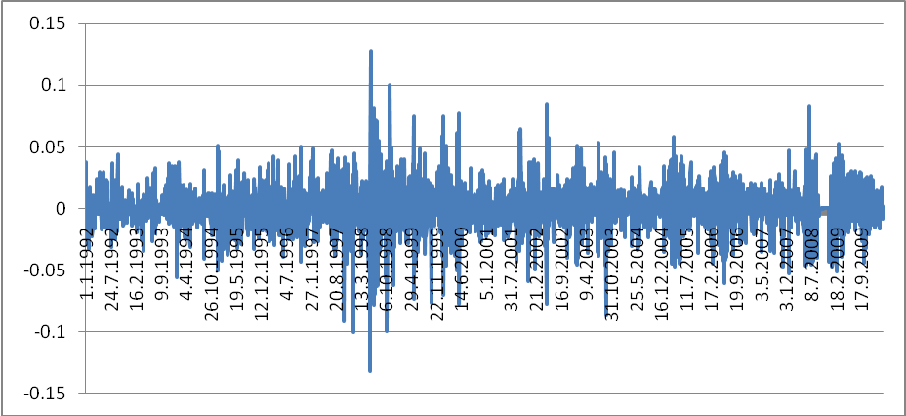

Figure 11 Oil and Gas
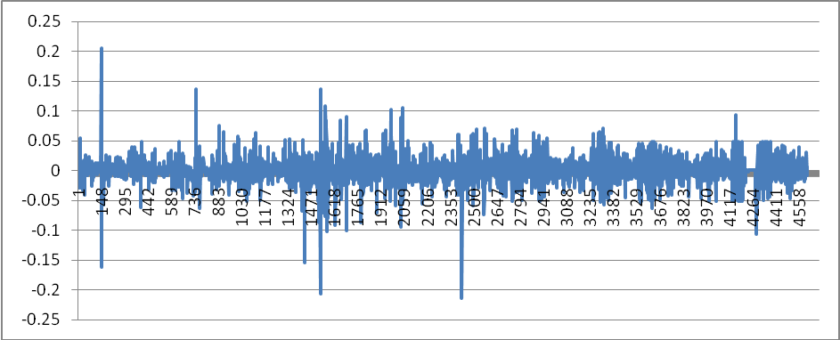
Figure 12 Financial
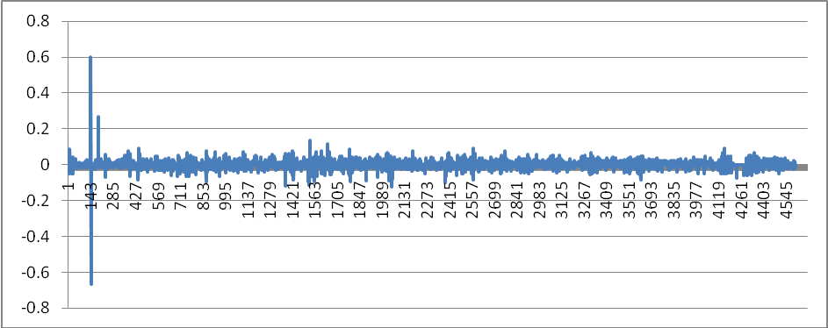
Figure 13 Basic Material
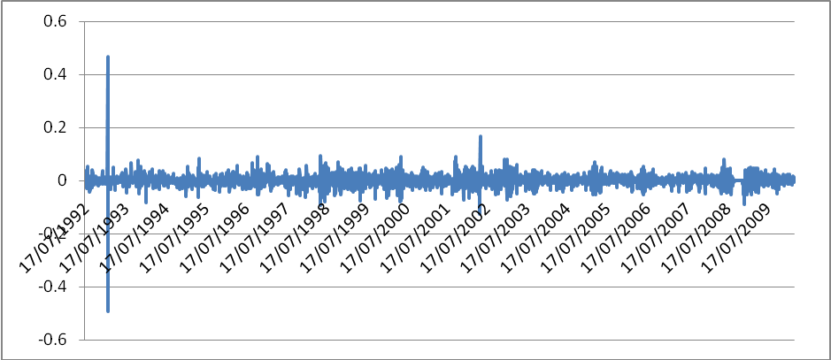
Figure 14 Utilities
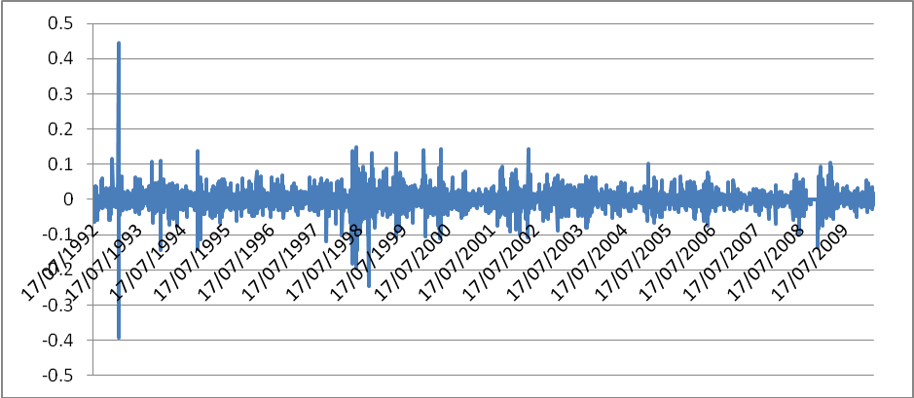
Figure 15 Food and Beverage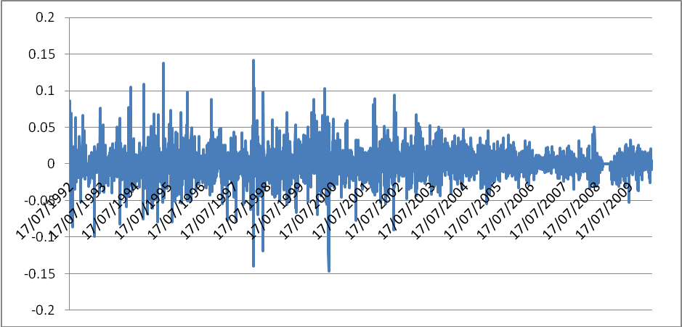
Figure 16 Industries
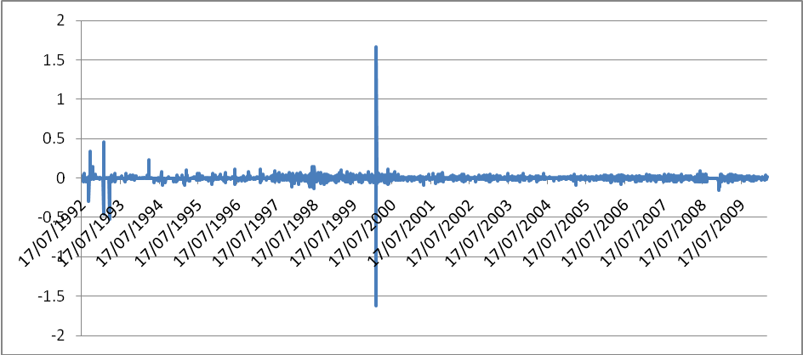
Figure 17 Health and Care
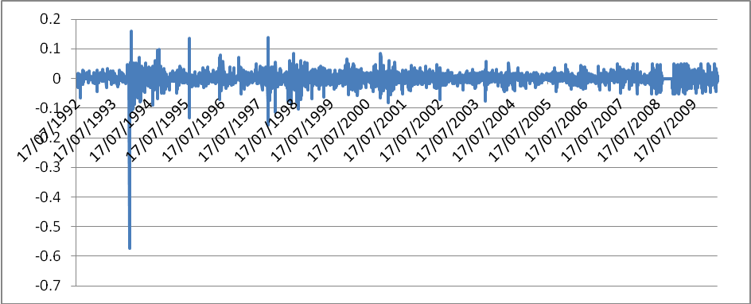
Figure 18 Auto and Parts
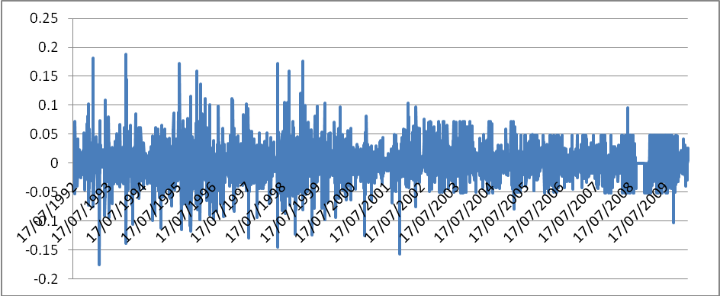

Author would like to thank Professor Johan Knif , Kenneth Högholm, Mujahid Hussain, Sheraz Ahamad and Hilal Butt for useful comments and suggestions.
This is for both good and bad news.
The main sources are: The News, Nation, Dawn newspaper and BBC.
Pakistan People’s Party, Pakistan Muslim League.

