The Analysis of Investment-Uncertainty Relationship
Under 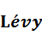 and CEV Processes

Chuang-Chang Chang, Miao-Ying Chen and Shih-Wei Lee

Abstract
Much of real options’ work assumes that the underlying variable follows a constant volatility geometric Brownian motion. This paper uses a more general assumption which is process framework and this paper chooses a specific case of process which is jump diffusion type model. We use jump diffusion type model with the constant elasticity of variance diffusion to examine the investment-uncertainty relationship in real options model. Finally we derive a solution for the critical investment value of a corporate’s projects.

Key words: process; Real option model; CEV; Critical investment value.

I. INTRODUCTION
In past literature, scholars often assume that the project cash flow stream follows geometric Brownian motion (GBM) with constant volatility. If the project cash flow stream follows this assumption, it means that the future cash flow stream is normally distributed. And we can use Black-Scholes formula to derive the implied volatility by substituting the option model price by market price. Actually we find that the implied volatility varies over time in the real world. This variation which is known as the implied volatility smile is found in most financial market and the underlying assets, for instance, Dennis and Mayhew (2002). In the past empirical literature, it also finds out that there exists a negative relation between return and volatility which is known as the leverage effect, for example, in Bekaert and Wu (2000). So the geometric Brownian motion with constant volatility assumption cannot capture these effects.
For financial assets, the constant elasticity of variance (CEV) model of cox (1975) exhibiting an implied volatility smile similar to the volatility curves. As point out by Bekaert and Wu (2000) the CEV component is also can explain the leverage effect. Although there is not well discussed in the past empirical real option literatures, the empirical results obtained for other financial market like crude oil, copper, and gold (Geman and Shih, 2009). They find out that these commodities’ spot price act like a CEV process.
As point out by Brennan & Schwartz, 1985 and McDonald & Siegel, 1986, the cash flow stream follows a lognormal diffusion process, usually with constant drift and variance parameters. In Dixit and Pindyck (1994), it discuss detailed in the basic case which the model follows geometric Brownian motion (GBM). Although the geometric Brownian motion assumption will make it easier to analyze, the past literature indicates that this assumption is not good enough to capture the behavior in most financial market. For example it find out that the option prices tend to be heavily skewed to the left and highly leptokurtic in Jackwerth and Rubinstein (2001) relative to the Merton (1973) geometric Brownian motion assumption.
To overcome the skewed and kurtosis problems, some real options literature’s authors use a jump diffusion process, (e.q., McDonald &Siegel, 1986) or a mean-reverting type diffusion (e.q., Brennan, 1991). As point out by Dixit and Pindyck (1994), a geometric Brownian motion model with discrete jumps is more realistic to model the cash flow stream of a firm’s project. For example, the earnings of a firm would be effect by some unpredictable but sizeable changes in response to good or bad news.
A process is a continuous time stochastic process with stationary independent increments. We can see process as a drifting Brownian motion add a pure jump process where the pure jump process generated non-normal innovations.
Many dynamic processes are special case of process. For example, Brownian motion with drift which used in Black and Scholes (1973) model, compound Poisson process, Merton model, variance gamma model, and Normal inverse Gaussian are all special cases of process.
There are two main categories for financial models with jumps. And both these two categories are examples of process. Jump-diffusion model is the first category, which contains a Brownian component and a jump part which is a compound Poisson process. Compound Poisson process is a jump process with finitely many jumps and the distribution of jump sizes is known. For example, Merton jump-diffusion model (Merton, 1976) and Kou model (Kou 2002) belong to this category. The second category is called Infinite activity model. This kind of model moves essentially by jumps and it has infinite number of jumps in every time interval. In these models do not necessarily contain a Brownian component, because the infinite number of jumps activity is rich enough to generate nontrivial small time behavior (Carr, Geman, Madan, and Yor, 2002). For example, variance gamma process (Madan, Carr, Chang, 1998) and Normal inverse Gaussian process (Barndorff-Nielsen, 1998) belong to this category.
This article extends the GBM process to process frame work and adding CEV components. By choosing a specific triplet we will discuss about Jump-diffusion type model. And in Jump-diffusion type we will add CEV components. We use this model to derive the optimal investment value V* and find out the relation between optimal investment value V* and other parameters.

- THE MODEL
If X~ process (γ, σ, ν), by -It decomposition X can derive to
(1)
Where γ is the drift term, is a Brownian motion, is compound Poisson process which jump size is bigger than 1, and is a compensated compound Poisson process.is a process which can be presented as
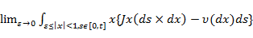 (2)

Definition 1 ()
}], which means is the expected number, per unit time, of jump whose size belongs to A. (from Financial Modelling with jump processes, Rama Cont & Peter Tankov)

Many famous dynamic processes are special cases of process. For example,
when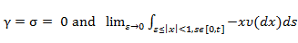 does not exist, it will become a compound Poisson process. And when it will become an GBM process with drift.
When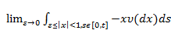 does not exist, it will become a jump diffusion type model which means jump is a rare event. When, it will become an Infinite activity type model, these kinds of models moves essentially by jumps. The jumps happen infinitely often but the jump sizes’ distribution does not exist.
We consider a firm’s net cash flow stream of Vt follows an exponential process, then Vt can presented as:
(3)

Let F(V) means the value of the investment opportunity. We can write F(V) as :
$F(V)=\text{max}E[(V_{t}−I)e^{−ρT}]$ (4)
By Dixit and Pyndick (1994), the Bellman equation can write as:
(5)
where ρ is a discount rate, and T is the future time when the investment is to be implemented. We assume that the firm is risk-neutral, which makes the discount rate ρ equal to the risk-free rate r.
And it will satisfy Partial integro-differential equations (PIDE) like follows:
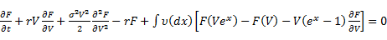 (6)
By different measures, the PIDE will become different.
Jump diffusion type with CEV component
We change the constant volatility σ into a function of Vt
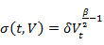 (7)
By Bellman equation we can get
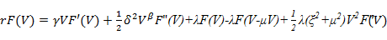 (8)
replace γ by γ=r-q
(9)
On the other words we can rewrite the dynamic process of V in a familiar form like follows:
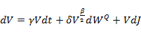 (10)
The dJ is a compound Poisson process with mean arrival rate λ, expectation jump size μ, and variance of the jump size .
The solution of F(V) in Equation (9) must satisfy the following three initial boundary conditions:
F(0)=0 (11)
F( (12)
F’()=1 (13)
To find the solution of Equation (9) we define a new function h(V) to construct F(V) like follows:
(14)
Substitution F(V) in to Equation (9), we obtain:
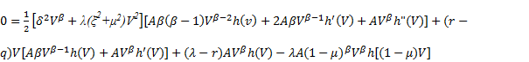 (15)

Rearranging Equation (15), we can get
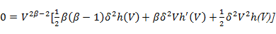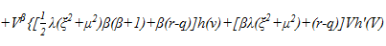
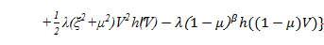 (16)
Equation (16) must hold for any value of V; therefore, the bracketed terms in the first and second lines of the equation must be equal to zero.
To solve (17) and (18)
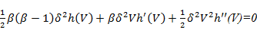 (17)
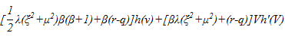
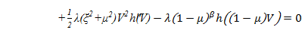 (18)
We can obtain a new function
1/2 λ(ξ^2+μ^2)V^2 h''(V)+[βλ(ξ^2+μ^2 )+(r-q)][-1/2 (β-1)h(V)-1/2V^2/β h''(V)]+[1/2 λ(ξ^2+μ^2 )β(β-1)+β(r-q)]h(V)-λ〖(1-μ)〗^βh[(1-μ)V] = 0 (19)
This equation is an case of Euler equation, so solution of h(V) must take the form:
Because the solution of Equation (19) is a more complicated nonlinear equation, we find parameter α by numerical way.
As we get the general solution of h(V), we substitute h(V) into Equation (14) to solve initial boundary problem. After that we can find the critical value of V*.
In appendix A we will derive the Special cases: Pure CEV model and discuss the case of β=0; and β=1.

- NUMERICAL SOLUTIONS
We start with setting the base case parameter values at r=5%, λ=0.1, μ=0.5, =1, β=1.5, I=1, =0.1, and T=10 years. From these parameters, we will compute the critical investment value V* and discuss the relation between the parameters and V*.
In this paper, we define F(V) as the value of the firm’s option to invest and the point of tangency between F(V) and V – I gives the critical investment value V*. F(V) >V – I and therefore V < I + F(V) when V < V*. This means when V < V*, the value of the firm’s project is less than the direct cost plus the opportunity cost F(V).
We make a brief review on the results reported in the past study before we start to discuss our numerical results. In Chang and Chen (2006), the critical value V* is a increasing function with volatility and there has a positive relation between the jump size and the critical investment value V*. It also finds that the critical investment value V* was a decreasing function of the jump frequency of earnings.
After making a brief review on the results in Chang and Chen (2006), we are going to summarize our numerical results as follow:

Result 1. The elasticity β of the CEV component has a negative effect on the critical value of investment under the jump diffusion process and CEV process. And F(V) decreases when β increases.
From Figure 1, we find that the trigger value V* is a decreasing function of β. When β is increasing it will make the value of volatility become larger at the same level of V in the situation that = 0.1. This result consists with the result in Chang and Chen (2006), that the volatility of a firm’s earnings can have a positive effect on the critical values.
We find that F(V) decreases when β increases in Figure 2. It means that the greater β decrease the value of a firm’s investment opportunities.

Here we assume that if an “event” occurs, J jumps with a distribution which mean is equal to μ with probability 1. Figure 3 and Figure 5 illustrate the effect of λ on the critical investment trigger value V*.

Result 2. The jump frequency in a firm’s earnings tends to have a negative effect on the critical values of investment when the expected jump size is negative. And F(V) has a negative relation with the jump frequency λ.
From Figure 3, we find that, all other things being equal and the expected jump size is equal -0.1, with an increase in λ there is a corresponding decrease in the critical value of investment (V*). This result consists with the result in Chang and Chen (2006). We can explain the result by two ways. First, it reduces the expected rate of capital gain on V, which would reduce (F(V)). Second, it increases the variance of percentage changes in V over finite interval of time.
From Figure 4, we can clearly observe that F(V) did decreases when the jump frequency λ increase. It means that the greater λ decreases the value of a firm’s investment opportunities when the expected jump size is negative.

Result 3. The jump frequency in a firm’s earnings tends to have a negative effect on the critical values of investment even when the expected jump size is positive. But F(V) has a positive relation with the jump frequency λ.
From Figure 5, we find that when other parameter remain the same and the expected jump size is equal 0.5, with an increase in λ there is also a corresponding decrease in the critical value of investment (V*). In Figure 6, we find that a firm’s investment opportunities increase with λ when the expected jump size is positive. Because the expected jump size is positive, it will raise the expected rate of capital gain on V, which could increase F(V).
Result 4. If the expected jump is positive, the jump size in a firm’s earnings trends to have a positive effect on the critical value of investment. If the expected jump is negative, the jump size in a firm’s earnings tends to have a negative effect on the critical value of investment. F(V) increases when jump size increases if the expected jump is positive. But F(V) decreases when jump size increase if the expected jump is negative.
From Figure 7, it illustrate the relation between μand critical investment value V*. We find that, all other things being equal and the jump size is positive, with an increase in μ there is a corresponding increase in the critical investment value V*. As the μ is negative, it means the expected jump goes down. It will imply a smaller value of the investment opportunity when the jump size is larger. It also means the opportunity cost of investing now is smaller than the opportunity cost of waiting. On the contrary, the opportunity cost of investing now is larger than the opportunity cost of waiting if μ is positive which means the expected jump goes up.
From Figure 8 , if μ is positive, F(V) increases when μ increases. It means that the greater μ increase the value of a firm’s investment opportunities. But F(V) decreases when |μ| decrease if μ is negative. It means that the greater |μ| decrease the value of a firm’s investment opportunities when μ is negative.

- CONCLUSIONS
In this paper we have used a process framework and we choose a jump diffusion type model which incorporating a drifting geometric Brownian motion and Compound Poisson process. And we add a CEV component which makes the constant volatility σ change by different V over time. We have also derived a solution for the critical investment value.
Our main findings are summarized as follows: (i) The elasticity β of the CEV component has a negative effect on the critical value of investment. And F(V) decreases when β increases; (ii) The jump frequency in a firm’s earnings tends to have a negative effect on the critical value of investment when the expected jump size is negative. And F(V) has a negative relation with the jump frequency λ; (iii) The jump frequency in a firm’s earnings tends to have a negative effect on the critical values of investment even when the expected jump size is positive. But F(V) has a positive relation with the jump frequency λ; (iv) If the expected jump is positive, the jump size in a firm’s earnings trends to have a positive effect on the critical value of investment. If the expected jump is negative, the jump size in a firm’s earnings tends to have a negative effect on the critical value of investment. F(V) increases when jump size increases if the expected jump is positive. But F(V) decreases when jump size increase if the expected jump is negative.
It would be interesting to study the second category model of process. In this
kind of model, the parameter of σ is equal to zero and the jump component is infinite
activity type. This issue is left for future research.

Appendix (A)
Pure CEV model
The dynamic process is like follows
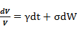 (A.1)
And the constant elasticity of variance makes the volatility follow a function of V like follows:
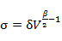 (A.2)
After we replace A.2 into A.1 we can get a new function like follows:
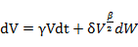 (A.3)
By using It formula we get (A4)
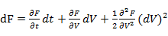 (A.4)
By Bellman equation we can obtain
rF =E[df]
=(r-q)VF’(V)+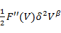 (A.5)

We define a new function h(V) to construct F(V) like follows:
F(V)=A (A.6)
The solution of F(V) in Equation (A.5) must satisfy the following three boundary conditions:
F(0)=0
F(
F’()=1
After replacing A.6 in A.5 we can get a new function like follows:

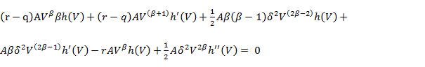
Rearranging the Equation we obtain
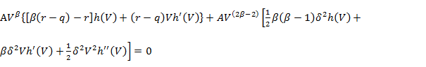 (A.7)
If β do not equal 0 and 1, this Equation must hold for any value of V; therefore, the bracketed terms in the first and second lines of the equation must be equal to zero.
To solve equation (A.8) and (A.9)
(A.8)

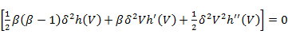 (A.9)
We obtain a new function
[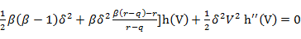 (A.10)
This equation is an case of Euler equation, so solution of h(V) must take the form:
h(V)=
By replacing h(V) into the equation we can derive a closed solution for α
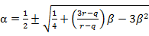 (A.11)
We can obtain
By the boundary condition
F(0)=0
F(
F’()=1
We can find the critical value V*

Appendix (B)
β=0
we can get the new function from (A.7) withβ=0 which like follows:
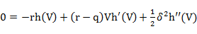 (B.1)
The function (B.1) is equal to
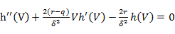 (B.2)
This function is not so trivial to solve so we use a series solution to solve the problem.
We assume that h(V) is function like follows:
(B.3)
By this assumption we can get follow two function
(B.4)
(B.5)
By replacing (B.3), (B.4) and (B.5) in function (B.2) we can obtain a function like follows:
(B.6)
Rearranging the function (B.6), we can get
(B.7)
By solving the problem we can get
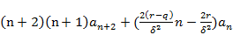=0 (B.8)
By function (B.8) we can find the relation between the coefficients of V, and use the boundary condition to solve the coefficient. After that we can get the function of F(V).

β=1
we can get the new function from (A.7) withβ=1 which like follows:
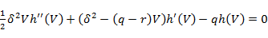 (B.9)
The function (B.1) is equal to
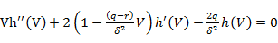 (B.10)
We still assume that h(V) is function l follows (B.3). we replace (B.3), (B.4) and (B.5) in function (B.10) again. We can get
(B.11)
By solving the problem we can get
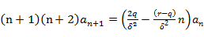 (B.12)
By function (B.8) we can find the relation between the coefficients of V, and use the boundary condition to solve the coefficient. After that we can get the function of F(V).

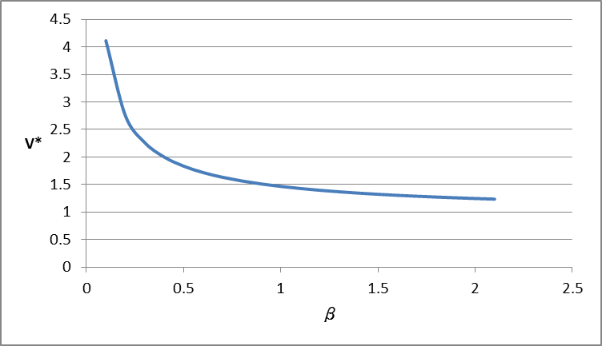
Figure 1. Critical value of investment as a function of β
Note :
- The parameters are: r=5%, λ=0.1, μ=0.5, =1, I=1, = 0.1, and T=10 years.
- We change β, in increments of 0.1, within the range of 0.1 to 2.1

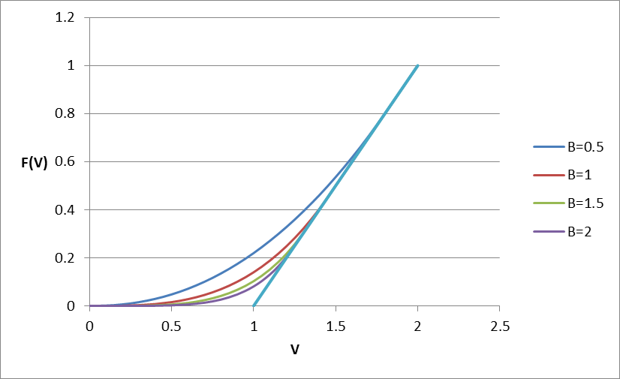
Figure 2. Value of Investment Opportunity, F(V), β=0.5, 1, 1.5, 2
Note : The parameters are: r=5%, λ=0.1, μ=0.5, =1, I=1, = 0.1

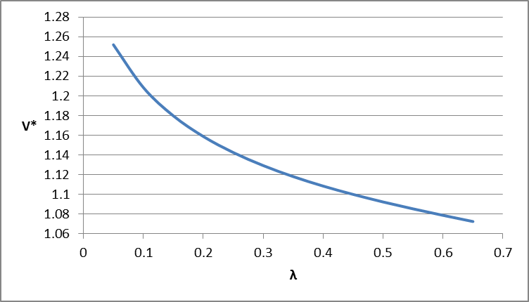
Figure 3. Critical value of investment as a function of λ
Note :
- The parameters are: r=5%, μ= -0.1, =1, I=1, = 0.1, and T=10 years.
- We change λ, in increments of 0.05, within the range of 0.05 to 0.65

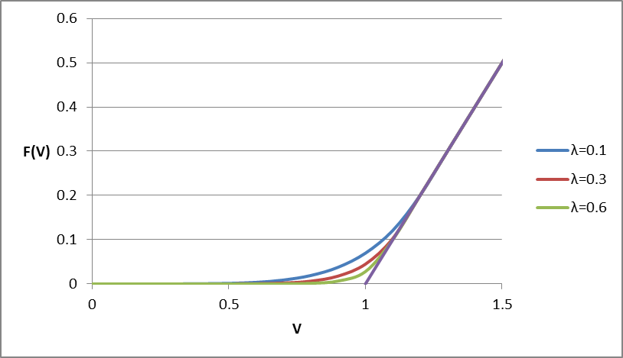
Figure 4. Value of Investment Opportunity, F(V), λ=0.1, 0.3 and 0.6
Note : The parameters are: r=5%, μ= -0.1, =1, I=1, = 0.1

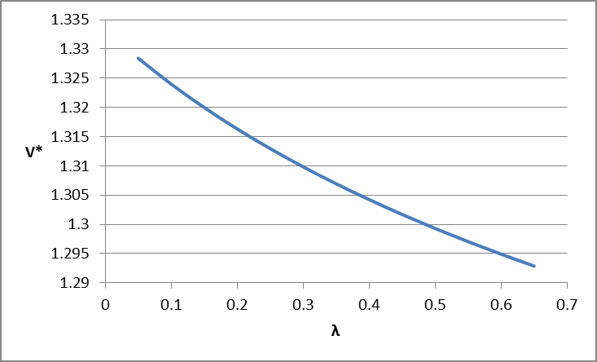
Figure 5. Critical value of investment as a function of λ
Note :
A. The parameters are: r=5%, μ= 0.5, =1, I=1, = 0.1, and T=10 years.
B. We change λ, in increments of 0.05, within the range of 0.05 to 0.65

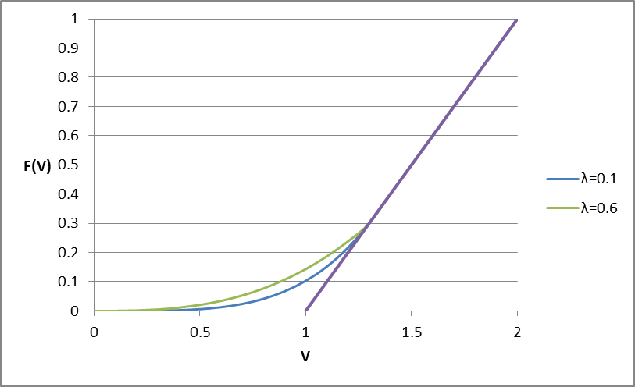
Figure 6. Value of Investment Opportunity, F(V), λ=0.1 and 0.6
Note : The parameters are: r=5%, μ= 0.5, =1, I=1, = 0.1

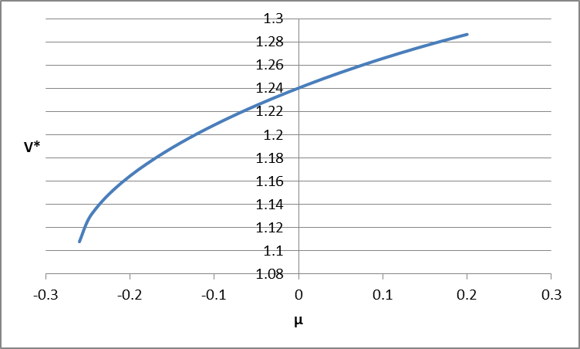
Figure 7. Critical value of investment as a function of μ
Note :
- The parameters are: r=5%, λ=0.1, =1, I=1, = 0.1, and T=10 years.
- We change μ, in increments of 0.01, within the range of -0.26 to 0.2

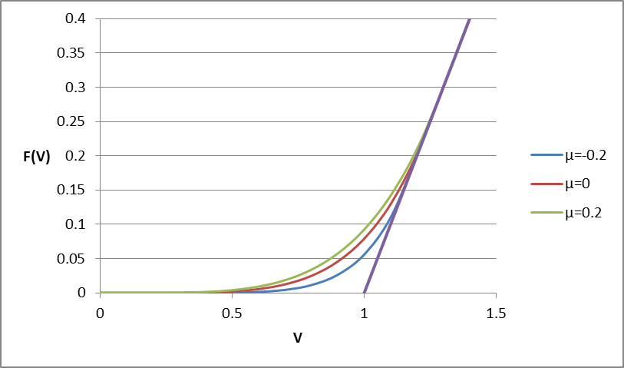
Figure 8. Value of Investment Opportunity, F(V), μ=-0.2, 0 and 0.2
Note : The parameters are: r=5%, λ=0.1, =1, I=1, = 0.1

Table 1 : The relation between Critical value of investment and the elasticity β
The parameters are: r=5%, λ=0.1, μ=0.5, =1, I=1, V0= 0.1, and T=10 years.

The relation between Critical value of investment and the elasticity β
Changes in β | V*
0.1 | 4.113628682
0.2 | 2.750329868
0.3 | 2.260865122
0.4 | 2.000000025
0.5 | 1.834550255
0.6 | 1.718750502
0.7 | 1.632409237
0.8 | 1.565144464
0.9 | 1.511034446
1 | 1.46643195
1.1 | 1.428957383
1.2 | 1.396984841
1.3 | 1.369361383
1.4 | 1.345243706
1.5 | 1.323998847
1.6 | 1.305141043
1.7 | 1.288290483
1.8 | 1.27314521
1.9 | 1.259461722
2 | 1.247041202
2.1 | 1.235719478

Table 2:The relation between Critical value of investment and the jump frequencyλwith negative expected jump size.
The parameters are: r=5%, β=1.5, μ=-0.1, =1, I=1, V0= 0.1, and T=10 years.
The relation between Critical value of investment and the jump frequencyλwith negative expected jump size
Change in λ | V*
0.05 | 1.251927
0.1 | 1.208408
0.15 | 1.179751
0.2 | 1.158812
0.25 | 1.142507
0.3 | 1.12924
0.35 | 1.118085
0.4 | 1.108459
0.45 | 1.099968
0.5 | 1.092328
0.55 | 1.08532
0.6 | 1.07876
0.65 | 1.072465

Table 3 :The relation between Critical value of investment and the jump frequencyλwith positive expected jump size.
The parameters are: r=5%, β=1.5, μ=0.5, =1, I=1, V0= 0.1, and T=10 years.
The relation between Critical value of investment and the jump frequencyλwith positive expected jump size
Change in λ | V*
0.05 | 1.32843
0.1 | 1.323999
0.15 | 1.319996
0.2 | 1.316337
0.25 | 1.31297
0.3 | 1.309854
0.35 | 1.306954
0.4 | 1.304245
0.45 | 1.301704
0.5 | 1.299311
0.55 | 1.297052
0.6 | 1.294913
0.65 | 1.292883

Table 4 : The relation between Critical value of investment and the expected jump size μ
The parameters are: r=5%, β=1.5, λ=0.1, =1, I=1, V0= 0.1, and T=10 years.

The relation between Critical value of investment and the expected jump size μ
Change in μ | V* | Change in μ | V*
-0.2 | 1.164436 | 0 | 1.240253
-0.19 | 1.169873 | 0.01 | 1.24305
-0.18 | 1.174974 | 0.02 | 1.245788
-0.17 | 1.179797 | 0.03 | 1.248469
-0.16 | 1.184386 | 0.04 | 1.251094
-0.15 | 1.188773 | 0.05 | 1.253666
-0.14 | 1.192984 | 0.06 | 1.256186
-0.13 | 1.197038 | 0.07 | 1.258655
-0.12 | 1.200951 | 0.08 | 1.261073
-0.11 | 1.204738 | 0.09 | 1.263443
-0.1 | 1.208408 | 0.1 | 1.265765
-0.09 | 1.211971 | 0.11 | 1.26804
-0.08 | 1.215436 | 0.12 | 1.270268
-0.07 | 1.218809 | 0.13 | 1.27245
-0.06 | 1.222096 | 0.14 | 1.274588
-0.05 | 1.225301 | 0.15 | 1.27668
-0.04 | 1.22843 | 0.16 | 1.278729
-0.03 | 1.231487 | 0.17 | 1.280733
-0.02 | 1.234474 | 0.18 | 1.282695
-0.01 | 1.237395 | 0.19 | 1.284613
 |  | 0.2 | 1.286489

References
Bekaert, G., & Wu, G. (2000). Asymmetric volatility and risk in equity markets. Review of Financial Studies, 13: 1-42

Bessembinder H, Coughenour JF, Seguin PJ, Smoller MM (1995) Mean-reversion in equilibrium asset prices: evidence from the futures term structure. J Financ, 50:361-375

Chang Chuang-Chang and Chen Miao-Ying (2011), ‘Re-examining the Investment- Uncertainty Relationship in a Real Options Model’, Review of Quantitative finance and accounting, forthcoming

Cox, J. C. (1975). Notes on option pricing I: Constant elasticity of variance diffusions (working paper), Stanford University.

Dennis, P. & Mayhew, S (2002). Risk-neutral skewness: Evidence from stock options. Journal of Financial and Quantitative Analysis, 37, 471-493

Dixit, A.K. and R.S. Pindyck(1994), Investment under Uncertainty, Princeton University Press.

Dmitry Davydov and Vadim Linetsky (2001), ‘Pricing and Hedging Path-Dependent options Under the CEV Process’, Management Science, 47: 949-965

Geman, H., & Shih, Y. F. (2009). Modeling commodity prices under the CEV model. Journal of Alternative Investment, 11: 65-84

Hassett KA, Metcalf GE (1995) Investment under alternative return assumptions: comparing random walks and mean reversion. J Econ Dyn Control, 19:1471-1488

Jos Carlos Dias and Joo Pedro Vidal Nunes (2011),’pricing Real Option Under the Constant Elasticity of Variance Diffusion’, Journal of Futures Markets, 31: 230-250

Lund D (1993) The lognormal diffusion is hardly an equilibrium price process for exhaustible resources. J Environ Econo Manag, 25:235-241

McDonald R, Siegel D (1986) The value of waiting to invest. Quart J Econ, 101:707-727
Peter Carr and Liuren Wu(2004),’Time-Changed Lvy Processes and Option Pricing, Journal of Financial Economics, 71:113-141

Rama Cont and Peter Tankov(2004), Financial Modelling With Jump Process, CRC Press LLC

Sarkar,S.(2000),’On the Investment-Uncertainty Relationship in a Real Option Model’, Journal of Economic Dynamics and Control, 24:219-25

Sarkar, S.(2003)’ The Effects of Mean Reversion on Investment under Uncertainty’, Journal of Economic Dynamics and Control, 28:377-96.

