An Analysis of Co-Movements in Industrial Sector Indices Over the Last 30 Years.

Authors: Jon G. Poynter, Rutgers Business School, Piscataway, NJ 08854

jon.g.poynter@gmail.com

James P. Winder, Rutgers Business School, Piscataway, NJ 08854
jpwinder@rci.rutgers.edu
office: 1-848-445-2996
fax: 1-732-445-2333

An Analysis of Co-Movements in Industrial Sector Indices Over the Last 30 Years.

Abstract
This paper analyses the Dow Jones daily industry sector total return indices for the last 18 years and the Datastream daily industry sector price indices over the past 30 years. We show how broad movements in both sets of data can be described in terms of five underlying variables and how interactions between individual industrial sectors can be revealed using structural equation modeling. In addition we show how these factors can be used to construct investible factor portfolios that can be used to take a position in the securities market and how normal investment tools such as the capital asset pricing models should be used to construct an optimal investment portfolio. Whilst the methodologies used are somewhat mathematical our aim is not to explain the math, but to show a way in which the tools are applied and the results interpreted.

Keywords
Equity Market Indices, Factor Analysis, Structural Equation Modeling, Investment Factor Portfolios

JEL Codes
G11: Portfolio Choice Investment Decisions
G14: Information and Market Efficiency; Event Studies
C18: Methodological Issues: General
C51: Model Construction & Estimation
C38: Classification Methods; Cluster Analysis; Factor Analysis

An Analysis of Co-Movements in Industrial Sector Indices Over the Last 30 Years.

Introduction
Valuation theory states that equity prices represent the market equilibrium view of the prospects of individual firms in terms of their growth and dividend prospects. These prospects are in turn related to the Political environment, Economic pressures, Societal and Technological (PEST) conditions in which they operate. The degree to which these factors influence the prospects of a firm depends upon the specific endeavor in which a firm is engaged and is expected to vary between industrial sectors. Consequently, we expect the overall performance of individual equities to be comprised of a systematic industrial segment factor and an idiosyncratic firm specific factor.
This assumption has resulted in a number of market segment indices which attempt to capture the systematic industrial sector’s component of equity performance forming a benchmark to be used in attribution, against which the performance of an individual security can be compared to its peers. The structure of this industrial segmentation is largely embodied by the Global Industrial Classification Standard (GICS) developed by Morgan Stanley Capital International and Standard & Poor’s upon which mainly market sector indices are based.
The resulting pattern of equity price time-series, comprising systematic covariance between groups of related stocks and firm specific idiosyncratic innovations, is therefore a natural subject for analysis using multivariate time series analysis.
Pioneers in the field of multivariate analysis of equity data were Feeney and Hester (1967), who questioned whether the use of equal weighting of stocks in the Dow Jones Industrial 30 index was a good idea. Their assumption was that such an index would be more sensitive to underlying changes in the index if weightings were based on the underlying variances of the stocks involved. This early work was based on equity prices or first moment data. The major factor dictating the outcome was long term price changes. Subsequently, there have been many applications of principal components and its derivatives to analyze financial time series, using first, second and higher order moments (Brown 1989, Connor 1993, Meric 2005, 2006, 2008). Typically, the latent variables (or hidden factors) determined are used as inputs into other models since being based upon covariance or correlation mode they provide insight into the level of diversification achieved within a portfolio (Meric 2008).

Data Used In This Study
The data chosen for this study are daily returns of Datastream sector index price levels and Dow Jones sector index total returns. Whilst the price data do not include a dividend component, expectation of future dividends should be in part reflected in relative price levels. The use of indices circumnavigates the problems of stock splits and mergers experienced by analysts using individual company data. The specific data used in this analysis are shown below in table 1. Complete sector level data were available from Dow Jones from 1992 to date, although the Datastream data spanned a longer period from 1980 to date, complete sector information was not available. Where sector level data were missing, available subsector data were used to infer sector performance. Since a single sector was frequently replaced by multiple subsector indices, this tended to increase the relative weight of that sector in subsequent models. Subsequent analysis however shows that the similar factors are present in both data sets.

Datastream US/Sector Equity Indices Price Data | Partial ICB Sector/Sub Sector | Daily Jan 1980 – July 2010
Dow Jones US/Sector Equity Indices Total Return Data Prices and Dividends | GCS sector | Daily Jan 1992 – Sep 2010
Table 1 Raw Data used.

Analysis
There are many possible methodologies that can be used in the multivariate analysis of equity data. Although each methodology may have similar goals, i.e. the extraction of latent variables or the reduction of the dimensionality of the raw data, each method represents the data in different ways, highlighting different aspects of the initial data. A good general overview of the techniques used can be found in Lattin (2003). The primary goal is the discovery of latent variables. These latent variables can be thought of as some hidden variable which exists within the data that is not readily apparent and that summarizes the variance within the initial data. The goal of multivariate analysis is to express the data using these hidden factors or latent variables; effectively reducing the dimensions (i.e. number of initial variables) to a simpler (fewer latent variables) view, for example an underlying Finance factor that is present in Finance related sub sectors. The rationale behind such statistical tools is that variables that co-vary or show a high degree of correlation respond to a single factor or latent variable. If we can identify and remove this covariant part we can isolate the latent variable. Having removed a factor, the process begins again. The next highest component of correlation is identified and removed. A consequence of this approach is that subsequent factors will have zero correlation with each other over the entire data set and are said to be orthogonal in multivariate space.
A second useful feature is that extracting successive correlated variables tends to eliminate local effects relating to just one or two input variables. Simply put systematic variance tends to be correlated between input time series, whereas non-systematic or specific variance tends to be random or local to one or two. This is why indices are not based upon a single company. In this manner the process can be thought of as a noise reduction technique, since random effects do not tend to be correlated and only systematic variance will be expressed in the factors.
Early work focused on price data, e.g. Feeney and Hester (1967). Using price data the major differences between sector indices will be cumulative over time and depend upon long-term trends or the growth phase of the industry. An alternative approach is to use return data or second moment data. The advantage of this data is that sector returns tend to be mean centered on zero, the structure of the data captures the relative performance of each sector over time but is not influenced by long term trends.
A feature of stock sector time series returns is that all indices to some degree tend to be correlated with overall market performance over the economic cycle. Since we are interested in relative performance within sectors, it makes sense to subtract this covariance with the market from the data by subtracting the market return from each sector index. This, however, has an unwanted consequence that overall performance of the market includes asset bubbles within individual sectors, e.g. the tech boom of 2002 and the performance of finance stocks from 1990 onwards. Subtracting the market index from other sectors imprints the effect of these sector bubbles on the other indices, e.g. causing an apparent negative correlation of non-tech stocks with the tech stock boom. This effect is called data closure. For this reason we use raw returns to avoid this data closure effect and to maintain the independence of individual industry sectors.
To summarize the effects of the different types of factor analysis used in this study, we provide a non-mathematical description of each method used. Whilst it is not possible to be entirely non-mathematical we hope to describe each technique without obscuring the results and aims of each process from those who do not have a quantitative background.

Principal Components Analysis
Principal components analysis is primarily used as a data dimension reduction technique. The dimensionality of an initial raw data set is equal to the number of initial raw time series variables. If two or more variables are highly correlated, they can be thought of, at least in part, as being related to a common underlying factor. This aim of PCA is to find a basis to describe the data using fewer dimensions, using these underlying common factors. The first principle component or underlying factor captures the largest component of correlated variance in the data. Using industry sector returns this will inevitably be the broad market return. Subsequent components effectively describe the variance in the data set after the previous component or broad market variance has been removed. The resultant latent variables or factors are a series of orthogonal (non-correlated) variables. The second component for example, describes the largest component of variation between sector indices after market returns have been accounted for. Assuming that no linear combinations of input variables are perfectly linearly correlated, to completely account for all the variance in the data set, the same number of latent variables will be required as the number of initial variables. However, the majority of the variance in the data set can generally be summarized by fewer variables. In this study due to covariance between industrial sector indices, it was possible to describe 70% of the variance in the initial 39 Dow Jones indices using just 5 factors.
The value or score of each latent variable at a point in time can be calculated by a linear combination of the input variables. Likewise if we account for all of the variance in the data, we can obtain the value of each variable by performing the reverse operation on our principal components. Specifically by multiplying the scores matrix by the inverse of the Eigen vector matrix. A key aspect of principal components analysis is that it assumes no specific variance associated with each variable, i.e., each principal component is an exact linear combination of index sector returns. In layman’s terms, we assume systematic variance only and attribute no variance specific to an individual variable. The value of index X₁ can therefore be written as a linear combination of our latent variables ξ and coefficients λ. Note for the equation to balance we have to include every latent variable so all variance is accounted for. In reality we only include the major factors, which explains why a principal component model only captures a fraction of the total variance.
Potentially, if we included all factors this may result in latent variables which are largely dependent upon only a single initial variable. However, by focusing on the most significant factors we find that the number of latent variables that capture the bulk of the variance in the data set is very much lower and is dependent upon the correlations between the initial variables.

Factor Analysis
Factor analysis, in contrast, works somewhat differently by including a term to account for specific non-correlated variance, e.g. non-systematic variance. In our case this specific variance is the specific non correlated variance associated with an individual sector index. Whereas with principal components analysis we simply ignored those factors which accounted for a small part of total variance, in factor analysis we account for them using δ. The basic model can be written as follows.
The rationale for this construct is that we assume the variance of our data is comprised of some underlying latent variables and sector specific terms attributable to individual indices, the δ. A stock market analogy would be if we considered a return for the car market industry. In general, we would expect the performance of car makers to be correlated. However, we would not expect the performance of all car makers to be exactly identical due to the specific management decisions and firm specific advantages.
In this analysis the results from PCA and FA were almost identical. This is because we only consider a few factors which account for a portion of the total variance in the data set. The sector specific variance is lost in the principal components we do not consider and in the specific terms used in the factor analysis. Results from the factor analysis are not presented here and only mentioned to introduce the third methodology described, Structural Equation Modeling (SEM).
An additional consideration is how we pre-scale the input variables to extract our latent variables. Both factor analysis and principal components can be determined using the covariance or correlation matrix of the raw data. These two methods of scaling the raw data have important implications. Using the correlation matrix every input is effectively standardized, that is it has a mean of zero and a variance of one. This standardization gives each input variable an equal weight in the model. Using the covariance matrix the relative size of the variance of each variable is important. In this study factor analysis and principal components analysis used the standardized correlation matrix, so each index had an equal weight in the model. This means that an index with low variance or volatility had the same weight as an index with high variance.

Rotation Matrix
As previously stated, the latent variables determined by principle components analysis and factor analysis effectively describe a vector through the multivariate space formed by our sector indices. The directions of these vectors are determined by the correlation (or covariance) matrix between these variables. The first vector is aligned with the maximum variation in the data and subsequent vectors are necessarily orthogonal or non-correlated. It is possible to maintain this orthoganality and yet find a new basis to define these latent variables by changing the direction of these vectors, e.g. a simple rotation of a vector in two dimensions can be achieved by multiplying the vectors by the following matrix where θ is angle of rotation.
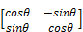

Since the largest component of variance in our initial model is dictated by movements in the market as a whole, our first factor will be defined by the correlation of the sector indices with the market. As we are interested in movements in groups of related sectors, this may not be particularly useful. To find these co-movements and aid in their interpretation, we use rotations. Rotations effectively change the basis of the latent variable vector, i.e., we project the vector on to a new vector which maximizes the contribution of some variables whilst minimizing others. This describes the variance of our initial data in terms of sub groups of initial variables that are highly correlated with specific latent variables allowing us to interpret our multivariate space in terms of these subgroups of variables, e.g., a latent variable found to be highly correlated with tech stocks would be interpreted as being related to tech stocks. As before, successive latent variables describe the variance after the variance of earlier vectors has been accounted for, effectively revealing the movement of groups of indices not necessarily related to the market movement.
In addition to orthogonal rotation, we can also perform oblique rotations. Oblique rotation behaves slightly differently. Whilst it too maximizes the contribution of some sector indices relative to others, it does not impose the constraint that vectors are orthogonal to each other. In many ways this is more typical of what we might expect to see in sub-indices of an equity market, i.e., we would expect tech stocks to co-vary but we would also expect some covariance with the market. Note the total amount of variance captured by our 5 initial latent variables and our rotated 5 latent variables does not change, but the distribution of variance between the vectors does.
Up to now, all of the approaches discussed can be termed exploratory, i.e. we make no initial assumptions about the interrelationships of the index variables.

Structural Equation Modeling (SEM)
Up to this point when performing an analysis, we have assumed no prior knowledge regarding the relationships between the raw returns and the latent variables present by allowing every observed sector index to contribute to every factor or latent variable and using rotation to maximize the contribution of groups of variables on to each factor to provide an interpretable solution. Having determined the relationship between sector indices and our identified factors, SEM allows us to use this knowledge to build an initial model which can subsequently be improved by only allowing a subset of observed sector indices to contribute to each factor. This class of model has several other important features as follows:
- Unlike PCA or FA (in the absence of oblique rotation) we do not impose orthogonality between factors, i.e., like oblique rotation using SEM allows latent variables to covary.
- Like factor analysis, SEM partitions variance explained using latent variables (ξ, λ) and unexplained variance or specific attribute variance (δ). In our case, this is the variance that is specific to an individual index.
- Being based on maximum likelihood rather than matrix decomposition, this technique provides us with a means of measuring goodness of fit statistics to assess the significance of any models and asymptotic standard errors of parameter estimates.
- The method also allows us to specify more complex measurement models, with nested and recursive measurement models by creating paths (interrelationships) between sector indices and latent variables.

The solution to an SEM model depends upon finding solutions to a set of simultaneous equations of the following type, where X_{n} is the index sector return, ξ_{n} is the latent variable score, λ_{n} is the contribution or coefficient of each latent variable score to a sector index and δ_{n} is the specific sector variance not captured by the model.

Because, as with all normal solutions to simultaneous equations, we cannot determine both the coefficient λ and the common factor ξ at the same time, we fix the variance of the common factor ξ to 1. The objective is to minimize the specific variance δ associated with each industry index. The parameters we have to play with are the coefficients λ assigning variance to the latent variables, referred to in SEM language as the paths, covariance between latent variables Φ_{i,j} as in oblique rotation and the specific variance of each index δ. Effectively we partition observed variance between these parameters. The goodness of fit statistic can be thought of as a measure of the adjusted ratio of the variance allocated to the coefficient paths and latent variable correlations to the industry specific variance not captured by the model.
One feature of SEM is that apart from the variance defined by the latent variables, it also enables us to look at interrelationships between variables. That is, after determining the parameters of the model, we find that the residue variance of a one sector index co-varies with another. So, we can then create an additional path between them. One interpretation of the solution is that SEM identifies dependencies between the variables and latent factors of the model. However some authors claim that this interpretation is overly optimistic. The most conservative interpretation is that they capture a combination of causality, dependence on a common unknown factor, and coincidence. In any case, it provides an insight into the data structure.
To illustrate this explanation, we provide a detail from our results that shows the observed relationship between sector indices and a cyclical industry factor. The performance of each of these industrial sectors exhibited covariance which was abstracted into a cyclical industrial factor. After accounting for this covariance, the residual variance of δ of each index was compared. The residual variance of the industrial metal industry was found to show significant covariance with the chemical and industrial engineering industry. Note this residual variance is orthogonal to the cyclical factor itself. Hence we account for this as an industrial metal industry effect on chemicals and industrial engineering. Hence, we have partitioned the variance into three components, a cyclical industry effect, an industrial metal industry effect and the residual index specific variance δ associated with each equity index.
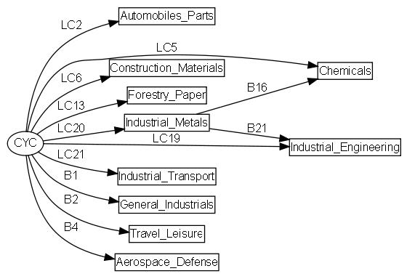
Figure 1 Detail from Figure 7, showing the cyclical industry factor and it’s components to illustrate the interpretation of SEM analysis results.
The approach used in this study is based on that proposed by Jöreskog (1996). We create an initial model from our PCA model which is subsequently updated by adding additional regression and factor loading coefficients based on “modification indices”. These modification indices attempt to identify missing paths which if added improve the ratio of variance fitted to the path coefficients relative to sector specific variance. The improved model is then run, new path coefficients are determined, and the improvement is measured using an adjusted Goodness of Fit statistic penalized for the loss of degrees of freedom.
Applying the approach of Jöreskog (1996) using the SEM R-Package written by John Fox (Fox 2006), we took the results from our PCA analysis with varimax rotation to identify the variables that showed the highest correlation with our latent variables to define our initial model.
To put the methods used into context and provide a bird’s eye view we summarize the methods diagrammatically below. To summarize, it can be seen that (i) principal component factors are pure linear combinations of the initial data, (ii) factor analysis is a linear combination of the initial data that allows for some idiosyncratic variance associated with each input variable and (iii) SEM models include linear combinations of the initial data, an idiosyncratic component, covariance between residuals of each indices not accounted for by our main factors and that our main factors may also have some degree of mutual correlation. SEM therefore provides the most complete view of our observed data by not imposing artificial constraints on our observed data.

X₁
X₂
X₃
X₄
X₅
ξ₁
ξ₂
δ₁
δ₂
δ₃
δ₄
δ₅
Normalized Daily Index Returns
{X_{i,j}-X_{i,Mrkt}}
Principal Components Analysis PCA
Daily Index Returns
{Xi,j}
Orthogonal Rotation
ρ(ξ_{i}ξ_{j})=0
Oblique Rotation
ρ(ξiξj)≠0

Structural Equation Modeling SEM
OR
Confirmatory Factor Analysis CFA
Exploratory
Factor Analysis EFA

X₁
X₂
X₃
X₄
X₅
ξ₁
ξ₂
X₁
X₂
X₃
X₄
X₅
ξ₁
ξ₂
δ₁
δ₂
δ₃
δ₄
δ₅

Φ_{1,2}

Figure 2 Summary of the techniques used to analyze data. Latent variable scores are represented as ξ, market sector returns are X and specific non-systematic variance associated with a variable are shown as δ.

Results
Analyzing the daily returns of Dow Jones GCS sector total return indices for the period Jan 1992 to August 2010 using FA and PCA with varimax rotation, we identified 5 factors. Varimax rotation is the orthogonal rotation technique most commonly used with principal component or factor analysis. The total variance accounted for by the resultant latent variables was 71% for PCA and 67% for FA, the slightly lower figure for FA is consistent with the inclusion of an index specific error term. The same 5 latent variables or factors were identified using both techniques. The correlations between the factors identified are shown below in Table 2.
 | PCA Cyclical | PCA Non-Cyc | PCA Energy | PCA Techs | PCA Finance
FA Finance | 0.03 | 0.04 | 0.00 | 0.02 | 0.97
FA Techs | 0.04 | 0.01 | 0.00 | 0.99 | 0.01
FA Energy | 0.06 | 0.02 | 0.97 | 0.01 | 0.02
FA Non-Cyclical | 0.00 | 0.98 | 0.02 | 0.02 | 0.04
FA Cyclical | 0.97 | 0.03 | 0.04 | 0.01 | 0.07
Table 2 Correlations R² between latent variables determined from factor analysis and PCA of Dow Jones GCS total return indices for the period Jan 1992 to Sep 2010 after 5 factor orthogonal rotation. The names shown illustrate the techniques used FA=Factor Analysis, PCA=Principal Components Analysis and the named factor, e.g., Tech, is a measure of the performance of the high tech industry stocks.
In addition, we compared the overlapping portions of the two data sets used in Table 1 to see if the factors persisted over time. The same 5 factors were identified using both techniques in the daily sector index return data from Data Stream for the period Jan 1980 to Sep 2010. The R² correlation between the overlapping portions of the identified factors are shown in Table 3.
This suggests that these factors are highly persistent over time and were identifiable using incomplete data as in the case of the Data Stream data. In addition the orthogonality of the two sets of factors is preserved, with neither set of factors showing a particularly high level of correlation with any index other than their equivalent factor counterpart.
 | DJ Cyclical | DJ Non-Cyc | DJ Energy | DJ Techs | DJ Finance
DS Finance | 0.01 | 0.01 | 0.00 | 0.01 | 0.74
DS Techs | 0.00 | 0.00 | 0.01 | 0.87 | 0.00
DS Energy | 0.00 | 0.00 | 0.89 | 0.00 | 0.00
DS Non-Cyclical | 0.00 | 0.881 | 0.00 | 0.01 | 0.00
DS Cyclical | 0.74 | 0.00 | 0.00 | 0.00 | 0.00
Table 3 Correlations R² between latent variables determined from PCA analysis of Dow Jones total return indices for the period Jan 1992 to Sep 2010 and Data Stream industry sector price returns for the period Jan 1980 to July 2010. The names shown illustrate the data set used DS=Data Stream US Sector Equity Price data 1980-2010, DJ=Dow Jones US Sector Equity Total Return Index and the named factor, e.g., Energy, is a measure of the performance on energy industry stocks.
As stated previously the factors were determined from a correlation matrix, consequently the factor scores are determined from a linear combination of the standardized (mean = 0, variance = 1) index sector return variables. To adjust the score coefficient’s λ to interpret the results in terms of a percentage holding in an investible index we need to transform the score coeffeiceints. For those interested in this transformation see Strang (2009) or Lattin (2003). To express the coefficients in terms of percentage holdings we need to calculate XU(D^{-.5}) where ξ_{s} are the factors scores, X is our matrix of sector returns, U is a matrix of eigenvectors determined by the rotated PCA solution and D is the diagonal variance matrix, i.e., with the variance of each equity sector return along the diagonal.
The product can be scaled so it represents ‘weights in a portfolio’ that would give factor returns R perfectly correlated with the identified factors. That is, we take each column in the matrix and divide by the absolute sum of the columns to produce a matrix of weights that when multiplied by X give factor returns.
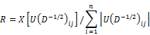
The percentage weights associated with the DJ daily sector index returns for the period Jan 1992 to Sept 2010 are shown in Table 4. This scaling produces a total absolute exposure of 1, i.e. the absolute sum of the weights was 100%. Since there are of course short positions net exposure would be very much lower, in some cases exposure to a factor may mean a net short position.
Since the factors correspond to maximum variance vectors, i.e., they define the directions of maximum variance in the data set, these portfolios are likely to be highly sensitive to changes in the factors described and hence potentially quite volatile.

DJ SECTOR INDEX [code] | Cyclical | Non-cyclical | Energy | Techs | Finance
Aerospace & Defense [2710 ] | 2.7% | 2.0% | -0.2% | 0.3% | -2.1%
Automobiles & Parts [3350 ] | 3.5% | -1.0% | -2.9% | -0.1% | 1.0%
Banks [8350 ] | -1.9% | -2.4% | -1.5% | -2.7% | 9.1%
Beverage [3530 ] | -0.3% | 10.7% | -1.2% | -2.8% | -4.1%
Chemicals [1350 ] | 5.7% | 0.2% | 0.3% | -2.0% | -2.2%
Construction & Materials [2350 ] | 4.2% | -1.6% | 0.5% | -1.2% | 0.2%
Electricity [7530 ] | -7.4% | 1.9% | 11.9% | -2.2% | 3.4%
Electronic & Electrical Equipment [2730 ] | 0.0% | -2.3% | 0.0% | 8.0% | -2.4%
Financial Services [8770 ] | -2.2% | -1.6% | -0.8% | 0.1% | 6.4%
Fixed Line Telecommunications [6530 ] | -5.4% | 0.7% | 2.7% | 4.2% | 2.2%
Food & Drug Retailers [5330 ] | 0.7% | 7.5% | -2.4% | -1.4% | -2.0%
Food Producers [3570 ] | 0.4% | 10.1% | 1.0% | -5.1% | -2.8%
Forestry & Paper [1730 ] | 3.7% | -1.3% | -0.8% | -2.2% | 1.1%
Gas Water Multi-utilities [7570 ] | -6.1% | 0.3% | 13.1% | -0.4% | 1.4%
General Industrials [2720 ] | 1.6% | 0.1% | -2.0% | 1.3% | 1.1%
General Retailers [5370 ] | 2.0% | 2.9% | -4.9% | 2.1% | -0.9%
Health Care Equipment & Services [4530 ] | -2.9% | 6.7% | 0.6% | 1.1% | -1.3%
Household Goods [3720 ] | 2.6% | 8.1% | -3.7% | -3.7% | -2.0%
Industrial Engineering [2750 ] | 5.5% | -0.4% | -1.1% | -0.7% | -2.2%
Industrial Metals [1750 ] | 4.0% | -1.5% | 2.3% | -0.6% | -2.4%
Industrial Transportation [2770 ] | 4.4% | -0.2% | -2.2% | 0.2% | -0.7%
Leisure Goods [3740 ] | 2.2% | 0.0% | -2.6% | 3.2% | -0.9%
Life Insurance [8570 ] | -2.0% | -2.1% | 0.3% | -3.0% | 8.1%
Media [5550 ] | -1.5% | -1.4% | 0.4% | 4.9% | 1.4%
Mining [1770 ] | 2.5% | -1.7% | 5.5% | -1.1% | -2.9%
Mobile Telecommunications [6570 ] | -2.6% | -1.8% | 1.5% | 4.5% | 1.0%
Nonlife Insurance [8530 ] | -3.3% | -0.2% | -0.4% | -2.8% | 8.9%
Oil & Gas Producers [0530 ] | -1.5% | -0.5% | 11.3% | -1.5% | -1.7%
Oil Equipment Services & Distribution [ 0570 ] | -0.6% | -1.9% | 8.2% | 0.0% | -1.2%
Personal Goods [3760 ] | 3.4% | 7.0% | -4.2% | -2.0% | -2.8%
Pharmaceuticals & Biotechnology [4570 ] | -4.1% | 7.4% | 1.0% | 2.5% | -2.5%
Real Estate Investment & Services [8630 ] | 0.9% | -3.6% | -0.4% | -3.4% | 7.2%
Software & Computer Services [9530 ] | -1.6% | -0.7% | -0.5% | 9.3% | -3.4%
Support Services [2790 ] | -1.1% | -0.4% | -0.4% | 8.2% | -1.8%
Technology Hardware & Equipment [9570 ] | -0.8% | -1.4% | -0.7% | 8.9% | -3.1%
Tobacco [3780 ] | -1.5% | 5.0% | 1.6% | -1.4% | -1.7%
Travel & Leisure [5750 ] | 3.2% | 1.3% | -4.8% | 0.5% | 0.7%
Table 4 Percentage weights for a hypothetical portfolio that reproduce returns perfectly correlated with the factor scores determined from our PCA analysis using 5 factor rotated solution. The weights were scaled to give an overall absolute exposure to the market of 1 Factor. The factor names were assigned according to those sector industries which had the highest positive weights in the factor.
The PCA factors are named according to the components that have the highest positive weights on them. For example, the Techs factor had the highest weights on indices such as computer hardware, software and electronic equipment. This naming, however, is somewhat arbitrary since it is noted that the cyclic index has a large negative utilities index. By this convention reversing the sign of the weights would therefore produce a Utilities factor, which presumably had a negative correlation with other cyclic sector indices. This cyclic index will therefore be inversely affected by utilities indices, e.g. we expect this cyclic index to benefit from the negative returns that impacted the utility indexes as a result of the Enron scandal in 2001. It does, however, represent an independent vector through the multivariate sector space and does represent a possible investment portfolio.
The corresponding factor weights can be used to construct factor portfolios. Given that the factors derived are orthogonal, the performance of these portfolios should be independent of each other and of the market as a whole reflecting we assume the co-varying groups of industry sectors they represent. In reality, however, although these factors are independent over the entire period, they exhibit non-zero correlations over shorter time periods. This point is illustrated by plot of a 6-month moving window of the correlation coefficient between the Cyclic and Non Cyclic factors derived from the Data Stream industry sector returns (Figure 3). Hence any investment model based upon these factors still requires the determination of an optimal portfolio based on a Capital Asset Pricing Model to be determined.

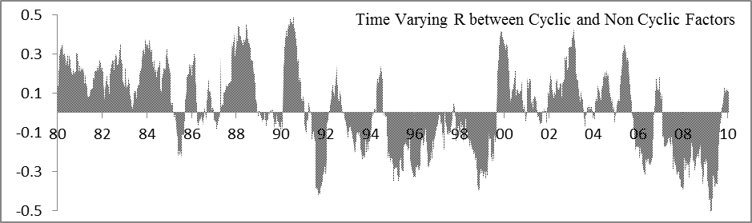
Figure 3 Time varying correlation coefficient R, determined by a 6 month of business data day moving window for the Cyclic and Non Cyclic factors determined from the data stream Jan 1980 – July 2010 industry sector price return data.
To visualize the trends in the factor portfolio, we show a relative price index based on the product of Data Stream index sector prices and portfolio weights from our five factor rotated PCA solution. This was determined by taking our portfolio weights and multiplying them by the prices of the underlying indices. The y axis units are arbitrary since we scaled the index to start at zero (Figure 4).

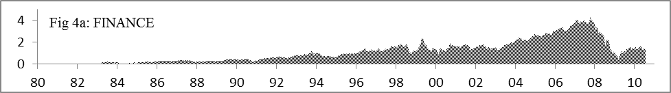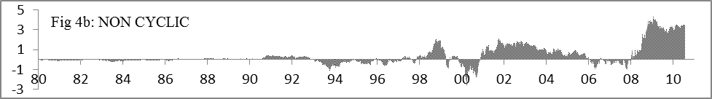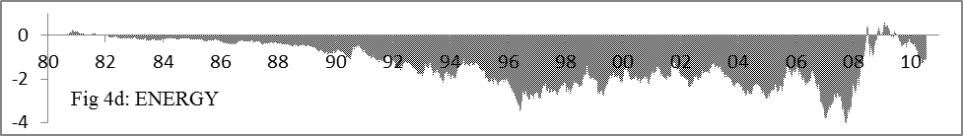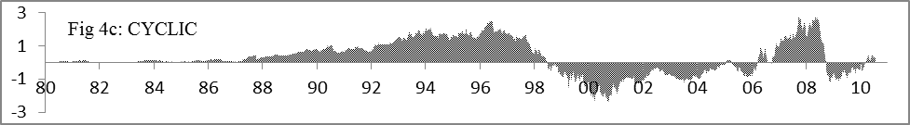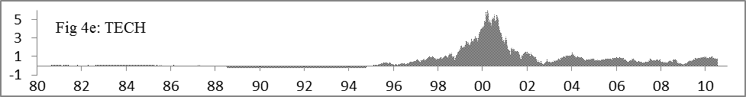
Figure 4 Relative price index of our PCA 5 factor rotated indices determined from the Datastream Jan 1980 – July 2010 industry sector returns. This was calculated from the product of the portfolio weights and the price of the underlying sectors indices. The vertical axis is in arbitrary units since the result was scaled so that each index started at zero.
The relative factor index levels show how each factor index moves independently of the others, capturing orthogonal aspects of the overall market movement. It should be noted that we did not use market adjusted sector indices, i.e., I_{banks}-I_{market}. This being the case, broad market movement is the dominant feature of the model, and will be captured by one of our latent variables. In this case the finance factor includes the broad market movement. Since the component finance sector indices were the group most highly correlated with the overall market suggesting that finance stocks were a main driver or beneficiary of this movement over the period studied. Continuing deregulation of the finance sector, such as the Gramm–Leach–Bliley Act (GLB) which became law in 1999 to repeal part of the Glass-Steagall act, coincides with a steady outperformance of the finance sector. Going forward it will be interesting to see what impact the current wave of tightening of regulation has on this sector of the market. The tech bubble or dot com bubble covering 1995 to 2000 is also clearly seen with a negative impact on the cyclic and most profoundly the non-cyclic factors possible as a result of liquidity issues as investment was transferred away from other sectors of the economy. The onset and development of the 2007 credit crunch can also be seen, with the financial factor falling first, followed by the cyclic factor as the economy slowed with non-cyclic factor showing relative gains as the money that remained in the markets move to safer territory with the energy factor also showing relative gains.
The results shown have been limited to five factors or drivers by explained variance. Because our five factor solution includes short positions as well as long caution must be used to attribute gains to one sector whilst ignoring losses in another. Since we chose five factors and used rotation, the weights assigned to each factor will use the space available. We tried other solutions. For example, when a six factor solution was used our energy factor split into Oil and Utilities, and when we used a 20 factor rotated solution, the resulting factors were highly correlated with only 2 or 3 sector indices per factor. For example, the tobacco sector had its own factor. However, even with such a large number of factors, orthogonality between the factors is preserved, i.e., each factor was independent of the other 19 factors.
Using the five factor solution for the Datastream daily returns as input into a Capital Asset Allocation Model (CAPM) described by Bodie (2008) enables us to devise an optimal portfolio based upon our factor portfolios (Figure 5).

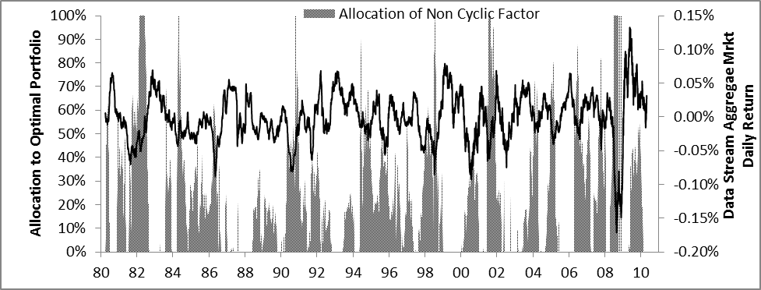
Figure 5 Allocation of Non Cyclic factor determined from Datastream industry sectors returns to an optimal model based on a CAPM model. Also shown is aggregate Data Stream market returns, clearly high allocations of this defensive factor occur during market down turns.
We used a 6-month moving window to determine between factor correlation coefficients and standard deviation. In addition to using daily returns of each portfolio, this also takes in to account volatility and correlation between returns. As we would expect, this shows defensive non-cyclical stocks with higher allocation in periods of poor market performance and with cyclical stocks having a higher allocation in periods of strong market performance. The only departure from this norm occurred during the dot-com boom when tech stocks had a high allocation. The CAPM model also takes account of the time varying correlation coefficient between the factors. In this way when viewed in association with some measure of the business cycle, e.g. relative changes in GDP, the CAPM allocations reveal information about the market timing approach to investment decisions. Clearly factor based portfolios can be used to simplify investment decisions and capture sector variance within the market as a whole.
Whilst the factor portfolios discussed so far capture broad patterns within the stock market as a whole, we were also interested in the micro structure, i.e., can we detect patterns or dependencies within individual sectors. To do this we analyzed the same data using Structural Equation Modeling (SEM). Our assumption was that we could describe a significant proportion of variance in the market in terms of five main factors. The initial model therefore assigned sector indices with a high positive correlation (R> 0.5) to our five main factors. The initial correlation between factors was set at zero. However the model was allowed to relax this condition allowing our five factors to co-vary using a Φ_{ij} parameter. The coefficient Φ_{ij}, allows the factors ξ_{i} ξ_{j} to covary. This is in contrast to previous models, with the exception of oblique rotation, which enforced orthogonality and is a more realistic representation of the market. But the solutions obtained will exhibit a high degree of covariance and are less useful in terms of constructing hedged positions or determining a CAPM solution.
This initial SEM model produced a poor model with a large proportion of the variance attributed to index specific variance. However, using the initial model as a starting point we refined the model by applying the ‘confirm and update’ approach developed by Jöreskog (1996), with the aid of “modification indices”. These modification indices estimate the additional paths that, if added to the model, would result in the greatest reduction of the Χ² fit statistic measuring the lack of fit between our restricted model and an unrestricted full model Lattin (2003). The new path is added and the process repeated. As a practical consideration, when adding subsequent paths, the previously determined parameter estimates were used as initial starting values to help the model converge to a solution. The additional paths improve the fit of the model by capturing more of the variance within industry sector interdependence and through the latent variables and less to the non-systematic sector specific variance. The improvement of the fit with subsequent iterations as additional paths are added after adjustment for a loss in degrees of freedom is shown in Figure 6.

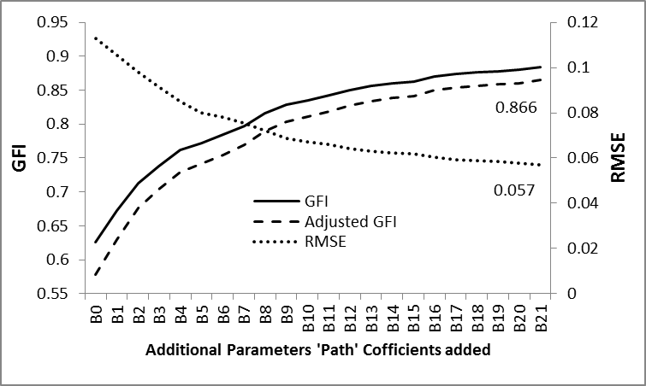
Figure 6 Improvement of model fit as additional paths were added. The initial model was based upon highest correlations between, sector indices and latent variables, addition paths were added according to modification indices, either between indices and latent variables or between indices. Each additional path improves the GFI index as correlations between residual variance is accounted for. The raw data use was daily industry sector returns from Dow Jones based on an absolute return index for the period Jan 1992 – Sep 2010. Terminal values of the AGFI and RMSE are shown. The identification of specific paths is shown in Figure 7, e.g., B12 adds a path between the Health Care Equipment Services index and Pharma Biotech index.
The GFI or Goodness of Fit Index can be thought of as analogous to the adjusted R² used in regression analysis in that it measures the proportion of variance that is accounted for by the estimated population covariance. There has, however, been a good deal of controversy over what constitutes a good measure of fit in an SEM model. For a good overview see Hooper (2008). A more rigorous parameter is the root mean square error of approximation (RMSEA). In this case a lower value is considered to be good. Current research by Hu and Bentler (1999) suggests a value lower than .06 represents a good fit. In this case our model terminal RMSE was 0.057.
A necessary modification to enable the SEM package to converge was the addition of a small constant to the diagonal of the initial covariance matrix derived from industry sector returns. This is required since the covariance model determined from the raw industry sector returns is almost singular, that is the sector returns exhibits strong collinearity. This was added as follows: where S is our initial Covariance matrix, ‘a’ is a small ‘relative to the covariance exhibited’ arbitrary constant and I in the identity matrix. The transformed covariance matrix is S’, where S’ is S modified.
This approach was proposed by Chen (2008) and follows the work of Tychonoff (1943) on the stability of inverse problems for ill posed problems. The work of Chen (2008) shows that the use of S+aI as the initial covariance matrix for Maximum Likelihood problems continues to produce consistent parameter estimates.
The first additional paths unsurprisingly correspond to variables that were not included in the initial model. For example, the first new path to be applied (B1, Figure 7) defines a path between general industries and our cyclic factor. Eventually however, we start to observe addition paths defining relationships between sector industries. For example support services, which include everything from financial and software consultancy to waste disposal was initially linked to our technology factor and software and computer services but subsequently found to also be related to gas/water multi utilities (B19, Figure 7). The diverse relationship of gas/water multi utilities is clearly shown since it is shown to be linked to our energy factor (LE14, Figure 7), residual variance in support services (B19, Figure 7) and residual variance in our electricity index (B7, Figure 7). Note by residual variance, we mean the variance remaining after variance attributed to our main factor has been accounted for. The size of the coefficients defining the paths (not shown here) defines the size and direction of these relationships. The final model with the additional paths added is shown in Figure 7.
The use of maximum likelihood SEM also provides us with a measure of statistical significance of these paths. All of the paths added had less than a 0.1% probability Pr(>|z|)of being identified by chance, in fact the only reason we decided to stop adding paths to the model was because the model was becoming rather complicated and because the improvement associated with the addition of a new path diminished. For practical reasons it is not possible to include the coefficients themselves, but in the Dow Jones case they were all positive, with a magnitude reflecting the strength of the relationship.
In addition to observing that X depends on or is related to Y, SEM also identified recursive relationships, for example using the Datastream sectors, we noted that as a consumer of fuel the Air Transport industry appeared to contribute (or at least co-vary) with are highly oil dependent energy sector. In addition to its dependence upon Air Transport the energy factor is dependent upon a number of industry sectors, in fact Air Transport is only a minor contributor. Therefore we also noted a negative dependency between air transport and the energy sector. The rational is that air transport contributes to the price of oil through demand but at the same time the price of oil reduces the performance of the air transport sector.
Clearly applying SEM in this way provide insights into the interrelationship of sector industry sector indices, it may appear that the model is telling us what we already know, yet in the context of this study this is considered to be a good thing, since it is presenting us with this information in a non-biased and quantitative way. It is interesting however to reflect that when looking at security prices or their proxies and the interrelationships between them, we are observing a man-made phenomenon. It is the collective expectations of the market that give rise to relationships we observe. These relationships however as has been frequently reported may appear irrational (Schiller 1999).

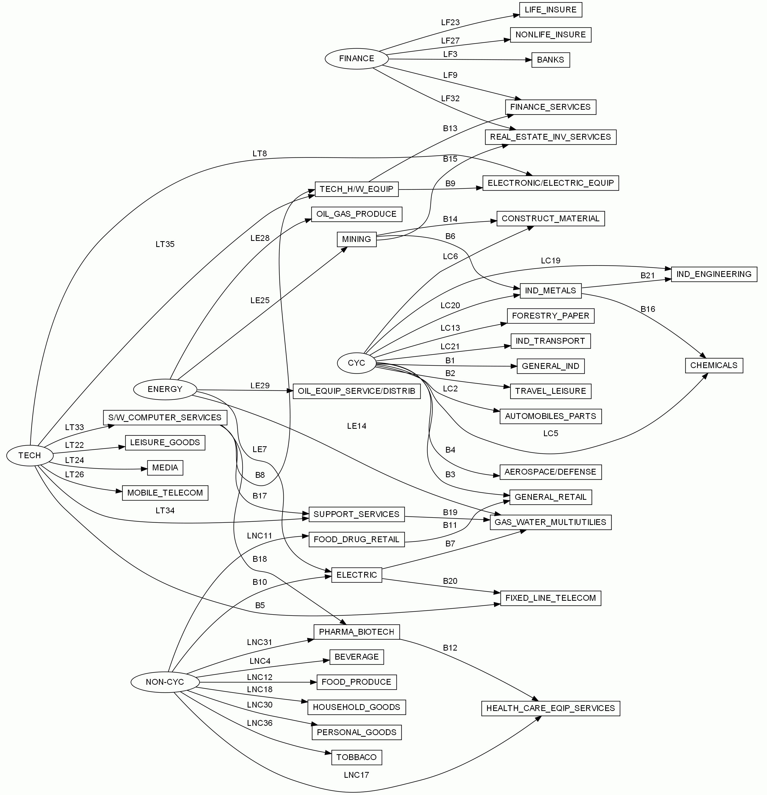
Figure 7 Complete path model, from the analysis of the Dow Jones industry sector returns for the period Jan 1992 to Sep 2010. Coefficient parameters are shown as LE, LNC, LC, LT, LF representing the initial parameters for the Energy, Non-Cyclic, Cyclic, Tech and Finance latent variables identified from the PCA analysis. B_{n} coefficients represent the coefficients added in response to the modification indices identified using the approach of Jöreskog (1996).

Conclusions
Investment through ETF’s and other index based securities offers an investor a means to become exposed to a broad range of underlying equities in the market. This approach is often viewed as a means of diversifying a portfolio to reduce risk. However, this work shows that an investor in industry sector indices may not necessarily achieve the asset diversification they desire. Clearly there are interrelationships between different sector indices both on the macro and micro scale.
These macro interrelationships can be determined using multivariate methods such as PCA and Factor Analysis and simplified into orthogonal factors capturing co movements between sector components and can be translated into investible portfolios. However, even with these underlying factors, the investor is not able to ignore other diversification tools such as capital asset pricing models. A set of factors which are orthogonal over the analysis period having zero covariance may not move independently over a shorter time frame. In addition, asset bubbles or single factor bubbles distort the relationships possibly through market liquidity constraints and are not predictable.
In contrast to the macro picture, micro scale relationships can be determined through Structural Equation Modeling showing how the innovations of prices of individual sector indices are related. In effect PCA and FA show the big picture but SEM shows both the big picture and the detail. The fact that the detailed picture makes sense, i.e., there is a relationship between biotech and health care equipment services pays tribute to the efficiency of the markets. Whilst we expect both industries to be non-cyclical defensive industries, the fact there fortunes are related to each other in manner not related to non-cyclic industries alone suggests there are other separate drivers for these industries.
Whilst multivariate analysis can simplify the investment problem by reducing the number of variables from which an investor has to select from over a given time frame, the fundamental problems remain that of identifying optimal portfolios, determining risk in the factor space, and market timing. The authors are not aware of any way to construct an SEM model based upon leads and lags but if possible, this might reveal some very profitable relationships.
Given these constraint’s, possibly the best place to start when deriving a factor based portfolio is to determine a rolling timeframe to be used in the analysis and to continually update the factor space to reflect innovations within this space. As a final word of caution the impact of sector or factor bubbles should be closely monitored to take account any distortion of the investment space.

References
Bodie Z, Kane A, Marcus AJ (2008) Investments. Irwin/McGraw-Hill
Feeney GJ, Hester DD (1967) Stock Market Indices: A Principal Components Analysis. In: Hester DD Tobn J (ed) Risk Aversion and Portfolio Choice. New York: Wiley and Sons
Fox J. (2006) Structural Equation Modeling with the SEM Package in R. Structural Equation Modeling 13(3):465-486, Copyright© 2006, Lawrence Erlbaum Associates, Inc.
Hooper D, Coughlan J, Mullen, MR (2008) Electronic Journal of Business Research Methods 6(1):53-60
Hu LT, Bentler PM (1999) Cutoff Criteria for Fit Indexes in Covariance Structure Analysis: Conventional Criteria Versus New Alternatives. Structural Equation Modeling 6 (1):1-55
Jöreskog KG, Yang F (1996) Non-linear structural equation models: The Kenny-Judd model with interaction effects. In: Marcoulides GA, Schumacker RE (eds) Advanced structural equation modeling: Issues and techniques. Lawrence Erlbaum Associates pp. 57-88
Lattin ML, Carroll JD, Green EG (2003) Analyzing Multivariate Data. Brooks/Cole Cennage Learning
Meric I, Ratner M, Meric G (2005) The co-movements of the world’s sector index returns. International Journal of Finance 17(1) 3376-3391
Meric I, Ratner M, Meric G (2008) The co-movements of sector index returns in the world’s major stock markets during bull and bear markets: Portfolio diversification implications. International Review of Financial Analysis 17(1):156-177
Meric I, Ratner M, Lentz C, Meric I (2006) Global portfolio diversification implications of the co-movements of Latin American stock markets with the world’s other stock markets. Journal of Emerging Markets 11(3):32-39
Schiller R (1999) Human Behavior and the Efficiency of the Financial System In: Taylor JB Woodford M (eds) Handbook of Macroeconomics Vol. 1 pp1305–1340
Steiger JH (1998) A note on multiple sample extensions of the RMSEA fit index. Structural Equation Modeling 5:411-419
Strang G (2009) Introduction to Linear Algebra. Wellesley – Cambridge Press
Tychonoff A (1943) On the stability of inverse problems Doklady Akademii Nauk SSSR 39(5):195–198
Yuan K Chan W (2008) Structural equation modeling with near singular covariance matrices. Computational Statistics & Data Analysis 52(10):4842-4858.

*************************

