The 6th NCTU International Finance Conference
第六屆交通大學財務金融國際研討會
Conference Theme: Corporate Finance and Risk Management
會議主題：公司理財與風險管理

時間(Date)：102年1月11日（星期五）8：30 AM --17：40 PM
(8：30 AM ~17：40 PM, Friday, January 11, 2013)

地點(Location)：國立交通大學光復校區管理一館
(Management Building 1, National Chiao Tung University, Kuang-Fu Campus)

Program Director:
Cheng-Few Lee, Foundation of Pacific Basin Financial Research and Development, Taiwan and Rutgers University, USA

Program Co-Director:
Wen-Liang Hsieh, National Chiao Tung University, Taiwan

主辦單位(Conference Organizers)：
Institute of Finance, National Chiao Tung University, Taiwan國立交通大學財務金融研究所
Foundation of Pacific Basin Financial Research and Development, Taiwan 財團法人亞太金融研究發展基金會
Rutgers University, USA羅格斯大學

合辦單位(Conference Co-Organizers)：
Executive Master of Business Administration (EMBA), National Chiao Tung University, Taiwan 國立交通大學EMBA
Department of Finance, National Central University, Taiwan 國立中央大學財務金融學系
Financial Engineering Association of Taiwan (FeAT), Taiwan 社團法人臺灣財務工程學會
Kainan University, Taiwan 開南大學

贊助單位(Sponsors)：
Taiwan Stock Exchange Corporation (TWSE), Taiwan 臺灣證券交易所
Wintek Corporation, Taiwan 勝華科技股份有限公司
Taiwan Securities Association, Taiwan 中華民國證券商業同業公會
SCSB Educational Foundation Development, Taiwan 財團法人上海商業儲蓄銀行文教基金會
Yuanta Financial Holding Co., Ltd and Yuanta Cultural & Educational Foundation (Yuanta Foundation), Taiwan 元大金融控股股份有限公司暨財團法人元大文教基金會
China Development Financial Holding Corporation 中華開發金控
GreTai Securities Market 證券櫃檯買賣中心

主辦單位聯絡電話(TEL)：(03)571-2121 Ext. 57071
聯絡地址(Address)： 300新竹市大學路1001號 國立交通大學財務金融研究所
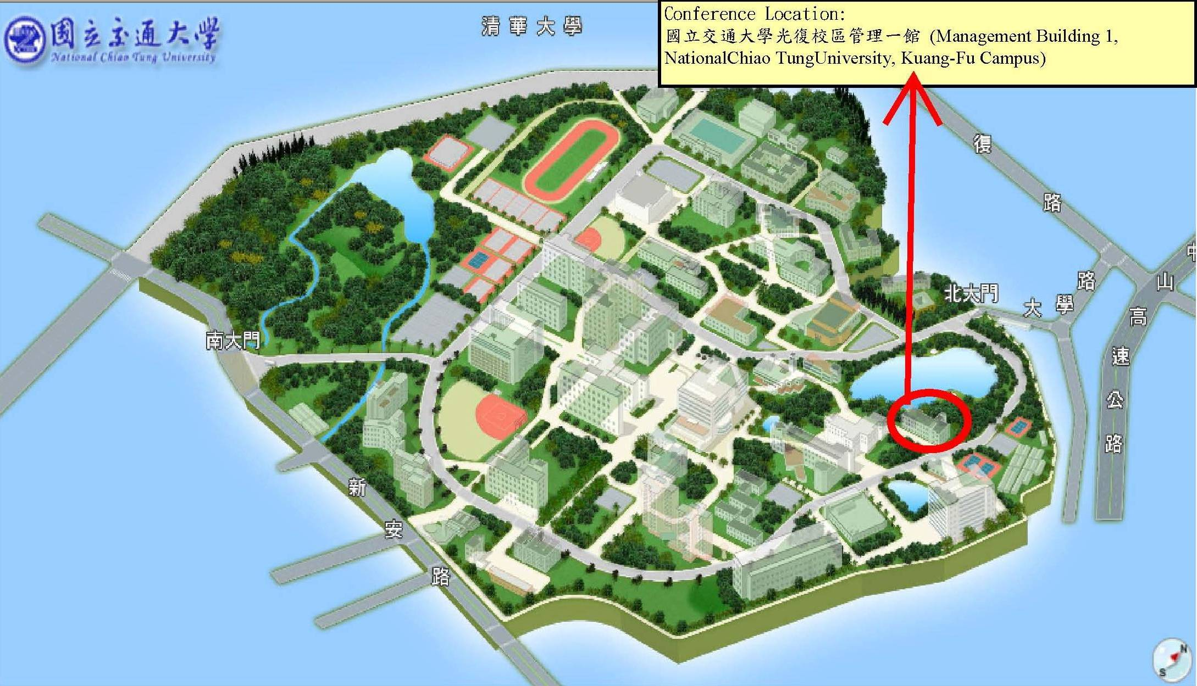
The 6th NCTU International Finance Conference
~∙~ Agenda ~∙~
8:30~9:00 | 報到 Registration
9:00~9:10 | 校長/院長致辭 Welcome Remark | (M-b10)
9:10~9:50  (40mins) | 專題演講(1) Keynote Speech (1)  Speaker: Ching Chang Yen, Yuanta Financial Holdings, Taiwan (顏慶章董事長 元大金控) | (M-b10)
9:50~10:30  (40mins) | 專題演講(2) Keynote Speech (2)  Speaker: Sheng-Syan Chen, National Taiwan University, Taiwan | (M-b10)
10:30~10:45 | 休息Tea Break
10:45~12:25  (100mins) | Panel Session I. 2013年臺灣採用IFRS後的焦點議題 | (M115)
10:45~12:25  (100mins) | Academic Session I. Microstructure | (M116)
 | Academic Session II. Corporate Finance (A) | (M102)
12:25~13:15  (50mins) | 午餐Lunch Time | (M102, M103)
13:15~14:55  (100mins) | Panel Session II. 兩岸金融與台灣金融業的大未來 | (M115)
13:15~14:55  (100mins) | Academic Session III. Risk Management | (M116)
13:15~14:55  (100mins) | Academic Session IV. Corporate Finance (B) | (M102)
14:55~15:10 | 休息Tea Break
15:10~16:50  (100mins) | Academic Session V. Investment | (M115)
15:10~16:50  (100mins) | Academic Session VI. Banking Management and Economic policy | (M116)
15:10~16:50  (100mins) | Academic Session VII. Corporate Finance (C) | (M102)
17:00~17:40 | 專題演講(3) Keynote Speech (3)  Speaker: Cheng-Few Lee, Rutgers University, USA | (M101)

The 6th NCTU International Finance Conference
~∙~ Detailed Program ~∙~
8:30~9:00 | 報到 Registration
9:00~9:10 | 校長/院長致辭 Welcome Remark | (M-b10)
9:10~9:50  (40mins) | 專題演講(1) Keynote Speech (1)  Chairperson: Cheng-Few Lee, Foundation of Pacific Basin Financial Research and Development, Taiwan and Rutgers University, USA  Speaker: Ching Chang Yen, Yuanta Financial Holdings, Taiwan  (顏慶章董事長 元大金控)  Title: What Lessons Taiwan Can Learn from the European Debt Crisis (歐債危機對臺灣的啟示) | (M-b10)
9:50~10:30  (40mins) | 專題演講(2) Keynote Speech (2)  Chairperson: Wen-Liang Hsieh, National Chiao Tung University, Taiwan  Speaker: Sheng-Syan Chen, National Taiwan University, Taiwan (陳聖賢教授 國立臺灣大學)  Title: Some Recent Trends in Empirical Corporate Finance Research | (M-b10)
10:30~10:45 | 休息Tea Break
10:45~12:25  (100mins) | Panel Session I. 2013年臺灣採用IFRS後的焦點議題  Chairperson: Rebecca Chung Fern Wu, Professor of Accounting and Director of Financial Econmic Intelligence and Regulation Research Center, National Taiwan University, Taiwan (Pre-commissioner, Financial Superviosry Commssion) (吳琮璠教授 臺灣大學會計系曁財經智慧法規研究中心主任(前首任金管會委員))  Panelists：  - Mei-Hwa Lin, Department of Accounting, National Chengchi University, Taiwan (林美花教授 國立政治大學會計學系)  - Yi Hsin Wang, Vice President, and Professor of Department of Accountancy, National Taipei University, Taiwan (王怡心副校長 臺北大學會計系教授暨國際會計準則翻譯覆審委員會)  - Chen Shan Chang, Director, Accounting and Auditing Supervision Division, Securities and Futures Bureau, Financial Supervisory Commission, Taiwan (張振山組長金融監督管理委員會證券期貨局)  - Joseph Chou, PricewaterhouseCoopers(PwC), Taiwan (周建宏會計師 資誠聯合會計師事務所審計部營運長) | (M-115)
10:45~12:25  (100mins) | Academic Session I. Microstructure  Chairperson: Quentin C. Chu, University of Memphis, USA  - Trades by Investors and Commonalities in Liquidity and Order Imbalances: Evidence from an Emerging Market  Chaoshin Chiao, National Dong Hwa University, Taiwan  Zi-May Wang, Ming Chuan University, Taiwan  Han-Lin Chen, Ming Chuan University, Taiwan  - High Frequency Trading, Liquidity, and Execution Cost  Edward W. Sun, BEM Management School Bordeaux, France & School of Economics and Business Engineering, KIT, Germany  Timm Kruse, School of Mathematics, KIT, Germany  Min-Teh Yu, National Chiao Tung University, Taiwan  - Do Settlement Procedures Matter? Revisit Expiration-Day Effects  Emily Lin, St. John’s University, Taiwan  - Modeling the Liquidity Risk under Information Asymmetry  Te-Chien Lo, National Dong Hwa University, Taiwan | (M116)
10:45~12:25  (100mins) | Academic Session II. Corporate Finance (A)  Chairperson: Hai-Chin Yu, Chung Yuan Christian University, Taiwan  - Corporate Hedging and The Cost of Debt  Jun Chen, University of North Carolina at Charlotte, USA  Tao-Hsien Dolly King, University of North Carolina at Charlotte, USA  - Compensation gaps among top executives: the role of the peer groups  Chi-Hung Chang, National Chiao Tung University, Taiwan  Min-Teh Yu, National Chiao Tung University, Taiwan  - Pricing Guaranteed Minimum Withdrawal Benefits with Various Provisions under a Stochastic Interest Rate Environment  Tian-Shyr Dai, National Chiao Tung University, Taiwan  Sharon S. Yang, National Central University, Taiwan  - R&D Spillover Effects and Firm Performance Following R&D Increases  Sheng-Syan Chen, National Taiwan University, Taiwan  Yan-Shing Chen, National Yunlin University of Science and Technology, Taiwan  Woan-lih Liang, Yuan Ze University, Taiwan  Yanzhi Wang, National Taiwan University, Taiwan | (M102)
12:25~13:15  (50mins) | 午餐Lunch Time | (M102, M103)
13:15~14:55  (100mins) | Panel Session II. 兩岸金融與台灣金融業的大未來  Chairperson: Yin-Hua Yeh, National Chiao Tung University, Taiwan (葉銀華教授 交大財金所)  Panelists：  - Alan Wang, Chairman & CEO of China Life Insurance Company., Ltd., Taiwan (王銘陽董事長 中國人壽保險股份有限公司)  Topic: The future development of Cross-strait life insurance industry (兩岸壽險業未來發展)  - Nan-Chou Joseph Huang, President, E.SUN Financial Holding Co., Ltd., Taiwan (黃男州總經理 玉山金控)  Topic: The development of cross-strait banking and cash flow business (兩岸銀行與金流業務之發展)  - Mark Wei, Chairman, KGI Securities Co., Ltd., Taiwan (魏寶生董事長 凱基證券)  Topic: OSU (Offshore Securities Unit) and cross-strait securities development (離境證券業務（OSU）與兩岸證券發展) | (M115)
13:15~14:55  (100mins) | Academic Session III. Risk Management  Chairperson: Chuang-Chang Chang, National Central University, Taiwan  - Forgive yet Penalize Your Debtor: A Default Threshold Model of Sovereign Debt  David S. Sun, Kainan University, Taiwan  Da Ching Chow, Yuan Ze University, Taiwan  - Forecasting Forward Defaults More Accurately: A Simple Hazard Model with Competing Risks  Ruey-Ching Hwang, National Dong Hwa University, Taiwan  - Using Alternative Models and a Combining Technique in Credit Rating Forecasting — an Empirical Study  Cheng-Few Lee, Rutgers University, USA  Keh-luh Wang, National Chiao-Tung University, Taiwan  Yating Yang, National Chiao-Tung University, Taiwan  Chan-Chien Lien, E.SUN Commercial Bank, Taiwan  - Instantaneous Volatility Estimation by Nonparametric Fourier Transform Methods  Chuan-Hsiang Han, National Tsing-Hua University, Taiwan | (M116)
 | Academic Session IV. Corporate Finance (B)  Chairperson: Chin-Chen Chien, National Cheng-Kung University, Taiwan  - An Integrated Model for the Cost-Minimizing Funding of Corporate Activities over Time  Manak C. Gupta, Temple University, USA  Hong-Yi Chen, National Central University, Taiwan  Alice C. Lee, State Street Corp., USA  - Benefits and Costs of Asset Reallocation in Mergers and Acquisitions  Wei-Hsien Li, National Central University, Taiwan  - Are Multiple Directorships Beneficial in East Asia?  Kin-Wai Lee, Nanyang Technological University, Singapore  Cheng-few Lee, Rutgers University, USA  - Is Earnings Management an Efficient Tool to Reduce the Diversification Discount?  Sue-Fung Wang, National Chiao Tung University, Taiwan  Yi-Cheng Shih, National Taipei University, Taiwan  Ya-Han Hsu, National Chiao Tung University, Taiwan | (M102)
14:55~15:10 | 休息Tea Break
15:10~16:50  (100mins) | Academic Session V. Investment  Chairperson: Hsuan-Chu Lin, National Cheng-Kung University, Taiwan  - Relationship between Stock Return Volatility and Informed Trading Activity  Alex YiHou Huang, Yuan Ze University, Taiwan  Ching-Liang Chang, Yuan Ze University, Taiwan  - Product Market Competition and Earnings Management around Open-market Repurchase Announcements  Wen-Chun Lin, National Taipei College of Business, Taiwan  Tsai-Ling Liao, National Formosa University, Taiwan  - Asymptotic Distribution of Sharpe Ratio under Weakly Stationary Portfolio Returns  Lie-Jane Kao, KaiNan University, Taiwan  Cheng-Few Lee, Rutgers University, USA  - The Information Content of the Limit Order Book and the Corresponding Trading Strategy  William T. Lin, Tamkang University, Taiwan and The Center for Research of Private Economy, Zhejiang University, China  Shih-Chuan Tsai, Taiwan Normal University, Taiwan  Zhenlong Zheng, Xiamen University, China  Pei-Yau Lung, Tamkang University, Taiwan | (M115)
 | Academic Session VI. Banking Management and Economic policy  Chairperson: Chung-Hua Shen, National Taiwan University, Taiwan  - Can Federal Reserve Policy Deviation Explain Response Patterns of Financial Markets Over Time?  Kent Wang, WISE, Xiamen University, China  Shin-Huei Wang, CORE, Universite Catholique de Louvain, Belgium  - Are Bank Capital Buffers Cyclical? Evidence from Developed and Developing Countries  Yi-Kai Chen, National University of Kaohsiung, Taiwan  Amy Yueh-Fang Ho, Providence University, Taiwan  Ching-Lan Hsu, National University of Kaohsiung, Taiwan  - The Impact of State Policies on the Relation between Ownership and Firm Value: Evidence from Chinese Listed Firms  Li Cheng, Providence University, Taiwan  Yenn-Ru Chen, National Cheng Kung University, Taiwan  Jeng-Ren Chiou, National Cheng Kung University, Taiwan  Cheng-few Lee, Rutgers University, USA  - Post-Merger Risk and Long-term Performance: The Role of Ownership Stake in Banking Merger Activities  Yin-Hua Yeh, National Chiao Tung University, Taiwan  Huimin Chung, National Chiao Tung University, Taiwan  Chih-Liang Liu, National Yunlin University of Science and Technology, Taiwan | (M116)
 | Academic Session VII. Corporate Finance (C)  Chairperson: Chiuling Lu, National Taiwan University, Taiwan  - Tournament Incentives and Firm Innovation  Carl Hsin-han Shen, National Central University, Taiwan  Hao Zhang, Rochester Institute of Technology, USA  - Growth Options and Managerial Compensation over the Business Cycle  Hsing-Hua Huang, National Chiao Tung University, Taiwan  Wei-liang Chuang, National Chiao Tung University, Taiwan  - Criminalizing Employee Negligence  Jiong Gong, University of International Business and Economics, China  R. Preston McAfee, Yahoo! Research, USA  Michael A. Williams, Competition Economics LLC, USA  - The Role of Heterogeneous Expectations in Forward Exchange Market  Xiaoping Li, Shanghai Lixin University of Commerce, China  Chunyang Zhou, Shanghai Jiao Tong University, China  Chongfeng Wu, Shanghai Jiao Tong University, China | (M102)
17:00~17:40 | 專題演講(3) Keynote Speech (3)  Chairperson: Sharon S. Yang, National Central University, Taiwan  Speaker: Cheng-Few Lee, Rutgers University, USA  Title: Dividend Policy and Dividend Payment Behavior: Theory and Evidence | (M101)

