2014 PBFEAM GUIDE

Contents pg

1.0 To and From Chubu International Airport 2
1.1 Train 2
1.2 Bus 3
1.3 Taxi 3
1.4 Private Shuttle 3

2.0 Hotels around Nagoya Station 4

3.0 Subway Map 5

4.0 Location Nagoya Campus, Aichi University 5

5.0 Room Price at Nagoya Marriott Associa Hotel; 6

Nagoya Convention & Visitors Bureau
http://www.nagoya-info.jp/en/

1.0 To and From Chubu International Airport

Centrair (Chubu International Airport: http://www.centrair.jp/en/) is the gateway of Central Japan to the sky. It takes 28 minutes by train and 30-40 minutes by car from Nagoya. http://www.centrair.jp/en/to_and_from/

1.1 Train:
Central Japan International Airport and Nagoya are just 28 minutes away from each other via the Nagoya Railroad (Meitetsu). http://www.centrair.jp/en/to_and_from/access/train.html
Fares are range from 870 yen (many station stops) to 1260 yen Meitetsu Myu-SKY Ltd. Exp. (less station stops)

Station Timetable (Meitetsu Myu-SKY Ltd. Exp.)
From Airport to Nagoya
http://www.hyperdia.com/cgi/en/deptime.html?dep_node=CENTRAL%20JAPAN%20INTERNATIONAL%20AIRPORT(NGO)&arv_node=MEITETSUNAGOYA&search_target=deptime&diagram=74407&year=2013&month=10&day=26&searchday=20131026

From Nagoya to Airport
http://www.hyperdia.com/cgi/en/deptime.html?dep_node=MEITETSUNAGOYA&arv_node=CENTRAL%20JAPAN%20INTERNATIONAL%20AIRPORT(NGO)&search_target=deptime&diagram=74477&year=2013&month=10&day=26&searchday=20131026

Nagoya Station Transfer Map

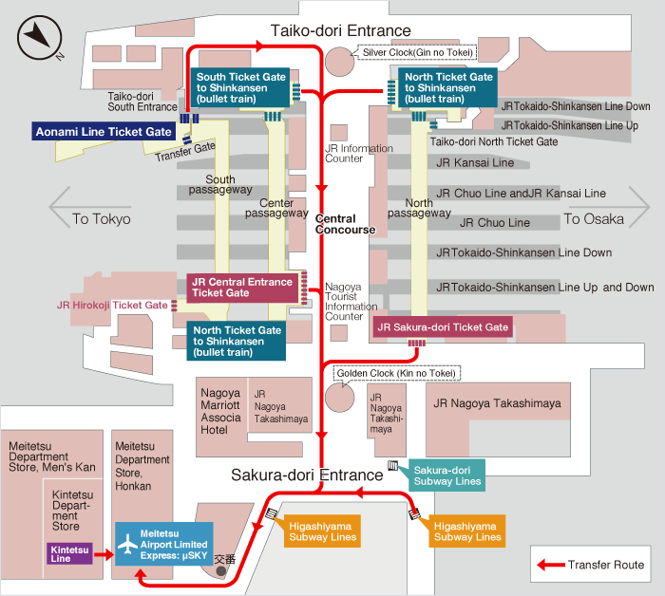
1.2 Bus:
Bus to Downtown Nagoya (Sakae/Fushimi) leave from Central Japan International Airport
Departure time: 11.15am; 3.15pm; 6.15pm & 10.15pm
http://www.centrair.jp/en/to_and_from/access/pdf/bus_02.pdf

Stops at Downtown Nagoya (Sakae/Fushimi): Nagoya Tokyu Hotel; Sakae (Oasis 21); Nishiki Dori Honmachi; Nagoya Kanko Hotel & Fushimi cho.

Bus from Downtown Nagoya (Sakae/Fushimi) to Central Japan International Airport
Departure time:
Fushimi cho | 6.50am | 9.30am | 1.30pm | 5.30pm
Hilton Nagoya | 6.52am | 9.32am | 1.32pm | 5.32pm
Nagoya Kanko Hotel | 6.59am | 9.39am | 1.39pm | 5.39pm
Nishiki Dori Honamchi | 7.01am | 9.41am | 1.41pm | 5.41pm
Sakae(Oasis21) | 7.08am | 9.48am | 1.48pm | 5.48pm
Nagoya tokyu hotel | 7.18am | 9.58am | 1.58pm | 5.58pm

http://www.centrair.jp/en/to_and_from/access/pdf/bus_01.pdf

Between Sakae and Nagoya Station may use a taxi (The fare is less than USD10.) or Subway that cost 200yen (5 minutes travel) using Higashiyama Line.

1.3 Taxi:
There are a number of taxi companies available at Central Japan International Airport, as well as a "noriai taxi" (rideshare taxi) for your convenience.

Taxis fare is estimated between 16,150yen to 20,650yen from Airport to Nagoya Station.

http://www.centrair.jp/en/to_and_from/access/pdf/taxi_01.pdf

1.4 Private Shuttle
A chartered jumbo taxi service between Centrair (Chubu International Airport, Central Japan International Airport) and hotels in major tourist destinations in Central Japan for a set price. It is a special price which is applied to the passengers who stay at a hotel in Central Japan. The vehicle is a jumbo taxi which has a capacity of 9 passengers and a wide baggage space. If you have more companions, you will get more advantage of our taxi more economically. Come together and travel for a more reasonable price.

http://www.centrair.jp/en/to_and_from/access/limousine.html

2.0 Hotels around Nagoya Station

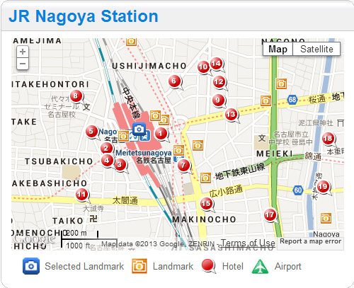

http://www.agoda.com/asia/japan/nagoya/attractions/hotels_near_jr_nagoya_station.html

- Nagoya Marriott Associa Hotel; 0.08km (5 star ranking)
http://www.associa.com/english/nma/

- Toyoko Inn Nagoya-eki Shin-kansen-guchi; 0.13km (2 star ranking)
http://www.toyoko-inn.com/e_hotel/00094/

- Eco Hotel Nagoya; 0.15km (1 star ranking)
http://ecohotelnagoya.com/

- Daiichi Fuji Hotel; 0.16km (4 star ranking)
http://www.fujihotel-nagoya.com/daiichi/eng/

- Nagoya Summit Hotel; 0.16km (2 star ranking)
http://www.summit-h.co.jp/

- Nagoya Ekimae Montblanc Hotel; 0.2km (3 star ranking)
http://www.montblanc-hotel.jp/

- Meitetsu Grand Hotel; 0.21km (5 star ranking)
http://www.meitetsu-gh.co.jp/en/

- Chisun Inn Nagoya; 0.23km (2 star ranking)
http://www.solarehotels.com/en/hotel/tokai/chisuninn-nagoya.html

- Hotel Resol Nagoya; 0.29km (3 star ranking)
http://www.resol-hotel.jp/resol/en/

- Toyoko Inn Nagoya-eki Sakuradori-guchi Honkan; 0.3km (2 star ranking)
http://www.toyoko-inn.com/e_hotel/00022/

- New Shochikubai Hotel; 0.3km (1 star ranking)

- Meitetsu Inn Nagoya Sakuradori; 0.32km (3 star ranking)
http://travel.rakuten.com/hotelinfo/86/107886/

- Castle Plaza Hotel; 0.32km (4 star ranking)
http://www.castle.co.jp/plaza/en/

- Toyoko Inn Nagoya-eki Sakuradori-guchi Shinkan; 0.34km (2 star ranking)
http://www.toyoko-inn.com/e_hotel/00092/

- Daiwa Roynet Hotel Nagoya-Ekimae; 0.35km (3 star ranking)
http://www.daiwaroynet.jp/english/nagoyaekimae/

- Dormy Inn Nagoya; 0.55km (3 star ranking)
http://www.hotespa.net/hotels/nagoya/

- Nagoya New Rolen Hotel; 0.65km (2 star ranking)
http://www.rolenhotel.co.jp/

- Richmond Hotel Nagoya Nayabashi; 0.67km (2 star ranking)
http://richmondhotel.jp/en/nagoya/

3.0 Subway Map

You can get Subway and JR Train Route Map at http://www.kotsu.city.nagoya.jp/dbps_data/_material_/localhost/_res/english/_res/pdf/subwaymap.pdf

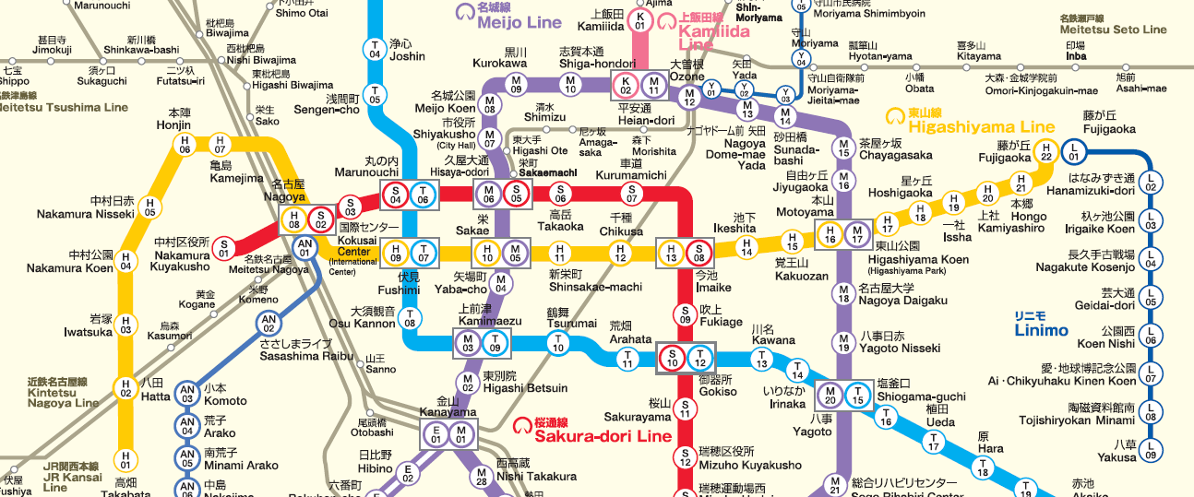

Kurumamichi Campus
Nagoya Campus

4.0 Location Nagoya Campus, Aichi University

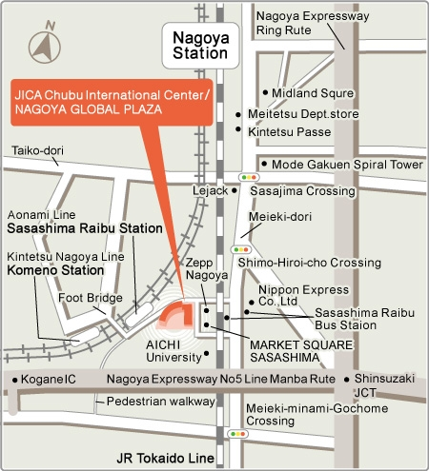
Aichi University
South of JICA

5.0 Room Price at Nagoya Marriott Associa Hotel;
Tel: +81 52 584 1113

Hotel Price with tax
Standard Room 17,383yen/person (Normal Price; 26,000yen/person)
Standard Room 23,554yen for 2 persons (Normal Price; 34,000yen/person)

Deluxe Room 19,440yen/person (Normal Price; 32,000yen/person)
Deluxe Room 25,611yen for 2 persons (Normal Price; 40,000yen/person)

This is discount price for the PBFEAM 2014 conference and need to contact us by sending an email for room reservation; 2014pbfeam@gmail.com
Please provide us:
- Name
- Contact Number
- Email address
- Number of person in the room
- Type of room

