|  |  |
| --- | --- |
|  | **PACIFIC TRAVEL INVESTMENT SERVICE TRADING CO.,LTD**  Address: 57/2 Bau Cat 9, Ward 14, Tan Binh District, Ho Chi Minh City  Tel: (84-8) 2243.7572 – 73 – 74 * Fax: (84-8) 6296.5455  Email: dulichthaibinhduong@yahoo.com.vn |

**COUNTRYSIDE TOUR PROGRAM**

**MY THO PROVINCE – LAN ISLET – PHUNG ISLET**

**FISH CATCHING**

**Duration: 01 day (July 18th, 2015)**

**Transportation: Bus**

------ 🙦🙤 -------

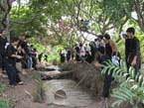**06:00 am** Tour guide will pick up and transfer to Tien Giang province by bus. Have breakfast at Trung Luong restaurant.  Join some funny games while moving on the bus.

**08:30am** Boat tour along Tien river and discover fish –feeding activities and view overall four islets (Dragon, Unicorn, Phoenix, Turtle).

**09:00am** Visit the Phoenix islet (Coconut religion, coconut land), learn how to make coconut candy at a coconut workshop and visit handicraft villages, crocodile farm, gallery where you can see the celebrities and historic relics of Ben Tre province. Enjoy honey tea, tropical fruits and listen to folk music.

-          Walk along the countryside path to see the daily activities of locals.

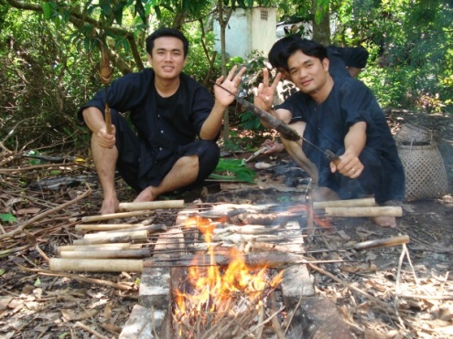

**10:30am** Being a local farmer to catch fish in traditional way. Enjoy grilled fish at the local garden.

-          Stroll along the canals on a rowing boat.

**12:00am**  Have lunch with local specialities.

**14:30am** Get on the boat and go back to My Tho city, visit Vinh Trang pagoda and then come back to Ho Chi Minh.

**17:30am** Drop you off at your place in Ho Chi Minh city, good bye and see you next time.

Price: **550.000vnđ/pax** for group of 40 pax

Included:

- Air-conditioner coach (Univer)

- Meals in the tour (attached menu)

- Breakfast at Trung Luong restaurant (pork noodles, beef noodles, omelet with bread, coffee, soft drink)

- English speaking tour guide

- Entrance fee

- Tourism insurance (maximum 20.000.000vnd/pax)

- Mineral water (1 bottle 500ml/day/pax)

- VAT

- Tip for tourguide and driver

Excluded:

- Personal services and expenses

- Ostrich riding, crocodile fishing