Chapter 24 Solutions

1. Portfolio insurance is a strategy which may allow portfolio managers to limit downside risk while maintaining upside potential.

Stop Loss Order - a conditional market order which indicates that the investor wishes to sell his holdings when the market price (asset price) drops to a predefined level.

Synthetic Options - a call option like position can be created by being long in equities and lending or/and borrowing the risk free asset. A put option like position can be created by selling short the equity and investing the funds at the risk-free rate. As the market decrease in value, more equity is sold with the proceeds invested in the risk-free asset. If the market increases, money borrowed to buy stock and reduce the short position.

Dynamic Hedging - the hedging or selling of futures contracts to adjust the risk exposure of the portfolio

2. Hedging reduces the risk of a portfolio to zero and locks in a certain return.

Portfolio insurance tries to eliminate the downside loss while maintaining the upside potential.

3. a) Cushion = Total Value − floor
= $10m − $7m = $3m
b) Exposure = Investment in risky assets to = $5m
c) m = e/c = $5m/$3m = 1 2/3

4. a) $5m(l + .3) = $6.5m risky assets

b) m = e/c = $6.5m/$4.5m = 1.44 Cushion = 11.5 − 7 = 4.5

c) m = 1 2/3 – X/4.5m
X = $7.5m

She must sell some of the risk-free asset ($1m) and invest the proceeds in the risky asset. So that the corporation of the portfolio is:
$ 7.5m risky asset
4m in risk-free asset
11.5m total value of the portfolio

As the market changes, the amount of borrowing or Lending is related to the delta value of the option.
5. When risky assets decreases by 10%, current risky asset is $5m(l -10%) =$4.5m
(a) Total value of the portfolio is current risky asset + risk-free asset =$4.5m+$5m=$9.5m
(b) The new multiple is m = e/c = $4.5m / $2.5m =1.8
Exposure = Investment in risky assets to = $4.5m
Cushion = Total Value – floor=$9.5m-$7m=$2.5m

(c) Target level of multiple in question 3 is 5/3.
e/c = X / $2.5m = 5/3, X= $4.167m
Therefore, she must sell some of the risky asset ($4.5m-$4.167m=$0.333m) and invest the proceeds in the risky asset. So that the corporation of the portfolio is:
$ 4.167m risky asset
$5.333m in risk-free asset
$9.5m total value of the portfolio

6.
Path dependence explains how the set of decisions one faces for any given circumstance is limited by the decisions one has made in the past, even though past circumstances may no longer be relevant.
In the view of portfolio insurance, the insurance strategies should work regardless of the subsequent movement of the market; thus it should be path independent. If the portfolio insurance strategy has the characteristic of path dependence, it may cause problem. For example, Stop-loss orders strategy allows to make money if the market goes up and cuts the losses to a predetermined level should the market fall. However, if the market falls, the stop-loss order is executed, and the portfolio is sold, the portfolio manager needs to make a decision about when to get back into the market. The manager should consider the market movement in the past to make a decision whether buy back assets or not. Therefore, the path dependence character on stop-loss orders strategy may cause the wrong decision that if the market were to continue to fall after the execution of the stop-loss order, the portfolio manager with 100% cash would be in a position enhanced by the portfolio insurance — that is, 100% cash in a falling market.

7.
Synthetic options are not options but a strategy for allocating assets that replicates the return on an option. The key variable in this strategy is the delta value, which measures the change in the price of an option with respect to the change in the value of the portfolio of risky stocks. The delta of an option, Δ, is defined as the rate of change of the option price respected to the rate of change of underlying asset price:
Δ = ∂Π/∂S, where Π is the option price and S is underlying asset price.
The synthetic options strategy is to buyΔshares in a rising market and sell Δshares in a falling market to hedge and replicate the return on option.

8. Delta value is the change in the value of an option given a $1 change in the value of the underlying stock. The value of the delta and its change will indicate how much rebalancing is required for the portfolios to remain insured.

9.

10. The result of a perfect hedge is dependent upon two assumptions: 1) the relationship of the volatility of the portfolio to the volatility of the index remains the same, i.e., the Beta doesn't change. 2) the movement of the price of the futures contract is in lock step with the movement of the Index, they are perfectly positively correlated.

11.
Portfolio insurance with options | Portfolio insurance with futures
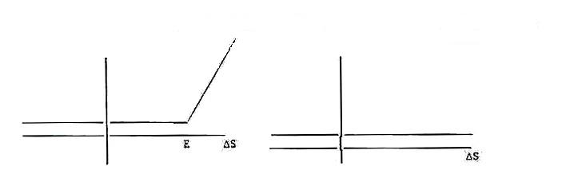

The use of options allows for a floor to the value of the portfolio at the same time as it allows for an increase in the value of the portfolio if the prices of the underlying assets increase.

With futures the value of the portfolio is fixed regardless of the change in price of the underlying assets.

12. When stock prices begin to fall portfolio managers using portfolio insurance to hedge their positions. Investors start selling futures and use the funds to invest in risk-free assets. The fall in the value of the futures with respect to the stock market creates an arbitrage opportunity for arbitrageurs to buy the cheap futures and sell the expensive stock. Thereby causing the stock market to fall. As the market falls, the portfolio managers need to sell more futures to insure their portfolios and the process starts again. Once this cycle begins, it may be difficult to stop. In this case, we have a case of the tail wagging the dog, i.e., the small futures market causes the larger stock market to move

13. Margin on equities is defined as borrowing money to invest in securities and is depicted below.
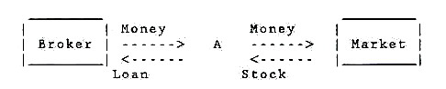
Margin in the futures markets means a down payment or good faith money which will insure future performance, and is depicted below.
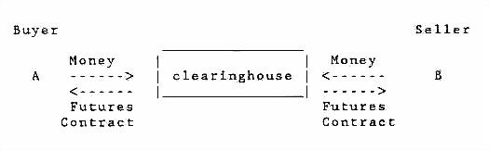
Both buyer and seller must put up margin as a sign of good faith that they will carry out the terms of the futures contract, it also serves as a down payment should the futures contract be delivered.

