CHAPTER 4 INTORDUCTION TO VALUATION THEORIES

1. Arbitrage is the act of simultaneously buying and selling two identical items selling at different prices to earn a riskless profit. The concept arbitrage is important in security analysis because it plays a fundamental role in models of security valuation.

2.

3.

IP = Coupon rate × Maturity value
= .09 × $1,000 = $90

4. A callable bond is a bond that the issuer has the right to Retire prior to maturity, usually for a price above the face value.

A noncallable bond will have greater value than a callable bond because the issuer will not be able to retire the bond early.

5. Under the Modigliani-Miller assumption, dividend policy will be irrelevant to the determination of the firm's value. The reason for this conclusion is that if investors prefer higher current dividends than the firm is paying, they can create the desired cash flow by borrowing against future dividends.

6. a)
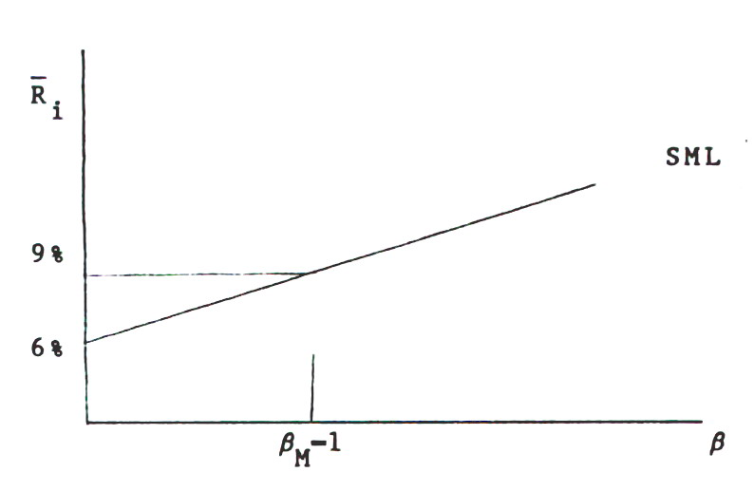

b)

7.
a) Call option - gives the purchaser the right but not the obligation to purchase a specified number of shares of a specific stock during a specific time period.

b) Put option - gives the purchaser the right but not the obligation to sell a specified number of shares of a specific stock during a specified time period.

c) Exercise price - price at which the underlying stock of the option can be bought or sold.

8. By purchasing a call option instead of IBM stock, you allow yourself to participate if the price of IBM stock rises while limiting your losses to the premium paid. The disadvantage of purchasing an option instead of the stock is that: i) the option may expire worthless and it will be necessary to purchase another option; ii) option holders do not receive any dividends.

9. Because options have limited downside risk (limited to premium) a higher variance for the stock increases the chances of the option expiring "In the money" so the greater the variance of IBM's stock price, the greater the value of the option.

10. The call money rate is the interest rate which a broker charges on loans used to buy securities. The rate is generally 1 percent below the prime rate.

11. A perpetuity represents an infinite amount of equal payments made at equal intervals.

12. Modigliani and Miller's Proposition I first introduced the concept of using arbitrage to determine value. This concept has been used by Black and Scholes to derive an option pricing model and by Ross to derive the APT asset pricing model.

