CHAPTER 9 CAPITAL ASSET PRICING MODELS AND BETA FORECASTING

1. The capital market line (CML) describes a linear relationship between expected return and total risk. The equation for the CML is:

The CML prices portfolios and the risk free asset. The SML prices securities, portfolios, and the risk free asset. The SML can be used to identify over or undervalued securities, whereas the CML cannot.

The CML is used to derive the SML under a set of assumptions.

2. E(R_{i}) = R_{f} + β_{i} [E(R_{m}) – R_{f}] = .05 + 2 [.09 – .05]
E(R_{i}) = .13
The firm with a beta of 2 should be earning a return of 13%. It is only earning a return of 9%, therefore, the stockholders are not receiving a fair return for the amount of risk they are taking. Hence, the firm should be granted a rate increase.

3.
The firm should earn a return of 9.5% for its risk level. It is expected to earn 15%, this is a good deal. Therefore, purchase stock ABC.

4. a)
E(R_{i}) = R_{f} + β[E_{i}(R_{m}) – R_{f}]
.07 = R_{f} + .7(E(R_{m}) – R_{f}) => .07 = R_{f} – .7R_{f} + .7E(R_{m})
.09 = R_{f} + 1.3(E(R_{m}) – R_{f}) => .09 = R_{f} – 1.3R_{f} + 1.3E(R_{m})
.07 = .3R_{f} + .7E(R_{m})
.09 = – .3R_{f} + 1.3E(R_{m})
add these two equations together to get
.11 = 2E(R_{m})
.08 = E(R_{m})
plug this value for E(R_{m}) back into one of the original equations and solve for R_{f}.
.07 = R_{f} + .7(.08 – R_{f})
.07 = R_{f} + .056 – .7R_{f}
.014 = .3R_{f}
0467 = R_{f}

therefore, the SML is
E(R_{i}) = .0467 + β(.08 – .0467)
E(R_{i}) = .0467 + .03330

b)
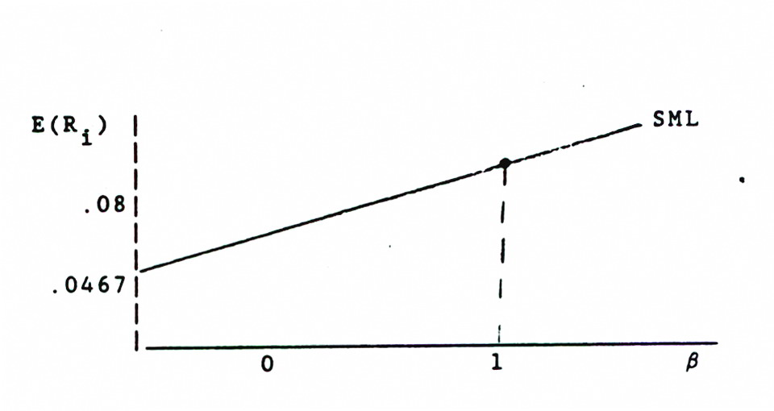

c)
E(R_{i}) = R_{f} + β[E_{i}(R_{m}) – R_{f}]
= .0467 + 2(.08 – .0467)
= 11.33% is required return for this risk level. The security is expected to return 15%, hence it is, not correctly priced. It is undervalued.

5. The market model shows a linear relationship between the return on a given security and the return on the market for all securities. The equation for the market model is
By using OLS regression and regressing the rates of return on a given security against the rates of return on the market, we can get an estimate of the β and α for a given security.

6. If it assumed that the investor can borrow money at the risk free rate R and invest the money in the risky market portfolio M, he will be able to derive portfolios with higher rates of return but with higher risks.

If it's assumed that the investor can lend some of his money at the risk free rate R_{f} and have some of his money invested in the risky portfolio M, he will be able to reduce both risk and return.
The linear relationship which is generated by the above two processes of lending and borrowing is the CML or CAPM.

7. E(R_{j}) = .07 + .12β
a) R_{f} = .07
b) E(R_{j}) = .07 +β(R_{m} – R_{f})
R_{m} – R_{f} = .12
R_{m} – .07 = .12
R_{m} = .19

c) market risk premium equals R_{m} – R_{f}
risk premium = .19 – .07
= . 12
8. Beta is the measure of systematic risk. Notationally it
Beta is a better measure of risk than standard deviation because if investors hold well diversified portfolios, then unsystematic risk will be diversified away. Hence, unsystematic risk should not be priced in the marketplace, only systematic risk. Therefore, standard deviation which measures total risk (systematic risk plus unsystematic risk) should not be a meaningful risk measure. Only the measure of systematic risk is useful.

9. If we don't have complete knowledge of the market portfolio, then it is impossible to reach any conclusions about empirical results testing the CAPM. Either the results show the CAPM is wrong or they provide evidence in support of the CAPM. In either case, we do not know whether the results are caused by the theory being correct or incorrect or the estimate of the market portfolio being correct or incorrect.
10.

11. a) a₀ = 0
a₁ = R_{m} – R_{f}
b) and c)
In general the empirical tests show that there are problems associated with the CAPM, see for example the discussion in Appendix 9A.

12.
E(R_{A}) = .05 + 1.33 [.10 – .05]
= 11.65

13. Beta can be forecast using one of three approaches:
1. market information
2. accounting information
3. a composite of 1 and 2

If a relationship can be found between accounting information and/or a mixture of accounting and market information and this relationship can be shown to be stable over time, then estimates or forecasts of the accounting variables can be used in conjunction with the model to forecast the beta.

