The Prediction of Default With Outliers--Robust Logistic Regression

Chung-Hua Shen
Department of Finance
National Taiwan University
TEL: 02-33661087
FAX: (886) 2-83695817
E-mail: chshen01@ntu.edu.tw

Yi-Kai Chen
Department of Finance
National University of Kaohsiung

Bor-Yi Huang,
Department of Business Management,
Shih Chien University, Taipei

Abstract
This paper suggests a Robust Logit method, which extends the conventional Logit model by taking outlier into account, to implement forecast of defaulted firms. We employ five validation tests to assess the in-sample and out-of-sample forecast performances, respectively. With respect to in-sample forecasts, our Robust Loigt method is substantially superior to the Logit method by using all validation tools. With respect to the out-of-sample forecasts, the superiority of Robust Logit is less pronounced.

Keywords: Logit, Robust Logit, forecast, validation test
JEL: C53, G33
- Introduction
In recent years a large number of researchers and practitioners have worked on the prediction of business defaults. This prediction is important not only can it reduce the non-performing loans but also can it help capital allocation. As required by the Basel Committee on Banking Supervision, the prediction of business default is the first step to fulfill the requirement of the internal rating based (IRB) of Basel II. Large banks therefore are eager to develop their default prediction system to monitor the credit risk. One of the issues regarding credit risk assessment is the model or method of default prediction used. Currently, the common model used include discriminant analysis (Atlman, 1968), logit and probit models (Ohlson, 1980, Westgaard and Wijst, 2001), mutli-group hierarchy model (Doumpos, et al.2002), neuro network and option type model like KMV to name a few. See Lennox (1999) for the comparison of the first three models, Dimitras, Zanakis and Zopounidis (1996) for the discussion of the first five models, has become a significant are of financial research.
While there are many methods to estimate the probability of default, none of them have taken the outliers into account when there is a discrete dependent variable. Outliers which can seriously distort the estimated results have been well documented in the conventional regression model. For example, Levine and Zervos (1998) employ 47 countries data and confirm the liquidity trading is positively related to economic growth. Zhu, Ash and Pollin (2002), however, reject this positive relation when they employ the econometric methods to minimize the outlier distortion effects caused by Taiwan and South Korea. Although methods and applications that take outliers into account are well known when the dependent variables are continuous (Rousseeuw, 1984; Rousseeuw and Yohai, 1984), few have conducted empirical studies when the dependent variable is binary. Atkinson and Riani (2001), Rousseau and Christmann (2003), Flores and Garrido (2001) have developed the theoretical foundations as well as the algorithm to obtain consistent estimator in logit model with outliers, but they do not provide applied studies. If outliers indeed exist when the dependent variable is binary, the conventional logit model might be biased.
The aim of this paper is to predict default probability with the consideration of outliers. This is a direct extension of the Logit estimation method and is referred to as the Robust Logit model hereafter. We apply the forward search method of Atkinson and Cheng (1999) and Atkinson and Riani (2001) to Taiwan data. To the best of our knowledge, our paper is the first one that using the Robust Logit model for actual data. Once estimated coefficients are obtained, we assess the performances of the Logit and the Robust Logit methods by five validation tools, i.e., contingency table (cross-classifications table), cumulative accuracy profile (CAR), relative or receive operation characteristic (ROC), Kolmogorov-Smirnov (KS) and Brier score.
The paper proceeds as follows. In addition to the first section, the next section provides literature of the Logit and the Roubst Logit regression model. Section 3 introduces the five validation models. Section 4 discusses the empirical model and estimated results. Section 5 provides the conclusion.
- Literature Review of Outliers in Conventional and in Logit Regression
Conventional linear regression analysis taking outliers into account has been developed since 1960. The methods, such as Least Median of Squares (LMS), Least Trimmed Squares (LTS)（Rousseew, 1983, 1984）, which exclude the effect of outliers on linear regression, are now standard options in many econometric softwares. The literature, however, is slow in the consideration of outliers when the Logit model is involved until 1990. Furthermore, most development centers on the theoretical derivations of outliers in logit method in the fields of statistics and actuaries.
2.1 Outliers in Conventional Regression
Cook and Welsch (1982) suggest a backward procedure to exclude outliers in the conventional linear model. By using the whole sample as the first step, Cook and Welsch (1982) detect one outlier and remove it out. Then, detecting the second outlier and taking it out as the second one, the third and so on. Repeating this step, they remove all outliers. While the backward approach appears straightforward, it however, has suffering the masking effect. Namely, the statistical properties of the former detected outlier, is affected by the outliers remained in the sample. Barrett and Gray (1985) and Haslett (1999) suggest a multiple outliers method to overcome this problem but the speed of detection is slow. Atkinson (1985, 1994) proposes a forward search algorithm (forward approach), which using only a small subset without outliers as the first step. Then, adding and examining the next observation. Continuing this step, he claims that the forward approach can remove outliers without suffering the masking effect.
2.2 Outliers in Logit Regression: Robust Logistic Regression
Our RL regression is based on Atkinson and Riani’s（2001）forward approach, which include five steps.
<Step 1>. Randomly choosing k+1 observations where k+1 is equal to one-third of total observations as our starting sample size. The corresponding estimated coefficient vector of Logit method is denoted as ${\hat{β}}^{(k+1)}$and the predicted probability is ${\hat{y}}_{i}=F\left(x_{i}{\hat{β}}^{(k+1)}\right)$, where i=1,…,N.
<Step 2>. calculating the probability of default and non-default companies$p^{(k+1),i}$：

， if
， if

and the corresponding error$e^{(k+1),i}$as $e^{(k+1),i}=1−p^{(k+1),i}$of the all observations. Taking an ascending order of $e^{(k+1),i}$, i.e.,
$$e^{(k+1),1}<e^{(k+1),2}<⋯<e^{(k+1),N}$$
and refer their median to$e^{(k+1),\text{med}}$ and save it.
<Step 3> Proceeding Forward Search Algorithm. Employ k+2 observations to yield coefficients${\hat{β}}^{(k+2)}$. These k+2 observations are the observations corresponding to the smallest errors of (k+2) observations in <Step 2>, i.e., observations corresponding to$e^{(k+1),1},e^{(k+1),2},\text{.}\text{.}\text{.},e^{(k+1),k+2}$. This is equivalent to removing the outliers.
Then, repeating <Step 2> and we can obtain the median of $e^{(k+2),i}$, which is $e^{(k+2),\text{med}}$.
<Step 4> Repeating <Step 3> but using k+3 observations corresponding to the smallest k+3 errors of $e^{(k+2),i}$ in <Step 3>. We then similarly obtain ${\hat{β}}^{(k+3)}$ and median$e^{(k+3),\text{med}}$.
Repeating the above steps by adding one observation in each estimation and is done until all sample are used. We thus obtain estimated coefficients ${\hat{β}}^{(k+4)},{\hat{β}}^{(k+5)},\text{.}\text{.}\text{.},{\hat{β}}^{N}$ and the corresponding median $e^{(k+4),\text{med}},e^{(k+5),\text{med}},\text{.}\text{.}\text{.},e^{N,\text{med}}$。
<Step 5> Calcaluting $e^{\text{*,}\text{med}}=\text{min}\left[e^{(k+1),\text{med}},e^{(k+2),\text{med}},\text{.}\text{.}\text{.}e^{N,\text{med}}\right]$ and its corresponding${\hat{β}}^{}$, which the estimator of RL method.
While this forward search method is intuitively appeal, it encournters three problems in actual application. First, the random sampling may pick all zeros or ones as dependent variable, which fail the estimation. Next, the chosen of the initial set of sample affects the estimation results. Thus, repeated sampling of the intital set become necessary. Third, companies identified as outliers may be those extremely good and bad companies. They are statistical outliers but not financial outliers.
- Five Validation Tests
Once we obtain the estimated results from two methods, we compare their forecasting ability based on the following five validation tests for the assessment of discriminatory power. The validation methods introduced here are mostly based on the work by Sobehart and Keenan (2004). Sobehart, Keenan and Stein (2000) and Stein (2002),
3.1 Contingency Table (Cross-Classification Table)
Contingency Table, is also referred to as the Cross-Classification Table, is the most often used validation tool in comparing the power of prediction. Let TP% and TN% be the ratios of success in predicting default and non-default firms, whereas FP% and FN% be the ratios of failure in predicting default and non-default firms. In conventional terms, the sum of TP% and TN% is referred to as the hit rate, whereas FP% and FN% are referred to as Type II and Type I errors, respectively. Furthermore, TP% + FN% = 1 and FP%+ TN% =1. The weakness of this table is that only one cutoff is chosen to decide these ratios. Typically, the selection of this cutoff is based on the average rule (the cutoff is then 0.5) or the sample proportion rule (the cut off is then the number of default/total number firms). More cutoffs may be needed, which motivating the development of the following validation tests.
3.2 CAP (Cumulative Accuracy Profile)
CAP curve is a visual tool whose graph can easily be drawn if two representative samples of scores for defaulted and non-defaulted borrowers are available. The shape of the concavity of the CAP is equivalent to the property that the conditional probabilities of default given the underlying scores form a decreasing function of the scores (default probability). Alternatively, non-concavity indicates suboptimal use of information in the specification of the score function. Researchers typically calculate the accuracy ratio, which is the area under the rating model divided the area under the perfect model, to examine the performance of model. This is equivalent to A/B graphed in Figure 1.
Figure 1 plots CAPs of a perfect, a rating and a random models. A perfect rating model will assign the lower estimated scores to the defaulters. In this case the CAP is increasing linearly and then staying at one. For a random model without any discriminative power, the fraction x of all debtors with the lower scores contain x percent of all defaults. Applied rating systems will be somewhere in between these two extremes. Statistically, the comparison ratio is defined as the ratio of A/B, where A is the area between the CAP of the rating model being validated and the CAP of the random model, and B is the area between the CAP of the perfect rating model and the CAP of the random model.
The calculation of area under rating model is as follows. First, a descending order of the estimated default rates is ranked. Then, it takes the top s% number of firms which have the higher estimated default rates, making these number be equal to G=s%×(N+D) where N and D are the number of non-defaulting and default companies in the data set. Within G firms, it then calculates the number of firms that are actually default and are divided by G to yield y%. Repeating the above process, we obtain a sequence of s% and y%. Plotting y% (y-axis) against s% (x-axis) yields CAP. The shape of the rating model depends on the proportion of solvent and insolvent borrowers in the sample.
3.3 ROC (Receiver Operating Characteristic)
ROC curve uses the same information as CAP to answer the question: What percentage of non-defaulters would a model have to exclude a specific percentage of defaulters? (Stein, 2002). It generalizes Contingency Table analysis by providing information on the performance of a model at any cut-off that might be chosen. It plots the FP% rate against the TP% rate for all credits in a portfolio. In particular, ROCs are constructed by scoring all credits and ordering the non-defaults from the worst to the best on the x axis and then plotting the percentage of defaults excluded at each level on the y axis. The area under the rating model is
$$A+B=\sum_{k=0}^{k=n−1}{(X_{k+1}−X_{k})(Y_{k+1}+Y_{k})÷2}$$
Where A and B are the area under rating model and 45 degree, respectively and n is the number of intervals.
For example, assuming that the number of default firm D = 50, and non-default firm N = 450. Then, similar to the CAP method, a descending order of the estimated default probability is ranked. Next, giving a fixed type II error, FP%, and find the corresponding cutoff of c%, we can calculate the corresponding TP%. To illustrate this, if FP% is first chosen to be 5%, then 23 non-default firms are misjudged as default (450×5%=22.5). At the same time, the cutoff c% is decided. Based on this c%, if we successfully predict four defaulted firms, making TP% = 8%(4/50=8%). Thus we obtain the first set of (FP%, TP%) = (5%, 8%). Continuing this process, we can get many sets of FP% and TP%, which generate ROC.
  - KS (Kolmogorov-Smirnov)
The KS-test tries to determine if two datasets differ significantly. The KS-test has the advantage of making no assumption about the distribution of data. It also enables us to view the data graphically. KS plots the cumulative distribution of default and non-default firms, denoted as F1 and F2, respective and then calculates the maximum distance between these two curves as
KS = max(F1 – F2)
The large KS suggesting the rejection of the null hypothesis of equality of distributions.
3.5 Brier Score
$B=\frac{\sum{{\left({\hat{P}}_{i}−I_{i}\right)}^{2}}}{n}$ Brier score computes the mean squares error between the estimated and actual default rate.

where${\hat{P}}_{i}$ is the predicted value and $I_{i}$ is the actual 0 and 1. From the above definition it follows that the Brier score is always between zero and one. The closer the Brier score is to zero the better is the forecast of default probabilities.
4. Source of Data and Empirical Model
4.1 Source of Data
Our samples are listed companies in Taiwan Stock Exchange to ensure the reliabilities of financial statements. Default firms are defined as those stocks which require full delivery, i.e., transaction with cash in Taiwan Stock Exchange. These firms include (i) check bounce of the CEOs, board directors and supervisors of companies; (ii) firms which ask for financial aid from government, having been restructuring, bankruptcy, liquidation, going-concern uncertainty, been taken over, tunneling, trading halts, credit crunch by banks.
There are 52 default companies from 1999 to 2004 in our sample. For each default company, we search for the three additional companies with similar size of assets in the same industry, making 156 non-default companies. Hence, 208 companies in total are in our sample. The names and codes of all companies are reported in Table 2 and the reasons of their defaults are also reported.
We also reserve 20% of our sample for out-of-sample forecast. That is, there are 42 firms are reserved.
4.2 Empirical Model
Our empirical model is on the basis of Altman’s z-score, which contains five variables. Four of them are financial accounting variables and one of them is market variable (X₄). Because of multicollinearity, we only choose four of them, i.e., our model is
$Y_{t}=f(X_{1_{t−1}}+X_{2_{t−1}}+X_{3_{t−1}}+X_{4_{t−1}}+1\text{.}{\text{0X}}_{5_{t−1}}$)
where Y is the binary variable with 1 and 0 and 1 denotes defaulted and zero otherwise, X₁ = operation capital/total asset (operating capital = liquid asset – liquid liability), X₃ = earnings before interest and tax (EBIT)/total asset, X₄ = Stock Value/Total liability, X₅ = Net Sales Revenue/Total asset (net sales revenues = sales – redemption and discount). All signs are expected to be negative.
5. Empirical Results
Table 3’s left and right parts report the estimated results using the Logit and the Robust Logit models, respectively. When the Logit model is used, all coefficients show the expected negative sign and all are signficaint except for coefficient of X₅ . By contrast, when the Robust Logit model is employed, all coefficients not only show the expected signs but also are significantly different from zero. Alongside this, the psudo-R² is 0.3918 for the Logit model but is higher up to 0.9359 for the Robust Logit model, suggesting that in-sample fitting is much better in the Robust Logit model than in the Logit model.
Figure 3 plots the curve of CAP, ROC and KS using in-sample forecasts. The curves generated by the Robust Logit method is more concave to the southeast than the Logit method shown in the CAP and ROC. With respect to KS method, the maximum distance between non-default and default is also bigger for the Robust Logit method than for the Logit method.
Figure 4 is similar to Figure 3 but out-of-sample forecast is used. The CAP and ROC curves generated by the two methods are twisted with each other to some extent and the area under the curves can be hardly evaluated by eyeballs. With respect to KS method, the maximum distance of non-defaults and defaults clearly show that the Robust Logit method is superior to the Logit method.
Table 4 reports the five validation tests by using the in-sample forecast. With respect to the Contingency Table, when the Logit method is used, the TP% and TN% are around 77% but are higher up to 97.67% and 93.67% when the Robust Logit method is undertaken. Thus, the Robust Logit method defeats the Logit method when the validation is based on the Contingency Table. The KS is 5.288 and 6.410 for the two methods, respectively, again supporting the superiority of the Robust Logit method. The CAP ratio also reaches the similar conclusion, where they are 0.7040 and 0.8308 for the two methods, respectively. Not surprisingly, ROC ratios also support the same conclusion as the two ratios are 0.8447 and 0.9867, respectively. Finally, the Brier score, whose definition is opposite to the previous validation tests, is smaller if the performance of the method is superior. The scores for two models are respective 0.1207 and 0.0226. Accordingly, all validation tests suggest that the Robust Logit method is superior to the Logit method in in-sample prediction.
Table 5 reports the validation tests by using the out-of-sample forecast. The superior performance of the Robust Logit method in in-sample forecast becomes less pronounced here. When Contingency Table is employed, the TP% and TN% yielded by the Logit model are around 75%, which is similar to their in-sample counterparts reported in Table 4. The values, however, change dramatically when the Robust Logit is used. The TP% becomes 100.0% but TN% is only around 48%. This implies that the Robust Logit method is aggressive in the sense that it has a greater tendency to assign companies as default. The use of KS test still support the conclusion reached by the in-sample case, i.e., the Logit method performs worse than the Robust Logit method. The differences between the two methods in CAP test become trivial as the Logit method is 0.6566 and the Robust Logit is only 0.6812. Similar results occur in ROC test as the former test is 0.6717 but the latter one is 0.6883. Thus, based on CAP and ROC, they are in a tie. Last, to our surprise, the Robust Logit method is defeated by the Logit method as its Brier score is higher than the Logit method. Thus, when the out-of-sample forecast is implemented, the differences between two methods are hard to distinguish from each other.
6. Conclusion
We compare the forecast ability between Logit and Robust Logit methods, where the latter take the possible outliers into account. Six validation tests are employed when the in-sample forecasts are compared, i.e., pseudo-R square, Contingency Table, CAP, ROC, KS and Brier score, whereas the latter five validation tests are undertaken for the out-of-sample forecast.
With respect to the in-sample forecasts, Robust Loigt method is substantially superior to the Logit method by using all validation tests here. With respect to the out-of-sample forecasts, Robust Logit method yields less type II but large type I errors than Logit method when Contingency Table is used, suggesting that Robust Logit is more aggressive in assign firms as default. Robust Logit is marginally better than Logit method when CAP, ROC and KS are adopted but worse when Brier score is used. Thus, the superiority of Robust Logit is less pronounced or even disappears in the out-of-sample forecasts.
References
- Altman, E. I. (1968), Financial Ratios, Discriminate Analysis and the Prediction of Corporate Bankruptcy, Journal of Finance 23, 589-609
- Altman, E. I. and P. Narayanan (1997), An International Survey of Business Failure Classification Models, Finance Markets, Institutions and Instruments, Vol. 6, N. 2.
- Atkinson, A.C. (1985), Plots, transformations and regression. Oxford U. Press, NY.
- Atkinson, A.C. (1994), Fast Very Robust Methods for the Detection of Multiple Outliers, Journal of the American Statistical Association, Vol. 89, 1329-1339.
- Atkinson, A. C. and M. Riani (2001), Regression diagnostics for binomial data from the forward search. The Statistician, Vol. 50, 63-78.
- Cook, R. D. and Weisberg, S. (1982), Residuals and Influence in Regression, London: Chapman and Hall.
- Dimitras, A. I., S. H. Zanakis and C. Zopoundis (1996), A survey of business failures with an emphasis on prediction methods and industrial application, European Journal of Operation Research, Vol. 90(3), 487-513.
- Doumpos, M., K. Kosmidou, G. Baourakis and C. Zopounidis (2002), Credit risk assessment using a multicriteria hierarchical discrimination approach: A comparative analysis, European Journal of Operational Research, Vol. 138, 392-412.
- Doumpos, M. and C. Zopounidis (2002), Multi-criteria Classification and Sorting Methods: A literature Review, European Journal of Operational Research, Vol. 138 (2), 229-246.
- Flores, E. and J. Garrido (2001), Robust Logistic Regression for Insurance Risk Classification, Business Economics, working paper 01-64, No. 13.
- Grice, J. S. and R. W. Ingram (2001), Tests of the generalizability of Altman’s bankruptcy prediction model, Journal of Business Research, 54, 53-61.
- Haslett, J (1999), Simple derivation-subset deletion diagnostics.
- Laitinen, E. K and T. Laitinen (2000), Bankruptcy prediction Application of the Taylor’s Expansion in logistic regression, International Review of Financial Analysis, Vol. 9, 327-349.
- Lennox, C (1999), Identifying failing companies: A reevalution of the logit, probit and DA approach, Journal of Economics and Business, Vol. 51, 347-364.
- Levine, R. and S. Zervos (1998), Stock markets, Banks, and Growth, American Economic Review, Vol.88(3), 537-558.
- Mossman, C. E., G. G. Bell, L. M. Swartz and H. Turtle (1998), An empirical comparison of bankruptcy model, The Financial Review, Vol. 33, 35-54.
- Ohlson, J. T. (1980), Financial Ratios and the Probabilistic Prediction of Bankruptcy, Journal of Accounting Research, Vol. 18, 109-131
- Pompe, P. M. P. and J. Bilderbeek (2005), The prediction of bankruptcy of small-and Medium-sized industrial firms, Journal of Business Venturing, Vol. 20, 847-868.
- Rousseeuw, P. J. (1983), Regression techniques with high breakdown point. The Institute of Mathematical Statistics Bulletin, Vol. 12, 155.
- Rousseeuw, P. J. (1984), Least median of squares regression. Journal of the American Statistical Association, 79, 871-880.
- Rousseeuw, P. J. and V. J. Yohai (1984), Robust regression by means of S-estimators, Robust and Nonlinear Time Series Analysis (Eds) W. H. Franke and R.D. Martin Springer Verlag, New York, 256-272.
- Sobehart, J. R. and S. C. Keenan (2004), Performance evaluation for credit spread and default risk models. In: Credit Risk: Models and Management. D. Shimko (ed.), second edition, Risk Books: London, pp. 275-305
- Sobehart, J. R., S. C. Keenan and R. M. Stein (2000). Benchmarking quantitative default risk models: a validation methodology, New York.
- Stein, R. M.(2002), Benchmarking default prediction models: Pitfall and Remedies in model validation, Moody’s KMV, technical report, No. 030124.
- Westgaard, S and N. Wijst (2001), Default probabilities in a corporate bank portfolio: A logistic model approach, European Journal of Operational Research, Vol. 135, 338-349.
- Wiginton, J. C. (1980), A note on the Comparison of Logit and Discriminant Models of Consumer Credit Behavior, The Journal of Financial and Quantitative Analysis, Vol. 15, No. 3.
- Zhu, A., M. Ash and R. Pollin (2002), Stock Market Liquidity and Economic Growth: A Critical Appraisal of The Levine and Zervos Model, Political Economy Research Institute, working paper, No. 47.
Figure 1: CAP Curve
Random Model
Perfect Model
Rating Model NormaNormalMod一般模型預測結果
45º
Perfect Turning points=
Fraction of Defaulted companies
Fraction of all companies
A
B

Figure 2. ROC Curve

0.2
0.4
0.6
0.8
1.0
0.2
0.4
0.6
0.8
1.0
False Alarm Rate
TP％
FP％
FN％
TN％
Hit Rate
A
B

Figure 3: In-Sample Forecast: Logit and Robust Logit

A. CAP Curve
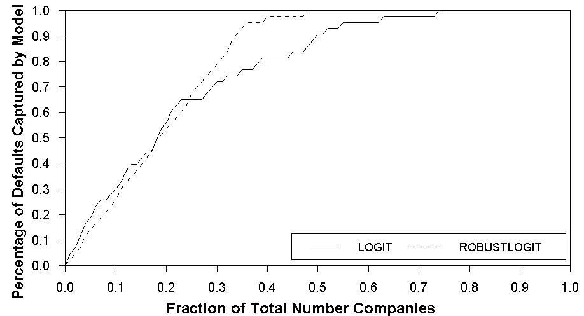

B. ROC curve
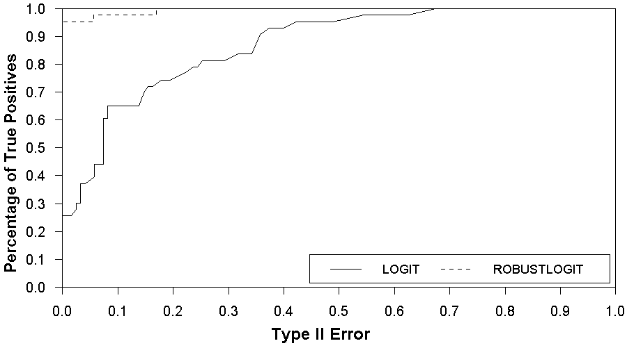

C. K-S
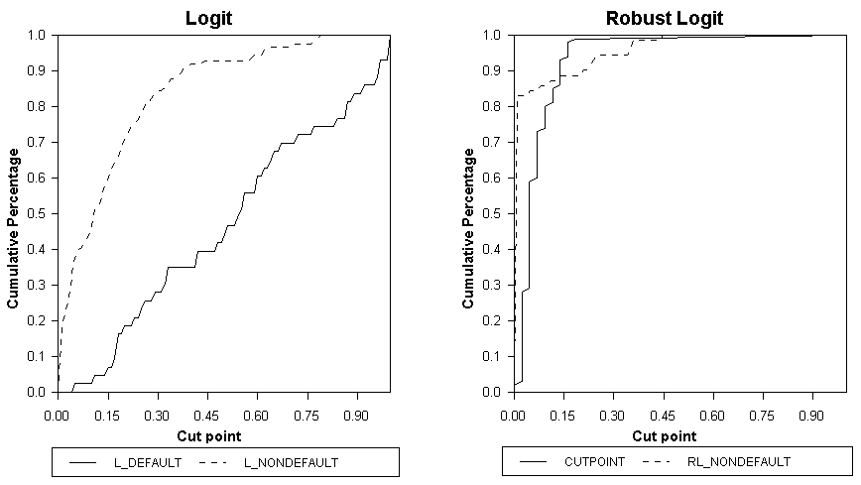
Figure 4: Out-of-Sample Forecast: Logit and Robust Logit Forecast

A. CAP curve
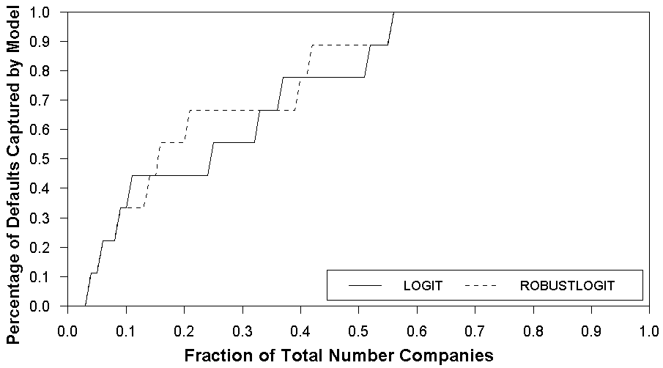

B. ROC curve
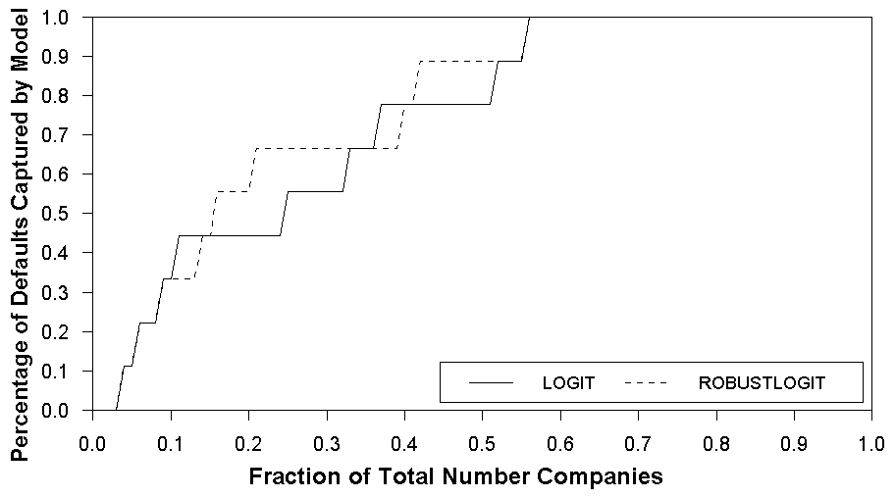

C. K-S
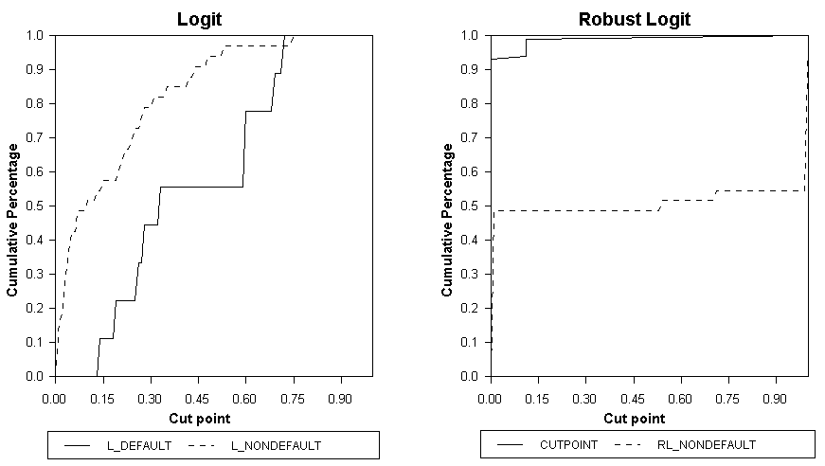
Table 1: Contingency Table (Cross Classification Table)
Actual  Predicted | Default Companies  （$y_{i}=1$） | Non-Default Compa nies  （$y_{i}=0$）
Default Companies  （${\hat{y}}_{i}=F\left(x_{i}{\hat{β}}^{}\right)≥$cutoff） | TP％×D | FP％×N
Non-Default Companies  （${\hat{y}}_{i}=F\left(x_{i}{\hat{β}}^{}\right)<$cutoff） | FN％×D | TN％×N
Notations are taken from Sobehart,. Keenan and Stein (2000). TP (True Positive) means that companies are default and are accurately predicted; FN (False Negative) means companies are not default and not correctly predicted; FP (False Positive) means companies are default and not correctly predicted; TN (True Negative) means that companies are not default and correctly predicted; D is number of default and N is number of non-default companies.

Table 2. All Sample Companies
Code of Failing Compines | Names of companies | Default Date | Types of Default | Matching Samples of Non-Default Companies | 資料年度  (民國)
9913 | MHF | 1999/1/18 | G | 9911(SAKURA),9915(Nien Made),9914(Merida) | 1998
2005 | U-Lead | 1999/1/24 | G | 2002(CSC),2006(Tung Ho Steel),2007(YH) | 1998
2539 | SAKURAD | 1999/3/22 | G | 2501(CATHAY RED),2504(GDC),2509(CHAINQUI) | 1998
2322 | GVC | 1999/4/1 | O | 2323(CMC),2324(Compal),2325(SPIL) | 1998
2522 | CCC | 1999/4/18 | C | 2520(KINDOM),2523(DP),2524(KTC) | 1998
1431 | SYT | 1999/5/21 | H | 1432(TAROKO),1434(F.T.C.),1435(Chung Fu) | 1998
1808 | KOBIN | 1999/5/24 | H | 1806(CHAMPION),1807(ROMA),1809(China Glaze) | 1998
9922 | UB | 1999/10/5 | G | 9918(SCNG),9919(KNH),9921(Giant) | 1998
1206 | TP | 1999/11/2 | H | 1216(Uni-President),1217(AGV),1218(TAISUN) | 1998
1209 | EHC | 2000/3/23 | N | 1201(Wei-Chuan),1203(Ve Wong),1207(CH) | 1999
2528 | CROWELL | 2000/4/28 | G | 2526(CEC),2527(Hung Ching),2530(DELPHA) | 1999
1462 | TDC | 2000/7/11 | G | 1458(CHLC),1459(LAN FA),1460(EVEREST) | 1999
2703 | Imperial | 2000/9/5 | H | 2702(HHG),2704(Ambassador),2705(Leo Foo) | 1999
1422 | MICDT | 2000/9/6 | C | 1417(CARNIVAL),1418(TONG-HWA),1419(SHINKO.SPIN.) | 1999
1505 | YIW | 2000/9/6 | G | 1503(Shihlin),1504(TECO),1506(Right Way) | 1999
2334 | KFC | 2000/9/6 | C | 2333(PICVUE),2335(CWI),2336(Primax) | 1999
2518 | EF | 2000/9/6 | G | 2514(LONG BON),2515(BES),2516(New Asia) | 1999
2521 | HCC | 2000/9/8 | G | 2505(ky),2509(CHAINQUI),2511(PHD) | 1999
2019 | Kuei Hung | 2000/9/16 | G | 2020(MAYER PIPE),2022(TYCOONS),2023(YP) | 1999
2011 | Ornatube | 2000/10/13 | C | 2012(CHUN YU),2013(CSSC),2014(CHUNG HUNG) | 1999
9906 | Corner | 2000/10/27 | C | 9905(GCM),9907(Ton Yi),9908(TGTG) | 1999
1222 | Yuan Yi | 2000/11/2 | C | 1224(HSAFC),1225(FOPCO),1227(QUAKER) | 1999
2902 | Choung Hsim | 2000/11/29 | H | 2903(FEDS),2910(CHUN YUAN STEEL),2912(7-ELEVEN) | 1999
2517 | CKA-LT | 2000/11/30 | G | 2520(KINDOM),2523(DP),2524(KTC) | 1999
2537 | Ezplace | 2001/1/12 | G | 2534(HSC),2535(DA CIN),2536(Hung Poo) | 2000
1408 | CST | 2001/4/2 | G | 1410(NYDF),1413(H.C.),1414(TUNG HO) | 2000
1407 | Hualon | 2001/5/22 | G | 1402(FETL),1416(KFIC),1409(SSFC) | 2000
2540 | JSCD | 2001/5/25 | G | 2533(YUH CHEN UNITED),2538(KeeTai),2530(DELPHA) | 2000
2304 | A.D.I. | 2001/7/28 | C | 2301(LTC),2302(RECTRON),2303(UMC) | 2000
1438 | YU FOONG | 2001/8/10 | E | 1435(Chung Fu),1436(FUI),1437(GTM) | 2000
1450 | SYFI | 2001/8/24 | G | 1451(NIEN HSING),1452(HONG YI),1453(PREMIER) | 2000
2318 | Megamedia | 2001/9/28 | G | 2315(MIC),2316(WUS),2317(HON HAI) | 2000
2506 | PCC | 2001/10/16 | G | 2514(LONG BON ),2515(BES),2516(New Asia) | 2000
1613 | Tai-I | 2001/10/22 | E | 1614(SANYO),1615(DAH SAN),1616(WECC) | 2000
2512 | Bao-Chen | 2002/4/16 | C | 2504(GDC),2509(CHAINQUI),2511(PHD) | 2001
1805 | KPT | 2002/6/2 | G | 1802(TG),1806(CHAMPION),1807(ROMA) | 2001
1602 | PEW | 2002/9/6 | G | 1601(TEL),1603(HwaCom),1604(SAMPO) | 2001
1221 | CCI | 2003/3/6 | C | 1217(AGV),1234(HEYSONG),1231(Lian Hwa Foods) | 2002
2342 | MVI | 2003/4/18 | G | 2344(WEC),2345(ACCTON),2347(Synnex) | 2002
3053 | DING ING | 2003/4/26 | E | 3045(TWN),3046(AOpen),3052(APEX) | 2002
2329 | OSE | 2003/6/30 | G | 2330(TSMC),2331(Elitegroup),2332(D-LINK) | 2002
1212 | SJI | 2003/9/30 | G | 1204(jingjing),1216(Uni-President),1218(TAISUN) | 2002
3001 | KIM | 2004/3/5 | C | 3010(WAN LEE),3011(JH),3018(TUNG KAI) | 2003
2525 | Pao Chiang | 2004/3/20 | G | 2520(KINDOM),2523(DP),2524(KTC) | 2003
2494 | Turbocomm | 2004/4/15 | E | 2489(AMTRAN),2488(HANPIN),2492(WTC) | 2003
2398 | Procomp | 2004/6/15 | H | 2382(QCI),2388(VIA),2409(AUO) | 2003
3021 | Cradle | 2004/7/26 | C | 3020(USTC),3022(ICP),3023(Sinbon) | 2003
2491 | Infodisc | 2004/8/23 | G | 2308(DELTA ),2311(ASE),2312(KINPO) | 2003
2490 | Summit | 2004/9/15 | C | 2349(RITEK),2350(USI),2351(SDI) | 2003
3004 | NAFCO | 2004/9/23 | H | 2356(INVENTEC),2357(ASUSTEK),2358(MAG) | 2003
1534 | Tecnew | 2004/9/24 | C | 1531(SIRUBA),1532(CMP),1533(ME) | 2003
9936 | Compex | 2004/10/20 | E | 9933(CTCI),9934(GUIC),9935(Ching Feng) | 2003
The number is the code listed in Taiwan Stock Exchange.
Type of Default: C: check bounce, E: concern of continuing operation, G: financial Aid from government, O: substantial loss (low net worth).

Table 3. Estimated Results: Logit vs. Robust Logit
Methods | Logit |  | Robust Logit
 | Coefficients | t-value | Coefficients | t-value
Constant | -0.3600 | -0.7506 | 17.0487** | 2.1627
X₁ | -1.6195 | -1.1766 | -10.2357* | -1.7913
X₃ | -13.1535*** | -4.1651 | -234.2707** | -2.2311
X₄ | -0.5519** | -2.0683 | -2.1146** | -2.3319
X₅ | -0.4227 | -0.5858 | -12.3312** | -2.0225
Log Likelihood | -61.4865 |  | -9.510
Average Likelihood | 0.6905 |  | 0.9200
Pseudo-R-square | 0.3918 |  | 0.9359
Number of Sample | 166 |  | 114
Number of Default Companies | 43 |  | 43
Number of Non-default Compaines | 123 |  | 71
Medium of residuals | - |  | 6.42811e-04
*, **, *** denote significant at 10％, 5％ and 1％ level, respectively

Table 4: Validation Tests (In-sample forecast)
Methods | Logit Method |  | Robust Logit  Method
Cross-Classification | TP％ | TN％ | TP％ | TN％
Cross-Classification | 76.74％ | 78.05％ | 97.67％ | 94.37％
KS | 5.288 |  | 6.410
CAP | 0.7040 |  | 0.8308
ROC | 0.8447 |  | 0.9867
Brier score | 0.1207 |  | 0.0226
CAP: cumulative accuracy profile; ROC: receiver operating curve, KS: Komolgos

Table 5: Estimated Results of Cross-Classification, KS and Brier (In-sample forecast)
Methods | Logit Method |  | Robust Logit  Method
Cross-Classification | TP％ | TN％ | TP％ | TN％
Cross-Classification | 77.78％ | 72.73％ | 100.00％ | 48.48％
KS | 1.45 |  | 1.558
CAP | 0.6566 |  | 0.6812
ROC | 0.6717 |  | 0.6883
Brier score | 0.1319 |  | 0.3756

Atkinson uses k=+1 as the number of parameters + 1 as the starting sample size. We do not adopt his suggestion because the small sample size often contains full of zeros without one, invalidating the logit model.
We could further repeat <Step 2> to start different set of observations.
We omit X₂ = retained earnings/total assets.

