Fuzzy Set Theory by Shin-Yun Wang
Before illustrating the fuzzy set theory which makes decision under uncertainty, it is important to realize what uncertainty actually is.
Uncertainty is a term used in subtly different ways in a number of fields, including philosophy, statistics, economics, finance, insurance, psychology, engineering and science. It applies to predictions of future events, to physical measurements already made, or to the unknown. Uncertainty must be taken in a sense radically distinct from the familiar notion of risk, from which it has never been properly separated.... The essential fact is that 'risk' means in some cases a quantity susceptible of measurement, while at other times it is something distinctly not of this character; and there are far-reaching and crucial differences in the bearings of the phenomena depending on which of the two is really present and operating.... It will appear that a measurable uncertainty, or 'risk' proper, as we shall use the term, is so far different from an immeasurable one that it is not in effect an uncertainty at all.

What is relationship between uncertainty, probability, vagueness and risk? Risk is defined as uncertainty based on a well grounded (quantitative) probability. Formally, Risk = (the probability that some event will occur) X (the consequences if it does occur). Genuine uncertainty, on the other hand, cannot be assigned such a (well grounded) probability. Furthermore, genuine uncertainty can often not be reduced significantly by attempting to gain more information about the phenomena in question and their causes. Moreover the relationship between uncertainty, accuracy, precision, standard deviation, standard error, and confidence interval is that the uncertainty of a measurement is stated by giving a range of values which are likely to enclose the true value. This may be denoted by error bars on a graph, or as value ± uncertainty, or as decimal fraction (uncertainty).
Often, the uncertainty of a measurement is found by repeating the measurement enough times to get a good estimate of the standard deviation of the values. Then, any single value has an uncertainty equal to the standard deviation. However, if the values are averaged and the mean is reported, then the averaged measurement has uncertainty equal to the standard error which is the standard deviation divided by the square root of the number of measurements. When the uncertainty represents the standard error of the measurement, then about 68.2% of the time, the true value of the measured quantity falls within the stated uncertainty range.
Therefore no matter how accurate our measurements are, some uncertainty always remains. The possibility is the degree that thing happens, but the probability is the probability that things be happen or not. So the methods that we deal with uncertainty are to avoid the uncertainty, statistical mechanics and fuzzy set (Zadeh in 1965).
(Figure from Klir&Yuan)
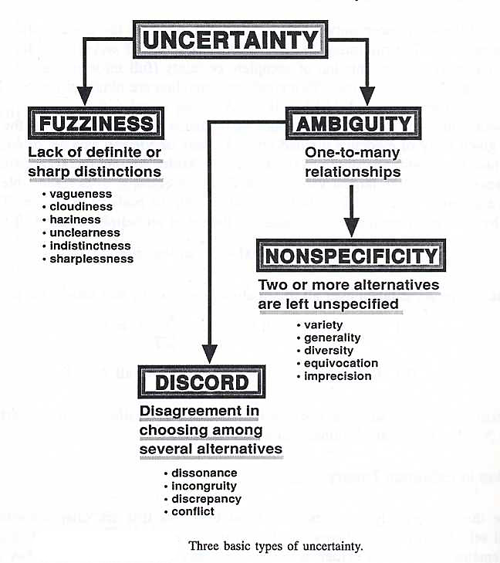
Fuzzy sets have been introduced by Lotfi A. Zadeh (1965). What Zadeh proposed is very much a paradigm shift that first gained acceptance in the Far East and its successful application has ensured its adoption around the world. Fuzzy sets are an extension of classical set theory and are used in fuzzy logic. In classical set theory the membership of elements in relation to a set is assessed in binary terms according to a crisp condition — an element either belongs or does not belong to the set. By contrast, fuzzy set theory permits the gradual assessment of the membership of elements in relation to a set; this is described with the aid of a membership function valued in the real unit interval [0, 1]. Fuzzy sets are an extension of classical set theory since, for a certain universe, a membership function may act as an indicator function, mapping all elements to either 1 or 0, as in the classical notion.
Specifically, A fuzzy set is any set that allows its members to have different grades of membership (membership function) in the interval [0,1]. A fuzzy set on a classical set Χ is defined as follows:
The membership function μ_{A}(x) quantifies the grade of membership of the elements x to the fundamental set Χ. An element mapping to the value 0 means that the member is not included in the given set, 1 describes a fully included member. Values strictly between 0 and 1 characterize the fuzzy members.
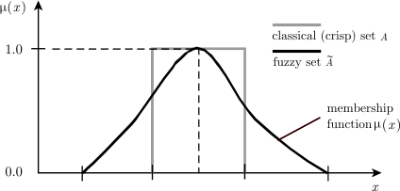
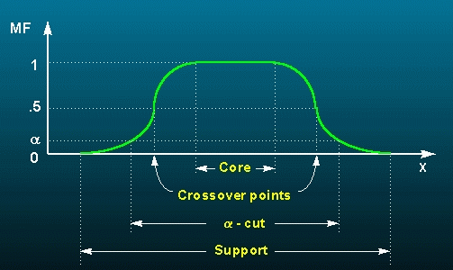
Membership function terminology
Universe of Discourse: the universe of discourse is the range of all possible values for an input to a fuzzy system.
Support: the support of a fuzzy set F is the crisp set of all points in the universe of discourse U such that the membership function of F is non-zero.

Core: the core of a fuzzy set F is the crisp set of all points in the universe of discourse U such that the membership function of F is 1.
Boundaries: the boundaries of a fuzzy set F is the crisp set of all points in the universe of discourse U such that the membership function of F is between 0 and 1.

Crossover point: the crossover point of a fuzzy set is the element in U at which its membership function is 0.5.
Height: the biggest value of membership functions of fuzzy set.
Normalized fuzzy set: the fuzzy set of
Cardinality of the set:

Relative cardinality:

Convex fuzzy set: , a fuzzy set A is Convex, if for

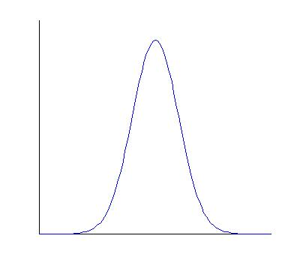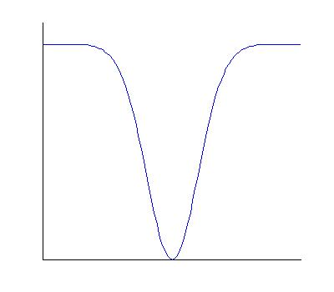
Type of membership functions
1. Numerical definition (discrete membership functions)
2. Function definition (continuous membership functions)
Including of S function, Z Function, Pi function, Triangular shape, Trapezoid shape, Bell shape.
(1) S function: monotonical increasing membership function
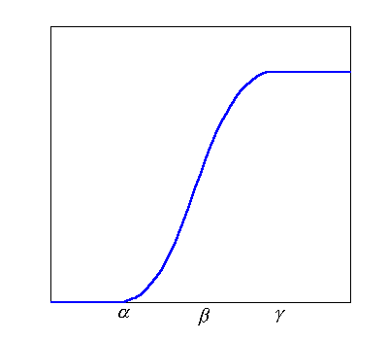
(2) Z function: monotonical decreasing membership function
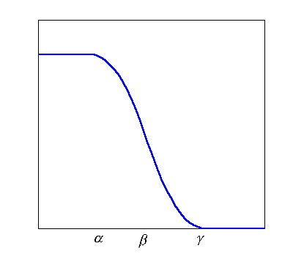
(3) Π function: combine S function and Z function, monotonical increasing and decreasing membership function
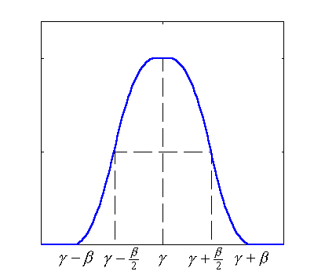
Piecewise continuous membership function
(4)Trapezoidal membership function

(5) Triangular membership function
(6) Bell-shaped membership function
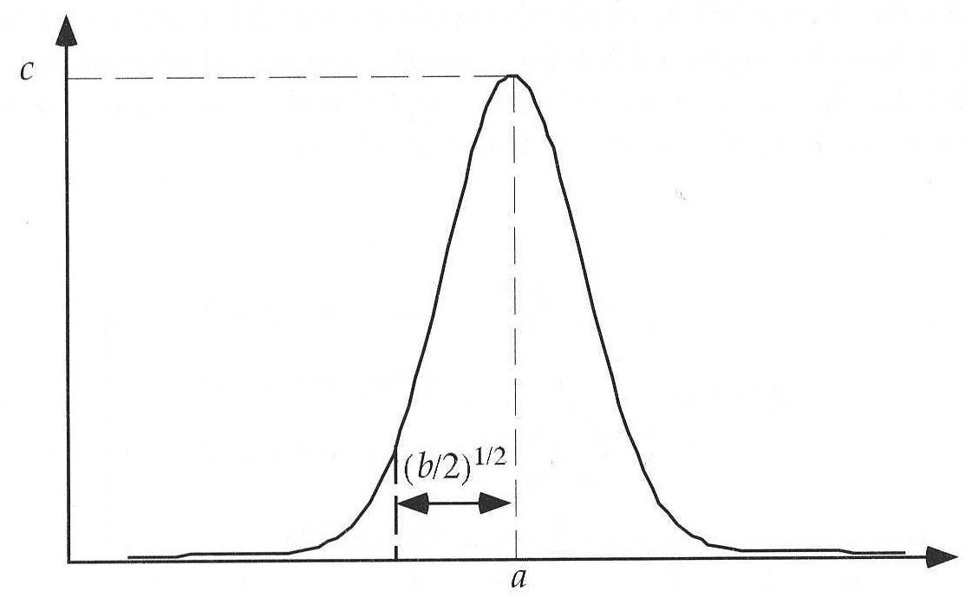
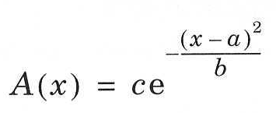
Before illustrating the mechanisms which make fuzzy logic machines work, it is important to realize what fuzzy logic actually is. Fuzzy logic is a superset of conventional (Boolean) logic that has been extended to handle the concept of partial truth- truth values between "completely true" and "completely false". As its name suggests, it is the logic underlying modes of reasoning which are approximate rather than exact. The importance of fuzzy logic derives from the fact that most modes of human reasoning and especially common sense reasoning are approximate in nature.
The essential characteristics of fuzzy logic are as follows.
- In fuzzy logic, exact reasoning is viewed as a limiting case of approximate reasoning.
- In fuzzy logic everything is a matter of degree.
- Any logical system can be fuzzified.
- In fuzzy logic, knowledge is interpreted as a collection of elastic or, equivalently, fuzzy constraint on a collection of variables.
- Inference is viewed as a process of propagation of elastic constraints.
After know about the characteristic of fuzzy set, we will introduce the operations of fuzzy set. A fuzzy number is a convex, normalized fuzzy set whose membership function is at least segmental continuous and has the functional value μ_{A}(x) = 1 at precisely one element. This can be likened to the funfair game "guess your weight," where someone guesses the contestants weight, with closer guesses being more correct, and where the guesser "wins" if they guess near enough to the contestant's weight, with the actual weight being completely correct (mapping to 1 by the membership function). A fuzzy interval is an uncertain set with a mean interval whose elements possess the membership function value μ_{A}(x) = 1. As in fuzzy numbers, the membership function must be convex, normalized, and at least segmental continuous.
Set- theoretic operations
Subset:
Complement:
Union:
Intersection:
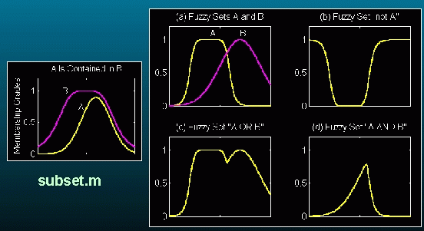
Although one can create fuzzy sets and perform various operations on them, in general they are mainly used when creating fuzzy values and to define the linguistic terms of fuzzy variables. This is described in the section on fuzzy variables. At some point it may be an interesting exercise to add fuzzy numbers to the toolkit. These would be specializations of fuzzy sets with a set of operations such as addition, subtraction, multiplication and division defined on them.
According to the characteristics of triangular fuzzy numbers and the extension principle put forward by Zadeh (1965), the operational laws of triangular fuzzy numbers, and are as follows:
(1) Addition of two fuzzy numbers
(2) Subtraction of two fuzzy numbers
(3) Multiplication of two fuzzy numbers
(4) Division of two fuzzy numbers
When we through the operations of fuzzy set to get the fuzzy interval, next we will convert the fuzzy value into the crisp value. Below are some methods that convert a fuzzy set back into a single crisp (non-fuzzy) value. This is something that is normally done after a fuzzy decision has been made and the fuzzy result must be used in the real world. For example, if the final fuzzy decision were to adjust the temperature setting on the thermostat a ‘little higher’, then it would be necessary to convert this ‘little higher’ fuzzy value to the ‘best’ crisp value to actually move the thermostat setting by some real amount.
Maximum Defuzzify: finds the mean of the maximum values of a fuzzy set as the defuzzification value. Note: this doesn't always work well because there can be x ranges where the y value is constant at the max value and other places where the maximum value is only reached for a single x value. When this happens the single value gets too much of a say in the defuzzified value.
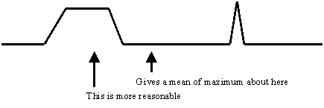
Moment Defuzzify: moment defuzzifies a fuzzy set returning a floating point (double value) that represents the fuzzy set. It calculates the first moment of area of a fuzzy set about the y axis. The set is subdivided into different shapes by partitioning vertically at each point in the set, resulting in rectangles, triangles, and trapezoids. The centre of gravity (moment) and area of each subdivision is calculated using the appropriate formulas for each shape. The first moment of area of the whole set is then:

where x_{i}' is the local centre of gravity, A_{i} is the local area of the shape underneath line segment (p_{i-1}, p_{i}), and n is the total number of points. As an example,
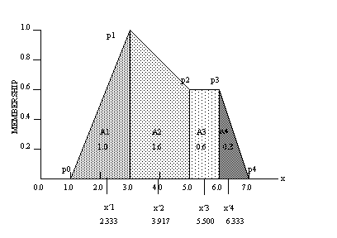
For each shaded subsection in the diagram above, the area and centre of gravity is calculated according to the shape identified (i.e., triangle, rectangle or trapezoid). The centre of gravity of the whole set is then determined:
x' = (2.333*1.0 + 3.917*1.6 + 5.5*0.6 + 6.333*0.3)/(1.0+1.6+0.6+0.3) = 3.943…
Center of Area (COA): defuzzification finds the x value such that half of the area under the fuzzy set is on each side of the x value. In the case above (in the moment defuzzify section) the total area under the fuzzy set is 3.5 (1.0+1.6+0.6+0.3). So we would want to find the x value where the area to the left and the right both had values of 1.75. This occurs where x = 3.8167. Note that in general the results of moment defuzzify and center of area defuzzify are not the same. Also note that in some cases the center of area can be satisfied by more than one value. For example, for the fuzzy set defined by the points:
(5,0) (6,1) (7,0) (15,0) (16,1) (17,0)
the COA could be any value from 7.0 to 15.0 since the 2 identical triangles centered at x=6 and x=16 lie on either side of 7.0 and 15.0. We will return a value of 11.0 in this case (in general we try to find the middle of the possible x values).
Weighted Average Defuzzify: finds the weighted average of the x values of the points that define a fuzzy set using the membership values of the points as the weights. This value is returned as the defuzzification value. For example, if we have the following fuzzy set definition:
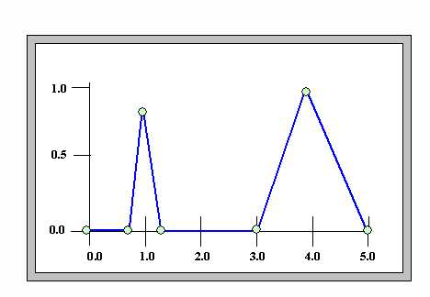
Then the weighted average value of the fuzzy set points will be:
(1.0*0.9 + 4.0*1.0) / (0.9 + 1.0) = 2.579
This is only moderately useful since the value at 1.0 has too much influence on the defuzzified result. The moment defuzzification is probably most useful in this case. However, a place where this defuzzification method is very useful is when the fuzzy set is in fact a series of singleton values. It might be that a set of rules is of the Takagi-Sugeno-Kang type (1st order) with formats like:
If x is A and y is B then c = k
where x and y are fuzzy variables and k is a constant that is represented by a singleton fuzzy set. For example we might have rules that look like:
where the setting of the hot valve has several possibilities, say full closed, low, medium low, medium high, high and full open, and these are singleton values rather than normal fuzzy sets. In this case medium low might be 2 on a scale from 0 to 5.
An aggregated conclusion for setting the hot valve position (after all of the rules have contributed to the decision) might look like:
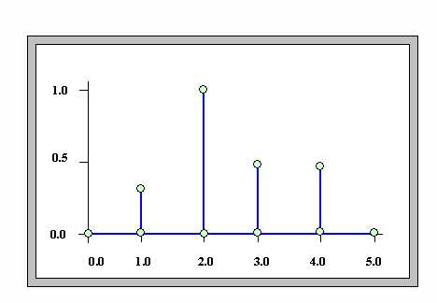
And the weighted average defuzzification value for this output would be:
(1.0*0.25 + 2.0*1.0 + 3.0*0.5 + 4.0*0.5) / (0.25 + 1.0 + 0.5 + 0.5) = 2.556
Note that neither a maximum defuzzification nor a moment defuzzification would produce a useful result in this situation. The maximum version would use only 1 of the points (the maximum one) giving a result of 2.0 (the x value of that point), while the moment version would not find any area to work with and would generate an exception. This description of the weighted average defuzzify method will be clearer after you have completed the sections on fuzzy values and fuzzy rules.
After the process of defuzzified, next step is to make a fuzzy decision. Fuzzy decision which is a model for decision making in a fuzzy environment, the object function and constraints are characterized as their membership functions, the intersection of fuzzy constraints and fuzzy objection function. Fuzzy decision-making method consists of three main steps:
- Representation of the decision problem: the method consists of three activities. (1) Identifying the decision goal and a set of the decision alternatives. (2) Identifying a set of the decision criteria. (3) Building a hierarchical structure of the decision problem under consideration
- Fuzzy set evaluation of decision alternatives: the steps consist of three activities. (1) Choosing sets of the preference ratings for the importance weights of the decision preference ratings include linguistic variable and triangular fuzzy number. (2) Evaluating the importance weights of the criteria and the degrees of appropriateness of the decision alternatives. (3) Aggregating the weights of the decision criteria.
- Selection of the optimal alternative: this step includes two activities. (1) Prioritization of the decision alternatives using the aggregated assessments. (2) Choice of the decision alternative with highest priority as the optimal.
Applications of fuzzy set theory:
An innovative method based on fuzzy set theory has been developed that can accurately predict market demand on goods. Based on the fuzzy demand function and fuzzy utility function theories, two real-world examples have been given to demonstrate the efficacy of the theory.
Example:
- Brief Background on Consumption Theory
1. Consumer Behaviors and Preference
One consumer would in general have different consumption behaviors or preferences from another. He may spend money on computers and technical books, while the other may spend on clothing and food. Availability of this information on consumer preference will be of great value to a marketing company, a bank, or a credit card company that can use this information to target different groups of consumer for improved response rate or profit. By the same token, information on consumption preference of the residents in one specific region can help businesses in planning their operations in this region for improved profit. Therefore, it is very important to have a tool that can help analyze consumers’ behaviors and forecast the changes in purchase patterns and changes in purchase trend.
2. Fuzzy Consumption Utility Functions-based Utility Theory
In studying advanced methodology for consumption behaviors, AI researchers at Zaptron Systems have developed the so called fuzzy utility functions that can model and describe the consumption behaviors of a target consumer group.
3. Consumption Utility - it is a criterion (or index) used to evaluate the effectiveness of customers consumption. A low value of consumption utility, say 0.15 indicates that a customer is not satisfied with the consumption of a certain commodity; while high value, say 0.96, indicates that the customer is very satisfied. There are formal theories on utility, including ordinal utility, cardinal utility and marginal utility.
4. Consumption utility function - The behavioral characteristics of human beings can be represented by the concept of consumption utility, and consumption utility function is the mathematical description of this concept. In addition, human consumption behaviors are determined by the following two types of factors:
(1) Objective factors - the physical, chemical, biological and artistic properties of goods;
(2) Subjective factors - consumer's interest, preference and psychological state.
5. Because of the objective and subjective factors, the fuzzy utility function for consumption can use the fuzzy set theoretical approach -- in fact, consumption utility is a fuzzy concept. To model the above subjective factors, fuzzy set theory is used to describe different levels of consumers’ satisfaction with respect to various consumption plans (spending patterns), such as "not satisfied," "somehow satisfied," "very satisfied," and etc. Mathematically, the fuzzy utility function is a more accurate measure on the consumption utility. It can describe the relationships among spending, price, consumption composition (decomposition), preference and subjective measure on commodity or service values.
- Brief Background on Demand Theory
1. Consumption Demand - it is the amount of consumption on goods (purchase amount). In general, it is related to the objective factors of commodities (such as physical, chemical and artistic characters) and the subjective value of the consumer (preference, personal habits, health conditions, etc.). Demand is affected by the total spending capability and population of a customer group, as well as the consumer prices.
2. Consumption Demand Function - the behavioral characteristics of financial market can be represented by the concept of consumption demand and the consumption demand function is the mathematical description of this concept. In addition, consumption demand can be determined by the following types of factors:
(1) Objective factors - the physical, chemical, biological and artistic properties of goods;
(2) Subjective factors - consumer's interest, preference and psychological state;
(3) Group factors - population and wealth of the consumers (consumer group);
(4) Comparative factors - the ratio of prices of different goods, ratio of different preference, and ratio of subjective values on
(i) Different goods (comparisons of different consumption can directly affect the consumption demand);
(ii) Fluctuation factors - wealth, population and price fluctuations.
3. Because of the objective, subjective, group and comparative factors, the fuzzy consumption demand functions can use the fuzzy set theoretical approach-- in studying advanced methodology for the analysis of consumption demand, AI researchers at Zaptron Systems have developed technology and software tool based on the so called fuzzy demand functions. They can model and describe the market demand, or consumption demand, on various commodities or services, based on consumption data available. The fuzzy demand functions discussed here are developed based on the fuzzy consumption utility function theory developed by Zaptron scientists.
4. In fact, consumption demand is a fuzzy logic concept. Mathematically, the fuzzy demand function is a more accurate measure on the consumption demand, compared against a traditional (non-fuzzy) demand function. It can describe relationships among wealth, price, consumption composition (decomposition), preference and subjective measure on commodity or service values. Computation of fuzzy demand functions and parameters - based on the maximum utility principle, they can be computed by solving a set of complex mathematical equations. From above examples, an innovative method based on fuzzy set theory has been developed that can accurately predict market demand on goods. Based on the fuzzy demand function and fuzzy utility function theories have been given to demonstrate the efficacy of the theory.
- Brief Background on Option Theory
1. Option pricing model: the optimal option price has been used to compute by the binomial model (1979) or the Black-Scholes model (1973). However, volatility and riskless interest rate are assumed as constant in those models. Hence, many subsequent studies emphasized the estimated riskless interest rate and volatility. Cox (1975) introduced the concept of Constant-Elasticity-of-Variance for volatility. Hull and White (1987) released the assumption that the distribution of price of underlying asset and volatility are constant. Wiggins (1987), Scott (1987), Lee, Lee and Wei (1991) released the assumption that the volatility is constant and assumed that the volatility followed Stochastic-Volatility. Amin (1993) and Scott (1987) considered that the Jump-Diffusion process of stock price and the volatility were random process. Researchers have so far made substantial effort and achieve significant results concerning the pricing of options (e.g., Brennan and Schwartz, 1977; Geske and Johnson, 1984; Barone-Adesi and Whaley, 1987). Empirical studies have shown that given their basic assumptions, existing pricing model seem to have difficulty in properly handling the uncertainties inherent in any investment process.
2. There are five primary factors affecting option prices. These are striking price, current stock price, time, riskless interest rate, and volatility. Since the striking price and time until option expiration are both determined, current stock prices reflect on ever period, but riskless interest rate determined the interest rate of currency market, and volatility can’t be observed directly but can be estimated by historical data and situation analysis. Therefore, riskless interest rate and volatility are estimated. The concept of fuzziness can be used to estimate the two factors riskless interest rate and volatility.
3. Fuzzy option pricing model: because most of studies have focused on how to release the assumptions in the CRR model and the B-S model, including: (1) the short-term riskless interest rate is constant, (2) the volatility of a stock is constant. After loosening these assumptions, the fuzzy set theory applies to the option pricing model, in order to replace the complex models of previous studies. (Lee, Tzeng and Wang, 2005).
4. As derivative-based financial products become a major part of current global financial market, it is imperative to bring the basic concepts of options, especially the pricing method to a level of standardization in order to eliminate possible human negligence in the content or structure of the option market. The fuzzy set theory applies to the option pricing model (OPM) can providing reasonable ranges of option prices, which many investors can use it for arbitrage or hedge.

References
Amin, K. I. (1993). Jump diffusion option valuation in discrete time. Journal of Finance, 48(5), 1833–1863.
Barone-Adesi, G. and R. E. Whaley (1987). Efficient analytic approximation of American option values. Journal of Finance, 42(2), 301–320.
Black, F., and M. Scholes (1973). The pricing of options and corporate liabilities. Journal of Political Economy, 81(3), 637–654.
Brennan, M. J. and E. S. Schwartz (1977). The valuation of American put options. Journal of Finance, 32(2), 449–462.
Cox, J. C. and S. A. Ross (1975). Notes on option pricing I: Constant elasticity of variance diffusion. Working paper. Stanford University.
Cox, J. C., S. A. Ross, and M. Rubinstein (1979). Option pricing: A simplified approach. Journal of Financial Economics, 7(3), 229–263.
Lee, C.F., G.H. Tzeng, and S.Y. Wang (2005). A new application of fuzzy set theory to the Black-Scholes option pricing model. Expert Systems with Applications, 29(2), 330-342.
Lee, C.F., G.H. Tzeng, and S.Y. Wang (2005). A Fuzzy set approach to generalize CRR model: An empirical analysis of S&P 500 index option. Review of Quantitative Finance and Accounting, 25(3), 255-275.
Lee, J. C., C. F. Lee, and K. C. J. Wei (1991). Binomial option pricing with stochastic parameters: A beta distribution approach. Review of Quantitative Finance and Accounting, 1(3), 435–448.
Goguen, J. A. (1967). L-fuzzy sets. Journal of Mathematical Analysis and Applications, 18, 145–174.
Geske, R. and H. E. Johnson (1984). The american put valued analytically. Journal of Finance, 1511–1524.
Gottwald, S. (2001). A Treatise on Many-Valued Logics. Baldock, Hertfordshire, England: Research Studies Press Ltd.
Hull, J. and A. White (1987). The pricing of options on assets with stochastic volatilities. Journal of Finance, 42(2), 281–300.
Klir, G.J. and B. Yuan. (1995). Fuzzy Sets and Fuzzy Logic. Theory. and Applications, Ed. Prentice-Hall.
Scott, L. (1987). Option pricing when variance changes randomly: Theory, estimation and an application. Journal of Financial and Quantitative Analysis, 22(4), 419–438.
Wiggins, J. B. (1987). Option values under stochastic volatility: Theory and empirical evidence. Journal of Financial Economics, 19(2), 351–372.
Zadeh, L. A. (1965). Fuzzy sets. Information and Control, 8, 338–353.
Zadeh, L. A. (1975). The concept of a linguistic variable and its application to approximate reasoning. Information Sciences, 8,199–249, 301–357; 9, 43–80.
Zadeh, L. A. (1978). Fuzzy sets as a basis for a theory of possibility. Fuzzy Sets and Systems, 1, 3–28.

