Copula, Correlated Defaults and Credit VaR

Jow-ran Changª, and An-Chi Chen ^{b}

ªDepartment of Quantitative Finance, National Tsing Hua University
No. 101, Sec. 2, Kuang-Fu Rd., Hsinchu, Taiwan
e-mail: jrchang@mx.nthu.edu.tw
Phone: 886-3-5742420
^{b} KGI Securities Co. Ltd.
No. 700 Ming Shui Road, Taipei, Taiwan
e-mail angel.chen@kgi.com.tw
Phone: 886-2- 21818750

Abstract

Almost every finance institution pays lots of attention and energy to deal with credit risk. The default correlations of credit assets have a fatal influence on credit risk. How to model default correlation correctly has become a prerequisite of effective management of credit risk. In this thesis, we provide a new approach to estimate future credit risk on target portfolio based on the framework of CreditMetricsTM by J.P. Morgan. However, we adopt the perspective of factor copula and then bring the principal component analysis concept into factor structure to construct a more appropriate dependence structure among credits. In order to examine the proposed method, we use real market data instead of virtual one. We also develop a tool for risk analysis which is convenient to use, especially for banking loan businesses. The results show the fact that people assume dependence structures are normally distributed will indeed lead to risks underestimate. On the other hand, our proposed method captures better features of risks and shows the fat-tail effects conspicuously even though assuming the factors are normally distributed.

Keywords: credit risk, default correlation, copula, principal component analysis, credit VaR

- Introduction

Credit risk is a risk that generally refers to counterparty fails to fulfill its contractual obligations. The history of financial institutions has shown that many banking association failures were due to credit risk. For the integrity and regularity, financial institutions attempt to quantify credit risk as well as market risk. Credit risk has great influence on all financial institutions as long as they have contractual agreements. The evolution of measuring credit risk has been progressed for a long time. Many credit risk measure models were published, such as CreditMetrics by J.P. Morgan, CreditRisk+ by Credit Suisse. On the other side, New Basel Accords (Basel II Accords) which are the recommendation on banking laws and regulations construct a standard to promote greater stability in financial system. Basel II Accords allowed banks to estimate credit risk by using either a standardized model or an internal model approach, based on their own risk management system. The former approach is based on external credit ratings provided by external credit assessment institutions. It describes the weights, which fall into 5 categories for banks and sovereigns, and 4 categories for corporations. The latter approach allows banks to use their internal estimation of creditworthiness, subject to regulatory. How to build a credit risk measurement model after banking has constructed internal customer credit rating? How to estimate their default probability and default correlations? This thesis attempts to implement a credit risk model tool which links to internal banking database and gives the relevant reports automatically. The developed model facilitates banks to boost their risk management capability

The dispersion of the credit losses, however, critically depends on the correlations between default events. Several factors such as industry sectors and corporation sizes will affect correlations between every two default events. The CreditMetricsTM model (1997) issued from J.P. Morgan proposed a binomial normal distribution to describe the correlations (dependence structures). In order to describe the dependence structure between two default events in detail, we adopt Copula function instead of binomial normal distribution to express the dependence structure.
When estimating credit portfolio losses, both the individual default rates of each firm and joint default probabilities across all firms need to be considered. These features are similar to the valuation process of Collateralized Debt Obligation (CDO). A CDO is a way of creating securities with widely different risk characteristics from a portfolio of debt instrument. The estimating process is almost the same between our goal and CDO pricing. We focus on how to estimate risks. Most CDO pricing literature adopted copula functions to capture the default correlations. David, Li (2000) extended Sklar’s issue (1959) that a copula function can be applied to solve financial problems of default correlation. Li (2000) pointed out that if the dependence structure were assumed to be normally distributed through binomial normal probability density function, the joint transformation probability would be consistent with the result from using a Normal copula function. But this assumption is too strong. It has been discovered that most financial data have skew or fat tail phenomenon. Bouye et al. (2000) and Embrechts et al. (1999) pointed out that the estimating VaR would be underestimated if the dependence structure was described by Normal copula comparing to actual data. Hull and White (2004) combined factor analysis and copula functions as a factor copula concept to investigate reasonable spread of CDO. How to find a suitable correlation to describe the dependence structure between every two default events and to speed up the computational complexity is our main object.
This paper aims to
- Construct a efficient model to describe the dependence structure
- Use this constructed model to analyze overall credit, marginal, and industrial risks
- Build up an automatic tool for banking system to analyze its internal credit risks

- Methodology
CreditMetrics
This paper adopts the main framework of CreditMetrics and calculates credit risks by using real commercial bank loans. The calculating dataset for this paper is derived from a certain commercial bank in Taiwan. Although there may be some conditions which are different from the situations proposed by CreditMetrics, the calculating process by CreditMetrics can still be appropriately applied to this paper. For instance, number of rating degrees in CreditMetrics adopt S&P’s rating category are 7, i.e. AAA to C; but in this loans dataset, there are 9 degrees instead. Chapter 4 will go deep into proposed methodology. The following is the introduction to CreditMetrics model framework.
This model can be roughly divided into three components, i.e. value at risk due to credit, exposures, and correlations respectively as shown in Figure 1. In this section, these three components and how dose this model work out on credit risk valuation will be briefly introduced.. More further detailed could refer to CreditMetrics technique document.

Figure 1 Structure of CreditMetrics model

Value at Risk due to Credit:
The process of valuing value at risk due to credit can be decomposed into three steps. For simplicity, we assumed there is only one stand-alone instrument which is a corporation bond. (The bond property is similar to loan they both receive certain amount of cash flow every period and receive principal at the maturity). This bond has five-year maturity and pays an annual coupon at the rate of 5% to express the calculation process if necessary. Some modifications to fit real situations will be considered later. Step 1, CreditMetrics assumed that all risks of one portfolio due to credit rating changes, no mater defaulting or rating migrating. It is significant to estimate not only the likelihood of default but also the chance of migration to move toward any possible credit quality state at the risk horizon. Therefore, a standard system that evaluated “rating changing” under a certain horizon of time is necessary. This information is represented more concisely in transition matrix. Transition matrix can be calculated by observing the historical pattern of rating change and default. They have been published by S&P and Moody’s rating agencies, or calculated by private banking internal rating systems. Besides, the transition matrix should be estimated for the same time interval (risk horizon) which can be defined by user demand, usually is one year period. Table 1 is an example to represent one-year transition matrix.

Table 1 One-year transition matrix
Initial  Rating | Rating at year-end (%)
Initial  Rating | AAA | AA | A | BBB | BB | B | CCC | D
1
AAA | 90.81 | 8.33 | 0.68 | 0.06 | 0.12 | 0 | 0 | 0
AA | 0.70 | 90.65 | 7.79 | 0.64 | 0.06 | 0.14 | 0.02 | 0
A | 0.09 | 2.27 | 91.05 | 5.52 | 0.74 | 0.26 | 0.01 | 0.06
BBB | 0.02 | 0.33 | 5.95 | 86.93 | 5.30 | 1.17 | 0.12 | 0.18
BB | 0.03 | 0.14 | 0.67 | 7.73 | 80.53 | 8.84 | 1.00 | 1.06
B | 0 | 0.11 | 0.24 | 0.43 | 6.48 | 83.46 | 4.07 | 5.20
CCC | 0.22 | 0 | 0.22 | 1.30 | 2.38 | 11.24 | 64.86 | 19.79
Source: J.P. Morgan’s CreditMetrics- technical document (1997)
In the transition matrix table, AAA level is the highest credit rating and D is the lowest, D also represents default occurs. According to the above transition matrix table , a company which stays in AA level at the beginning of the year has the probability of 0.64% to go down to BBB level at the end of the year. By the same way, a company which stays in CCC level at the beginning of the year has the probability of 2.38% to go up to BB level at the end of the year. In this paper, the transition matrix is to be seen as an external data.
In step 1, we describe the likelihood of migration move to any possible quality states (AAA to CCC) at the risk horizon. Step 2 is valuation. The value at the risk horizon must be determined. According to different states, the valuation falls into two categories. First, in the event of a default, recovery rate of different seniority class is needed. Second, in the event of up (down) grades, the change in credit spread that results from the rating migration must be estimated, too.
In default category, following table 2 is recovery rates by seniority class which this paper adopt to revaluate instruments. For instance, if the holding bond (five-year maturity and pays an annual coupon at the rate of 5%) is unsecured and the default occurs, the recover value will be estimated using its mean value which is 36.15%.

Table 2 Recovery rates by seniority class
Class |  | Recovery rate of Taiwan debt business research using TEJ Data
 |  | Mean (%) | Standard Deviation (%)
Loan | Secured | 55.38 | 35.26
Loan | Unsecured | 33.27 | 30.29
Corporation  bond | Secured | 67.99 | 26.13
Corporation  bond | Unsecured | 36.15 | 37.17
Source: Da-Bai Shen, Yong-Kang Jing, Jia-Cian Tsia (2003), Research of Taiwan recovery rate with TEJ Data Bank

In rating migration category, the action of revaluation is equal to determine the cash flows which result from holding the instrument (corporation bond position). Assuming a face value of $100, the bond pays $5 (an annual coupon at the rate of 5%) each at the end of the next four years. Now, the calculating process to describe the value V of the bond assuming the bond upgrades to level A by the formula below:
$$V=5+\frac{5}{(1+3\text{.}\text{72}\text{\%})}+\frac{5}{(1+4\text{.}\text{32}\text{\%})^{2}}+\frac{5}{(1+4\text{.}\text{93}\text{\%})^{3}}+\frac{\text{105}}{(1+5\text{.}\text{32})^{4}}=\text{108}\text{.}\text{66}$$
The discount rate in above formula comes from the forward zero curves shown in table 3, which is derived from CreditMetrics technical document. This paper does not focus on how to calculate forward zero curves. It is also seen as an external input data.

Table 3 One-year forward zero curves by credit rating category
Category | Year 1 | Year 2 | Year 3 | Year 4
AAA | 3.60 | 4.17 | 4.73 | 5.12
AA | 3.65 | 4.22 | 4.78 | 5.17
A | 3.72 | 4.32 | 4.93 | 5.32
BBB | 4.10 | 4.67 | 5.25 | 5.63
BB | 5.55 | 6.02 | 6.78 | 7.27
B | 6.05 | 7.02 | 8.03 | 8.52
CCC | 15.05 | 15.02 | 14.03 | 13.52
Source: J.P. Morgan’s CreditMetrics- technical document (1997)
Step 3 is to estimate the volatility of value due to credit quality changes for this stand-alone exposure (level A, corporation bond). From step 1 and step 2, the likelihood of all possible outcomes and distribution of values within each outcome are known. CreditMetrics used two measures to calculate the risk estimate. One is standard deviation, the other is percentile level. Besides these two measures, this paper also embraces marginal VaR which denotes the increment VaR due to adding one new instrument in the portfolio.

Exposures:
As discussed above, the instrument is limited to corporation bonds. CreditMetrics is allowed following generic exposure types.
- non-interest bearing receivables;
- bonds and loans;
- commitments to lend
- financial letters of credit; and
- market-driven instruments (swap, forwards, etc.)
The exposure type this paper aims at is loans. The credit risks calculation process of loans is similar to bonds as previous example. The only difference is that loans do not pay coupons. Instead, loans receive interests. But the CreditMetrics model can definitely fit the goal of this paper to estimate credit risks on banking loans business.

Correlations:
In most circumstances, there is usually more than one instrument in a target portfolio. Now, multiple exposures are taken into consideration. In order to extend the methodology to a portfolio of multiple exposures, estimating the contribution to risk brought by the effect of non-zero credit quality correlations is necessary. Thus, the estimation of joint likelihood in the credit quality co-movement is the next problem to be resolved. There are many academic papers which address the problems of estimating correlations within a credit portfolio. For example, Gollinger & Morgan (1993) used time series of default likelihood to correlate default likelihood, and Steveson & Fadil (1995) correlated the default experience across 33 industry groups. On the other hand, CreditMetrics proposed a method to estimate default correlation. They have several assumptions.
- a firm’s asset value is the process which drives its credit rating changes and default.
- the asset returns are normally distributed
- two asset returns are correlated and bivariate normally distributed, and multiple asset returns are correlated and multivariate normally distributed.
According to assumption A, individual threshold of one firm can be calculated. For a two exposure portfolio, which credit rating are level B and level AA, and standard deviation of returns are σ and σ’ respectively, it only remains to specify is the correlation ρ between two asset returns. The covariance matrix for the bivariate normal distribution:
$$Σ=\left(\begin{matrix}σ^{2} & \text{ρσσ}' \\ \text{ρσσ}' & σ'^{2}\end{matrix}\right)$$
Then the joint probability of co-movement that both two firms stay in the same credit rating can be described by the follow formula:
$$\text{Pr}\left\{Z_{\text{BB}}<R_{1}<Z,Z'_{\text{AAA}}<R_{2}<Z'_{\text{AA}}\right\}=\int{\int{f(r,r\text{';}Σ)(\text{dr}')\text{dr}}}$$
Where Z_{BB}, Z_{B}, Z’_{AAA}, Z’_{AA} are the thresholds. Figure 2 gives a concept of the probability calculation. These three assumptions regarding estimating the default correlation are too strong, especially assuming the multiple asset returns are multi-normally distributed. In the next session, a better way of using copula to examine the default correlation is proposed.

Figure 2 Distribution of asset returns with rating change thresholds

Copula Function

Consider a portfolio consists of m credits. Marginal distribution of each individual credit risks (defaults occur) can be constructed by using either the historical approach or the market implicit approach (derived credit curve from market information). But the question is - how to describe the joint distribution or co-movement between these risks (default correlation)? In a sense, every joint distribution function for a vector of risk factors implicitly contains both a description of the marginal behavior of individual risk factors and a description of their dependence structure. The simplest way is assuming the dependence structure to be mutual independence amount the credit risks. However, the independent assumption of the credit risks is obviously not realistic. Undoubtedly, the default rate for a group of credits tends to be higher when the economy is in a recession and lower in a booming. This implies that each credit is subject to the same factors from macroeconomic environment, and that there exists some form of dependence amount these credits. The copula approach provides a way of isolating the description of the dependences structure. That is, the copula provides a solution to specify a joint distribution of risks, with given marginal distributions. Of course, this problem is no unique solution. There are many different techniques in statistics which can specify a joint distribution with given marginal distributions and a correlation structure. In the following section, the copula function is briefly introduced.

Copula function
A m-dimension copula is a distribution function on [0,1]^{m} with standard uniform marginal distributions.
C(u) = C (u₁ ,u₂ ,…, u_{m}) | (1)
C is called a copula function.
The Copula function C is a mapping of the form C:[0,1]^{m} → [0,1] , i.e. a mapping of the m-dimensional unit cube [0, 1]^{m} such that every marginal distribution is uniform on the interval [0, 1]. The following two properties must hold
- $C(u_{1},u_{2},\text{.}\text{.}\text{.},u_{m},Σ)$is increasing in each component u_{i}
- $C(1,\text{.}\text{.}\text{.},1,u_{i},1,\text{.}\text{.}\text{.},1,Σ)=u_{i}$for all i$∈\left\{1,\text{.}\text{.}\text{.},m\right\}$, u_{i}$∈[0,1]$

Sklar’s theorem
Sklar (1959) underlined applications of the copula. Let F(‧) be a m-dimension joint distribution function with marginal distribution F₁, F_{2,}…,F_{m}. There exits an copula C: [0,1]^{m} → [0,1] such that,
$$F(x_{1},x_{2},\text{.}\text{.}\text{.},x_{m})=C(F_{1}(x_{1}),F_{2}(x_{2}),\text{.}\text{.}\text{.}F_{m}(x_{m}))$$ | (2)
If the margins are continuous, then C is unique.
For any x₁,…, x_{m} in$ℜ=[−∞,∞]$ and X has joint distribution function F, then
$$F(x_{1},x_{2},\text{.}\text{.}\text{.},x_{m})=\text{Pr}[F_{1}(X_{1})≤F_{1}(x_{1}),F_{2}(X_{2})≤F_{2}(x_{2}),\text{.}\text{.}\text{.},F_{m}(X_{m})≤F_{m}(x_{m})]$$ | (3)
According to (2), the distribution function of ( F₁(X₁), F₂(X₂),…,F_{m}(X_{m}) ) is a copula. Let x_{i} = F_{i}⁻¹(u_{i}), then
$$C(u_{1},u_{2},\text{.}\text{.}\text{.},u_{m})=F(F_{1}^{−1}(u_{1}),F_{2}^{−1}(u_{2}),\text{.}\text{.}\text{.},F_{m}^{−1}(u_{m}))$$ | (4)
This gives an explicit representation of C in terms of F and its margins.

Copula of F
Li (1999) used the copula function conversely. The copula function links univariate marginals to their full multivariate distribution. For m uniform random variables, U₁,U_{2,}…,U_{m}, the joint distribution function C, defined as
$$C(u_{1},u_{2},\text{.}\text{.}\text{.},u_{m},Σ)=\text{Pr}[U_{1}≤u_{1},U_{2}≤u_{2},\text{.}\text{.}\text{.},U_{m}≤u_{m}]$$ | (5)
where, Σ is correlation matrix of U₁,U₂,…,U_{m}.
For given univariate marginal distribution functions F₁(x₁), F₂(x₂),…, F_{m}(x_{m}). The same as above, let x_{i} = F_{i}⁻¹(u_{i}), the joint distribution function F can be describe as following
$$F(x_{1},x_{2},\text{.}\text{.}\text{.},x_{m})=C(F_{1}(x_{1}),F_{2}(x_{2}),\text{.}\text{.}\text{.},F_{m}(x_{m}),Σ)$$ | (6)
The joint distribution function F is defined by using a copula.
The property can be easily shown as follows:
C(F₁(x₁),F₂(x₂),…F_{m}(x_{m}),Σ) = | $$\text{Pr}[U_{1}≤F_{1}(x_{1}),U_{2}≤F_{2}(x_{2}),\text{.}\text{.}\text{.},U_{m}≤F_{m}(x_{m})]$$
= | $$\text{Pr}[F_{1}^{−1}(U_{1})≤x_{1},F_{2}^{−1}(U_{2})≤x_{2},\text{.}\text{.}\text{.},F_{m}^{−1}(U_{m})≤x_{m}]$$
= | $$\text{Pr}[X_{1}≤x_{1},X_{2}≤x_{2},\text{.}\text{.}\text{.},X_{m}≤x_{m}]$$
= | $$F(x_{1},x_{2},\text{.}\text{.}\text{.},x_{m})$$
The marginal distribution of X_{i} is
$$C(F_{1}(+∞),F_{2}(+∞),\text{.}\text{.}\text{.},F_{i}(x_{i}),\text{.}\text{.}\text{.},F_{m}(+∞),Σ)$$ | (7)
= $\text{Pr}[X_{1}≤+∞,X_{2}≤+∞,\text{.}\text{.}\text{.},X_{i}≤x_{i},\text{.}\text{.}\text{.},X_{m}≤+∞]$ | (7)
= $\text{Pr}[X_{i}≤x_{i}]$ | (7)
= $F_{i}(x_{i})$ | (7)
Li showed that with given marginal functions, we can construct the joint distribution through some copulas accordingly. But what kind of copula should be chosen corresponding to realistic joint distribution of a portfolio? For example, the CreditMetrics chose Gaussian copula to construct multivariate distribution.
By (6), this Gaussian copula is given by
$C^{\text{Ga}}($u,Σ$)=\text{Pr}(Φ(X_{1})≤u_{1},Φ(X_{2})≤u_{2},\text{.}\text{.}\text{.},Φ(X_{m})≤u_{m},Σ)$ | (8)
$=Φ_{Σ}(Φ^{−1}(u_{1}),Φ^{−1}(u_{2}),\text{.}\text{.}\text{.},Φ^{−1}(u_{m}))$ | (8)
Where$Φ$denotes the standard univariate normal distribution, $Φ^{−1}$denotes the inverse of a univariate normal distribution, and$Φ_{Σ}$denotes multivariate normal distribution. In order to easily describe the construction process, we only discuss two random variables u₁ and u₂ to demonstrate the Gaussian copula.
$$C^{\text{Ga}}(u_{1},u_{2},ρ)=\int{\int{\frac{1}{2π\sqrt{(1−ρ^{2})}}\text{exp}\left\{−\frac{v_{1}^{2}−2{ρv}_{1}v_{2}+v_{2}^{2}}{2(1−ρ^{2})}\right\}{\text{dv}}_{2}{\text{dv}}_{1}}}$$ | (9)
ρdenotes the correlation of u₁ and u₂.
(9) is also equivalent to the bivariate normal copula which can be written as follow:
$$C(u,u_{2},ρ)=Φ_{2}(Φ^{−1}(u_{1}),Φ^{−1}(u_{2}))$$ | (10)
Thus, with given individual distribution (ex: credit migration over one year’s horizon) of each credit asset within a portfolio, we can obtain the joint distribution and default correlation of this portfolio through copula function. In our methodology, we do not use copula function directly. Next session, we bring in the concept of factor copula for further improvement to form the default correlation. Using factor copula has two advantages. One is to avoid constructing a high dimension correlation matrix. If there are more and more instruments (N>1000) in our portfolio, we need to store N by N correlation matrix, scalability is one problem. The other advantage is to speed up the computation time because of the lower dimension.

Factor Copula Model

In this section, copula models have a factor structure will be introduced. It is called factor copula because this model describes dependence structure between random variables not from the perspective of a certain copula form, such as Gaussian copula, but from the factors model. Factor copula models have been broadly used to assess price of collateralized debt obligation (CDO) and credit default swap (CDS). The main concept of factor copula model is: under a certain macro environment, credit default events are independent to each other. And the main causes affect default events come from potential market economic conditions. This model provides another way to avoid dealing with multivariate normal distribution (high dimensional) simulation problem.
Continuing the above example - a portfolio is consisted of m credits. In the first we consider the simplest example which contains only one factor. Define V_{i} is the asset value of ith-credit under single factor copula model. Then this ith-credit asset value can be express by one factor M (mutual factor) chosen from macro economic factors and one error term$ε_{i}$.
$$V_{i}=r_{i}M+\sqrt{1−r_{i}^{2}}ε_{i}$$ | (11)
Where r_{i} is weight of M, and the mutual factor M is independent of$ε_{i}$
Let the marginal distribution of V₁,V₂,..,V_{m} are F_{i}, i=1,2,…,m. Then the m-dimensional copula function can be written as
$$C(u_{1},u_{2},\text{.}\text{.}\text{.},u_{m})=F(F_{1}^{−1}(u_{1}),F_{2}^{−1}(u_{2}),\text{.}\text{.}\text{.},F_{m}^{−1}(u_{m}))$$ | (12)
$=\text{Pr}(V_{1}≤F_{1}^{−1}(u_{1}),V_{2}≤F_{2}^{−1}(u_{2}),\text{.}\text{.}\text{.},V_{m}≤F_{m}^{−1}(u_{m}))$ | (12)
F is the joint cumulative distribution function of V₁,V₂,…,V_{m}
It has been known that M and$ε_{i}$ are independent of each other, according to iterated expectation theorem, (3.12) can be written as
$$C(u_{1},u_{2},\text{.}\text{.}\text{.},u_{m})=E\left\{\text{Pr}(V_{1}≤F_{1}^{−1}(u_{1}),V_{2}≤F_{2}^{−1}(u),\text{.}\text{.}\text{.},V_{m}≤F_{m}^{−1}(u_{n}))|M\right\}$$ | (13)
$=E\left\{\prod_{i=1}^{m}{\text{Pr}(r_{i}M+\sqrt{1−r_{i}^{2}}ε_{i}≤F_{i}^{−1}(u_{i}))|M}\right\}$ | (13)
$=E\left\{\prod_{i=1}^{m}{F_{ε,i}(\frac{F_{i}^{−1}(u_{i})−r_{i}M}{\sqrt{1−r_{i}^{2}}})|M}\right\}$ | (13)
$=\int{(\prod_{i=1}^{m}{F_{ε,i}(\frac{F_{i}^{−1}(u_{i})−r_{i}M}{\sqrt{1−r_{i}^{2}}})})g(M)\text{dM}}$ | (13)
Using above formula, m-dimensional copula function can be derived. Moreover, according to (13), the joint cumulative distribution F can also be derived
$$F(t_{1},t_{2},\text{.}\text{.}\text{.},t_{m})=\int{(\prod_{i=1}^{m}{F_{ε,i}(\frac{(F_{i}^{−1}(F_{T,i}(t_{i}))−r_{i}M)}{\sqrt{1−r_{i}^{2}}})})g(M)\text{dM}}$$ | (14)
Let $F_{i}(t_{i})=\text{Pr}(T_{i}≤t_{i})$ represent i-credit default probability (default occurs before time t_{i}), where F_{i} is marginal cumulative distribution. We note here that CDX pricing cares about when the default time T_{i} occurs. Under the same environment (systematic factor M) Andersen and Sidenius (2004), the default probability $\text{Pr}(T_{i}≤t_{i})$will equal to$\text{Pr}(V_{i}≤c_{i})$, which represent the probability asset value V_{i} is below its threshold c_{i}. Then joint default probability of these m credits can be described as follows
$$F(c_{1},c,\text{.}\text{.}\text{.},c_{m})=\text{Pr}(V_{1}≤c_{1},V_{2}≤c_{2},\text{.}\text{.}\text{.},V_{m}≤c_{m})$$
Now, we bring the concept of principal component analysis (pca). People use pca to reduce the high dimensions or multivariable problems. If someone would like to explain one thing (or some movement of random variables), he has to gather interpreting variables relate to those variables movements or their correlation. Once the kinds of interpreting variables are too huge or complicated, it becomes harder to explain those random variables and will produce complex problems. Principal component analysis provides a way to extract approximate interpreting variables to cover maximum variance of variables. Those representative variables may not be “real” variables. Virtual variables are allowed and depend on the explaining meaning. We do not talk about pca calculation processes, the further detail could refer to Jorion (2000). Base on factor model, the asset value of m credits with covariance matrix Σ can be described as following
$$V_{i}=r_{i1}y_{1}+r_{i2}y_{2}+\text{.}\text{.}\text{.}+r_{\text{im}}y_{m}+ε_{i}$$ | (15)
Where the y_{i} are common factors between these m credits, and r_{ij} is the weight (factor loading) of each factor. The factors are independent of each other. The question is: how to determinate those y_{i} factors and their loading? We use pca to derive the factor loading. Factor loadings are base on listed price of those companies in the portfolio to calculate their dependence structure. The experimental result will show in next section. We note here that the dependence structure among assets have been absorbed into factor loadings.

Figure 3 Architecture of proposed model

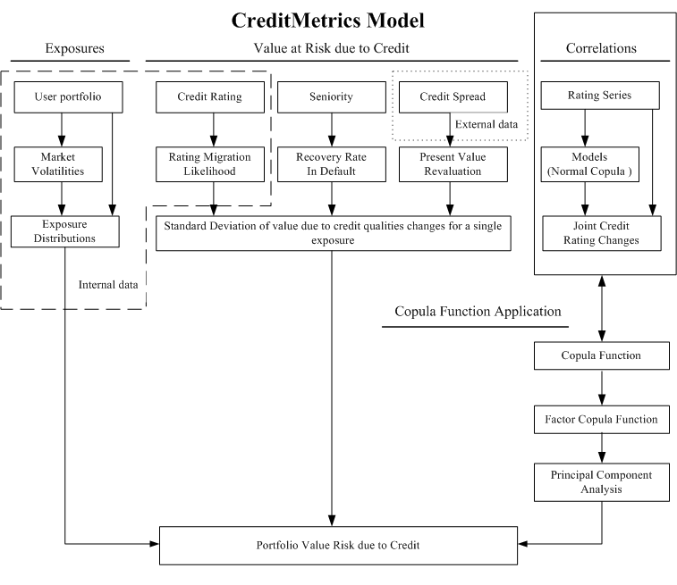

- Experimental Results

The purpose of this paper is to estimate credit risk by using principal component analysis to construct dependence structure without giving any assumptions to specify formulas of copula. In other words, the data were based on itself to describe the dependence structure.

Data

In order to analyze credit VaR empirically through proposed method, this investigation adopts the internal loan account data, loan application data and customer information data from a commercial bank on current market in Taiwan. For reliability of data authenticities, all the data Taiwan market instead of virtual one. This also means now the portfolio pool contains only the loans of listed companies and do not contain the loan of unlisted companies. According to the period of these data, we can estimate two future portfolio values. They are values on 2003 and 2004 respectively.
All requirement data are downloaded automatically from database system to workspace for computations. Before going to the detail of the experiments, the relevant data and experimental environment are introduced as follows

Requirements of data input:
- Commercial bank internal data: This internal data contains nearly 40,000 entries customer’s data, 50,000 entries loans data and 3,000 entries application data. These data contain maturity dates, outstanding amount, credit ratings, interest rate for lending, market type, etc. up to December 31, 2004.
- One-year period transition matrix: The data was extracted from Tze-Chen Yang (2005), who used the same commercial bank history data to estimate a transition matrix which obeyed Marcov Chain. (Table 4)
Table 4 One-year transition matrix (commercial data)
Initial  Rating | Rating at year-end (%)
Initial  Rating | 1 | 2 | 3 | 4 | 5 | 6 | 7 | 8 | 9 | D
1
1 | 100 | 0 | 0 | 0 | 0 | 0 | 0 | 0 | 0 | 0
2 | 3.53 | 70.81 | 8.90 | 5.75 | 6.29 | 1.39 | 0.19 | 2.74 | 0.06 | 0.34
3 | 10.76 | 0.03 | 72.24 | 0.24 | 10.39 | 5.78 | 0.31 | 0.09 | 0.06 | 0.10
4 | 1.80 | 1.36 | 5.85 | 57.13 | 18.75 | 11.31 | 2.45 | 0.32 | 0.70 | 0.33
5 | 0.14 | 0.44 | 1.58 | 2.39 | 75.47 | 16.97 | 1.49 | 0.61 | 0.49 | 0.42
6 | 0.09 | 0.06 | 0.94 | 2.44 | 13.66 | 70.58 | 6.95 | 1.68 | 0.76 | 2.81
7 | 0.05 | 0.05 | 0.27 | 3.72 | 3.75 | 14.49 | 66.39 | 8.05 | 0.12 | 3.11
8 | 0.01 | 0 | 0.03 | 0.45 | 0.21 | 1.34 | 2.00 | 77.10 | 0.44 | 18.42
9 | 0 | 0 | 0.02 | 0.09 | 1.46 | 1.80 | 1.36 | 3.08 | 70.06 | 22.13
D | 0 | 0 | 0 | 0 | 0 | 0 | 0 | 0 | 0 | 100
Source: Tze-Chen Yang and (2005)
- Zero forward rate: Refer to Tze-Chen Yang (2005), based on computed transition matrix to estimate the term structure of credit spreads. Further more, they added corresponding risk free interest rate to calculate zero forward rates from discounting zero spot rates. (Table 5)

Table 5 One-year forward zero curves by credit rating category (commercial data)
Yield (%) |  | 1 year | 2 year | 3 year | 4 year | 5 year | 6 year | 7 year | 8 year | 9 year
Credit  rating | 1 | 1.69 | 2.08 | 2.15 | 2.25 | 2.41 | 2.53 | 2.58 | 2.62 | 2.7
Credit  rating | 2 | 2.57 | 2.88 | 3.19 | 3.44 | 3.72 | 3.94 | 4.07 | 4.18 | 4.33
Credit  rating | 3 | 2.02 | 2.41 | 2.63 | 2.85 | 3.11 | 3.32 | 3.45 | 3.56 | 3.71
Credit  rating | 4 | 2.6 | 2.93 | 3.28 | 3.59 | 3.91 | 4.17 | 4.34 | 4.48 | 4.65
Credit  rating | 5 | 2.79 | 3.1 | 3.48 | 3.81 | 4.15 | 4.42 | 4.6 | 4.75 | 4.93
Credit  rating | 6 | 4.61 | 5.02 | 5.16 | 5.31 | 5.51 | 5.67 | 5.76 | 5.83 | 5.93
Credit  rating | 7 | 6.03 | 6.16 | 6.56 | 6.83 | 7.07 | 7.23 | 7.28 | 7.31 | 7.36
Credit  rating | 8 | 22.92 | 23.27 | 22.54 | 21.91 | 21.36 | 20.78 | 20.15 | 19.52 | 18.94
Credit  rating | 9 | 27.51 | 27.82 | 26.4 | 25.17 | 24.09 | 23.03 | 21.97 | 20.97 | 20.08
Source: Tze-Chen Yang (2005)
- Listed shares prices at exchange market and over-counter market: We collected weekly listed shares prices of all companies at exchange and over-counter market in Taiwan from January 1, 2000 to December 31, 2003, in total three years data, through Taiwan Economic Journal Data Bank (TEJ).

Simulation

In this section, the simulation procedure of analyzing banking VaR is briefly introduced. There are two main methods of experiments: A and B. A is the method that this paper proposed which uses factor analysis to explain the dependence structure and to simulation the distribution of future values. B is contrast set which traditionally and popularly used in most applications such as CreditMetrics. We call it the multi-normal (Normal/Gaussian copula) simulation method.
Both of these two methods need three input data tables- credit transition matrix, forward zero curves, and shares prices of each corporation in portfolio pool. The detail of normal copula method procedure does not mention here, readers can refer to technical documentation of CreditMetrics. Now, the process of factor analysis method is shown as follows:
- Extracting the data entries that do not mature under given date, from database system including credit ratings, outstanding amounts, interest rates, etc.
- According to the input transition matrix, we can calculate standardized thresholds for each credit rating.
- Using the shares prices of those corporations in the portfolio pool to calculate equities correlations.
- Using principal component analysis to obtain each factor loadings for all factors. Under the assumption that these factors obey some distributions (ex: standard normal distribution) to simulate their future asset value and future possible credit ratings.
- According to possible credit ratings, to discount the outstanding amounts by their own forward zero curves to evaluate future values distributions.
- Displaying the analysis results.

Discussion

Tools and Interfaces Preview:
For facility and convenience, this paper uses MATLAB and MySQL to construct an application tool to help tool users analyze future portfolio value more efficiently. Following is this tool’s interactive interfaces:

  - Basic information of experimental data: (Pie Chart)
Extracts the non-computing data and shows as pie charts to give user the basic view of loans information. These charts present the proportion of each composition of three key elements - loan amount of companies, industry and credit rating. To assist user construct an overview of concerned portfolio.
Figure 4 Interface of part I.
Pie chart of loan amount weight in terms of enterprise, industry and credit rating
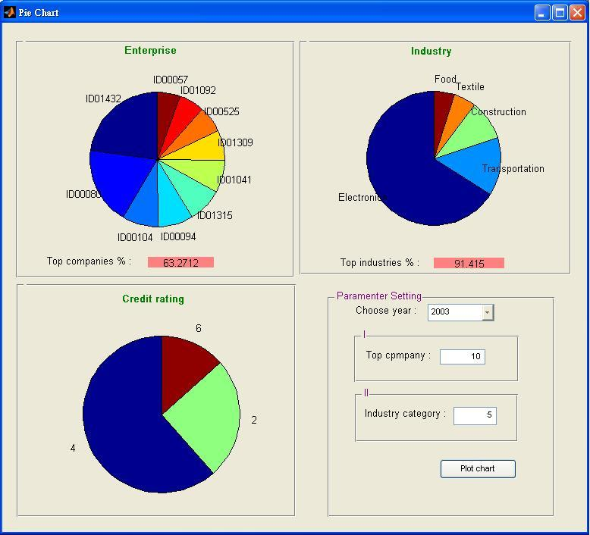  At the end of 2003 | 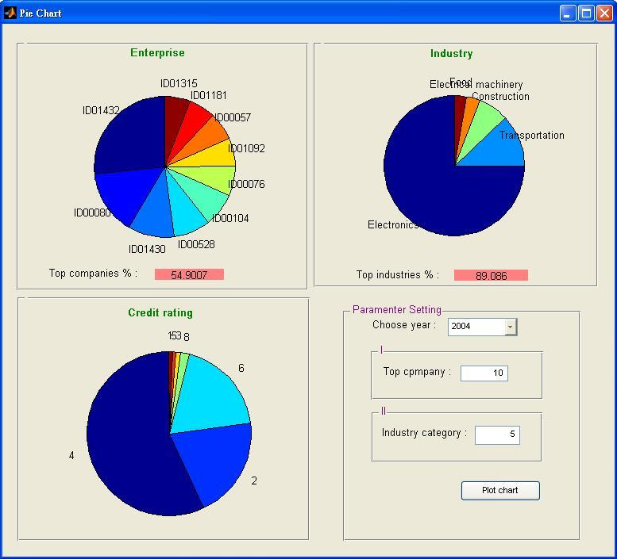  At the end of 2004

  - Information according to experimental data: (Statistic Numbers)
Besides graphic charts, the second part demonstrates a numerical analysis. First part the extraction of the company data which has maturity more than the given months and second part is to extract the essential data of top weighting companies. Part I and II extract data without any computation, the only thing has been done is to sort or remove some useless data.
Figure 5 Interface of part II
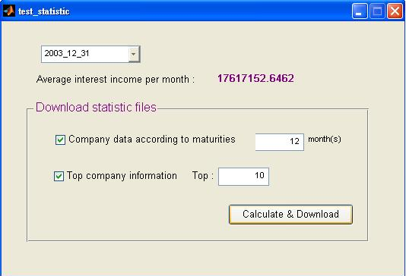
Figure 6 Companies data downloads from part II interface
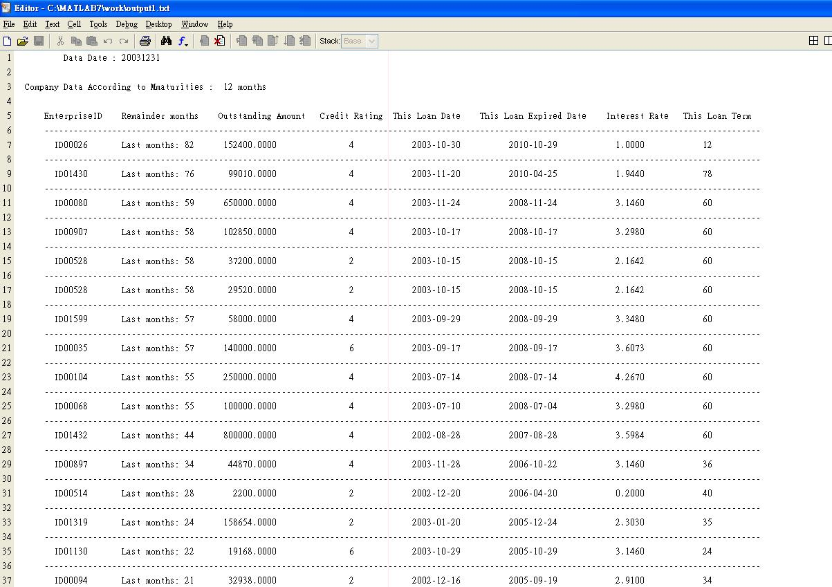

  - Set criteria and derive fundamental experimental result :
This portion is the core of proposed tool; it provides several functions of computations. Here are the parameters that users must decide themselves:
- Estimated year
- Confidence level
- Simulation times. Of course, the more simulation time user chooses, the more computational time will need.
- Percentage of explained factors which is defined for PCA method. Using the eigenvalues of given normalized assets (equities) values, we can determinate the explained percentage.
- This function gives user the option to estimate all or portion of the companies of portfolio pool. The portion part is sorted according to the loan amount of each enterprise. User can choose multiple companies they are most concerned. The computational result is written to a text file for further analysis.
- Distribution of factors. This is defined for PCA method, too. There are two distributions that user can choose - standard normal distribution or student-t distribution. The default freedom of student-t distribution is set as one.
Figure 7 Interface of part III
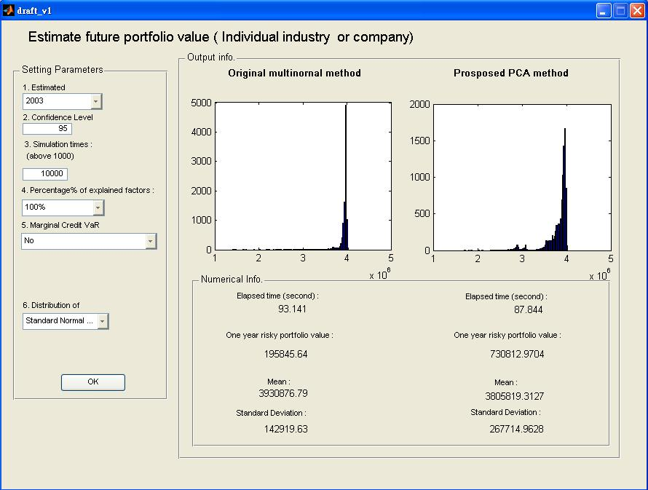

  - Report of overall VaR contributor :
User may be more interested in the detail of risk-profile at various levels. In this part, industries are discriminated from nineteen sections and credits are discriminated from nine level. This allow user to see where the risk is concentrated visually.

Figure 8 VaR Contribution of Individual credits and industries
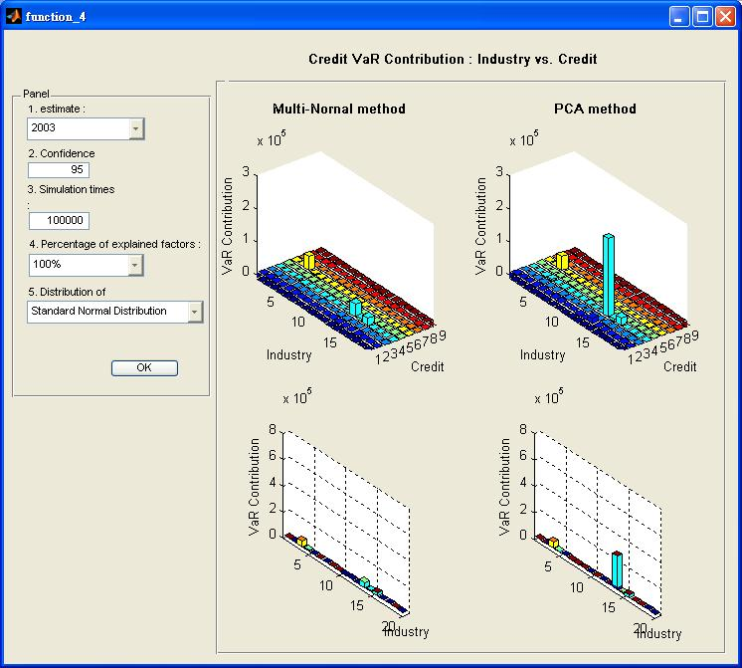

Experimental Result and Discussion
Table 6 represents the experimental results. (More experimental results are listed on Appendix A). For objectivity, all simulations times are set to 100,000 times which is large enough to obtain stable numerical results. Based on the provided data, the one year future portfolio value of listed corporations on 2003 and 2004 can be estimated. In other words, for instance, stands on t₀ = January 1, 2002 to estimate the portfolio value at the time t_{T} = December 31, 2003. Or stands on t₀ = January 1, 2003 to estimate the portfolio value at the time t_{T} = December 31, 2004. Following tables listed the experimental results of factor copula methods of different factor distributions and compared with multi-normal method by CreditMetrics. The head of the tables are parameters setting, and the remained fields are experimental results. We note here to the formula (3.15)
$$V_{i}=r_{i1}y_{1}+r_{i2}y_{2}+\text{.}\text{.}\text{.}+r_{\text{im}}y_{m}+ε_{i}$$
the distribution of factors y₁, y₂…y_{m} listed in following table are standard normally distributed and student-t distributed (assumes freedoms are 2, 5 and 10).

Table 6 Experimental result of estimated portfolio value at the end of 2003
Estimate Year : 2003
Parameter Setting :
Simulation time : 100,000 |  |  |  | Percentage of explained factors : 100.00%
Involved listed Enterprise Number: 40 |  |  |  | Loan Account Entries: 119
Result :
Factor distribution assumption : Normal distribution F~N(0,1)
 | Credit VaR 95% | Credit VaR 99% |  |  | Portfolio mean | Portfolio s.d.
Multi-Normal | 192,113.4943 | 641,022.0124 |  |  | 3,931,003.1086 | 136,821.3770
PCA | 726,778.6308 | 1,029,766.9285 |  |  | 3,812,565.6170 | 258,628.5713
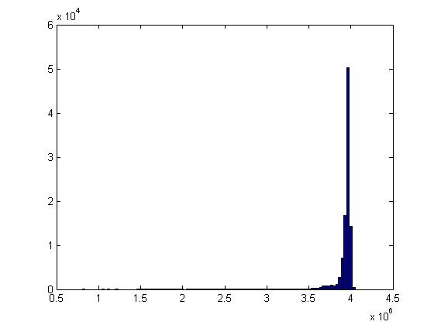 Multi-Normal method |  |  | 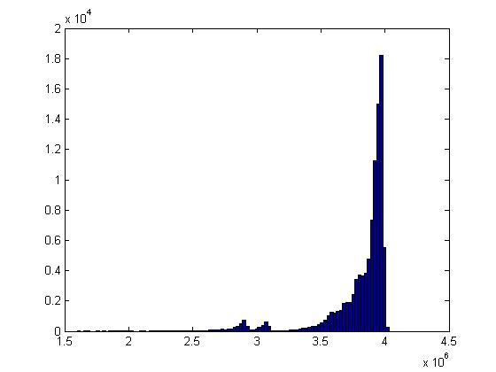 PCA method
Factor distribution assumption : Student-t distribution, Freedom=(2)
 | Credit VaR 95% | Credit VaR 99% |  |  | Portfolio mean | Portfolio s.d.
Multi-Normal | 191,838.2019 | 620,603.6273 |  |  | 3,930,460.5935 | 136,405.9177
PCA | 1,134,175.1655 | 1,825,884.8901 |  |  | 3,398,906.5097 | 579,328.2159
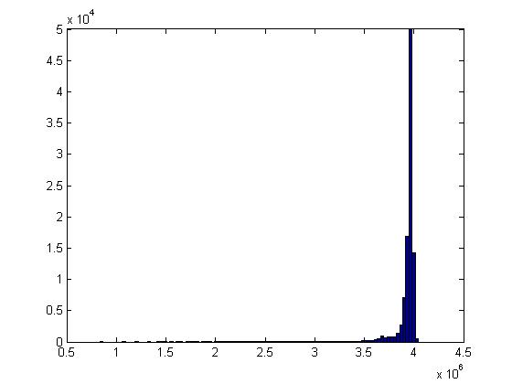 Multi-Normal method |  |  | 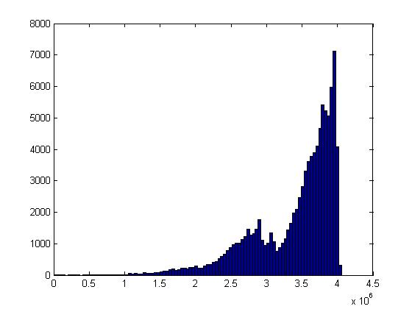 PCA method
Factor distribution assumption : Student-t distribution, Freedom=(5)
 | Credit VaR 95% | Credit VaR 99% |  |  | Portfolio mean | Portfolio s.d.
Multi-Normal | 192,758.7482 | 610,618.5048 |  |  | 3,930,923.6708 | 135,089.0618
PCA | 839,129.6162 | 1,171,057.2562 |  |  | 3,728,010.5847 | 337,913.7886
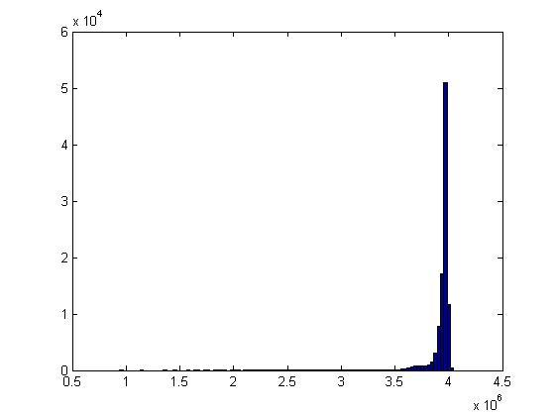 Multi-Normal method |  |  | 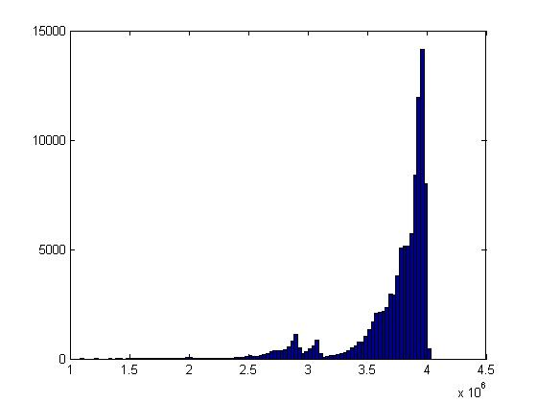 PCA method
Factor distribution assumption : Student-t distribution, Freedom=(10)
 | Credit VaR 95% | Credit VaR 99% |  |  | Portfolio mean | Portfolio s.d.
Multi-Normal | 192,899.0228 | 600,121.1074 |  |  | 3,930,525.7612 | 137,470.3856
PCA | 773,811.8411 | 1,080,769.3036 |  |  | 3,779,346.2750 | 291,769.4291
Multi-Normal method |  |  | 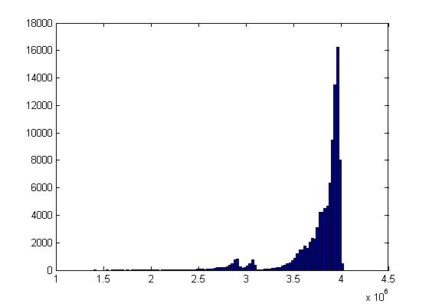 PCA method
There are some messages that can be derived from above table. First, obviously, risk of future portfolio value by multi-normal method is less than by proposed method. Risk amount of proposed method is 3 to 5 times over multi-normal method. This result corresponds to most research that copula function can capture the fat-tail phenomenon which prevails over practical market more adequately. Second, the distribution of future portfolio value by proposed method is more diversified than multi-normal method which concentrated on nearly 400,000 with 50,000 times while proposed method with 17,000 times. Third, it is very clear to see that risks with factors using student-t distribution to simulate is more than with normal distribution and the risk amount tends toward the same while the degree of freedom becomes larger. Fourth, the mean of portfolio of proposed method is smaller than of multi-normal method, but the standard deviation of proposed method is much more than multi-normal method. It shows the overall possible portfolio values by proposed method have the trend to become less worth and also fluctuate more rapidly.
The above discrepancies between two methods give us some inferences. First, the proposed method provides another way to estimate more actual credit risks of portfolio containing risky credits through market data, and this method capture fat-tail event more notably. Second, the computation time of proposed method is shorter than multi-normal method. As following Table 7, when using fully explained factors, computation time by proposed method is still faster than by multi-normal method. The computation time decreases as the required explained ratio set lower,
Table 7 CPU Time for factor computation (Simulation time: 100,000 year: 2003)
Explained ratio (s)  method | 100% | 90%~95% | 80%~85% | 70%~80% | Below 60%
Multi-normal | 2.5470 | 2.6090 | 2.2350 | 2.2500 | 2.3444
PCA | 1.2030 | 0.7810 | 0.7030 | 0.6720 | 0.6090
this means less number of factors are used for the expected explained level. Third, according to Table 8 which retrieve individual Credit VaR contribution to whole portfolio from 19 industries shows the main risk comes from Electronics Industry. Base on the commercial data, we can find out that among its loan account entries the Electronics Industry customers have the proportion of exceeding half of loan entries (63/119). The Credit VaR of Electronics Industry computed by proposed method is six times more than by multi-normal method. This effect reveals that the multi-normal method lacks the ability to catch concentrative risks. On the contrary, base on factor structure, the mutual factors loadings extracted by the correlation among companies expresses more actual risks. Forth, for finite degree of freedom, the t-distribution has fatter tails than Gaussian distribution and is known to generate tail dependence in the joint distribution.
Table 8 Individual Credit VaR of top 5 industries
Credit VaR  Industry | Multi-Normal method | PCA method
(No. 1) Electronics | 40,341 | 252,980
(No. 2) Plastic | 42,259 | 42,049
(No. 3) Transportation | 22752 | 22391
(No. 4) Construction | 7011 | 7007
(No. 5) Textile | 2884 | 2765
Table 9 shows the impact on risks amount by using different factor numbers. More experimental results are lists in Appendix B. According to Table 9, the risks decrease as the explained level decreases, this is a tradeoff between time consuming and afforded risk amount. Most research and reports say 80% explained level is large enough to be accepted.
Table 9 Estimate portfolio value at the end of 2004 with different explained level
95% confidence level, F~(0,1)
 | 100% | 90%~95% | 80%~85% | 70%~80% | 60%~70%
Multi-Normal | 208,329.40 | 208,684.38 | 209,079.72 | 208,686.22 | 207,710.63
PCA | 699,892.33 | 237,612.60 | 200,057.74 | 187,717.73 | 183,894.43

- Conclusion
Credit risks and default correlations issues have been probed in recent research and many solutions have been proposed. We take another view to examine credit risks and derivative tasks. On our perspective, the loan credits in target portfolio like the widely different risk characteristics from a portfolio of debt instruments, their properties and behavior are the same in the main.
In this paper, we propose a new approach which connects the principal component analysis and copula functions to estimate credit risks of bank loan businesses. The advantage of this approach is that we do not need to specify particular copula functions to describe dependence structure among credits. On the contrary, we use a factor structure which covers market factor and idiosyncratic factor and the computed risks have heavy tail phenomenon. Another benefit is to reduce the difficulties to estimate parameters which copula functions will use. This approach provides another way and has better performance than conventional method such as assume the dependence structures are normally distributed.
In order to describe the risks features and other massages that bank policymakers may like to know, we wrote a tool for risks estimation and results display. It contains basic data information preview which just downloads data from database and do some statistic analyses. It also provides different parameters setting and uses Monte Carlo simulation to calculate credit VaR and finally gives an overview of individual credit VaR contributions. The experimental results are consistent with previous studies that the risk will be underestimated compared with real risks if people assume dependence structure are normally distributed. In addition, the forementioned approach and tool still have some rooms to be improved such as recovery rate estimations, how to chosen distributions of factors, and more friendly user interface.

Reference:

L. Andersen, J. Sidenius (2004),”Extensions to the Gaussian Copula: Random Recovery and Random Factor Loadings,” Journal of Credit Risk 1(1), pages 29-70.

E. Bouye, V. Durrleman, A. Nikeghbali, G. Riboulet and T. Roncalli (2000), “Copulas for finance—a reading guide and some application”, Groupe de Recherche.

P. Embrechts, A. McNeil and D. Straumann (1999), “Correlation and dependence in risk management: Properties and pitfalls,” Mimeo. ETHZ Zentrum, Zurich.

T. L. Gollinger and J. B. Morga (1993) “Calculation of an Efficient Frontier for a
Commercial Loan Portfolio,” Journal of Portfolio Management, pages 39-46.

G. M. Gupton, C. C. Finger and M. Bhatia (1997), “CreditMetrics –Technical Document”, Morgan Guaranty Trust Company, New York.

J. Hull and A.White (2004), “Valuing of a CDO and an n-th to default CDS without Monte Carlo simulation,” Journal of Derivatives 12 (2), page 8-48.

P. Jorion (2000), Value at Risk, McGraw Hill, New York

D. X. Li (2000), “On default correlation: A copula function approach,” Journal of Fixed Income 9, page 43-54.

A. Sklar (1959), “Functions de repartition an n dimension et leurs marges,” Pub. Inst. Statistics. University Paris 8, 229-231.

B. G. Stevenson and M. W. Fadil (1995) “Modern Portfolio Theory: Can It Work for Commercial Loans?” Commercial Lending Review, Vol. 10, No. 2, pages 4-12

Tze-Chen Yang (2005), “The pricing of credit risk of portfolio base on listed corporation in Taiwan market.” Master Thesis at National Tsing Hua University in Taiwan.

We do not focus on how to model probability of default (PD) but focus on how to establish the dependence structure. The one-year transition matrix is a necessary input to our model.
We have examine the simulation times, 100000 times is enough to have a stable computational result.

