**Chapter 21 Solutions**

1. Technical analysis - the study of charts (data) of aggregate stock movements in an attempt to determine trends in the stock market which influences movements in individual stocks.

Fundamental analysis - the study of a firm's earnings management, competition and market condition along with macroeconomic activity to determine a correct value for a security.

P/E - the market price of the stock divided by the accounting earnings. It is an indication of the markets assessment of the value or worth of the stock.

Dow Theory - a tool used by technical analysts to measure the supply and demand for a security. According to the theory, there are three movements in the market: 1) daily fluctuations; 2) secondary movements (short run); and 3) primary trends (long run). The daily fluctuations are meaningless but the secondary and primary trends can be discovered by plotting daily prices over time.

Market Anomalies - the pricing of securities related to certain events (January, Monday, P/E) which cannot be explained in economic terms.

Selectivity - the ability of a portfolio manager to pick securities so that the return on the portfolio is better than the return on a naively selected portfolio with the same level of risk.

Time Series - the data set of some event (prices) through time.

ARIMA - Autoregressive integrated Moving Average. The difference between successive data (prices) is a stationary mixed autoregressive moving average process. It is the combination of an autoregressive process (a weighted average of past values) plus a moving average process (a weighted average of past error terms).

2.



Because the payout ratio is 50%, Dividend/Earning=50%. So Earning=2*dividend=4



3.





The price and the P/E ratio are approximately halved with a halving of the growth rate.

4. 1) You could use a methodology similar to Aeilly, Griggs and Wong (1983).

2) Take the approach of Schiller (1984).

3) Perform a direct test of the Gordon Dividend Model.

5. Technical analysis is the study of historic price (volume) information about securities with the objective of predicting future price movements. Fundamental analysis is the study of macroeconomic and firm specific information with the aim of finding under or over valued securities. From an economic perspective fundamental analysis seems to make more sense because it is based on identifiable relationships (i.e. Gordon Model) whereas technical analysis is without theoretical backing.

6. Basu found that the low P/E stocks outperformed middle and high P/E stocks on a risk adjusted basis. This result is consistent with the view that P/E ratio information is not fully reflected in security prices in as rapid a manner as postulated by the semistrong form of the EMH. Therefore, publicly available P/E ratios seem to possess information content that is not reflected in security prices.

7. The two major approaches to time series analysis are component analysis and function analysis.

Component analysis regards the time series as being composed of several influences or components which are trend-XXX, seasonal and random. In component analysis the seasonal and trend are modeled in a deterministic manner.

Function analysis regards a time series as an observed sample function representing a realization of an underlying stochastic process. Procedures such as ARIMA can be used to identify the properties of the data series

8. By means of two rankings (timeliness and safety), value line shows its expectations about performance of securities. Timeliness is scaled from 1 to 5 with 1 being the most timely. Safety is ranked 1 to 5 and is a measure of risk avoidance 1 being least risky and 5 being most risky. All the rankings are based on publicly available information. In the context of the EMH any ranking based on public information should not prove to be effective. Value line success provides further evidence which refutes the EMH in its semistrong firm.

9. Growth - a well diversified holding of common stocks

Income & Growth - a mixture of fixed income (bonds) and stock

Income - a portfolio of fixed income securities

Income, growth, stability - depending on the emphasis on growth or income a portfolio of bonds and stocks weighted toward the appropriate objective.

10. Fama's Overall Performance Measure

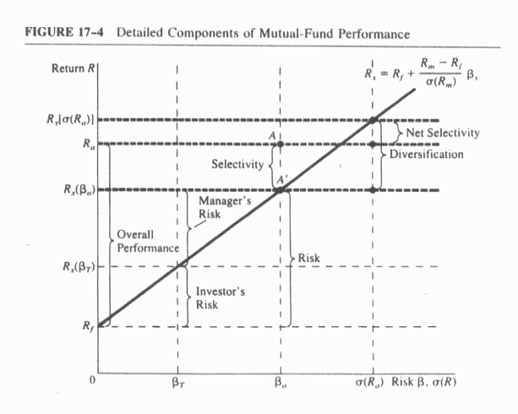

Overall Performance = Selectivity + Risk

Selectivity is a measure of how well the portfolio does relative to a naively selected portfolio. It is very similar to Treynor's measure.

The difference between Treynor's and Sharpe's measures is that Treynor uses βand Sharpe uses σ*.* If a portfolio is completely diversified it does not have any unsystematic risk, then total risk is equal to systematic risk and Treynor's and Sharpe's measures are equal.

The Jensen measure like the Treynor measure is interested in β risk. Hence it does not measure the manager's ability to diversify. It is concerned with the manager's ability to select under valued securities and is therefore similar to Fama's measure of selectivity.

11. Micro forecasting involves the identification of individual stocks which are under or over valued relative to an index for equities. The microforecastor is interested in the nonsystematic or non market component of return.

A macroforecastor attempts to identify when equities in general are under or over valued relative to other types of securities.

12. It depends on how the manager achieved this superior performance. Did he invest in the most risky stocks, if he did, he would be expected to outperform the averages. Did his success rely on selecting individual securities or timing? And finally can be manager be expected to repent this performance in the future.

13. The returns on stocks in the month of January are statistically the highest returns expressed in any month.

Explanations for this are:

1. Tax loss selling effect. Investors sell stocks in December to the advantage of tax losses thereby depressing prices (returns) in January.

2. Professional Management. Most mutual fund managers are hired and evaluated on a calendar basis. Hence when they begin the period they have a lot of interest and funds to put into equities during January. This raises the prices (returns) of equities during January.

1. Discuss how the timing and selectivity of a mutual fund’s performance can be tested empirically

The forecasting skills of Fama's (1972) overall performance measure can be partitioned into two distinct components: (1) selectivity which forecasts of price movements of selected individual stocks (**microforecasting)**, and (2) market timing which forecasts of price movements of the general stock market as a whole **(macroforecasting)**.

The first component, selectivity of a mutual fund’s performance can be test empirically by the CAPM as a framework. The microforecaster (selectivity), in essence, forecasts the nonsystematic or nonmarket-explained component of the return on individual stocks. From equation (21.42), the random variable return per dollar  on security *j* at time *t* can be algebraically shown as

. (21.42)

Where  is the return on the market,  is the return on the riskless asset, and  is the error term with the property that its expectation is conditional on knowing that the outcome of  is equal to its unconditional expectation ( follows a martingale process). Given such a model, a microforecaster (selectivity) would be interested in forecasting based on the properties of .

The second component, macroforecaster (market timing of a mutual fund’s performance) can be identified when equities in general are undervalued or overvalued relative to other types of security, such as fixed-income securities. Therefore, a microforecaster tries to forecast –and can be tested empirically by {} in CAPM framework.