Pricing Dynamic Guaranteed Funds Under a Double Exponential
Jump Diffusion Model

Chuang-Chang Chang and Min-Hung Tsay∗

ABSTRACT
This paper complements the extant literature to evaluate the prices of dynamic guaranteed funds when the price of underlying naked fund follows a double exponential jump-diffusion process. We first derive the closed-form solution for the Laplace transform of dynamic guaranteed fund price, and then apply the efficient Gaver-Stehfest algorithm of Laplace inversion to obtain the prices of dynamic guaranteed funds. Based on the numerical pricing results, we find that the proposed pricing method is much more efficient than the Monte Carlo simulation approach although it loses a sufficiently small accuracy. On the other hand, we also provide an investigation on the behavior of prices of dynamic guaranteed funds when jumps are taken into consideration. In addition, the sensitivity analyses of the prices of dynamic guaranteed funds with respect to jump-related parameters are also given in this paper.

Key words：Dynamic Guaranteed Funds, Jump Diffusion, Laplace Transform

- INTRODUCTION

The dynamic guaranteed fund has been one of the most popular investment funds in the insurance industry, recently. The fund provides a dynamic guarantee for an equity-index linked portfolio to its investors with a necessary payment so that the upgraded fund unit value does not fall below a guaranteed level during the protection period. Hence, both individual and institutional investors can use this product against the downside risk of their target portfolio. Gerber and Shiu (1998, 1999) firstly introduced the dynamic guaranteed funds by generalizing the guaranteed concept of financial put option to supply a continuous protection. Since the fund has a more profitable and complex payoff structure than the traditional put option for its investors, the value of the fund will be greater than a traditional put option, and more difficultly be priced. Extension of the extant literature to price this product under pure diffusion frameworks, we provide a closed form solution for the Laplace transformation of the price of dynamic guaranteed fund under a double exponential jump-diffusion (DEJD) model in this paper, and implement this solution to obtain the prices of the dynamic guaranteed funds by using the Gaver-Stehfest algorithm of the Laplace inversion. The analytical valuation of this fund includes the special case of pure diffusion models considered in past literature. Moreover, we also compare our pricing results with the Monte Carlo approach and perform the sensitivity analysis for the price of the dynamic guaranteed fund with the model’s parameters to show that how the price will be changed under different market and contract conditions.

Recently, the interest rates of almost countries in the world have been adjusted to a sufficient low level, and the inflation rate increases with an unexpected speed. Traditional insurance contracts with fixed rates of return seem to unable to satisfy the requirements of insurance holders for their pension plans. Thus, many innovative insurance products that attempt to satisfy their requirements, have been introduced by insurance companies in recent years. One of such products is equity-indexed annuities (EIAs) which combine a guarantee with a payoff linked to some reference portfolios like a stock market index. Moreover, EIAs also possess an advantage of the tax-defer. Since they were firstly introduced in the United States in early 1995, sales of EIAs have grown dramatically. Approximately $25 billion in equity-indexed annuities were sold last year in the U.S., and today, EIAs have been one kind of the most popular insurance contracts in the world.

EIAs can be view as a special case of dynamic guaranteed funds. Previous literatures, e.g., Gerber and Shui (1998, 1999, 2003), Gerber and Pafumi (2000), Imai and Boyle (2001), and Tse, Chang, Li, and Mok (2008), proposed a dynamic guaranteed fund featured by automatic multiperiod reset guarantees. The fund value is upgraded to the protection level if it ever falls below the level before the maturity date. Actually, a dynamic guaranteed fund can be decomposed as a naked fund and dynamic protection. Tse, Chang, Li, and Mok (2008) mentioned that such a property internalizes both call and put option characteristics. That is, the fund allows investors to participate in an upside market with a floor protection. Besides, since it provides a continuous protection, investors do not need to worry about the complicated early-exercise problems.

Gerber and Pafumi (2000) firstly derived the close form solution for the price of dynamic guaranteed funds under a pure diffusion model. Since the fund can be viewed as a put option with continuous protection, the authors also compared its price with the corresponding put option, and showed that the prices of dynamic guaranteed funds are more expensive than two times of the put option prices. On the other hand, based on Broadie, Glasserman, and Kou (1999) and Heynen and Kat (1995) noted that the possible mispricing if the closed form formulas are mistakenly applied to price a derivative that is actually monitored at fixed discrete dates, Imai and Boyle (2001) and Tse, Chang, Li, and Mok (2008) obtained the pricing formulas for the discretely monitored dynamic guaranteed fund under the same diffusion model with Gerber and Pafumi (2000). Imai and Boyle (2001) applied the Monte Carlo simulation approach to implement their pricing formula, and they showed the payoff structure of the dynamic guaranteed funds is similar to a certain type of lookback option. Moreover, they also evaluate the price of discretely monitored dynamic fund protection when the underlying fund follows a constant elasticity variance (CEV) diffusion process. In contrast with Imai and Boyle (2001), Tse, Chang, Li, and Mok (2008) not only derived a closed form valuation of the discretely monitored dynamic guaranteed fund, but also provided a dynamic hedging strategy for the discretely monitored dynamic guaranteed fund by adding a gamma factor to the conventional delta. Based on their simulation results, the proposed hedging strategy is shown to outperform the dynamic delta hedging strategy by reducing the expected hedging error, lowering the hedging error variability, and improving the self-financing possibility when hedging discretely.

To the best our knowledge, the extant literature only provides the valuation of dynamic guaranteed funds under pure diffusion models that assume the price of underlying naked fund follows a geometric Brownian motion or a CEV diffusion process. Although pricing derivatives under pure diffusion models is analytical tractability, many empirical evidences show that the distribution of equity returns has the asymmetric leptokurtic features, i.e. the return distribution is skewed to the left, and has a higher peak and two heavier tails than those of the normal distribution, and exhibits the implied volatility smile. Since these features can not be explained by a pure diffusion model simultaneously, many improvements of the model were introduced to overcome them. In this paper, we consider the jump-diffusion model that is one of the most favorite generalizations of pure diffusion models. Merton (1976) firstly incorporated the model with normal jumps to price plain vanilla options. This normal jump-diffusion model can lead to the two features of equity returns, but it is unable to give analytical solutions of path dependent options, such as barrier, lookback, and perpetual American options. On the other hand, Zhou (1997) used numerical examples to show that ignoring jump risk might lead to serious biases in path-dependent derivative pricing with both long and short maturities. Thus, for keeping the analytical tractability of pricing the path-dependent options, Kou (2002) and Kou and Wang (2004) introduced the DEJD model to price a variety of plain vanilla options and path-dependent options. This model offers not only a complete explanation for the two mentioned empirical phenomena but also based on the unique memoryless property of the double exponential distribution, the closed-form solutions (or approximations) for various path-dependent option pricing problems, that is difficult for many other models, including the normal jump-diffusion model. Recently, Wong and Lan (2008) also apply the DEJD model to investigate the price of a new derivative, so-called turbo warrants.

In this paper, for the analytical tractability of pricing the interested derivative, we adopt the DEJD model to obtain the prices of dynamic guaranteed funds. We firstly derive the closed-form solution for the Laplace transform of dynamic guaranteed funds under a DEJD process, and then apply an efficient Gaver-Stehfest algorithm of Laplace inversion to obtain the prices of dynamic guaranteed funds. Based on the proposed methodology, we use some numerical results to investigate the behavior of prices of dynamic guaranteed funds when jump is taken into consideration, and compare our pricing results with Monte Carlo approach. In addition, the sensitivity analyses of prices of dynamic guaranteed funds with respect to jump-related parameters are also given.

Based on the numerical pricing results, we find that the proposed pricing method is much more efficient than the Monte Carlo simulation approach with a sufficient low losing of accuracy. On the other hand, the prices of dynamic guaranteed funds are found to be positively (negatively) impacted by positive (negative) jumps. Finally, all results on the sensitivity analyses of prices of dynamic guaranteed funds are in line with our expectation.

This paper is organized as follows. Section 2 gives the introduction of the DEJD model and derives the computation of the Laplace transform of the first passage times. Section 3 gives the analytical solution of the dynamic guaranteed fund price. Numerical results are presented in section 4. Section 5 makes the conclusion. All proofs are given in appendix.

2. THE DOUBLE EXPONENTIAL JUMP-DIFFUSION MODEL

  - The Model

In this paper, we consider the price of underlying naked fund F(t) follows a DEJD process under the risk-neutral probability measure , i.e. for all 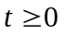,
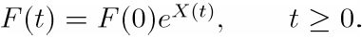 (1)
where F(0) is the initial fund price, 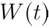 is a standard Brownian motion, and constants and are the drift and volatility coefficients of the diffusion part, respectively. 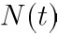 is a Poisson process with the intensity rate 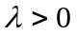, and the jump sizes 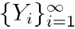 form a sequence of independent and identical distribution (i.i.d.) random variables with a double exponential density
(2)
where , and
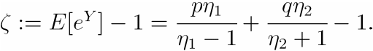 (3)
Note that the means of the two exponential distributions are 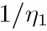 and 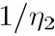 representing the positive and negative jump sizes respectively, and and are the probabilities of occurring positive and negative jumps respectively. Moreover, in this paper, we assume all sources of randomness, , , and to be independent.

In this paper, we adopt the pricing method proposed by Kou and Wang (2004) for path-dependent derivatives to evaluate the price of dynamic guaranteed fund. Hence, we first change the risk-neutral probability measure to a new probability measure for reducing the complexity of computation, where
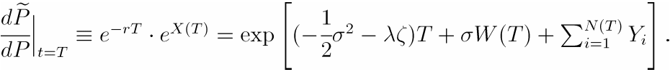 (4)
Using the Girsanov theorem for jump-diffusion models, we can show that under , 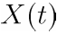 still follows a new double exponential jump diffusion process as
(5)
where 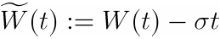 is a new 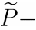Brownian motion, the Poisson process 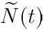 with new rate 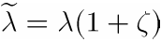, and under , the jump sizes 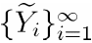 have new parameters
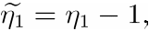 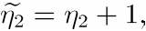 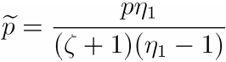, 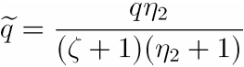.
Based on this probability measure, we then derive the Laplace transform of the price of dynamic guaranteed fund in the next section. Finally, the numerical Laplace inversion will be applied to obtain the price of dynamic guaranteed fund.

  - Distribution of The First Passage Times

For pricing the dynamic guaranteed funds and obtaining the Laplace transform of the price of dynamic guaranteed fund, it is important to study the distribution of the first passage times. Let the first passage times of the double exponential jump diffusion process be
(6)
that is the first time of underlying naked fund price falling below the protection level 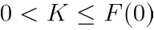, where 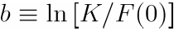 is negative since the protection level is not larger than the initial fund price 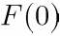. The distribution of the first passage times is then defined by
(7)
where

We consider the moment generating function of which is given by：
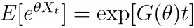,
where
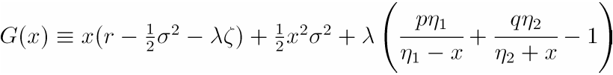. (8)
Then the following result can be obtained.

Lemma 2.1. [Kou and Wang (2003) and Kou, Petrella and Wang (2005)] For > 0, the equation 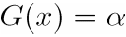 has exactly four roots：
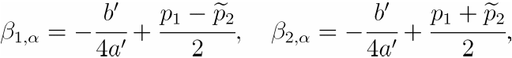
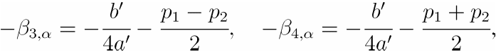 (9)
with 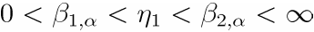, 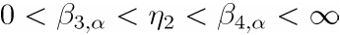.

Finally, the following theorem gives the closed form evaluation of the Laplace transform of the first passage times that will be used in next section for pricing the dynamic guaranteed fund.

Theorem 2.1. For > 0,
(10)
Proof. See Appendix A.

3. THE VALUATION OF DYNAMIC GUARANTEED FUNDS

Let 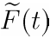 denote the payoff of a dynamic guaranteed fund with a positive constant protection level at time t, i.e.
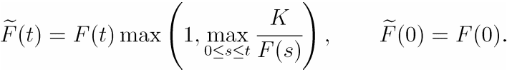 (11)
This definition was given by Gerber and Pafumi (2000) that defines the dynamic guaranteed fund payoff in the sense that additional money is injected to bring the fund value up to the protection level K whenever the fund value goes below to K. The construction of the processes and 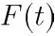 is illustrated in Figure 1. In the remainder of this section, we will propose a pricing method to evaluate the dynamic guaranteed fund price. We note that for our analytical valuation, we consider the special case of the dynamic guaranteed funds with a constant protection level. When the protection level grows at a rate , in equation (11) is replaced by 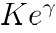.
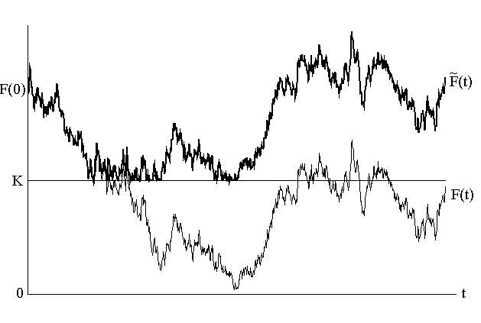
Figure 1. Sample Paths of the Dynamic Guaranteed Fund Values and the Underlying
Naked Fund Values

We first denote the minimum value of the rate of the underlying naked fund’s return X(t) by
(12)
Then the payoff of a dynamic guaranteed fund can be represented by
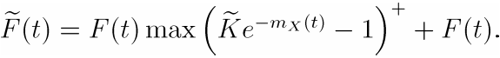 (13)
where 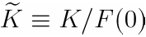. Let 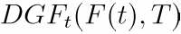 denote the price of the dynamic guaranteed fund with maturity T at time t with the initial underlying naked fund price . Then from Equation (13) and the risk-neutral pricing method for European-type derivatives, we have that
(14)
It is obvious that the price of the dynamic guaranteed fund equals to the naked fund price plus the dynamic protection price. Therefore we define the price of the dynamic protection at time 0 as
(15)
Then the price of the dynamic guaranteed fund can be obtained as follows.

Proposition 3.1.： The price of the dynamic guaranteed fund at time 0 can be represented by
(16)
where 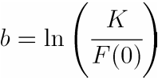, and is a new probability measure that is equivalent with respect to the risk-neutral probability measure with 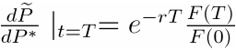.
Proof . See the Appendix B.

It is not easy to evaluate the integral part of Equation (16) directly because it involves the probability cumulative function of the first passage times which can not be represented with a closed form function. But, fortunately, based on Theorem 2.1, we can obtain the closed form Laplace transform of the price of the dynamic guaranteed funds in the following proposition.

Proposition 3.2.： For any 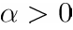, the Laplace transform of the dynamic guaranteed fund price is given by
(17)
where
Proof. See the Appendix C.

Remark 3.1. : Based on the decomposition of (15) and Proposition 3.2, we can derive that the Laplace transform of the dynamic protection price is given by
(18)

According to this closed form representation of the Laplace transform of the dynamic guaranteed fund price, we can easily apply a numerical Laplace inversion to obtain the price of the dynamic guaranteed fund. In the following section, we will adopt the Gaver-Stehfest algorithm of Laplace inversion to obtain our numerical results since it has several advantages, e.g., simplicity, fast convergence, and good stability. The details of the Gaver-Stehfest algorithm for Laplace inversion are given in Appendix D of this paper.

4. NUMERICAL RESULTS

4.1. Analytical Valuation and Simulation of Dynamic Guaranteed Funds

To justify the validity of our analytical solution in equation (17) implemented with the Gaver-Stehfest algorithm, we compare the numerical results of the dynamic guaranteed fund prices without jumps with the closed form pricing formula for the geometric Brownian motion case proposed by Gerber and Pafumi (2000). On the other hand, we also compare our numerical results with the Monte Carlo approach to show the accuracy and efficiency of our valuation method.

Figure 2 shows the convergence of Monte Carlo simulation with different jump intensities = 0, 3, and 5. The model parameters used here are F(0) = 100, r = 0.04, T = 1, 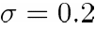, p = 0.3 , 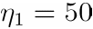, and 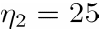. The Monte Carlo results are based on 30,000 simulation paths. When is zero, which means no jumps, the dynamic guaranteed fund prices simulated from Monte Carlo method, namely the MC price, are compared to that obtained under the Black-Scholes model, namely the BS price. Moreover, if is positive, there may be the occurrence of jumps; and the MC prices are compared to the DEJD prices which calculated under the double exponential jump diffusion model. Figure 2 indicates that the difference of the prices decreases when the number of partition points in a unit time increases. It can be seen that as partition points increases about 200,000, the MC prices will converge to both of the BS prices and DEJD prices. Therefore we perform Monte Carlo simulation based on 256,000 partition points and 30,000 paths for approximating one year dynamic protection price in the following numerical results.
In Table 1, we calculate the prices of dynamic guaranteed funds under DEJD model with zero jump intensity. Suppose that the risk-free rate, r, is 4%, and the other parameters are set by F(0) = 100, = 0.2, p = 0.3, 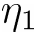 = 50, and 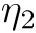 = 25. Panel A, B, and C of Table 1 consider that the dynamic guaranteed funds with time to maturity, T = 1, 3, and 5 years respectively, and each panel displays the values with different protection level, K = 100, 90, and 80 respectively.

Based on the numerical results in Table 1, we can find that the prices of dynamic guaranteed funds obtained from our analytical valuation converges very fast when n = 7, 8, and 9. We can see that as n = 9, the prices are closest to the BS prices, and then we follow this result to perform our numerical results in the remainder of this paper with n = 9 only. On the other hand, it can be seen that when the protection level K becomes lower, the approximation tends to be more precise. In Table 1, the maximum relative error between the DEJD prices with n = 9 and the BS prices is only 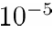.

In Table 2 and Table 3, we perform the numerical results of the dynamic guaranteed fund prices with jumps for T = 1 and 3 years respectively. Every table includes three panels, and each panel reports the prices of dynamic guaranteed funds calculated from our analytical solution in the DEJD columns and simulated from Monte Carlo approach in the MC columns with different positive jump probabilities, namely p = 0.3, 0.5, and 0.7 respectively. Besides, we price the dynamic guaranteed funds with different parameter values K, , , and in each panel. The defaulting parameters used here are F(0) = 100, = 0.2, and r = 0.04.

Table 2 shows the prices of dynamic guaranteed funds decrease as the protection level K decreases, and the differences are about two to three times. Moreover, the prices of dynamic guaranteed funds increase with the jump intensity . It is expected since frequency of jump occurrence will increase the uncertainty of the payoff of dynamic guaranteed fund. Fixed all parameters except , the prices of dynamic guaranteed funds decrease with since the positive jump size is getting lower as increases. Similarly, the price of dynamic guaranteed funds is also found to decrease with .

From panels in Table 2, we also compare the prices of dynamic guaranteed funds with different jump probabilities. Based on the similarity between dynamic guaranteed fund and put option, the prices of dynamic guaranteed funds are expected to increase with the negative jump probability q. This expectation is satisfied by our numerical results with (,) = (50,25). But for other settings of and , where the mean of negative jump size is not larger than the mean of positive jump size, it is not fully satisfied. It implies that the prices of dynamic guaranteed funds are much more sensitive to the mean of jump size than the jump probability. On the other hand, in Table 3, as time to maturity increases to three years, the prices of dynamic guaranteed funds are found to increase about 1.65 times of the one-year dynamic guaranteed fund prices. Finally, the behavior of the prices of dynamic guaranteed funds under different jump parameters in Table 3 is similar to the results shown in Table 2.

To compare the DEJD prices with the MC prices, Tables 2 and 3 show that the DEJD prices are very closed to the MC prices. Let the MC prices be a benchmark, the maximum absolute value of relative error is about 9.71%, while almost relative errors are less than 1%. Only five of the DEJD prices go out of the 95% confidence intervals of the MC prices, but the absolute value of relative error is at most 3.9%. It takes only about 0.04 second to compute the prices of dynamic guaranteed funds by using our pricing method. However, the MC prices have to spend several hours, and the computing time becomes longer as T increases. These facts show that our valuation method is very accurate and efficient.

Finally, we investigate the prices of dynamic guaranteed funds with and without jumps effect. Table 4 shows that the prices of dynamic guaranteed funds with jumps are higher than that without jumps. It implies that the dynamic guaranteed fund prices would be underestimated if jumps are not taken into consideration. Rel. Err. measures the degree of underestimating the dynamic guaranteed fund prices without considering jumps. We found that for one year contract, the price of dynamic guaranteed funds with the protection level K = 100 is underestimated by about 6% and 14% for the frequency of jump occurrence is 3 and 7 respectively. When the protection level decreases to 80, the degrees of underestimation increase to about 23% and 41%. Since such underestimation would cause a significant loss for the fund issuers, it is important to consider the jump effect for pricing the dynamic guaranteed funds. Figure 3 plots the prices of dynamic guaranteed funds under the Black-Scholes model and under the double exponential jump diffusion model with jump intensity = 3 and 7 respectively. The other parameters are fixed by r = 4%, T = 1, = 0.2, F(0) = 100 , K = 100, p = 0.5, = 25, and = 25. Figure 3 shows both of the DEJD prices are larger than the BS price, and the price difference between the BS and DEJD prices with = 7 is higher than that with = 3. Furthermore, as the protection level K decreases, the price difference is found to get smaller.

4.2. Sensitivity Analysis

We perform the sensitivity of the dynamic guaranteed fund prices with respect to the model-related parameters, i.e. K, λ, , , p and q, in Figure 4. The defaulting parameters are set by F(0) = 100, K = 100, T = 1, r = 0.04, σ= 0.2, λ= 3, = 50 , = 25, and p = 0.3 in this figure. Figure 4 indicates that the price of dynamic guaranteed funds is an increasing function of K, λ, and , since it can be viewed as a put option with a continuous-time protection. On the other hand, it is very interesting that the dynamic protection price is an increasing function of the mean of positive jumps . As a similar phenomenon pointed out in Merton (1976), it is because that the risk-neutral drift also depends on . Besides, the price of dynamic guaranteed funds is an increasing function of q in this set of and necessarily.

5. CONCLUSION

In this paper, we provide an analytical method for pricing the dynamic guaranteed funds under the double exponential jump diffusion model of Kou (2002). We first derive the closed form Laplace transform of dynamic guaranteed fund price, and then obtain the price by doing Laplace inversion via the Gaver-Stehfest algorithm. The numerical results verify that our valuation method is accurate, and more efficient than the Monte Carlo approach. Since the prices of dynamic guaranteed funds with jumps are significantly higher than the prices without jumps, it implies that the prices of dynamic guaranteed funds may be seriously underestimated if jumps are not taken into consideration. We also examine the sensitivity of the prices of dynamic guaranteed funds to jump parameters. It is found that the price of dynamic guaranteed funds is an increasing function of K, λ, , and . In addition, the price of dynamic guaranteed funds is necessarily an increasing function of q, the probability of occurring negative jumps, as the negative jump size is higher than the positive jump size. It implied that the prices of dynamic guaranteed funds are much more sensitive to the mean of jump sizes than to the jump probabilities. Finally, since this paper does not deal with the issue related hedging dynamic guaranteed funds, we leave this important issue to future research.

REFERENCES

[1] Abate, J., and W. Whitt, (1992) “The Fourier-series method for inverting transforms of probability distributions”, Queueing System, 10, pp. 5–88.
[2] Cont, R., and P. Tankov, (2004) Financial Modelling with Jump Processes. Chapman & Hall/CRC.
[3] Gerber H. U., and G. Pafumi, (2000) “Pricing dynamic investment fund protection”, North American Actuarial Journal, 4(2), pp. 28–36.
[4] Gerger, H. U., and E. S. W. Shiu, (1998) “Pricing Perpetual Options for Jump Processes”, North American Actuarial Journal, 2(3), pp. 101–12.
[5] Gerger, H. U., and E. S. W. Shiu, (1999) “From Ruin Theory to Pricing Reset Guarantees and Perpetual Put Options”, Insurance: Mathematics and Economics, 24, pp. 3–14.
[6] Gerger, H. U., and E. S. W. Shiu, (2003) “Pricing Lookback Options and Dynamic Guarantees”, North American Actuarial Journal, 7(1), pp. 48–67.
[7] Imai, J., and P. P. Boyle, (2001) “Dynamic fund protection”, North American Actuarial Journal, 5(3), pp. 31–49.
[8] Lieb, B., (2000) “The Return of Jump Modeling: Is Steven Kou’s Model More Accurate Than Black-Scholes?”, Derivatives Strategy Magazine, pp. 28–32.
[9] Merton, R., (1976) “Option pricing when the underlying stock returns are discontinuous”,
Journal of Financial Economics, 3, pp. 125–144.
[10] Kou, S. G., (2002) “A jump diffusion model for option pricing”, Management Science, 48, pp. 1086–1101.

[11] Kou, S. G., and H. Wang, (2003) “First passage times for a jump diffusion process”, Advances in Applied Probability, 35, pp. 504–531.
[12] Kou, S. G., and H. Wang, (2004) “Option Pricing Under a Double Exponential Jump Diffusion Model”, Management Science, 50, pp. 1178–1192.
[13] Kou, S. G., G. Petrella, and H. Wang, (2005) “Pricing Path-Dependent Options with Jump Risk via Laplace Transforms”. Kyoto Economic Review, 74(1), pp. 1–23.
[14] Tse, W. M., Chang, E. C., Li, L. K., and H. M. K. Mok, (2008) “Pricing and Hedging of Discrete Dynamic Guaranteed Funds”, Journal of Risk and Insurance, 75(1), pp. 167–192.
[15] Wong, H. Y., and K. Y. Lau, (2008) “Analytical Valuation of Turbo Warrants under Double Exponential Jump Diffusion”, Journal of Derivatives,15(4), pp. 61–73.
[16] Zhou, C., (1997) “A Jump-Diffusion Approach to Modeling Credit Risk and Valuing Defaultable Securities”, Working Paper, Federal Reserve Board.

Appendix A. Proof of Theorem 2.1.

To prove Theorem 2.1, we adopt the method proposed by Kou and Wang (2003) as follows.
For any fixed level b < 0 , define the function u to be
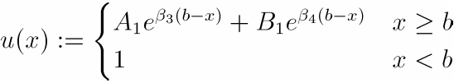
where 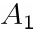 and 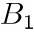 are yet to be determined. Since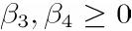, it is obviously that 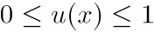 for all 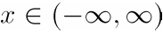. Note that, on the set 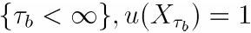 since 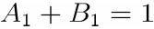. Furthermore, the function u is continuous.
Denote the infinitesimal generator of the jump diffusion process X(t) as
Applying the Ito lemma to the process 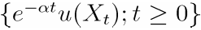, we find that the process
is a local martingale with 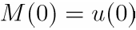. If 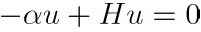, 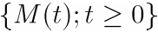 is actually a martingale. In addition, by letting
.
To obtain 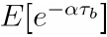 we have to solve the equation . After some algebra, it shows that for all x > b,
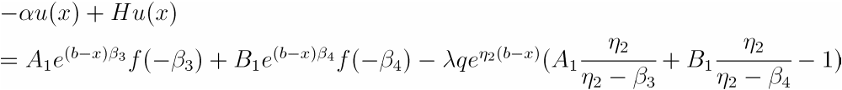,
where .
Clearly 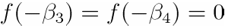. Solving the solution gives
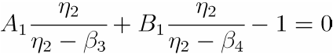, and .
It enables us to solve and , and to obtain
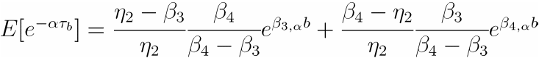.
Appendix B. Proof of Proposition 3.1.

From equation (14), we have
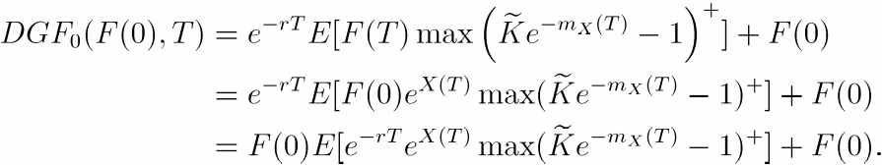
Here we use a change of measure to a new probability defined as
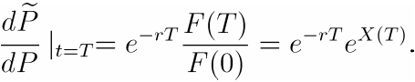
In summary, we have
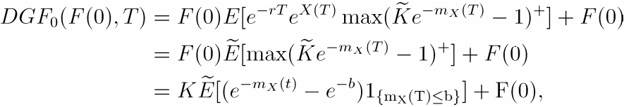
where 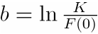.
Integration by parts yields
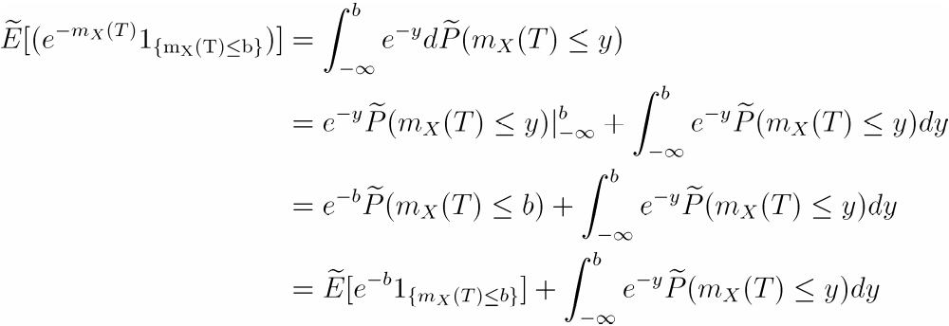
It follows that
.

Appendix C. Proof of Proposition 3.2.

To yield the Laplace transform of 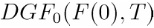, we apply the following equation provided in Proposition 3.1:
.
For any α> 0,
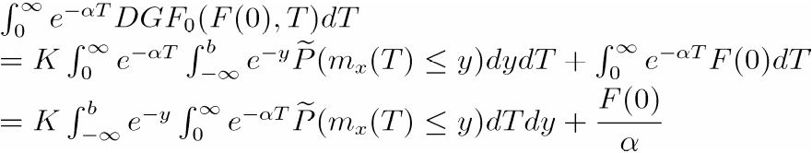
Since
we can obtain that 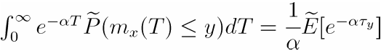. Form equation (10),
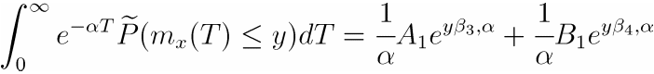,
where 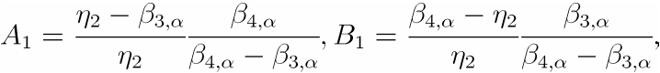 and 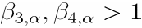.
Therefore, the Laplace transform of is given by
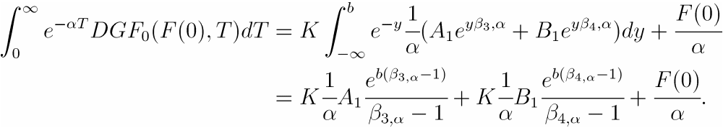

Appendix D. The Gaver-Stehfest algorithm

Given the Laplace transform of the price of dynamic guaranteed funds
where 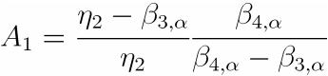 and 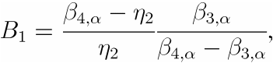
we use the Gaver-Stehfest algorithm to do the numerical inverse of Laplace transform. Kou and Wang (2003) noted that the algorithm is the only one that dose the inversion on the real line and is suitable for the Laplace transform involves the roots 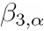 and 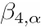. Given the algorithm 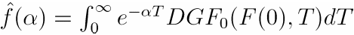 of the price of dynamic guaranteed funds, the algorithm generates a sequence 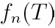 such that .
Numerically, the sequence is given by
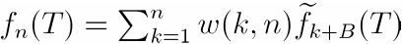
where
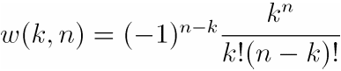 ,
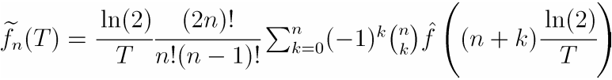.
And the initial burning-out number B is 2 as used in Kou and Wang (2003) for the numerical illustration.

Table 1. The Prices of Dynamic Guaranteed Funds Without Jumps

Each panel in this table reports the prices of dynamic guaranteed funds without jumps for T = 1, 3, and 5 years respectively. Every panel includes the prices with different protection level K. The columns of DEJD price report the prices of dynamic guaranteed funds which are obtained from our analytical solution under the double exponential jump diffusion model. In the columns, we report nine approximations calculated from G-S algorithm. The rows of BS price denote the prices of dynamic guaranteed funds calculated by using the closed form formula in Gerber and Pafumi (2000). The Monte Carlo simulation is obtained by using 256,000 partition points and 30,000 simulation paths for T = 1. To keep the comparison fair, we increase the numbers of steps to 768,000 and 1,280,000 for T = 3 and 5. The defaulting parameters are F(0) = 100, r = 0.04, . Note that all CPU times are in seconds.

Panel A. T = 1 year.
 | DEJD price
n | K=100 | K=90 | K=80
1 | 16.4318 | 7.3990 | 2.7269
2 | 15.6435 | 6.7326 | 2.2669
3 | 15.1487 | 6.3139 | 1.9789
4 | 14.9176 | 6.1179 | 1.8443
5 | 14.8306 | 6.0440 | 1.7933
6 | 14.8060 | 6.0205 | 1.7769
7 | 14.7955 | 6.0140 | 1.7723
8 | 14.7936 | 6.0125 | 1.7712
9 | 14.7948 | 6.0124 | 1.7709
Total CPU time | 0.335 | 0.226 | 0.250
BS price | 14.7931 | 6.0120 | 1.7709
Monte Carlo simulation
256,000 points | 14.7980 | 6.0262 | 1.7159
Standard Error | 0.0885 | 0.0917 | 0.1050
CPU time | 3,291 | 3,254 | 3,256

Panel B. T = 3 years.
 | DEJD price
n | K=100 | K=90 | K=80
1 | 25.9875 | 15.3287 | 8.1784
2 | 24.9897 | 14.4494 | 7.4573
3 | 24.3500 | 13.8851 | 6.9929
4 | 24.0443 | 13.6151 | 6.7697
5 | 23.9264 | 13.5109 | 6.6831
6 | 23.8882 | 13.4771 | 6.6548
7 | 23.8775 | 13.4676 | 6.6468
8 | 23.8749 | 13.4653 | 6.6449
9 | 23.8730 | 13.4639 | 6.6442
Total CPU time | 0.250 | 0.206 | 0.216
BS price | 23.8741 | 13.4646 | 6.6443
Monte Carlo simulation
768,000 points | 23.8144 | 13.4217 | 6.6281
Standard Error | 0.1802 | 0.1720 | 0.1790
CPU time | 9,349 | 9,315 | 9,387

Panel C. T = 5 years.
 | DEJD price
n | K=100 | K=90 | K=80
1 | 31.2794 | 19.9010 | 11.7337
2 | 30.2978 | 19.0284 | 10.9934
3 | 29.6589 | 18.4599 | 10.5093
4 | 29.3485 | 18.1835 | 10.2730
5 | 29.2268 | 18.0750 | 10.1799
6 | 29.1867 | 18.0392 | 10.1490
7 | 29.1752 | 18.0289 | 10.1402
8 | 29.1723 | 18.0263 | 10.1379
9 | 29.1716 | 18.0254 | 10.1372
Total CPU time | 0.241 | 0.272 | 0.246
BS price | 29.1716 | 18.0257 | 10.1373
Monte Carlo simulation
1,280,000 points | 29.1049 | 18.0202 | 10.1238
Standard Error | 0.2514 | 0.2364 | 0.2383
CPU time | 16,646 | 17,567 | 17,533

Table 2. Comparison of The Analytical Valuation and Monte Carlo Valuation for The Prices of Dynamic Guaranteed Funds with T = 1 Year
Each panel of this table reports the prices of 1 year dynamic guaranteed funds calculated from our analytical solution and simulated from Monte Carlo method with different jump probabilities, where p and q represent the probabilities of occurring positive and negative jumps. The columns of DEJD report the prices of dynamic guaranteed funds which are obtained from our analytical solution under the double exponential jump diffusion model. The MC is obtained by using 256,000 partition points and 30,000 simulation paths. K is the protection level. is the frequency of jump occurrence. and means the positive and negative jump size respectively. The defaulting parameters are F(0) = 100, r =0.04, and T= 1 year. All CPU times are in seconds.

Panel A. Jump Probabilities ： p = 0.3 and q = 0.7
Parameter values |  |  |  | DEJD (a) | CPU time | Monte Carlo (b) | Standard Error | CPU time | Relative Error (a-b)/b%
K
100 | 1 | 25 | 25 | 15.3315 | 0.03 | 15.3695 | 0.0909 | 3,736 | -0.25
100 | 1 | 25 | 50 | 15.0695 | 0.05 | 15.2420 | 0.0917 | 3,185 | -1.13
100 | 1 | 50 | 25 | 15.2126 | 0.02 | 15.2830 | 0.0904 | 3,463 | -0.46
100 | 1 | 50 | 50 | 14.9454 | 0.02 | 15.1533 | 0.0904 | 3,672 | -1.37
100 | 3 | 25 | 25 | 16.3830 | 0.04 | 16.4417 | 0.0982 | 3,944 | -0.36
100 | 3 | 25 | 50 | 15.6105 | 0.04 | 15.7112 | 0.0948 | 3,218 | -0.64
100 | 3 | 50 | 25 | 16.0377 | 0.05 | 16.0297 | 0.0955 | 3,240 | 0.05
100 | 3 | 50 | 50 | 15.2494 | 0.05 | 15.2959 | 0.0907 | 3,300 | -0.30
100 | 5 | 25 | 25 | 17.3976 | 0.04 | 17.5867 | 0.1050 | 3,958 | -1.08
100 | 5 | 25 | 50 | 16.1448 | 0.05 | 16.0563 | 0.0988 | 3,768 | 0.55
100 | 5 | 50 | 25 | 16.8393 | 0.02 | 16.7959 | 0.0999 | 3,770 | 0.26
100 | 5 | 50 | 50 | 15.5524 | 0.03 | 15.5880 | 0.0930 | 3,798 | -0.23
100 | 7 | 25 | 25 | 18.3778 | 0.04 | 18.3612 | 0.1107 | 3,284 | 0.09
100 | 7 | 25 | 50 | 16.6689 | 0.04 | 16.7466 | 0.1038 | 3,319 | -0.46
100 | 7 | 50 | 25 | 17.6194 | 0.04 | 17.7680 | 0.1042 | 3,592 | -0.84
100 | 7 | 50 | 50 | 15.8484 | 0.05 | 15.8426 | 0.0945 | 3,644 | 0.04
90 | 1 | 25 | 25 | 6.4626 | 0.02 | 6.4472 | 0.0943 | 3,688 | 0.24
90 | 1 | 25 | 50 | 6.2256 | 0.02 | 6.1815 | 0.0927 | 3,695 | 0.71
90 | 1 | 50 | 25 | 6.3742 | 0.03 | 6.4245 | 0.0948 | 3,686 | -0.78
90 | 1 | 50 | 50 | 6.1350 | 0.03 | 6.1679 | 0.0923 | 3,690 | -0.53
90 | 3 | 25 | 25 | 7.3427 | 0.03 | 7.3375 | 0.1000 | 3,515 | 0.07
90 | 3 | 25 | 50 | 6.6486 | 0.04 | 6.6564 | 0.0966 | 3,700 | -0.12
90 | 3 | 50 | 25 | 7.0831 | 0.04 | 7.1667 | 0.0979 | 3,363 | -1.17
90 | 3 | 50 | 50 | 6.3798 | 0.04 | 6.3985 | 0.0933 | 3,889 | -0.29
90 | 5 | 25 | 25 | 8.1955 | 0.02 | 8.1860 | 0.1072 | 3,740 | 0.12
90 | 5 | 25 | 50 | 7.0690 | 0.02 | 7.2950 | 0.1027 | 3,790 | -3.10
90 | 5 | 50 | 25 | 7.7716 | 0.02 | 7.7500 | 0.1008 | 3,729 | 0.28
90 | 5 | 50 | 50 | 6.6228 | 0.03 | 6.6216 | 0.0957 | 3,735 | 0.02
90 | 7 | 25 | 25 | 9.0239 | 0.03 | 9.1884 | 0.1122 | 3,114 | -1.79
90 | 7 | 25 | 50 | 7.4851 | 0.04 | 7.6638 | 0.1063 | 3,165 | -2.33
90 | 7 | 50 | 25 | 8.4415 | 0.04 | 8.6743 | 0.1066 | 3,503 | -2.68
90 | 7 | 50 | 50 | 6.8629 | 0.04 | 6.9940 | 0.0977 | 3,410 | -1.88
80 | 1 | 25 | 25 | 2.0361 | 0.03 | 2.2220 | 0.1084 | 3,681 | -8.37
80 | 1 | 25 | 50 | 1.8815 | 0.05 | 2.0285 | 0.1075 | 3,750 | -7.25
80 | 1 | 50 | 25 | 1.9921 | 0.05 | 2.0139 | 0.1073 | 3,773 | -1.08
80 | 1 | 50 | 50 | 1.8378 | 0.02 | 2.0353 | 0.1065 | 3,657 | -9.71
80 | 3 | 25 | 25 | 2.5699 | 0.05 | 2.5352 | 0.1139 | 3,616 | 1.37
80 | 3 | 25 | 50 | 2.1071 | 0.04 | 2.1751 | 0.1120 | 3,687 | -3.13
80 | 3 | 50 | 25 | 2.4328 | 0.03 | 2.4895 | 0.1112 | 3,763 | -2.28
80 | 3 | 50 | 50 | 1.9723 | 0.04 | 2.0288 | 0.1079 | 3,880 | -2.79
80 | 5 | 25 | 25 | 3.1064 | 0.06 | 3.0802 | 0.1196 | 3,719 | 0.85
80 | 5 | 25 | 50 | 2.3381 | 0.02 | 2.3397 | 0.1136 | 3,767 | -0.07
80 | 5 | 50 | 25 | 2.8713 | 0.06 | 2.9443 | 0.1153 | 3,771 | -2.48
80 | 5 | 50 | 50 | 2.1079 | 0.02 | 2.0323 | 0.1082 | 3,777 | 3.72
80 | 7 | 25 | 25 | 3.6436 | 0.03 | 3.6064 | 0.1267 | 3,303 | 1.03
80 | 7 | 25 | 50 | 2.5737 | 0.03 | 2.5148 | 0.1172 | 3,052 | 2.34
80 | 7 | 50 | 25 | 3.3073 | 0.04 | 3.3094 | 0.1203 | 3,097 | -0.07
80 | 7 | 50 | 50 | 2.2443 | 0.04 | 2.2239 | 0.1103 | 3,191 | 0.92

Panel B. Jump Probabilities ： p = 0.5 and q = 0.5
Parameter values |  |  |  | DEJD (a) | CPU time | Monte Carlo (b) | Standard Error | CPU time | Relative Error (a-b)/b%
K
100 | 1 | 25 | 25 | 15.3379 | 0.04 | 15.3170 | 0.0915 | 3,615 | 0.14
100 | 1 | 25 | 50 | 15.1498 | 0.05 | 15.2885 | 0.0920 | 3,815 | -0.91
100 | 1 | 50 | 25 | 15.1403 | 0.05 | 15.1335 | 0.0902 | 732 | 0.05
100 | 1 | 50 | 50 | 14.9483 | 0.02 | 15.0894 | 0.0896 | 3,711 | -0.94
100 | 3 | 25 | 25 | 16.3983 | 0.04 | 16.7151 | 0.1013 | 3,137 | -1.90
100 | 3 | 25 | 50 | 15.8531 | 0.04 | 15.9990 | 0.0981 | 3,135 | -0.91
100 | 3 | 50 | 25 | 15.8125 | 0.03 | 15.8211 | 0.0939 | 3,112 | -0.05
100 | 3 | 50 | 50 | 15.2528 | 0.04 | 15.3367 | 0.0921 | 3,154 | -0.55
100 | 5 | 25 | 25 | 17.4241 | 0.03 | 17.5008 | 0.1078 | 3,599 | -0.44
100 | 5 | 25 | 50 | 16.5432 | 0.03 | 16.4562 | 0.1041 | 3,255 | 0.53
100 | 5 | 50 | 25 | 16.4742 | 0.05 | 16.4175 | 0.0967 | 3,228 | 0.35
100 | 5 | 50 | 50 | 15.5566 | 0.02 | 15.5357 | 0.0929 | 3,767 | 0.13
100 | 7 | 25 | 25 | 18.4180 | 0.05 | 18.4278 | 0.1150 | 3,196 | -0.05
100 | 7 | 25 | 50 | 17.2221 | 0.04 | 17.2284 | 0.1082 | 3,146 | -0.04
100 | 7 | 50 | 25 | 17.1239 | 0.03 | 17.0828 | 0.1006 | 3,164 | 0.24
100 | 7 | 50 | 50 | 15.8557 | 0.04 | 15.9748 | 0.0955 | 3,227 | -0.75
90 | 1 | 25 | 25 | 6.4529 | 0.06 | 6.4270 | 0.0953 | 3,492 | 0.40
90 | 1 | 25 | 50 | 6.2833 | 0.02 | 6.3022 | 0.0936 | 3,482 | -0.30
90 | 1 | 50 | 25 | 6.3049 | 0.07 | 6.2264 | 0.0926 | 3,512 | 1.26
90 | 1 | 50 | 50 | 6.1336 | 0.03 | 6.1336 | 0.0916 | 3,114 | 0.00
90 | 3 | 25 | 25 | 7.3174 | 0.04 | 7.3925 | 0.1021 | 3,155 | -1.02
90 | 3 | 25 | 50 | 6.8242 | 0.04 | 6.9073 | 0.1002 | 3,115 | -1.20
90 | 3 | 50 | 25 | 6.8775 | 0.03 | 6.9081 | 0.0965 | 3,045 | -0.44
90 | 3 | 50 | 50 | 6.3748 | 0.03 | 6.4534 | 0.0947 | 3,026 | -1.22
90 | 5 | 25 | 25 | 8.1603 | 0.02 | 8.1440 | 0.1088 | 3,472 | 0.20
90 | 5 | 25 | 50 | 7.3624 | 0.05 | 7.5149 | 0.1055 | 3,557 | -2.03
90 | 5 | 50 | 25 | 7.4386 | 0.05 | 7.4821 | 0.1006 | 3,654 | -0.58
90 | 5 | 50 | 50 | 6.6147 | 0.02 | 6.5702 | 0.0961 | 3,772 | 0.68
90 | 7 | 25 | 25 | 8.9836 | 0.03 | 8.9994 | 0.1152 | 3,124 | -0.18
90 | 7 | 25 | 50 | 7.8972 | 0.05 | 7.9629 | 0.1087 | 3,118 | -0.82
90 | 7 | 50 | 25 | 7.9886 | 0.03 | 8.1580 | 0.1036 | 3,140 | -2.08
90 | 7 | 50 | 50 | 6.8521 | 0.04 | 6.7682 | 0.0977 | 3,119 | 1.24
80 | 1 | 25 | 25 | 2.0191 | 0.05 | 2.1956 | 0.1083 | 3,259 | -8.04
80 | 1 | 25 | 50 | 1.9084 | 0.04 | 1.9055 | 0.1074 | 3,683 | 0.15
80 | 1 | 50 | 25 | 1.9456 | 0.12 | 2.1529 | 0.1068 | 3,915 | -9.63
80 | 1 | 50 | 50 | 1.8352 | 0.07 | 1.9332 | 0.1068 | 3,278 | -5.07
80 | 3 | 25 | 25 | 2.5249 | 0.04 | 2.6189 | 0.1154 | 3,036 | -3.59
80 | 3 | 25 | 50 | 2.1922 | 0.04 | 2.2089 | 0.1128 | 3,038 | -0.76
80 | 3 | 50 | 25 | 2.2948 | 0.05 | 2.3708 | 0.1107 | 3,054 | -3.20
80 | 3 | 50 | 50 | 1.9649 | 0.04 | 1.9792 | 0.1077 | 3,037 | -0.72
80 | 5 | 25 | 25 | 3.0399 | 0.02 | 3.2374 | 0.1212 | 3,362 | -6.10
80 | 5 | 25 | 50 | 2.4866 | 0.04 | 2.5983 | 0.1173 | 3,288 | -4.30
80 | 5 | 50 | 25 | 2.6440 | 0.06 | 2.4514 | 0.1130 | 3,297 | 7.86
80 | 5 | 50 | 50 | 2.0960 | 0.02 | 2.1307 | 0.1090 | 3,303 | -1.63
80 | 7 | 25 | 25 | 3.5611 | 0.03 | 3.5963 | 0.1278 | 3,117 | -0.98
80 | 7 | 25 | 50 | 2.7899 | 0.04 | 2.8613 | 0.1225 | 3,135 | -2.49
80 | 7 | 50 | 25 | 2.9928 | 0.04 | 2.9513 | 0.1161 | 3,142 | 1.41
80 | 7 | 50 | 50 | 2.2282 | 0.03 | 2.1083 | 0.1116 | 3,122 | 5.69

Panel C. Jump Probabilities ： p = 0.7 and q = 0.3
Parameter values |  |  |  | DEJD (a) | CPU time | Monte Carlo (b) | Standard Error | CPU time | Relative Error (a-b)/b%
K
100 | 1 | 25 | 25 | 15.3446 | 0.15 | 15.4418 | 0.0930 | 3,000 | -0.63
100 | 1 | 25 | 50 | 15.2301 | 0.03 | 15.3257 | 0.0923 | 3,145 | -0.62
100 | 1 | 50 | 25 | 15.0600 | 0.03 | 15.1190 | 0.0903 | 3,035 | -0.39
100 | 1 | 50 | 50 | 14.9493 | 0.03 | 15.0672 | 0.0894 | 3,049 | -0.78
100 | 3 | 25 | 25 | 16.4202 | 0.04 | 16.4030 | 0.1009 | 3,673 | 0.11
100 | 3 | 25 | 50 | 16.0986 | 0.05 | 16.1619 | 0.1006 | 3,174 | -0.39
100 | 3 | 50 | 25 | 15.5922 | 0.04 | 15.5772 | 0.0929 | 3,997 | 0.10
100 | 3 | 50 | 50 | 15.2547 | 0.03 | 15.2564 | 0.0911 | 3,990 | -0.01
100 | 5 | 25 | 25 | 17.4626 | 0.03 | 17.6710 | 0.1102 | 3,053 | -1.18
100 | 5 | 25 | 50 | 16.9445 | 0.07 | 16.8720 | 0.1071 | 3,050 | 0.43
100 | 5 | 50 | 25 | 16.1148 | 0.04 | 16.0642 | 0.0962 | 3,049 | 0.32
100 | 5 | 50 | 50 | 15.5588 | 0.06 | 15.6015 | 0.0932 | 3,044 | -0.27
100 | 7 | 25 | 25 | 18.4742 | 0.04 | 18.4872 | 0.1164 | 3,962 | -0.07
100 | 7 | 25 | 50 | 17.7727 | 0.05 | 17.8737 | 0.1159 | 3,510 | -0.57
100 | 7 | 50 | 25 | 16.6217 | 0.04 | 16.8276 | 0.1003 | 3,731 | -1.22
100 | 7 | 50 | 50 | 15.8595 | 0.04 | 15.9793 | 0.0965 | 3,662 | -0.75
90 | 1 | 25 | 25 | 6.4434 | 0.02 | 6.4120 | 0.0953 | 3,010 | 0.49
90 | 1 | 25 | 50 | 6.3412 | 0.03 | 6.3771 | 0.0947 | 3,009 | -0.56
90 | 1 | 50 | 25 | 6.2335 | 0.06 | 6.1123 | 0.0922 | 3,042 | 1.98
90 | 1 | 50 | 50 | 6.1318 | 0.02 | 6.1956 | 0.0932 | 3,043 | -1.03
90 | 3 | 25 | 25 | 7.2958 | 0.03 | 7.4109 | 0.1025 | 3,140 | -1.55
90 | 3 | 25 | 50 | 7.0020 | 0.03 | 7.0764 | 0.1032 | 3,389 | -1.05
90 | 3 | 50 | 25 | 6.6726 | 0.05 | 6.6992 | 0.0959 | 3,705 | -0.40
90 | 3 | 50 | 50 | 6.3694 | 0.04 | 6.4075 | 0.0950 | 3,397 | -0.59
90 | 5 | 25 | 25 | 8.1339 | 0.07 | 8.1025 | 0.1092 | 3,045 | 0.39
90 | 5 | 25 | 50 | 7.6598 | 0.02 | 7.7981 | 0.1086 | 3,052 | -1.77
90 | 5 | 50 | 25 | 7.1043 | 0.02 | 7.1431 | 0.0981 | 3,052 | -0.54
90 | 5 | 50 | 50 | 6.6060 | 0.02 | 6.5055 | 0.0955 | 3,045 | 1.54
90 | 7 | 25 | 25 | 8.9570 | 0.04 | 9.3207 | 0.1197 | 3,708 | -3.90
90 | 7 | 25 | 50 | 8.3138 | 0.04 | 8.1951 | 0.1133 | 3,439 | 1.45
90 | 7 | 50 | 25 | 7.5275 | 0.04 | 7.5531 | 0.1023 | 3,725 | -0.34
90 | 7 | 50 | 50 | 6.8409 | 0.04 | 6.8073 | 0.0974 | 3,510 | 0.49
80 | 1 | 25 | 25 | 2.0021 | 0.03 | 2.1808 | 0.1097 | 3,431 | -8.19
80 | 1 | 25 | 50 | 1.9354 | 0.02 | 2.0744 | 0.1088 | 3,241 | -6.70
80 | 1 | 50 | 25 | 1.8989 | 0.04 | 1.9027 | 0.1068 | 3,202 | -0.20
80 | 1 | 50 | 50 | 1.8327 | 0.03 | 2.0014 | 0.1061 | 3,245 | -8.43
80 | 3 | 25 | 25 | 2.4803 | 0.05 | 2.5592 | 0.1163 | 3,804 | -3.08
80 | 3 | 25 | 50 | 2.2795 | 0.05 | 2.3859 | 0.1158 | 3,954 | -4.46
80 | 3 | 50 | 25 | 2.1563 | 0.04 | 2.1519 | 0.1091 | 3,838 | 0.20
80 | 3 | 50 | 50 | 1.9575 | 0.04 | 1.9670 | 0.1086 | 3,817 | -0.48
80 | 5 | 25 | 25 | 2.9750 | 0.02 | 2.7820 | 0.1214 | 3,213 | 6.94
80 | 5 | 25 | 50 | 2.6405 | 0.02 | 2.6460 | 0.1203 | 3,213 | -0.21
80 | 5 | 50 | 25 | 2.4149 | 0.05 | 2.3602 | 0.1126 | 3,217 | 2.32
80 | 5 | 50 | 50 | 2.0840 | 0.02 | 2.0040 | 0.1096 | 3,213 | 3.99
80 | 7 | 25 | 25 | 3.4819 | 0.05 | 3.5682 | 0.1304 | 3,798 | -2.42
80 | 7 | 25 | 50 | 3.0156 | 0.04 | 3.0630 | 0.1266 | 3,711 | -1.54
80 | 7 | 50 | 25 | 2.6742 | 0.04 | 2.5548 | 0.1158 | 3,719 | 4.68
80 | 7 | 50 | 50 | 2.2120 | 0.04 | 2.1317 | 0.1109 | 3,715 | 3.77

Table 3. Comparison of The Analytical Valuation and Monte Carlo Valuation for Dynamic Protection Price with T = 3 Year
Each panel of this table reports the prices of 3 year dynamic guaranteed funds calculated from our analytical solution and simulated from Monte Carlo method with different jump probabilities, where p and q represent the probabilities of occurring positive and negative jumps. The columns of DEJD report the prices of dynamic guaranteed funds which are obtained from our analytical solution under the double exponential jump diffusion model. The MC is obtained by using 768,000 partition points and 30,000 simulation paths. K is the protection level. is the frequency of jump occurrence. and means the positive and negative jump size respectively. The defaulting parameters are F(0) = 100, r =0.04, and T= 3 years. All CPU times are in seconds.

Panel A. Jump Probabilities ： p = 0.3 and q = 0.7
Parameter values |  |  |  | DEJD (a) | CPU time | Monte Carlo (b) | Standard Error | CPU time | Relative Error (a-b)/b%
K
100 | 1 | 25 | 25 | 24.9388 | 0.04 | 25.2170 | 0.1883 | 9,018 | -1.10
100 | 1 | 25 | 50 | 24.4082 | 0.05 | 24.4357 | 0.1823 | 9,519 | -0.11
100 | 1 | 50 | 25 | 24.7012 | 0.03 | 24.8302 | 0.1843 | 9,136 | -0.52
100 | 1 | 50 | 50 | 24.1647 | 0.05 | 24.1803 | 0.1800 | 9,156 | -0.06
100 | 3 | 25 | 25 | 27.0084 | 0.03 | 27.3127 | 0.2018 | 9,255 | -1.11
100 | 3 | 25 | 50 | 25.4588 | 0.03 | 25.4563 | 0.1902 | 9,444 | 0.01
100 | 3 | 50 | 25 | 26.3149 | 0.04 | 26.4397 | 0.1944 | 9,524 | -0.47
100 | 3 | 50 | 50 | 24.7354 | 0.04 | 24.8121 | 0.1859 | 9,605 | -0.31
100 | 5 | 25 | 25 | 29.0043 | 0.02 | 29.3115 | 0.2164 | 9,191 | -1.05
100 | 5 | 25 | 50 | 26.4914 | 0.03 | 26.6274 | 0.2006 | 9,192 | -0.51
100 | 5 | 50 | 25 | 27.8771 | 0.02 | 27.8937 | 0.2052 | 9,161 | -0.06
100 | 5 | 50 | 50 | 25.3086 | 0.03 | 25.2687 | 0.1893 | 9,049 | 0.16
100 | 7 | 25 | 25 | 30.9295 | 0.04 | 30.9558 | 0.2296 | 9,967 | -0.08
100 | 7 | 25 | 50 | 27.5113 | 0.04 | 27.6754 | 0.2105 | 9,219 | -0.59
100 | 7 | 50 | 25 | 29.4004 | 0.05 | 29.8532 | 0.2168 | 9,651 | -1.52
100 | 7 | 50 | 50 | 25.8712 | 0.04 | 25.7960 | 0.1919 | 9,518 | 0.29
90 | 1 | 25 | 25 | 14.3929 | 0.02 | 14.3457 | 0.1769 | 9,159 | 0.33
90 | 1 | 25 | 50 | 13.9160 | 0.05 | 13.8559 | 0.1747 | 9,157 | 0.43
90 | 1 | 50 | 25 | 14.1937 | 0.05 | 14.2393 | 0.1752 | 9,173 | -0.32
90 | 1 | 50 | 50 | 13.7134 | 0.02 | 13.6165 | 0.1723 | 9,163 | 0.71
90 | 3 | 25 | 25 | 16.1997 | 0.03 | 16.1792 | 0.1905 | 9,258 | 0.13
90 | 3 | 25 | 50 | 14.8092 | 0.05 | 14.9417 | 0.1826 | 9,681 | -0.89
90 | 3 | 50 | 25 | 15.6166 | 0.04 | 15.5999 | 0.1835 | 9,741 | 0.11
90 | 3 | 50 | 50 | 14.2049 | 0.04 | 14.1046 | 0.1745 | 9,775 | 0.71
90 | 5 | 25 | 25 | 17.9457 | 0.05 | 18.1615 | 0.2063 | 9,190 | -1.19
90 | 5 | 25 | 50 | 15.6903 | 0.02 | 15.6343 | 0.1898 | 9,170 | 0.36
90 | 5 | 50 | 25 | 16.9963 | 0.05 | 16.9232 | 0.1965 | 9,196 | 0.43
90 | 5 | 50 | 50 | 14.6962 | 0.05 | 14.9773 | 0.1812 | 9,088 | -1.88
90 | 7 | 25 | 25 | 19.6353 | 0.03 | 19.7025 | 0.2151 | 9,691 | -0.34
90 | 7 | 25 | 50 | 16.5625 | 0.05 | 16.8794 | 0.2018 | 9,765 | -1.88
90 | 7 | 50 | 25 | 18.3409 | 0.05 | 18.9244 | 0.2073 | 9,897 | -3.08
90 | 7 | 50 | 50 | 15.1805 | 0.05 | 15.2679 | 0.1833 | 9,316 | -0.57
80 | 1 | 25 | 25 | 7.3406 | 0.05 | 7.5587 | 0.1874 | 9,027 | -2.88
80 | 1 | 25 | 50 | 6.9674 | 0.05 | 6.9261 | 0.1819 | 9,153 | 0.60
80 | 1 | 50 | 25 | 7.1993 | 0.02 | 7.3216 | 0.1835 | 9,169 | -1.67
80 | 1 | 50 | 50 | 6.8252 | 0.02 | 6.9433 | 0.1805 | 9,026 | -1.70
80 | 3 | 25 | 25 | 8.7159 | 0.04 | 8.7843 | 0.1981 | 9,948 | -0.78
80 | 3 | 25 | 50 | 7.6149 | 0.05 | 7.4851 | 0.1906 | 9,855 | 1.73
80 | 3 | 50 | 25 | 8.2928 | 0.05 | 8.2055 | 0.1934 | 9,806 | 1.06
80 | 3 | 50 | 50 | 7.1854 | 0.04 | 7.3967 | 0.1858 | 9,280 | -2.86
80 | 5 | 25 | 25 | 10.0683 | 0.03 | 10.1180 | 0.2111 | 9,181 | -0.49
80 | 5 | 25 | 50 | 8.2632 | 0.02 | 8.2185 | 0.1949 | 9,186 | 0.54
80 | 5 | 50 | 25 | 9.3656 | 0.02 | 9.0493 | 0.1988 | 9,189 | 3.50
80 | 5 | 50 | 50 | 7.5461 | 0.02 | 7.1916 | 0.1871 | 9,191 | 4.93
80 | 7 | 25 | 25 | 11.3967 | 0.03 | 11.2267 | 0.2201 | 9,742 | 1.51
80 | 7 | 25 | 50 | 8.9125 | 0.04 | 9.0812 | 0.2051 | 9,717 | -1.86
80 | 7 | 50 | 25 | 10.4205 | 0.04 | 10.6592 | 0.2109 | 9,464 | -2.24
80 | 7 | 50 | 50 | 7.9053 | 0.04 | 8.0339 | 0.1924 | 9,770 | -1.60

Panel B. Jump Probabilities ： p = 0.5 and q = 0.5
Parameter values |  |  |  | DEJD (a) | CPU time | Monte Carlo (b) | Standard Error | CPU time | Relative Error (a-b)/b%
K
100 | 1 | 25 | 25 | 24.9517 | 0.15 | 25.3510 | 0.1899 | 9,167 | -1.57
100 | 1 | 25 | 50 | 24.5717 | 0.06 | 24.5714 | 0.1841 | 9,067 | 0.00
100 | 1 | 50 | 25 | 24.5475 | 0.02 | 24.7146 | 0.1838 | 9,084 | -0.68
100 | 1 | 50 | 50 | 24.1615 | 0.09 | 24.1942 | 0.1801 | 9,015 | -0.14
100 | 3 | 25 | 25 | 27.0429 | 0.04 | 27.1585 | 0.2047 | 9,602 | -0.43
100 | 3 | 25 | 50 | 25.9484 | 0.04 | 26.2173 | 0.1940 | 9,489 | -1.03
100 | 3 | 50 | 25 | 25.8704 | 0.04 | 25.9830 | 0.1895 | 9,369 | -0.43
100 | 3 | 50 | 50 | 24.7495 | 0.05 | 24.8248 | 0.1840 | 9,383 | -0.30
100 | 5 | 25 | 25 | 29.0608 | 0.04 | 29.2090 | 0.2192 | 9,975 | -0.51
100 | 5 | 25 | 50 | 27.2889 | 0.06 | 27.4496 | 0.2096 | 9,196 | -0.59
100 | 5 | 50 | 25 | 27.1611 | 0.03 | 27.2219 | 0.2006 | 9,085 | -0.22
100 | 5 | 50 | 50 | 25.3122 | 0.03 | 25.2106 | 0.1896 | 9,177 | 0.40
100 | 7 | 25 | 25 | 31.0135 | 0.04 | 31.3388 | 0.2373 | 9,495 | -1.04
100 | 7 | 25 | 50 | 28.6118 | 0.03 | 28.8568 | 0.2197 | 9,575 | -0.85
100 | 7 | 50 | 25 | 28.4184 | 0.04 | 28.4821 | 0.2096 | 9,946 | -0.22
100 | 7 | 50 | 50 | 25.8761 | 0.04 | 25.8142 | 0.1934 | 9,587 | 0.24
90 | 1 | 25 | 25 | 14.3914 | 0.02 | 14.3521 | 0.1778 | 9,074 | 0.27
90 | 1 | 25 | 50 | 14.0503 | 0.04 | 13.9724 | 0.1758 | 9,991 | 0.56
90 | 1 | 50 | 25 | 14.0551 | 0.02 | 14.1013 | 0.1743 | 9,047 | -0.33
90 | 1 | 50 | 50 | 13.7103 | 0.02 | 13.6073 | 0.1724 | 9,047 | 0.76
90 | 3 | 25 | 25 | 16.1984 | 0.03 | 16.3373 | 0.1936 | 9,394 | -0.85
90 | 3 | 25 | 50 | 15.2131 | 0.03 | 15.1748 | 0.1880 | 9,723 | 0.25
90 | 3 | 50 | 25 | 15.2151 | 0.05 | 15.0638 | 0.1816 | 9,345 | 1.00
90 | 3 | 50 | 50 | 14.2080 | 0.04 | 14.1709 | 0.1757 | 9,424 | 0.26
90 | 5 | 25 | 25 | 17.9495 | 0.03 | 18.4167 | 0.2102 | 9,043 | -2.54
90 | 5 | 25 | 50 | 16.3548 | 0.02 | 16.4585 | 0.1996 | 9,053 | -0.63
90 | 5 | 50 | 25 | 16.3469 | 0.02 | 16.1324 | 0.1915 | 9,354 | 1.33
90 | 5 | 50 | 50 | 14.6915 | 0.02 | 14.9500 | 0.1811 | 9,386 | -1.73
90 | 7 | 25 | 25 | 19.6520 | 0.04 | 19.8882 | 0.2253 | 9,361 | -1.19
90 | 7 | 25 | 50 | 17.4838 | 0.04 | 17.3776 | 0.2085 | 9,384 | 0.61
90 | 7 | 50 | 25 | 17.4515 | 0.04 | 16.9538 | 0.1970 | 9,384 | 2.94
90 | 7 | 50 | 50 | 15.1733 | 0.05 | 15.1739 | 0.1861 | 9,393 | 0.00
80 | 1 | 25 | 25 | 7.3275 | 0.05 | 7.5408 | 0.1877 | 9,385 | -2.83
80 | 1 | 25 | 50 | 7.0604 | 0.02 | 6.9295 | 0.1822 | 9,529 | 1.89
80 | 1 | 50 | 25 | 7.0903 | 0.05 | 7.2482 | 0.1828 | 9,455 | -2.18
80 | 1 | 50 | 50 | 6.8224 | 0.02 | 6.8921 | 0.1802 | 9,393 | -1.01
80 | 3 | 25 | 25 | 8.6852 | 0.04 | 8.5445 | 0.1994 | 9,391 | 1.65
80 | 3 | 25 | 50 | 7.8991 | 0.04 | 7.8281 | 0.1963 | 9,397 | 0.91
80 | 3 | 50 | 25 | 7.9732 | 0.03 | 8.0446 | 0.1903 | 9,386 | -0.89
80 | 3 | 50 | 50 | 7.1811 | 0.04 | 7.2433 | 0.1852 | 9,387 | -0.86
80 | 5 | 25 | 25 | 10.0286 | 0.06 | 10.2493 | 0.2153 | 9,393 | -2.15
80 | 5 | 25 | 50 | 8.7412 | 0.02 | 8.8242 | 0.2024 | 9,379 | -0.94
80 | 5 | 50 | 25 | 8.8440 | 0.02 | 8.5823 | 0.1959 | 9,522 | 3.05
80 | 5 | 50 | 50 | 7.5362 | 0.07 | 7.1243 | 0.1858 | 9,285 | 5.78
80 | 7 | 25 | 25 | 11.3564 | 0.04 | 11.2908 | 0.2251 | 9,380 | 0.58
80 | 7 | 25 | 50 | 9.5866 | 0.04 | 9.8197 | 0.2124 | 9,389 | -2.37
80 | 7 | 50 | 25 | 9.7030 | 0.05 | 9.8616 | 0.2033 | 9,392 | -1.61
80 | 7 | 50 | 50 | 7.8917 | 0.05 | 7.9322 | 0.1912 | 9,376 | -0.51

Panel C. Jump Probabilities ： p = 0.7 and q = 0.3
Parameter values |  |  |  | DEJD (a) | CPU time | Monte Carlo (b) | Standard Error | CPU time | Relative Error (a-b)/b%
K
100 | 1 | 25 | 25 | 24.9603 | 0.12 | 25.4336 | 0.1909 | 9,414 | -1.86
100 | 1 | 25 | 50 | 24.7332 | 0.03 | 24.7333 | 0.1858 | 9,798 | 0.00
100 | 1 | 50 | 25 | 24.3973 | 0.07 | 24.5555 | 0.1829 | 9,624 | -0.64
100 | 1 | 50 | 50 | 24.1703 | 0.02 | 24.2048 | 0.1803 | 9,427 | -0.14
100 | 3 | 25 | 25 | 27.0817 | 0.04 | 27.2887 | 0.2052 | 9,725 | -0.76
100 | 3 | 25 | 50 | 26.4260 | 0.04 | 26.3796 | 0.2013 | 9,834 | 0.18
100 | 3 | 50 | 25 | 25.4263 | 0.04 | 25.5505 | 0.1883 | 9,210 | -0.49
100 | 3 | 50 | 50 | 24.7484 | 0.04 | 24.8869 | 0.1861 | 9,025 | -0.56
100 | 5 | 25 | 25 | 29.1277 | 0.08 | 29.1111 | 0.2214 | 9,850 | 0.06
100 | 5 | 25 | 50 | 28.0821 | 0.06 | 28.3743 | 0.2197 | 9,427 | -1.03
100 | 5 | 50 | 25 | 26.4339 | 0.05 | 26.4681 | 0.1959 | 9,472 | -0.13
100 | 5 | 50 | 50 | 25.3216 | 0.02 | 25.1638 | 0.1902 | 9,917 | 0.63
100 | 7 | 25 | 25 | 31.1150 | 0.04 | 31.1615 | 0.2394 | 9,070 | -0.15
100 | 7 | 25 | 50 | 29.7073 | 0.04 | 30.0186 | 0.2318 | 9,434 | -1.04
100 | 7 | 50 | 25 | 27.4234 | 0.05 | 27.7347 | 0.2047 | 9,329 | -1.12
100 | 7 | 50 | 50 | 25.8939 | 0.04 | 26.1060 | 0.1940 | 9,453 | -0.81
90 | 1 | 25 | 25 | 14.3881 | 0.03 | 14.2782 | 0.1781 | 9,445 | 0.77
90 | 1 | 25 | 50 | 14.1840 | 0.02 | 14.1167 | 0.1771 | 9,732 | 0.48
90 | 1 | 50 | 25 | 13.9181 | 0.03 | 13.8988 | 0.1729 | 9,546 | 0.14
90 | 1 | 50 | 50 | 13.7133 | 0.02 | 13.6275 | 0.1724 | 9,276 | 0.63
90 | 3 | 25 | 25 | 16.2012 | 0.03 | 16.5516 | 0.1974 | 9,184 | -2.12
90 | 3 | 25 | 50 | 15.6116 | 0.04 | 15.9036 | 0.1956 | 9,121 | -1.84
90 | 3 | 50 | 25 | 14.8118 | 0.04 | 15.0015 | 0.1818 | 9,372 | -1.26
90 | 3 | 50 | 50 | 14.2028 | 0.04 | 14.5490 | 0.1792 | 9,571 | -2.38
90 | 5 | 25 | 25 | 17.9644 | 0.06 | 18.5616 | 0.2134 | 9,453 | -3.22
90 | 5 | 25 | 50 | 17.0183 | 0.05 | 16.9647 | 0.2055 | 9,055 | 0.32
90 | 5 | 50 | 25 | 15.6878 | 0.02 | 15.4882 | 0.1875 | 9,531 | 1.29
90 | 5 | 50 | 50 | 14.6896 | 0.08 | 14.9577 | 0.1819 | 9,153 | -1.79
90 | 7 | 25 | 25 | 19.6859 | 0.04 | 20.0712 | 0.2281 | 9,446 | -1.92
90 | 7 | 25 | 50 | 18.4076 | 0.05 | 18.1826 | 0.2125 | 9,714 | 1.24
90 | 7 | 50 | 25 | 16.5492 | 0.04 | 16.8777 | 0.1954 | 9,525 | -1.95
90 | 7 | 50 | 50 | 15.1743 | 0.04 | 15.2675 | 0.1868 | 9,425 | -0.61
80 | 1 | 25 | 25 | 7.3139 | 0.03 | 7.5002 | 0.1878 | 9,631 | -2.48
80 | 1 | 25 | 50 | 7.1536 | 0.04 | 6.9384 | 0.1826 | 9,962 | 3.10
80 | 1 | 50 | 25 | 6.9817 | 0.02 | 7.1241 | 0.1820 | 9,993 | -2.00
80 | 1 | 50 | 50 | 6.8213 | 0.02 | 6.9336 | 0.1809 | 9,884 | -1.62
80 | 3 | 25 | 25 | 8.6563 | 0.03 | 8.9619 | 0.2028 | 9,123 | -3.41
80 | 3 | 25 | 50 | 8.1845 | 0.04 | 8.4880 | 0.1992 | 9,847 | -3.58
80 | 3 | 50 | 25 | 7.6520 | 0.04 | 7.7993 | 0.1892 | 9,544 | -1.89
80 | 3 | 50 | 50 | 7.1740 | 0.04 | 7.4007 | 0.1849 | 9,267 | -3.06
80 | 5 | 25 | 25 | 9.9952 | 0.02 | 10.2286 | 0.2175 | 9,161 | -2.28
80 | 5 | 25 | 50 | 9.2249 | 0.08 | 9.3674 | 0.2099 | 9,761 | -1.52
80 | 5 | 50 | 25 | 8.3163 | 0.08 | 8.0831 | 0.1922 | 9,435 | 2.88
80 | 5 | 50 | 50 | 7.5273 | 0.07 | 7.0024 | 0.1853 | 9,445 | 7.50
80 | 7 | 25 | 25 | 11.3267 | 0.03 | 11.3872 | 0.2294 | 9,200 | -0.53
80 | 7 | 25 | 50 | 10.2711 | 0.04 | 10.4561 | 0.2210 | 9,656 | -1.77
80 | 7 | 50 | 25 | 8.9754 | 0.04 | 9.2060 | 0.2006 | 9,566 | -2.51
80 | 7 | 50 | 50 | 7.8809 | 0.04 | 7.8910 | 0.1907 | 9,600 | -0.13

Table 4. Comparison The Prices of Dynamic Guaranteed Funds With And Without Jumps Effect
Each panel of this table shows the prices of dynamic guaranteed funds with different maturities T = 1, 3, and 5. The columns of DEJD price report the prices of dynamic guaranteed funds with jumps, and the rows of BS price means the prices of dynamic guaranteed funds without jumps. Rel. Err. represents the degree of underestimating the dynamic guaranteed fund prices without considering jumps. is the frequency of jump occurrence. Note that for BS prices, equals zero; p and q are the probabilities of occurring positive and negative jumps. The defaulting parameters used here are F(0) = 100, r = 0.04, = 0.2, = 50, and = 25.

Parameter Values |  |  |  | K=100 |  |  |  | K=90 |  |  |  | K=80
 | p | q |  | DEJD price | Rel. Err. |  |  | DEJD price |  | Rel. Err. |  |  | DEJD price | Rel. Err.
Panel A. T = 1
 | 0.3 | 0.7 | 16.0377 |  |  | 8 | 7.0831 |  |  |  | 15 | 2.4328 |  |  | 27
3 | 0.5 | 0.5 | 15.8125 |  |  | 6 | 6.8775 |  |  |  | 13 | 2.2948 |  |  | 23
 | 0.7 | 0.3 | 15.5922 |  |  | 5 | 6.6726 |  |  |  | 10 | 2.1563 |  |  | 18
 | 0.3 | 0.7 | 17.6194 |  |  | 16 | 8.4415 |  |  |  | 29 | 3.3073 |  |  | 46
7 | 0.5 | 0.5 | 17.1239 |  |  | 14 | 7.9886 |  |  |  | 25 | 2.9928 |  |  | 41
 | 0.7 | 0.3 | 16.6217 |  |  | 11 | 7.5275 |  |  |  | 20 | 2.6742 |  |  | 34
BS price |  |  | 14.7931 |  |  |  | 6.012 |  |  |  |  | 1.7709
Panel B. T = 3
 | 0.3 | 0.7 | 26.3149 |  |  | 9 | 15.6166 |  |  |  | 14 | 8.2928 |  |  | 20
3 | 0.5 | 0.5 | 25.8704 |  |  | 8 | 15.2151 |  |  |  | 12 | 7.9732 |  |  | 17
 | 0.7 | 0.3 | 25.4263 |  |  | 6 | 14.8118 |  |  |  | 9 | 7.6520 |  |  | 13
 | 0.3 | 0.7 | 29.4004 |  |  | 19 | 18.3409 |  |  |  | 27 | 10.4205 |  |  | 36
7 | 0.5 | 0.5 | 28.4184 |  |  | 16 | 17.4515 |  |  |  | 23 | 9.7030 |  |  | 32
 | 0.7 | 0.3 | 27.4234 |  |  | 13 | 16.5492 |  |  |  | 19 | 8.9754 |  |  | 26
BS price |  |  | 23.8741 |  |  |  | 13.4646 |  |  |  |  | 6.6443
Panel C. T = 5
 | 0.3 | 0.7 | 32.4443 |  |  | 10 | 20.9279 |  |  |  | 14 | 12.4642 |  |  | 19
3 | 0.5 | 0.5 | 31.8470 |  |  | 9 | 20.3885 |  |  |  | 12 | 12.0196 |  |  | 16
 | 0.7 | 0.3 | 31.2468 |  |  | 7 | 19.8452 |  |  |  | 9 | 11.5722 |  |  | 12
 | 0.3 | 0.7 | 36.5980 |  |  | 20 | 24.6128 |  |  |  | 27 | 15.4619 |  |  | 34
7 | 0.5 | 0.5 | 35.2700 |  |  | 17 | 23.4149 |  |  |  | 23 | 14.4642 |  |  | 30
 | 0.7 | 0.3 | 33.9171 |  |  | 14 | 22.1942 |  |  |  | 19 | 13.4505 |  |  | 25
BS price |  |  | 29.1049 |  |  |  |  |  | 18.0257 |  |  | 10.1373
Note : Rel. Err. = ( DEJD price - BS price ) / DEJD price *100 (%)

Figure 2. The Convergence of Monte Carlo Simulation with Different Jump Intensities

Figure 2 shows the prices of dynamic guaranteed funds simulated by Monte Carlo method ( MC price ) versus simulation step. BS price means the prices of dynamic guaranteed funds under the Black-Scholes model. DEJD price is the prices of dynamic guaranteed funds under the double exponential jump diffusion model. Lambda denotes the frequency of jump occurrence. The defaulting parameters used here are F(0) = 100, r = 0.04, T = 1, , p = 0.3 , , and . Note that the MC prices are based on 30,000 simulation paths.

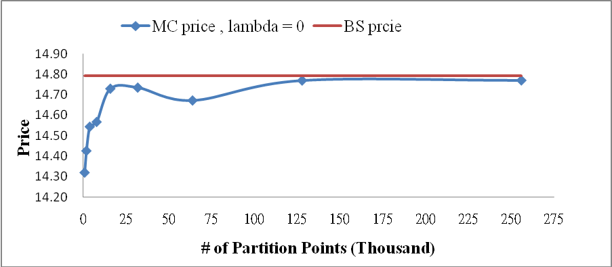

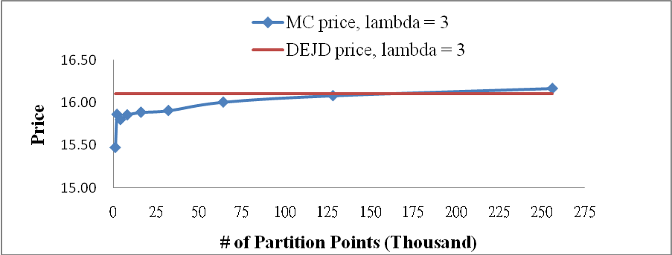

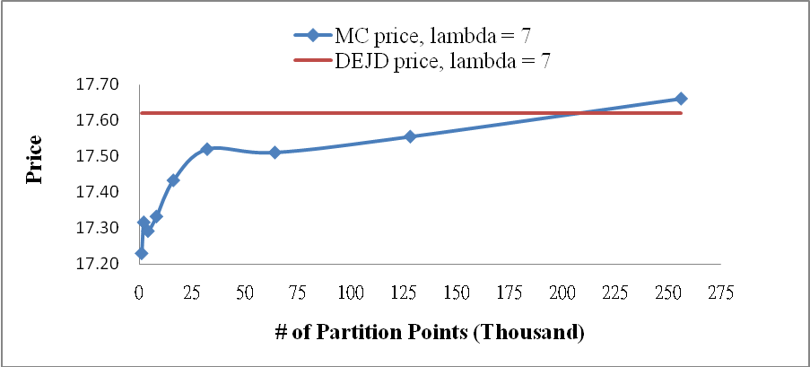
Figure 3. Comparison The Prices of Dynamic Guaranteed Funds With And Without Jumps Effect

Figure 3 shows the prices of dynamic guaranteed funds versus protection level K under the Black-Scholes model ( BS price ) and the double exponential jump diffusion model ( DEJD price ) with lambda = 3 and 7. The parameters used here are F(0) = 100, r = 0.04, T = 1, , p = 0.3 , , and .

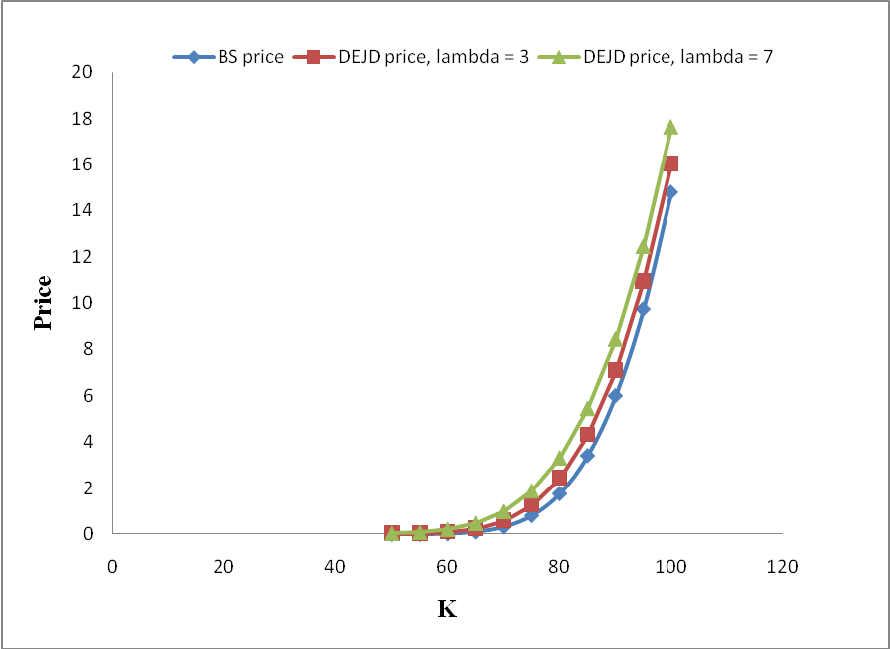

Figure 4. Sensitivity Analysis

Figure 4 shows the prices of dynamic guaranteed funds versus its parameters K, , , , p and q. The defaulting parameters are F(0) = 100 , K =100, r = 0.04, T = 1, , p = 0.3, , , and .

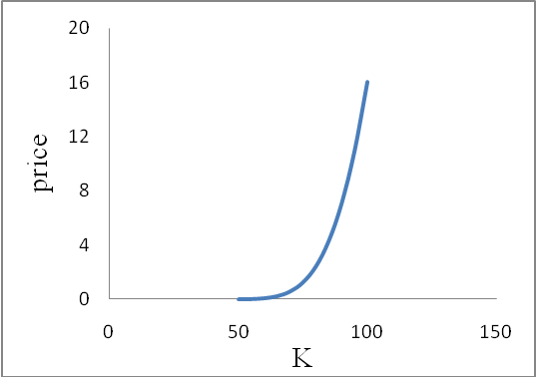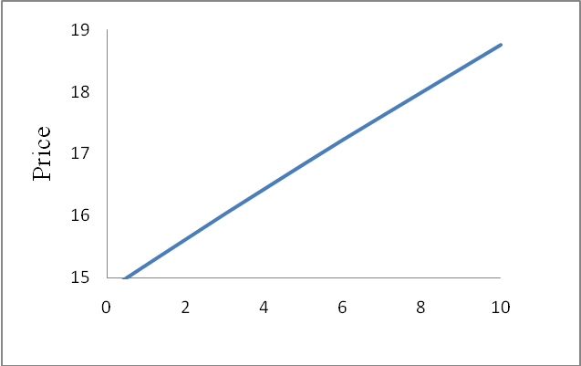

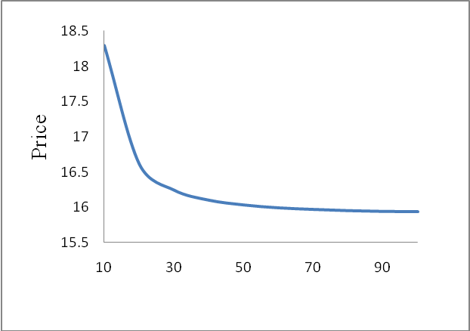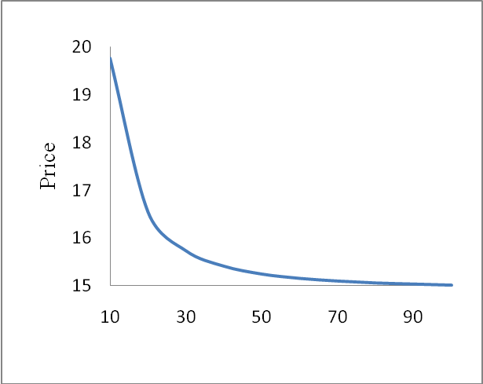

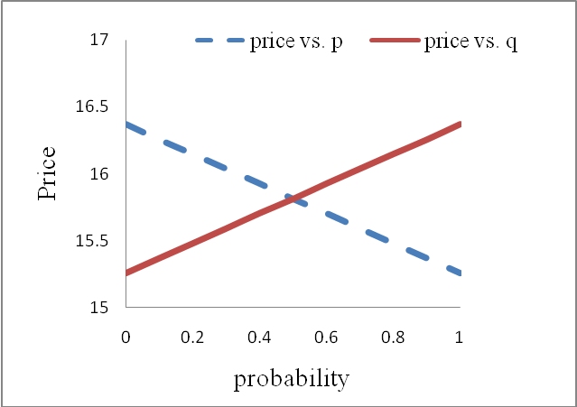

 Chaung-Chang Chang and M.H.Tsay are collocated at the National Central University, Taiwan. Address for correspondence: Department of Finance, National Central University Jungli 32001, Taiwan, Republic of China; Fax: 886-3-4252961; e-mail:ccchang@cc.ncu.edu.tw.
In contrast with pure diffusion models, Gerber and Shiu (1998) evaluated reset options under a pure jump process.
Kou (2008) and Cont and Tankov (2004) performed the empirical analyses to support these facts, and they also showed that these facts still exist in the market index level.
Kou (2008), Kou and Wang (2004), and Kou (2002) discussed a variety of models which have been proposed to incorporate the two empirical phenomena, such as jump-diffusion models, and stochastic volatility models…,etc.
Leib (2000) also provided a discussion on the advantage and disadvantage of DEJD model from a practical point of view.
This model can be supported by the rational expectations equilibrium of a typical exchange economy in which a representative agent uses an exogenous endowment process to solve a utility maximization problem, where the endowment process is assumed to follow a DEJD model. See Kou (2002, 2008) for a detailed discussion on this topic.
In this subsection, we consider the underlying naked fund follows the jump-diffusion process under a fixed probability measure , i.e. under the probability measure , 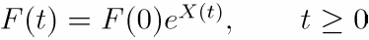, where
All parameters in Lemma 2.1 are defined as follows. 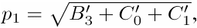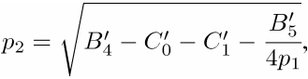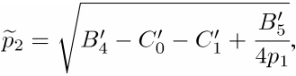 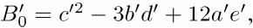 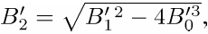 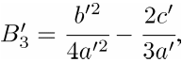 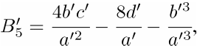 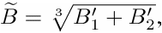 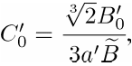 and 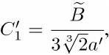 where 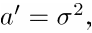 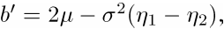 and with 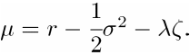
See, e.g. Abate and Whitt (1991) for a detail discussion on this algorithm.
The Monte Carlo results are based on 256,000 partition numbers and 3,000 simulation paths for T = 1. On the other words, for T=3 and 5, we increase the number of partitions to 768,000 and 1,280,000, respectively.

